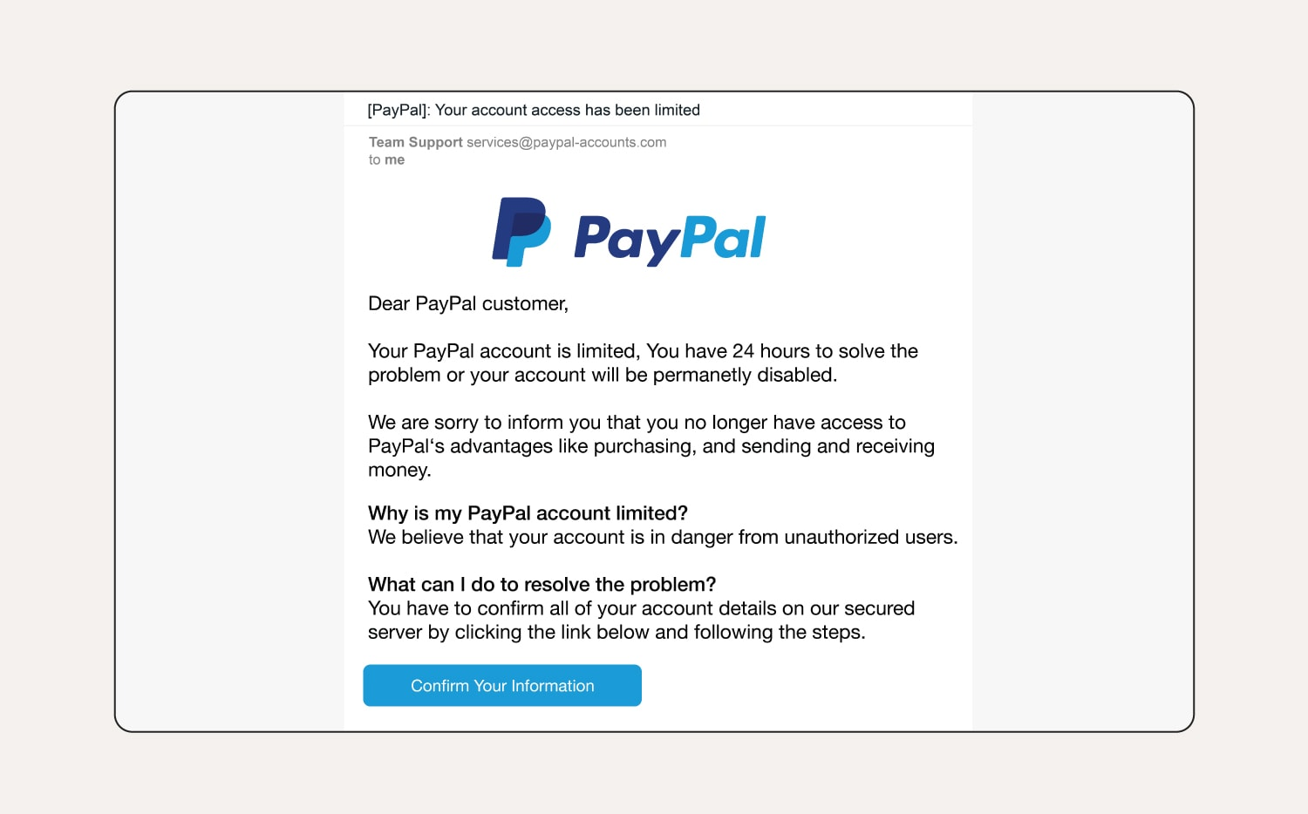
Sender Address
Real PayPal emails come from @paypal.com not @paypal-accounts.com
Generic Greeting
Usually, an important email will address you specifically by name. Not Customer
Urgency & Threats
Scammers love using time pressure to cause you to act without thinking
Phishing Link Button
Always hover over links, they usually reveal a suspicious URL that isn’t the official site (PayPal.com)
Suspicious Instructions
Instructed to confrim all account details through a link provided in the email
Grammar & Punctuation Errors
Random capitalization and punctuation.
Awkward phrasing: “Purchasing, and, sending and receiving money”

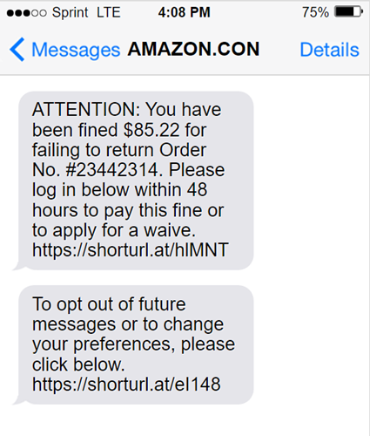
Unusual Opt-Out Message
Real opt-out texts will ask you to Reply YES or NO to opt out of future texts
Suspicious Links
Uses shortened URLs, commonly used to hide suspicious links. Normally would link somewhere in amazon.com
Order Number Trap
Scammers throw in numbers to make the message look official, but they rarely match real orders
Urgency & Threats
A fine wouldn’t be issued to you through text or email. The “48-hour deadline” is designed to scare you into clicking

Strange Wording
Apply for a “waive” is strangely worded. Larger companies like Amazon would have caught mistakes like this while proof-reading
Fake Name
Name appears as “Amazon.con”, sometimes done intentionally to avoid legality issues.

