

|  |  |  |
| --- | --- | --- |
| 1. | 2. | 3. |
| 4. | 5. | 6. |

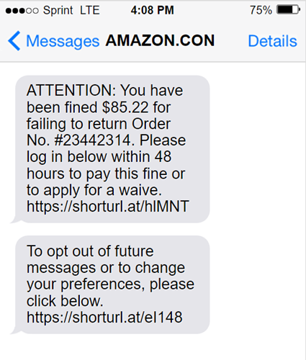

|  |  |  |
| --- | --- | --- |
| 1. | 2. | 3. |
| 4. | 5. | 6. |