**Bountiful Foods**

**Site Purpose:**

The purpose of the Bountiful Foods website is to serve as an online platform for an organic grocery store called "Bountiful Foods." The website aims to provide a convenient and user-friendly experience for customers to explore and purchase a wide range of organic and locally sourced food products. It will showcase the store's commitment to quality, sustainability, and supporting local farmers and suppliers. The website will feature product catalogs, detailed product information, a seamless ordering and checkout process, as well as helpful resources and recipes to promote a healthy and organic lifestyle. The goal is to attract health-conscious individuals, environmentally conscious consumers, and those who prioritize supporting local businesses and sustainable food practices.

**Personas:**

Persona 1: Health-Conscious Helen

Demographics: Female, 35-45 years old

Characteristics:

Values health and wellness

Concerned about the environment and sustainability

Has a higher income and is willing to spend more on quality organic products

Enjoys cooking and experimenting with new recipes

Active on social media platforms for discovering new food trends and sharing experiences

Persona 2: Eco-Conscious Ethan

Demographics: Male, 25-35 years old

Characteristics:

Environmentally conscious and supports local businesses

Seeks organic products that are ethically sourced and have minimal environmental impact

Tech-savvy and relies on online platforms for researching and purchasing products

Prefers convenience and quick delivery options

Interested in educational content related to sustainable living and healthy eating

**Site Map:  
  
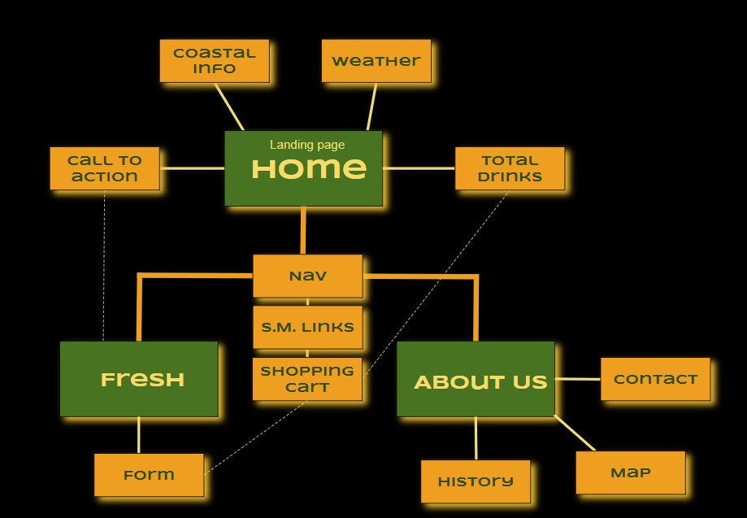**

**Color Scheme:**



**Typography:**

**Title and Headings:**

**Syncopate (Bold)**

Subtitles or Subheadings:

Syncopate (Regular 400)

Paragraphs or Body Text:

Roboto (Regular 300)

**Wireframe Sketches:**

