<Assessment>
LIST OF PROBLEMS
Version <1.0>

Iορδάνης-Ραφαήλ Φυδανάκης AM:420
Ευάγγελος Δημουλής ΑΜ:421

Table of Contents

Introduction 4
Architecture
Design Level 4
Code & Style Level 5
Style Violations 5
Pie Chart 5
Preliminary Plan of Actions

Introduction
The objectives of this phase is to comprehend the functionality of the project having in mind the way that each class works. Also we have to understand how the classes function and how exactly they connect with each other to create the final result. We must be able to identify the errors within the code and take meaning of why they exist.

ARCHITECTURE & DESIGN LEVEL

Architecture
We found two main problems at the Package level of the project.
First, there is a lack of back-end "server" package that hosts the business logic and as a result the (1) package has dependencies to all other packages which the GUI depends on and increases the coupling. The back-end "server" package would play the role of an intermediate between the DataKeeper and the GUI populated with "load" methods, which are currently in the GUI package.
Second, in the GUI there are methods that do some useful processing on data and we need to move the logic to the DataKeeper i.e. "Move behavior close to data" pattern. This will result in converting the Data class to something like a "service provider". The DataKeeper will become a "God" class that way. So as a next step we will divide that class into smaller subsystems that deligates work to other classes "Facade" pattern.
Packages where problematic behavior has been observed.
(1) gui.MainEngine
(2) tablelustering.clusterExtractor.common
(3) data.dataPPL.pplSQLSChema
(4) data.dataKeeper

Detailed Design

At the class level of the project we found problems at 3 packages.
- At the Data package the GlobalDataKeeper uses Worker to create the data and then copies it to his own class attributes (unnecessary step), we will remove these attributes from GlobalDataKeeper.
- At the Gui package the Gui class acts as a "God" class, it has many dependencies inside the Gui package and also outside of it, it contains very long methods and contains too many attributes, as a result we will work on refactoring this class so that it contains only the front-end logic.
The PldConstruction could be implemented by 3 Abstract classes each for a version of getNumOfAttributesOfNextSchema and the shared attributes of these classes. Also the getSegmentSize private method is the same for every class, It could be created in these 3 abstract classes.
- At the TableClustering package the Cluster class is the class which keeps the information of a cluster. The ClusterInfoKeeper should be renamed to ClusterMetricsComputator or something relevant because its name is misleading.

The Phase package doesn’t appear to have any serious problem at first glance.

CODE & STYLE LEVEL

Style Violations

ChesckStyle Pie
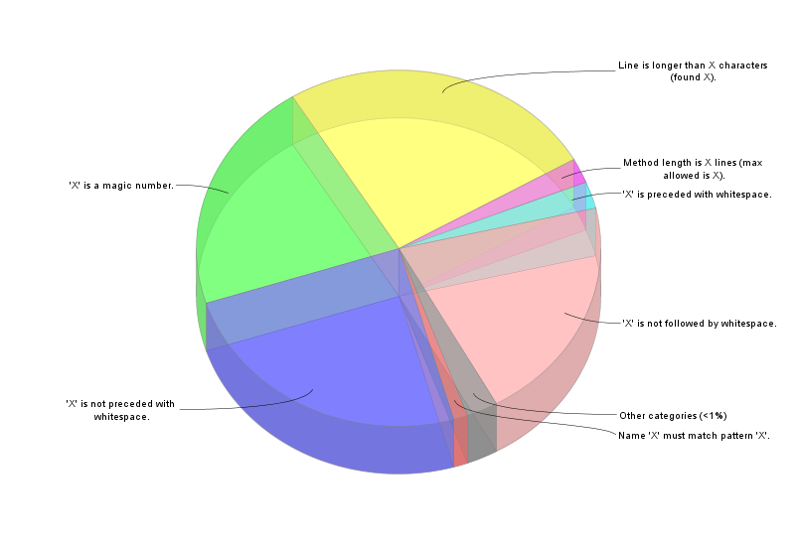

CheckStyle Violations

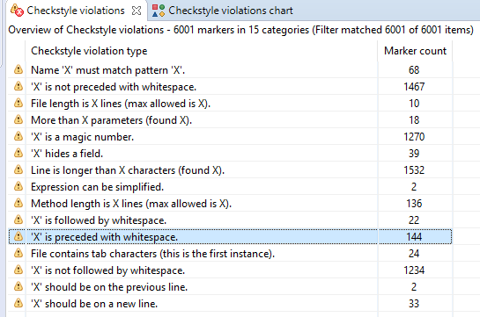

Preliminary Plan of Actions
1. Develop tests for the existing systems.
2. Add a Business logic package intermediary to the GUI and the Data packages.
3. Move methods that process data to the DataKeeper.
4. Divide the DataKeeper into smaller subsystems that handle the logic.
5. Apply general refactoring patterns on the code e.g. extract methods, duplicate code, clean dead code, spaghetti code...
6. If needed, add more tests to verify the functionality of the final system.

