<FINAL VERSION>
REFACTORING PLUTARCH PARALLEL LIVES
Version <1.0>

Iορδάνης-Ραφαήλ Φυδανάκης AM:420
Ευάγγελος Δημουλής ΑΜ:421

Table of Contents
Introduction 4
Refactoring 4
Refactoring 4
patterns used 7
Testing 7
Tests 7
UML DIAGRAMS 9
Code quality 13

Introduction

The objective of this work is to refactor the legacy code of the project Plutarch Parallel Lives which is part of the graduate course Software and Data Evolution. As a first step, we performed actions towards understanding the architecture of the project and reverse engineer the legacy code by generating the corresponding package diagrams, class diagrams CRC cards per class etc. Afterwards, we listed the problems detected at the architecture and design level, code and style level and prepared a preliminary plan of action towards re-engineering the code. As a next step, we developed JUnit tests regarding general use cases of the project in order to facilitate the migration process, and we also applied some initial refactoring to the code. Finally, we proceeded towards refactoring the legacy code using the knowledge we obtained at the fore mentioned steps and by applying refactoring patterns studied at class lectures, we solved architecture and design problems, prepared tests for future use and refactoring, and improved code quality.
You can find the source code of the project in GitHub at:
https://github.com/JordanRaphael/l1-software-data-evolution

DESIGN RECOVERY
In this section we present and analyze the architecture and design of Plutarch by providing the initial package and class diagrams before applying any refactoring to the legacy code. In order to focus better on the problems we detected, in this report we will not provide all the diagrams however they are included in the deliverable.

PACKAGE DIAGRAMS

Project hyper package diagram: shows structure and dependencies between all sub-packages of the system. gui.mainEngine and data.DataKeeper packages present many dependencies with other packages of the system.
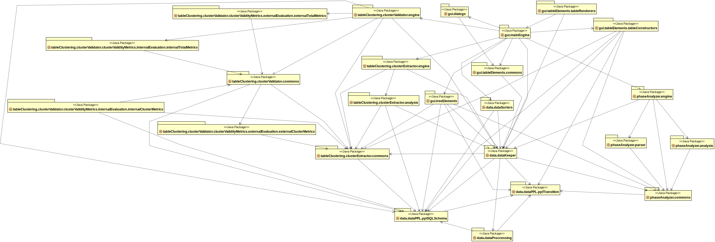

Data hyper package diagram: shows structure and dependencies between all sub-packages of the data package. Cycles between the packages are observed here.
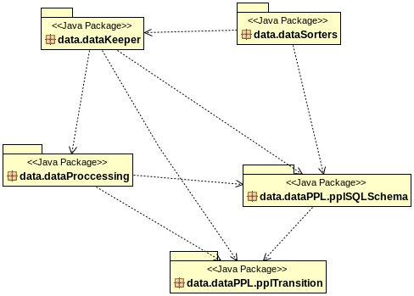

Gui hyper package diagram: shows structure and dependencies between all sub-packages of the GUI. gui.mainEngine package depends on all other packages.
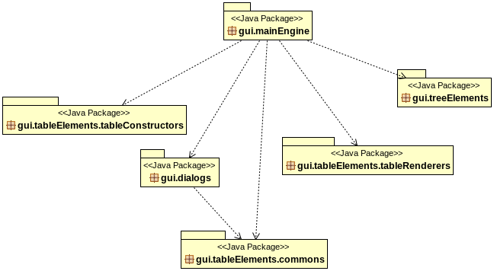

CLASS DIAGRAMS
Gui class diagram: high coupling and many dependencies between the Gui class and all other classes of the GUI package.
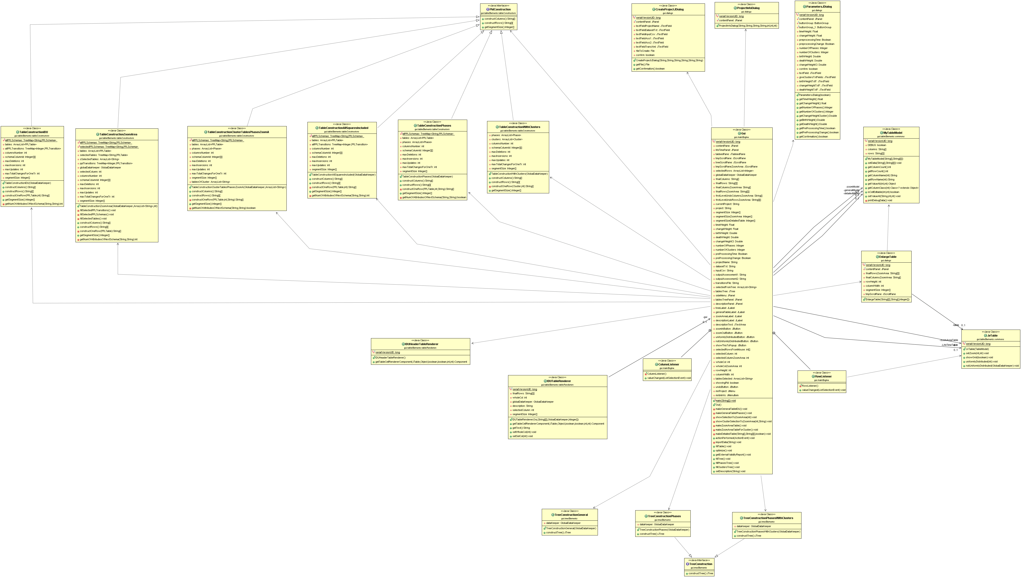
Data class diagram: many dependencies on Worker class. GlobalDataKeeper does not contain any processing logic but only accessor and mutator methods.
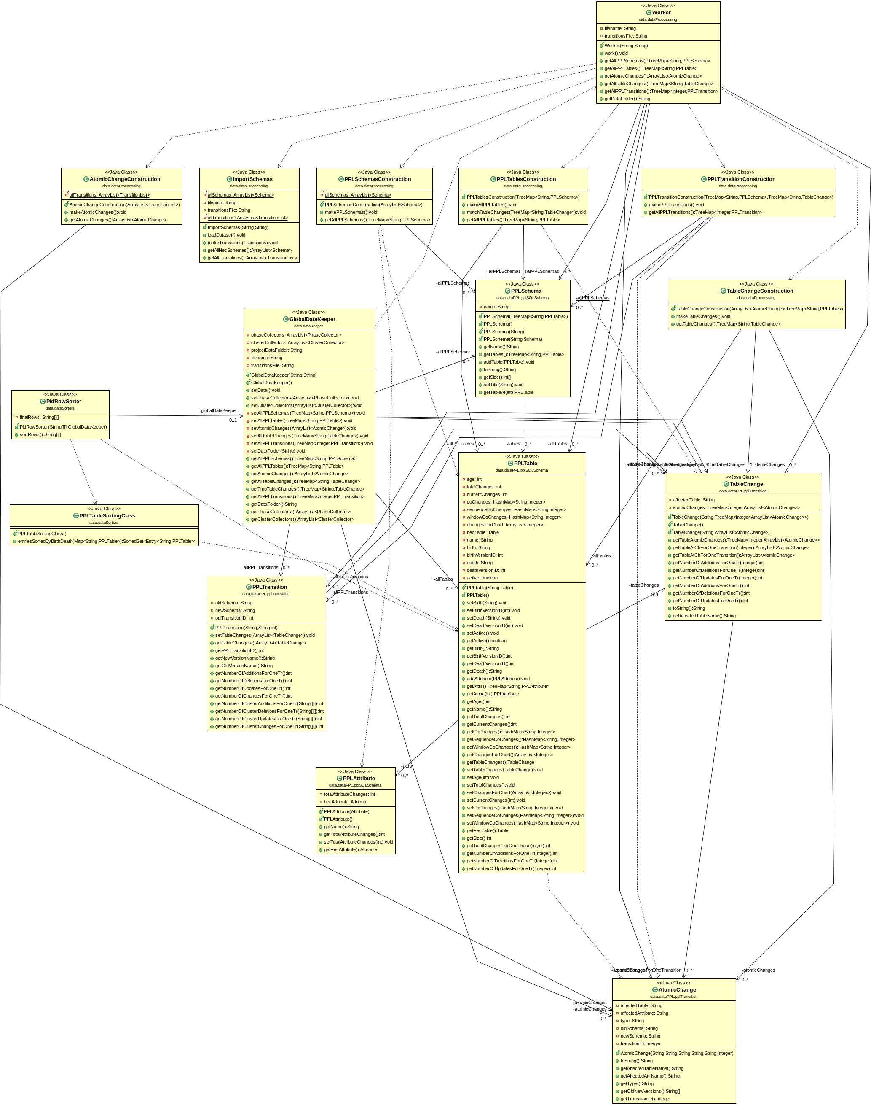

LIST OF PROBLEMS
In this section we report a list of architecture, design and source code style problems. After identifying and listing the problems, we provide a preliminary plan of actions towards re-engineering the legacy code.

ARCHITECTURE & DesiGN

We detected two main issues at the Package level of the project.
First, there is a lack of back-end "server" package that hosts the business logic and as a result the gui.MainEngine package has dependencies to all other packages which the GUI depends on and increases the coupling. The back-end "server" package would play the role of an intermediate between the DataKeeper and the GUI populated with "load" methods, which are currently in the GUI package. Furthermore, in the GUI there are methods that do some useful processing on data and we need to move the logic to the DataKeeper i.e. "Move behavior close to data" pattern. This will result in converting the Data class to something like a "service provider". The DataKeeper will become a "God" class that way. So as a next step we will divide that class into smaller subsystems that delegate work to other classes "Facade" pattern.
The two main packages where problematic behavior has been observed are:
(1) gui.MainEngine (2) data.dataKeeper

At the class level of the project we identified problems mainly at two packages:
1. At the Data package the GlobalDataKeeper makes use of the Worker class to create the data and then copies it to his own class attributes (unnecessary step). We will remove these attributes from GlobalDataKeeper.
2. At the Gui package the Gui class acts as a "God" class, it has many dependencies inside the Gui package and also outside of it, it is composed of very long methods and contains too many attributes. As a result we will work on refactoring this class so that it is populated only with the front-end code logic.

STYLE VIOLATIONS

CheckStyle Violations

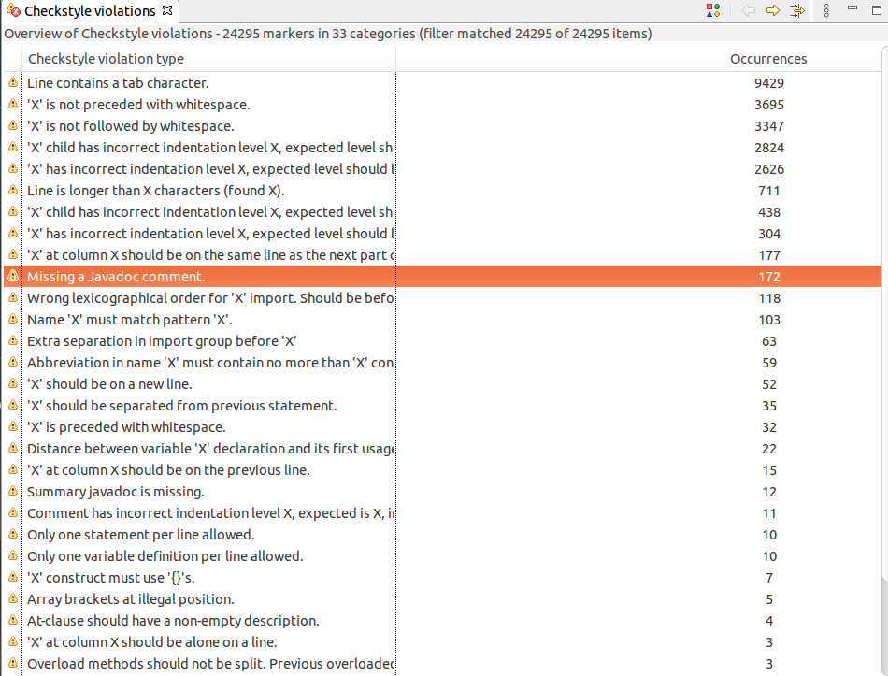

PRELIMINARY PLAN OF ACTIONS

1. Develop tests for the existing legacy system.
2. Add a Business logic class, intermediary to the GUI and the Data packages in order to offload the GUI from data processing logic.
3. Move methods that process data to the DataKeeper in order to bring behavior closer to data.
4. Divide the DataKeeper into smaller subsystems that handle the logic depending on the type of processing we need to apply.
5. Apply general refactoring patterns on the code e.g. extract methods, duplicate code,
clean dead code, spaghetti code, factory etc.
6. If needed, add more tests to verify the functionality of the refactored version of the
system.

TESTING

In this section we report the list of tests that we constructed to facilitate the migration process. In order to develop tests for Plutarch Parallel Lives tool, we had to do some basic refactoring on the legacy code so as for the code to be testable. The tests we developed involve mainly general use cases of the tool and the framework we used is JUnit. In most cases we use the Atlas project to construct the tests and compare to the dumped data we generated.
We developed tests for GUI’s createProject, editProject, loadProject, zoomIn and zoomOut. In each test we have a ground truth and we test that the methods have the expected results. Additionally, we added tests regarding all table display options the tool provides such as: Show PLD, Show Phases PLD, Show Phases with Clusters PLD and Show Full Detailed LifeTime table.
For the GlobalDataKeeper we developed a test to verify that the method setData() works properly. To achieve that, we had to create a file with the expected results of the setData() method. We then call the importData() which uses the setData() and other methods to insert the data to the GUI components. When this step is complete, we check if the imported data match perfectly the data that we wanted to import. The tests are configured to be automated by selecting “Run as JUnit” at the tests package.

Next we provide a list of tests we developed along with a brief description for each test.
- testCreateProject: populates a new dialog with test data needed to create a new project.
- testEditProject: imports the Atlas project and compares the dumped data we get from edit in the project to the data generated in the test.
- testLoadProject: imports the Atlas project using the ProjectManager class (will be introduced later) and compares the contents of the project to the dumped contents.
- testZoomIn: imports the phpBB project, sets constants about the size of the Gui components and compares them to what they should be.
- testZoomOut: same concept as in testZoomIn.
- testSetData: imports the Atlas project and populates the GlobalDataKeeper module with data in order to compare this data to the dumped data that we use as a ground truth.
- testShowPLD: imports the Atlas project, use the ShowPLD functionality and check the integrity of the updated data.
- testShowPhasesPLD: populates the dialog used to display the phases of the loaded project, executes the processing logic to fill the table and compares the table contents to the dumped contents.
- testShowPhasesWithClusters: same concept as in testShowPhasesPLD adding a number of clusters parameter.
- testShowFullDetailedLifetimeTable: compares the contents of the Full Detailed Lifetime to the contents of the dumped Lifetime table.

Refactoring THE CODE
In this section we present the steps towards refactoring the legacy code by breaking up the GUI to subsystems handling the business logic of the project and moving logic related to any useful processing on data to the DataKeeper. As a last step, we broke up the newly generated GlobalDataKeeper which we renamed to GlobalDataManager to subsystems handling the client requests, thus making the GlobalDataManager act as a “Service Provider”.

GUI PACKAGE

Through the class diagram and by reading the code of the Gui class we observed that the Gui contained all the business logic of the project such as loading a project, editing a project etc., which was hidden inside action listeners. Moreover, those action listeners contained also processing logic which applied to data generally stored in the back-end and not in the Gui making the Gui act as a “God Class”. In order to resolve the issues we observed we took the following steps to extract functionality from the Gui class and from he GUI hyper-package:
Moving packages from GUI to data package
We moved gui.treeElements package to the data hyper-package, renaming it to data.treeElements. This package contains classes responsible for constructing JTree objects. However, even though JTree objects are part of java.swing package, these classes make use of the GlobalDataKeeper to fill a JTree with data and contain processing logic in them. As a result we moved them to the data package to bring behavior closer to data.
As a next step, we moved the gui.tableElements.tableConstructors package to the data hyper-package, renaming it to data.tableConstructors. The tableConstructors package is responsible for constructing and filling table contents using to a greater extent the back-end than the front-end similarly to the treeElements package fore mentioned.

Extracting the listeners and the business logic from the GUI
In order to split up the Gui class we created some extra classes, each with distinct responsibilities in order to extract functionality from the Gui and reduce also duplicate code.
JItemsHandler: The JItemsHandler class is responsible for the creation and initialization of the JItems which are part of the Gui. The creation of these components contain a lot of duplicate code which is reduced by creating methods at the JItemsHandler to handle the initialization and reduce duplication.
GuiController: The GuiController class acts as an intermediary between the front-end and the back-end of the application. At first, all listeners and processing logic which was part of the Gui was moved to this class. The GuiController handles the interaction between the GlobalDataManager and the Gui classes by populating the Gui with the data fetched from the back-end, and it also stores all business logic for loading a project creating a project etc.
ZoomTableListenerHandler: The ZoomTableListenerHandler class is responsible for handling and storing all the logic related to the action listeners used for manipulating the “Zoom Table” of the application at mouse click events mostly.
GeneralTableListenerHandler: The GeneralTableListenerHandler class is responsible for handling and storing all the logic related to the action listeners used for manipulating the “General Table” of the application at mouse click events mostly.
TableRenderer: The Table Renderer class is an abstract class which defines two methods for the creation of DefaultTableRenderers which are responsible for rendering the view of a table after changes. We use this abstraction in the next classes to generalize the creation process of table renderers and add a level of abstraction to the code.

TablesFactory: The TablesFactory class acts a factory and is responsible for the creation of objects of type TableRenderer. After specifying one of the two existing table types, the class handles the creation of the corresponding TableRenderer object, which inherits from the type TableRenderer.
GeneralTableRendererHandler: The GeneralTableRendererHandler extends the TableRenderer class and implements the abstract methods defined at TableRenderer. It is responsible for the creation of DefaultTableRenderer objects which are part of displaying the “General Table” contents at the Gui.
ZoomTableRendererHandler: The ZoomTableRendererHandler extends the TableRenderer class and implements the abstract methods defined at TableRenderer. It is responsible for the creation of DefaultTableRenderer objects which are part of displaying the “Zoom Table” contents at the Gui.
Moving data processing logic to data package
After refactoring the Gui class and splitting up the logic into subsystems, the GuiController class contained methods and logic related to data processing. We moved this logic into the GlobalDataManager to bring behavior closer to data. The methods populateWithClusters( ) and populatedWithPhases( ) are a brief example of methods solely doing some useful processing on data, related to Cluster objects and Phase data used when the clustering algorithms are triggered at the back-end of the project. Similarly, showClusterSelectionZoomArea( ) operates on Cluster data and prepares this data to be visualized in the Gui. More details about how the GlobalDataManager operates and what functionality is pushed there will be given in the next section.

DATA PACKAGE

One of the first problem that we observed by looking at the source code of data package was that the global data keeper was a huge data container without logic. So, our goal was to break it down to simpler classes with meaning. At the development stage, the first thing we did was to develop tests, so that we can test that any change to the source code. didn’t break the logic or functionality of the program. For the data package, we developed a test for the setData method, which sets up all the necessary data for the program to run. As a next step, we started moving logic from Gui to GlobalDataKeeper, in order to have a purpose besides being a data container. Final steps, as we moved logic to GlobalDataKeeper, it became a god class, so we split it up to 5 classes, 1 GlobalDataManager to be the intermediary between the Gui and the Data, ‘facade” pattern, and 4 classes that stores and processes the data.

Data Package observed problems
As a first step to the refactoring of the PPL’s source code, we created the UML diagrams of the project to have a look at the higher level of the project’s design. At the UML diagrams we observed that the GlobalDataKeeper is being used data container from every system of the project, so we had to give it a purpose and split it up.
Testing
At the test development stage, we developed a test for the data package as well. We tested the setData method in order to have a way to test that the data storing and data retrieval are intact after our changes to the source code. The setData method uses the other classes t the dataKeeper package, in order to store the schemas, tables, transitions, table changes, atomic changes and all the necessary project information. To test this method, we have a file that’s our ground truth, it contains all the data that should have been stored to the dataKeeper classes for a given project. So, we load up that project, we use the setData method and recreate a file using the newly added data. If the new file is the same as the ground truth, we are certain that the setData method works as expected. If they aren’t the same, the test fails.

Moving Logic Closer to Data
Next, we extracted logic and methods from the Gui, to move to the GlobalDataKeeper. But this refactoring created another problem, the GlobalDataKeeper became a god class itself.
Refactoring GlobalDataKeeper
After our changes to the GlobalDataKeeper, it became clear to us that we had to split up this class. So we split it up to 5 classes. The GlobalDataManager which handles the storing of the data and 4 classes that actually store the data and process these data. We also moved even more logic out of Gui and transfer it to these 4 classes.
Global Data Manager
This class is now a manager class that manages the storing of the data, an intermediary between Gui and Data packages. We used a variation of “facade” pattern here.
Data Collectors Manager
This class manages the phase and cluster collections of the project, as well as their processing. Its purpose is to save these data and process it on demand.
PPL Data Manager
This class stores the schemas, tables and transitions of the project. It processes these data on demand for other subsystems of the project.
Project Manager
This is another class that stores data, more specifically, it stores the information of the loaded project such as project name, dataset path, project folder etc. Its purpose is to parse the input file of a project, and provide to any class that needs it, the project’s information.
Table Change Manager
This class stores the changes that have been made to the tables of the loaded project. Its purpose is to store these data, process them and provide them when needed.

patterns used

A variation of Factor out state pattern was used at the Gui Package where we created a Factory class
Facade at GlobalDataManager for the data container methods.

REFACTORED SYSTEM ARCHITECTURE
In this section we present and analyze the architecture and design of the refactored version of Plutarch by providing the initial package and class diagrams after refactoring the legacy code showing how responsibilities were split to subsystems and hierarchies were added.

PACKAGE DIAGRAMS

Project hyper package diagram: shows the structure and dependencies between all sub-packages of the system after the refactoring.
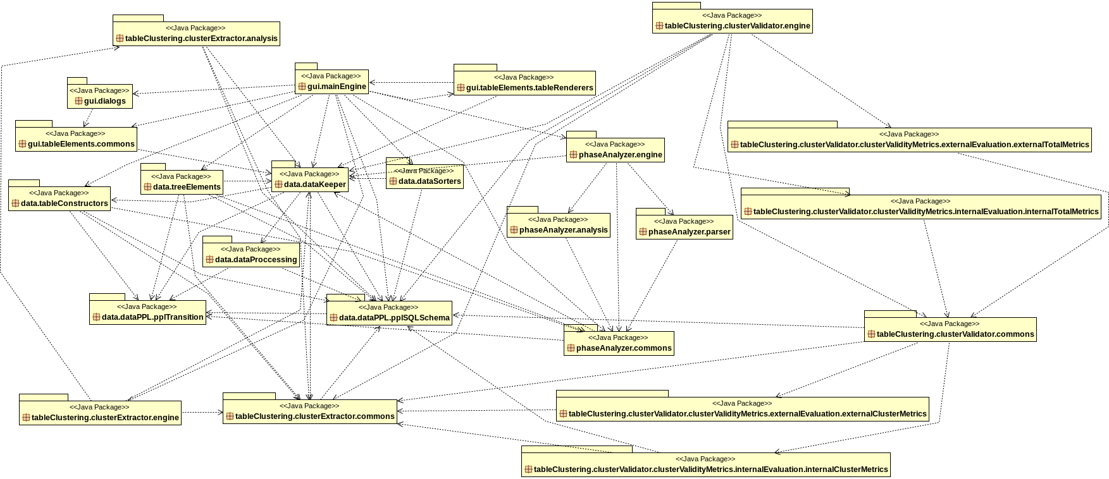

Data hyper package diagram: shows structure and dependencies between all sub-packages of the refactored data package. Cycles that existed between the packages were broken.
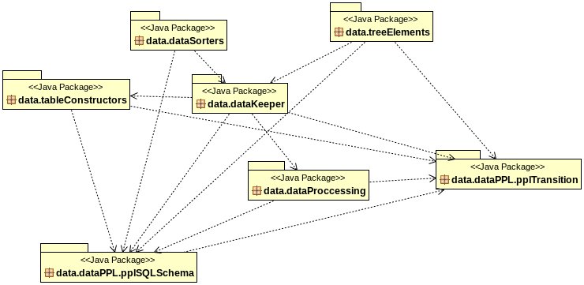

Gui hyper package diagram: shows structure and dependencies between all sub-packages of the GUI.
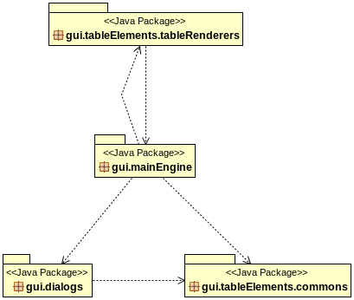

CLASS DIAGRAMS

Gui class diagram: after refactoring the Gui class was split up to subystems distributing responsibilities. As a result more classes were added to the diagram.

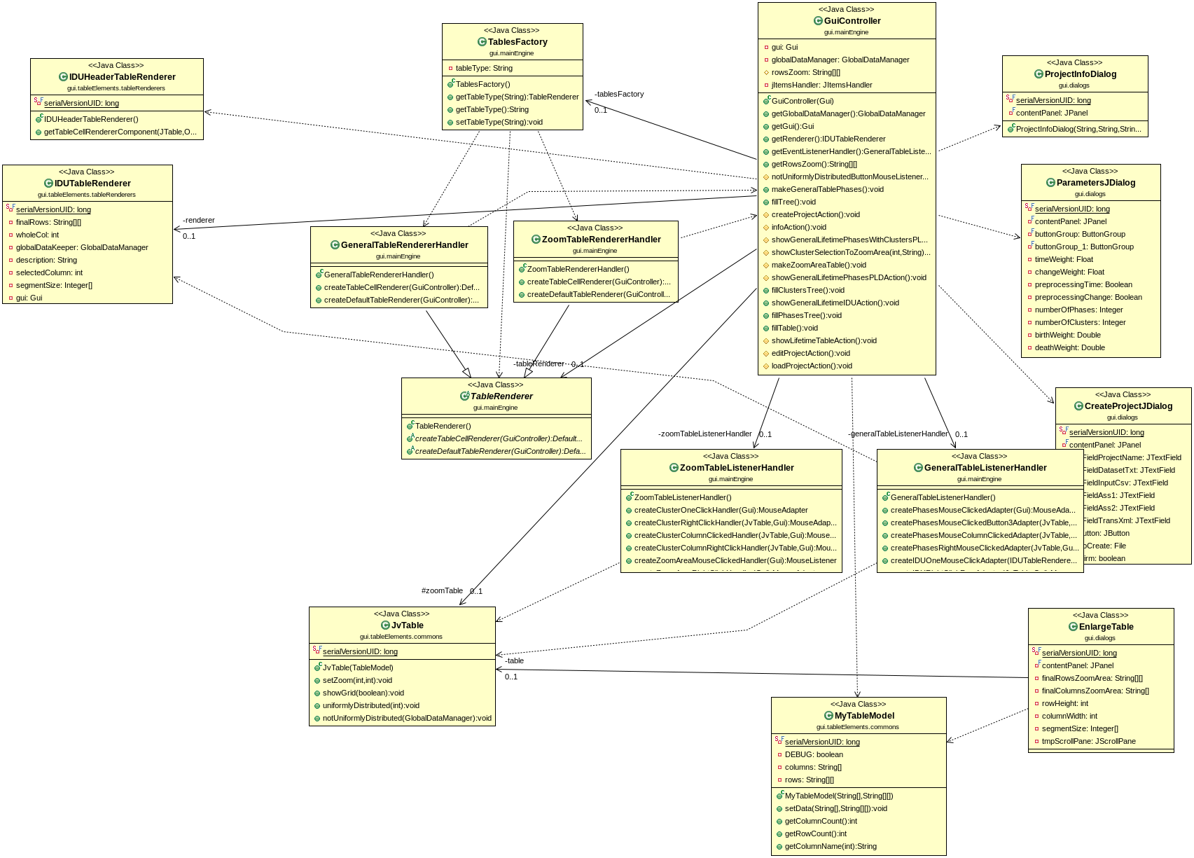

Gui gui.mainEngine class diagram:
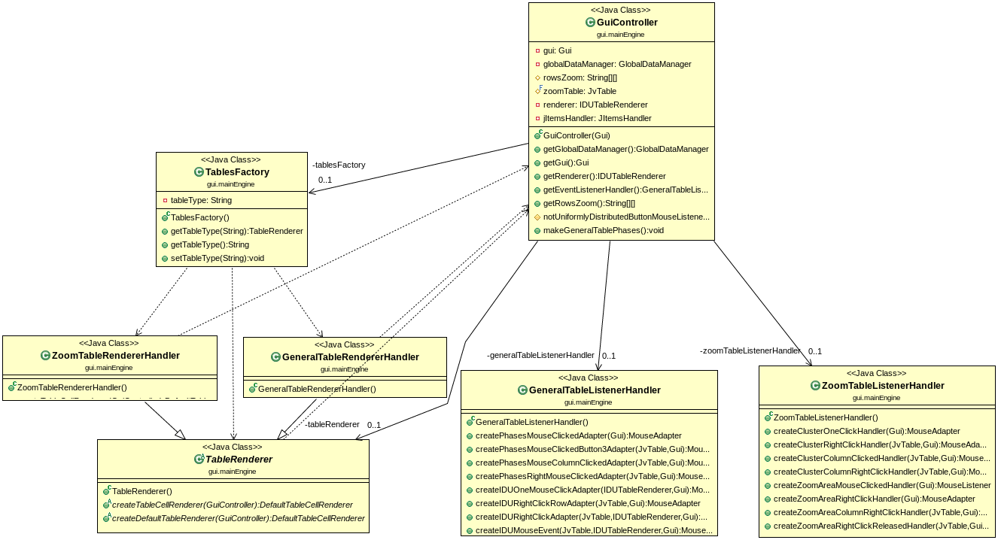
Data class diagram: by moving the logic closer to data the data class diagram ws populated with more classes but each with distinct responsibilities.
Data data.Keeper class diagram:

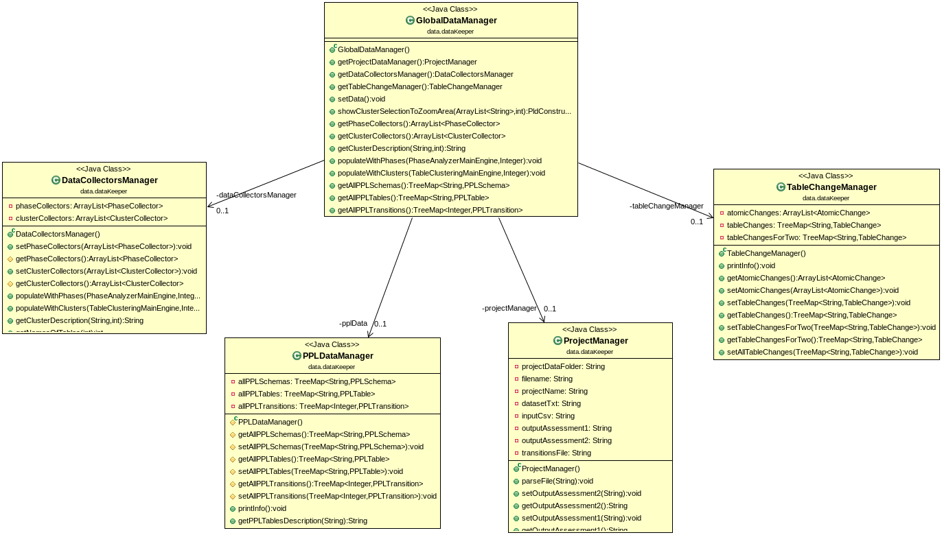

Code quality

The code had complicated if statements which were extracted to separate methods in order to make the code more readable and less complex. The indentation of the code was fixed where code was not properly structured and in some cases no whitespaces were followed after variable declaration or object declarations. Many variable and class names were misleading and it was not obvious what purpose they served in the code so we did a lot of refactoring in order to give more proper names.
Furthermore, some methods was extremely long, they were split into smaller methods or even classes with discrete functionality splitting up possible “God Class” cases such as the Gui class. .Some methods could be moved to another class or package, so we applied method extraction techniques.
Finally, there was a lot of duplicate code, so we spent effort and time in removing duplication code or methods with same functionality but located in different classes. Dead code or code in comments was also removed.

STYLE VIOLATIONS

CheckStyle Violations
- Checkstyle violations picture need to be added.

OPEN ISSUES

Create a factory or interface at the dataKeeper package.
We tried to create an interface at datakeeper but there is no similarity between them and we couldn’t create an interface or factory to unify these data containers.

