<FINAL VERSION>
REFACTORING PLUTARCH PARALLEL LIVES
Version <1.0>

Iορδάνης-Ραφαήλ Φυδανάκης AM:420
Ευάγγελος Δημουλής ΑΜ:421

Table of Contents
Introduction 4
Refactoring 4
Refactoring 4
patterns used 7
Testing 7
Tests 7
UML DIAGRAMS 9
Code quality 13

Introduction

The objective of this work is to refactor the legacy code of the project Plutarch Parallel Lives which is part of the graduate course Software and Data Evolution. As a first step, we performed actions towards understanding the architecture of the project and reverse engineer the legacy code by generating the corresponding package diagrams, class diagrams CRC cards per class etc. Afterwards, we listed the problems detected at the architecture and design level, code and style level and prepared a preliminary plan of action towards re-engineering the code. As a next step, we developed JUnit tests regarding general use cases of the project in order to facilitate the migration process, and we also applied some initial refactoring to the code. Finally, we proceeded towards refactoring the legacy code using the knowledge we obtained at the fore mentioned steps and by applying refactoring patterns studied at class lectures, we solved architecture and design problems, prepared tests for future use and refactoring, and improved code quality.
You can find the source code of the project in GitHub at:
https://github.com/JordanRaphael/l1-software-data-evolution

DESIGN RECOVERY
In this section we present and analyze the architecture and design of Plutarch by providing the initial package and class diagrams before applying any refactoring to the legacy code. In order to focus better on the problems we detected, in this report we will not provide all the diagrams however they are included in the deliverable.

PACKAGE DIAGRAMS

Project hyper package diagram: shows structure and dependencies between all sub-packages of the system. gui.mainEngine and data.DataKeeper packages present many dependencies with other packages of the system.
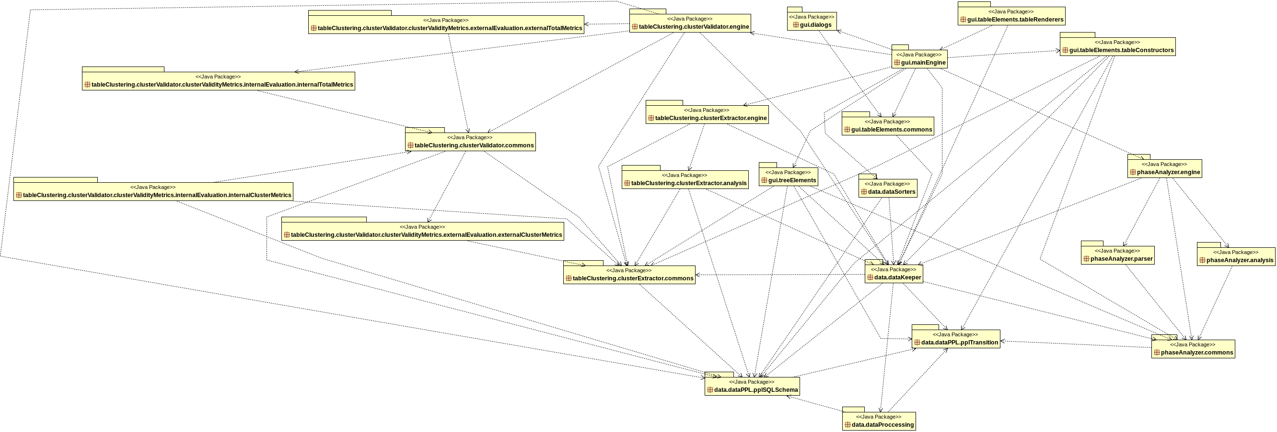

Data hyper package diagram: shows structure and dependencies between all sub-packages of the data package. Cycles between the packages are observed here.
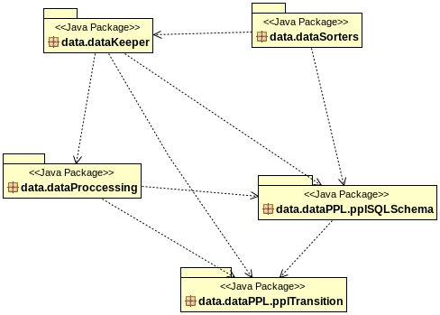

Gui hyper package diagram: shows structure and dependencies between all sub-packages of the GUI. gui.mainEngine package depends on all other packages.
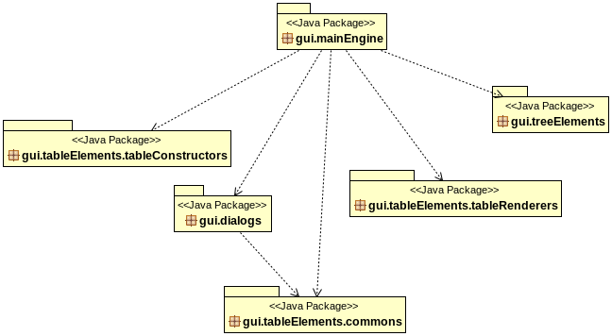

CLASS DIAGRAMS
Gui class diagram: high coupling and many dependencies between the Gui class and all other classes of the GUI package.
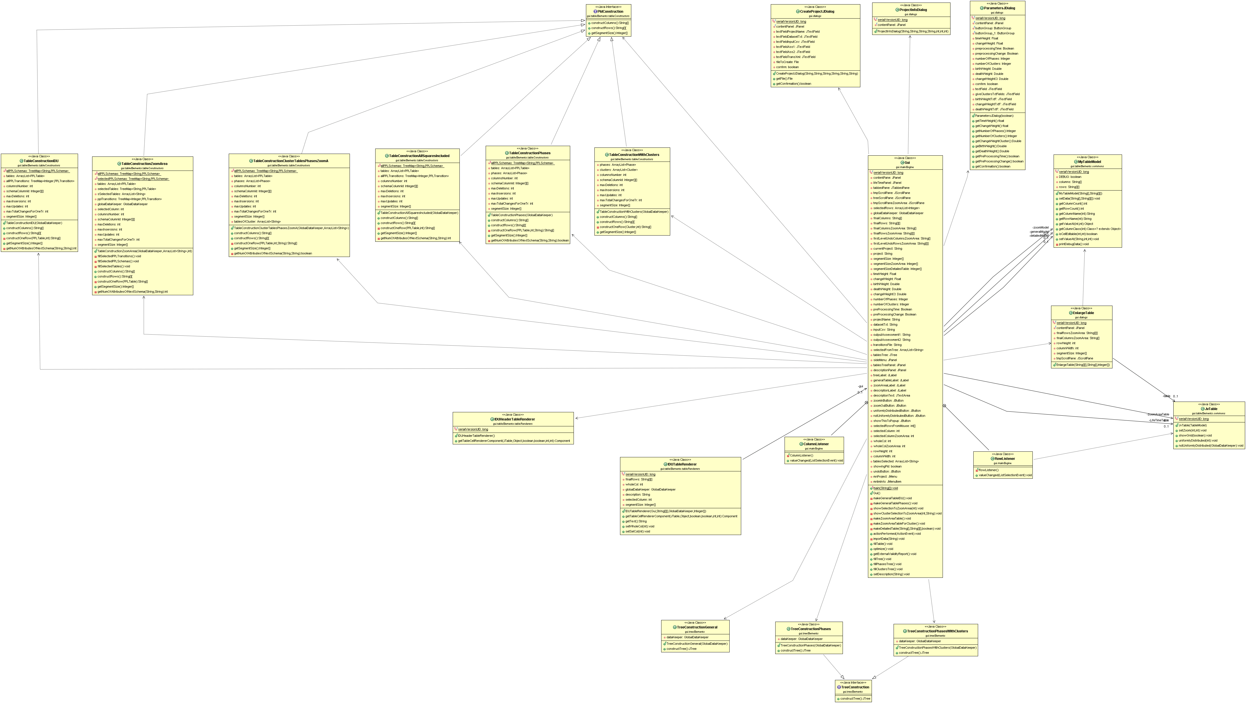
Data class diagram: many dependencies on Worker class. GlobalDataKeeper does not contain any processing logic but only accessor and mutator methods.
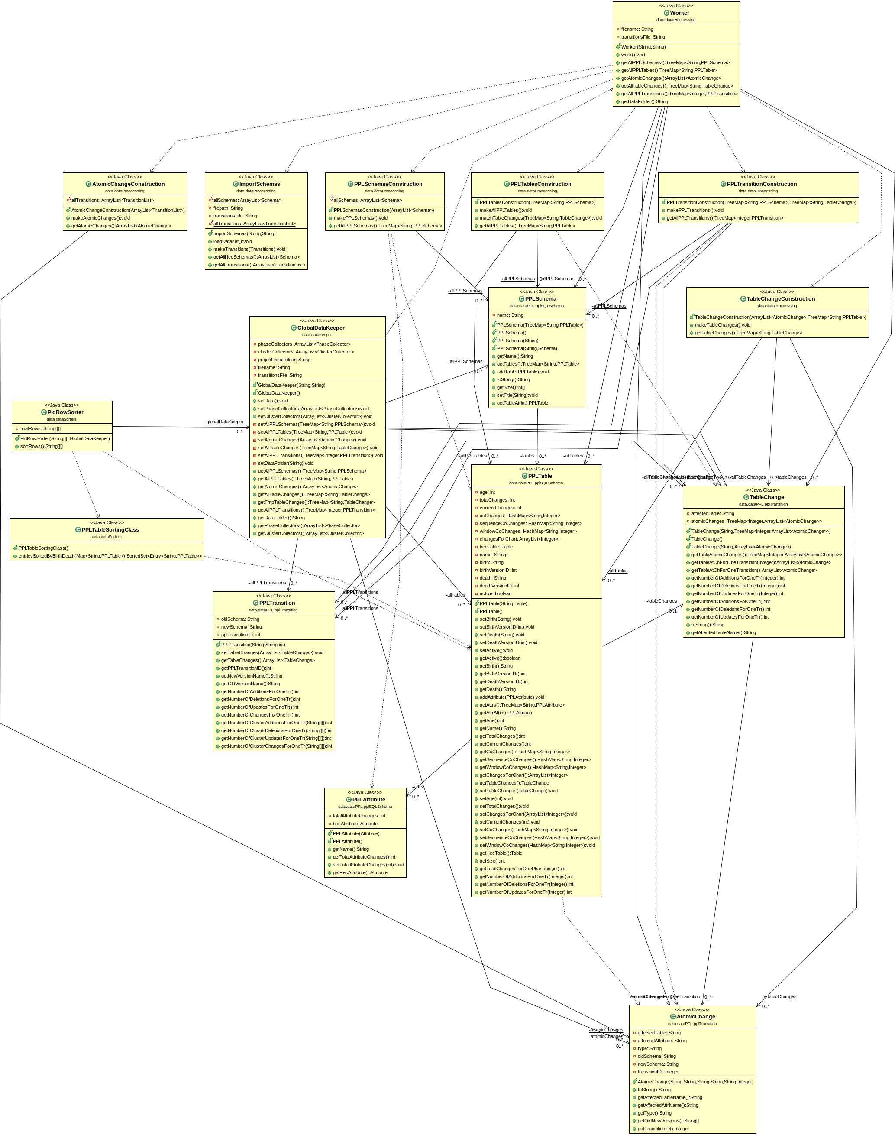

LIST OF PROBLEMS
In this section we report a list of architecture, design and source code style problems. After identifying and listing the problems, we provide a preliminary plan of actions towards re-engineering the legacy code.

ARCHITECTURE & DesiGN

We detected two main issues at the Package level of the project.
First, there is a lack of back-end "server" package that hosts the business logic and as a result the gui.MainEngine package has dependencies to all other packages which the GUI depends on and increases the coupling. The back-end "server" package would play the role of an intermediate between the DataKeeper and the GUI populated with "load" methods, which are currently in the GUI package. Furthermore, in the GUI there are methods that do some useful processing on data and we need to move the logic to the DataKeeper i.e. "Move behavior close to data" pattern. This will result in converting the Data class to something like a "service provider". The DataKeeper will become a "God" class that way. So as a next step we will divide that class into smaller subsystems that delegate work to other classes "Facade" pattern.
The two main packages where problematic behavior has been observed are:
(1) gui.MainEngine (2) data.dataKeeper

At the class level of the project we identified problems mainly at two packages:
1. At the Data package the GlobalDataKeeper makes use of the Worker class to create the data and then copies it to his own class attributes (unnecessary step). We will remove these attributes from GlobalDataKeeper.
2. At the Gui package the Gui class acts as a "God" class, it has many dependencies inside the Gui package and also outside of it, it is composed of very long methods and contains too many attributes. As a result we will work on refactoring this class so that it is populated only with the front-end code logic.

STYLE VIOLATIONS

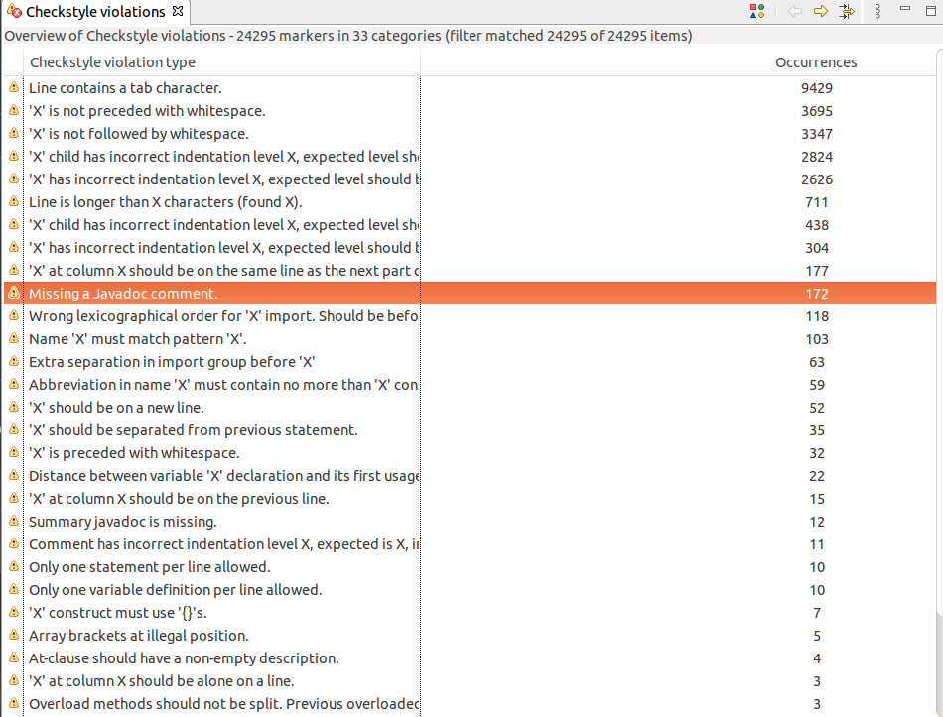
CheckStyle Violations

PRELIMINARY PLAN OF ACTIONS

1. Develop tests for the existing legacy system.
2. Add a Business logic class, intermediary to the GUI and the Data packages in order to offload the GUI from data processing logic.
3. Move methods that process data to the DataKeeper in order to bring behavior closer to data.
4. Divide the DataKeeper into smaller subsystems that handle the logic depending on the type of processing we need to apply.
5. Apply general refactoring patterns on the code e.g. extract methods, duplicate code,
clean dead code, spaghetti code, factory etc.
6. If needed, add more tests to verify the functionality of the refactored version of the
system.

TESTING

In this section we report the list of tests that we constructed to facilitate the migration process. In order to develop tests for Plutarch Parallel Lives tool, we had to do some basic refactoring on the legacy code so as for the code to be testable. The tests we developed involve mainly general use cases of the tool and the framework we used is JUnit. In most cases we use the Atlas project to construct the tests and compare to the dumped data we generated.
We developed tests for GUI’s createProject, editProject, loadProject, zoomIn and zoomOut. In each test we have a ground truth and we test that the methods have the expected results. Additionally, we added tests regarding all table display options the tool provides such as: Show PLD, Show Phases PLD, Show Phases with Clusters PLD and Show Full Detailed LifeTime table.
For the GlobalDataKeeper we developed a test to verify that the method setData() works properly. To achieve that, we had to create a file with the expected results of the setData() method. We then call the importData() which uses the setData() and other methods to insert the data to the GUI components. When this step is complete, we check if the imported data match perfectly the data that we wanted to import. The tests are configured to be automated by selecting “Run as JUnit” at the tests package.

Next we provide a list of tests we developed along with a brief description for each test.
- testCreateProject: populates a new dialog with test data needed to create a new project.
- testEditProject: imports the Atlas project and compares the dumped data we get from edit in the project to the data generated in the test.
- testLoadProject: imports the Atlas project using the ProjectManager class (will be introduced later) and compares the contents of the project to the dumped contents.
- testZoomIn: imports the phpBB project, sets constants about the size of the Gui components and compares them to what they should be.
- testZoomOut: same concept as in testZoomIn.
- testSetData: imports the Atlas project and populates the GlobalDataKeeper module with data in order to compare this data to the dumped data that we use as a ground truth.
- testShowPLD: imports the Atlas project, use the ShowPLD functionality and check the integrity of the updated data.
- testShowPhasesPLD: populates the dialog used to display the phases of the loaded project, executes the processing logic to fill the table and compares the table contents to the dumped contents.
- testShowPhasesWithClusters: same concept as in testShowPhasesPLD adding a number of clusters parameter.
- testShowFullDetailedLifetimeTable: compares the contents of the Full Detailed Lifetime to the contents of the dumped Lifetime table.

Refactoring THE CODE
In this section we present the steps towards refactoring the legacy code by breaking the up the GUI to subsystems and moving logic related to any useful processing on data to the DataKeeper. As a last step, we broke up the newly generated DataKeeper which we ranamed to GlobalDataManager to subsystems handling the client requests, thus making the GlobalDataManager act as a “Service Provider”.
******************* TO DELETE *********************************************/
Mentioned how we broke the GUI into subsystems mention patterns used, and for each class give a brief description about its responsibilities.
-Mention the packages (whole packages) that were moved to data.
The Gui class is a god class and does a lot of things, logic needs to be moved out.
/**************************************************************************/

Refactoring THE GUI PACKAGE

The refactorings applied to the different stages of the project involved:
- Moving the gui.treeElements package to the data hyper-package, renaming it to data.treeElements.
- Moving the gui.tableElements.tableConstructors package to the data hyper-package, renaming it to data.tableConstructors.
- Moving all listeners related to the General Table to a separate class called GeneralTableListenerHandler that handles Action Listeners initialization.
- Moving all listeners related to the Zoom Table to a separate class called ZoomTableListenerHandler that handles Action Listeners initialization.
- Moving data logic from BusinessLogic infoAction() to GlobalDataKeeper printInfo().
- Moving data logic from BusinessLogic showClusterSelectionZoomArea() to GlobalDataKeeper showClusterSelectionZoomArea().
- Moving Constructors of tableConstruction inside GlobalDataKeeper (e.g. TableConstructionPhases).
- Moving two population methods (populateWithPhases, populateWithClusters) inside GlobalDataKeeper.
- Extracted the Action Listeners to separate classes
- Added class JItemsCreator which is responsible for the creation and initialization of JItems

Refactoring THE DATA PACKAGE

Refactoring DATA PACKAGE

Final Changes
Populated GlobalDataManager with logic methods, removed DataManipulator, now everything goes through GlobalDataManager.
<TBD> Created Interface/Factory at DataKeeper
We followed the these ideas as we moved on with the refactoring of the code:
The project needs test to verify the integrity of the code.
There is a lot of code duplication, some factory classes would help.
The GlobalDataKeeper class has no logic, the logic needs to move closer to Data.
The code has unnecessary coupling and complicated logic, it needs to be fixed.

- The methods that were handling the functionality Create Project, Edit Project, Load Project, Show PLD, Show Phases PLD, Show Phases PLD with Clusters, Show Full Detailed Lifetime Table, Zoom In, Zoom out, Set Data
- Extracted code from the forementioned methods which depended on GlobalDataKeeper e.g. pupulateWithPhases, populatewithClusters
- Moved TableConstructors inside the GlobalDataKeeper to avoid passing the GlobalDataKeeper object every time as a parameter to these constructors
- Renamed the BusinessLogic class to GuiController
- Broke the Cycles at the Data Package Diagram and Gui Class Diagram
- Split GlobalDataKeeper to 6 classes. 4 classes that store data, 1 class that handles the processing of the data and 1 GlobalDataManager.

patterns used

A variation of Factor out state at Gui Package
Facade at GlobalDataManager for the data container methods
Include these patterns at each syb-section Gui and Data and delete this header afterwards,

REFACTORED SYSTEM ARCHITECTURE
In this section we present and analyze the architecture and design of the refactored version of Plutarch by providing the initial package and class diagrams after refactoring the legacy code showing how responsibilities were split to subsystems and hierarchies were added.

PACKAGE DIAGRAMS
Project hyper package diagram: shows the structure and dependencies between all sub-packages of the system after the refactoring.
- To add diagram
Data hyper package diagram: shows structure and dependencies between all sub-packages of the refactored data package. Cycles that existed between the packages were broken.
DONEEE
Gui hyper package diagram: shows structure and dependencies between all sub-packages of the GUI.
DONEE

CLASS DIAGRAMS
Gui class diagram: after refactoring the Gui class was split up to subystems distributing responsibilities. As a result more classes were added to the diagram.
- To add diagram
Gui gui.mainEngine class diagram:
DONEE
Data class diagram: by moving the logic closer to data the data class diagram ws populated with more classes but each with distinct responsibilities.
Data data.Keeper class diagram:
DONEE

Code quality

The code had complicated if statements which was extracted to methods.
The identation of the code was refactored.
Many variables and class names were misleading or just bad, they was name refactoring as well.
Also, some methods was extremely long, they were split into smaller methods or even classes.
Some methods could be moved to another class or package, so there was method extraction.
A LOT of code was duplicate, so quite some time was given to removing duplication code. (some of the duplications were hard to locate)

STYLE VIOLATIONS

CheckStyle Violations
- Checkstyle violations picture need to be added.

OPEN ISSUES

