# Example 1: Continuous Model

## Import Data

1. Start GO-RXR by running the *GUI_GO.py* python file.
2. The data for *Example 1* can be loaded into the project workspace by opening the **File** tab and selecting the **Import Dataset** option.
3. Navigate to the **DOCS/Tutorial** folder in the current directory and open the **example1.h5** data file.
4. The experimental data can be found in the **Reflectivity** workspace (top left pink button in the window).
5. You can plot different sets of data by selecting a new scan in the option box labeled **Scan** on the top right corner of the window. The **1_400.0_S** scan name should be displayed in the **Scan** option box.

## Create Continuous Model

1. In this example we will model the LaMnO3/SrTiO3 thin-film heterostructure (**Sample** workspace).
2. The first step is to define the SrTiO3 substrate. The default model in GO-RXR contains only a substrate and set as SrTiO3. Therefore, the substrate does not need to be redefined and can be left with the default values. Click the **Density Profile** button to preview the density profile of the model.
3. The next step is to define the LaMnO3 film. This can be done by clicking the **Add Layer** button, where a window similar to Figure 1 will appear. This window is used to input the layer information in compound mode. The **Formula** field must be entered as a chemical formula with the appropriate stoichiometry. GO-RXR will automatically enter a density in the **Density** field for perovskite oxides. For this example, enter the values as shown in Figure 1 for the LaMnO3 film and click **Enter** once finished.

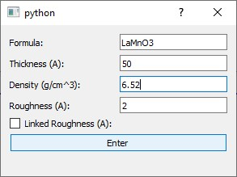

*Figure 1: Add Layer Parameters*

1. After clicking **Enter** a new layer will be defined. You can navigate the various layers defined in the model by selecting the **Layer** option box in the **Sample** workspace as shown in Figure 2.

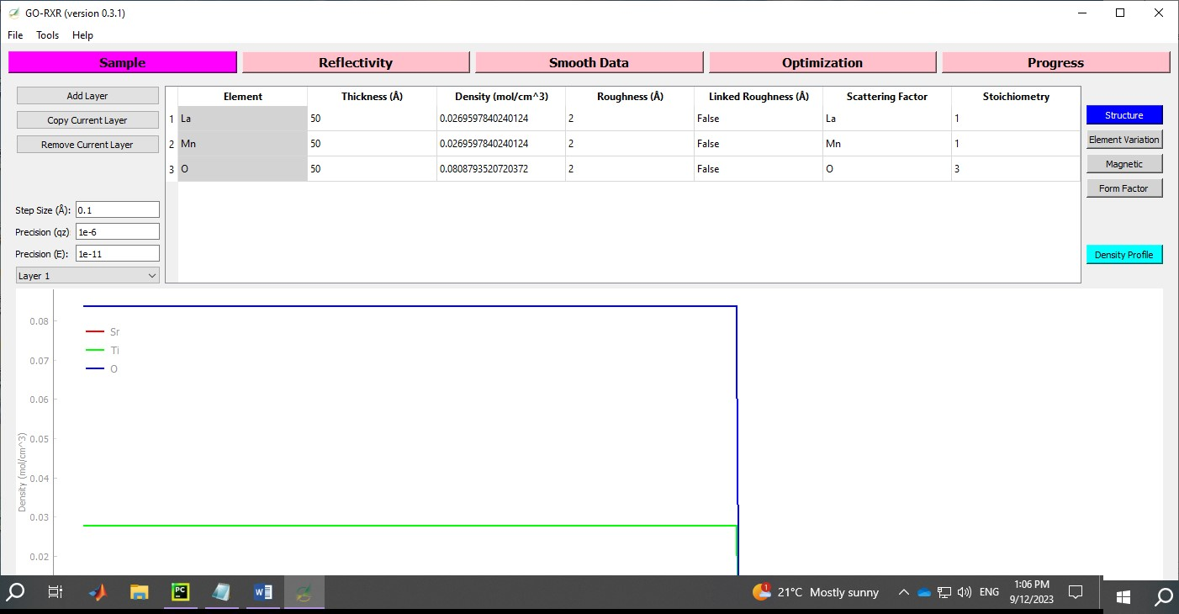

Navigate Layers

*Figure*

*2*

*:*

*Navigate Layers*

1. In GO-RXR, the **Add** Layer and **Copy Current Layer** buttons will define the new layer on top of the selected layer in the **Layer** option box. Therefore, it is important that when adding new layers that the correct layer is selected.
2. In the next step we will add a surface contaminate layer on top of the defined LaMnO3 in **Layer**

**1**. The first step is to select **Layer 1** from the **Layer** option box. After selecting **Layer** 1, click **Add Layer** to model the impurities at the surface. Enter the values as displayed in Figure 3 and after completing this task click **Enter**. A new layer will now be defined in the model. Click the **Density Profile** button to view the depth-dependent density profile of the model.

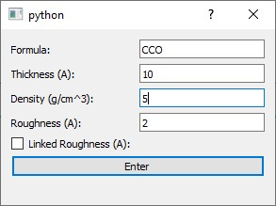

*Figure 3: Impurity Layer*

1. Navigate to **Layer 2** and set the thickness, density, and roughness as shown in Figure 4. Note that the multiple carbons entered are labeled as **C1** and **C2**. This is done to differentiate between the multiple carbons in the layer, where **C1** is neglected in the model by setting the density to zero. The idea behind the multiple carbons is to identify if the impurities are linked (via roughness) to a particular element. Another way to define the **Formula** for the impurity layer is by include a dummy variable (e.g. X). Instead of writing the formula as **CCO**, the formula can be written as **XCO**. Note that dummy variables are pre-set to have a molar density and form factor values for all energies with a value of zero.

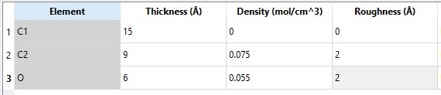

*Figure 4: Surface Layer Parameters*

1. After changing the impurity layer parameters navigate to the **Reflectivity** workspace and plot the various scans in the experimental data.
2. Plot the energy scans with the names **23_E630.0_Th15.0_S** and **29_E830.0_Th15.0_S**. Figure 5 displays the energy scans that should be observed in this step. Note that the resonance peaks are not aligned. This must be corrected for in order to achieve adequate results.

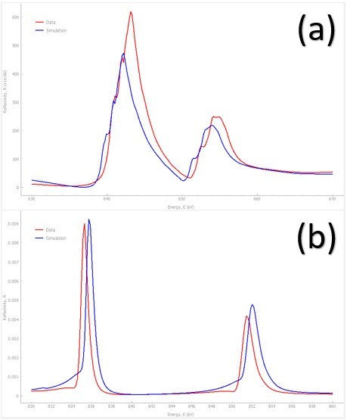

*Figure 5: Energy scans (a) 23_E630.0_Th15.0_S (b) 29_E830.0_Th15.0_S. Note that these scans correspond to (a) Mn-resonance and (b) La-resonance.*

1. To correct for the shift in the resonance peaks return back to the **Sample** workspace and click on the **Form Factor** button on the right side of the window.
2. A table similar to Figure 6 will appear. The horizontal headers indicate the atomic form factors used in the simulation, where the pre-factor **ff** indicate the non-magnetic form factors and **ffm** indicates magnetic form factors. The atomic form factors that are colored black indicate that the simulation will use the atomic form factor values retrieved from the database in the calculation. Atomic form factors colored blue indicate that the reflectivity calculations will use the atomic form factor files included in the project directory. The **Energy Shift** column indicates the energy shift that is applied to the atomic form factor. The **Scale** column indicates the value that the atomic form factors are multiplied with, where the **Scale** is typically only used for magnetic form factors.
3. In our example, we only need to change the **ff-Mn** and **ff-La** form factor energy shifts, so that all the resonance peaks are aligned. Try various values for the energy shift and observe how the energy shift impacts both the energy and theta/two-theta reflectivity scan. Figure 6 demonstrates the correct energy shift values that need to be applied to the the **ff-Mn** and **ff-La** atomic form factors.

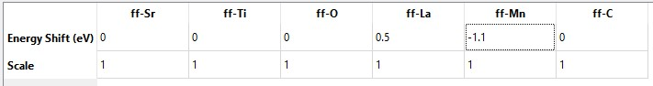

*Figure 6: Energy Shift*

1. Plot the energy scans named **23_E630.0_Th15.0_S** and **29_E830.0_Th15.0_S** (**Reflectivity** workspace). Notice how the resonance peaks have now shifted and the experimental and simulated resonance peaks are now aligned.

## Data fitting

1. Navigate to the **Sample** workspace and on the **Structure** button. In this section, we will learn how to select model parameters to include in the data fits.
2. First, we will practice selecting parameters using **Element Fit** and **Compound Fit** options. We will also practice removing selected parameters from the data fit by using the **Remove Fit** option.
3. The fitting options are accessed by right-clicking on the highlighted cells. The **Element Fit** option will only fit the selected element. The **Compound Fit** option will fit all the elements in the chosen column, where the selected parameter of each element will be tied together using internal functions. For example, if a **Compound Fit** is applied to the density parameter, then the density will vary while maintaining the defined stoichiometry in the layer. Note that a **Compound Fit** and **Element Fit** cannot be applied to the same parameter column. The **Remove Fit** option removes the selected parameter from the data fitting.
4. A fit can be applied one cell at a time, GO-RXR also provides the ability to apply multiple fits by highlighting multiple cells, right-clicking, then selecting the desired data fitting option.

1. First, we will practice using the various fitting options. Navigate to the **Substrate** layer and highlight all of the roughness cells, right click, and select the **Element Fit** option. You will know if the **Element Fit** has been applied properly if the roughness cells turn green as shown in Figure 7. Note that cells that are green indicate an **Element Fit** and purple cells indicate a **Compound Fit**.

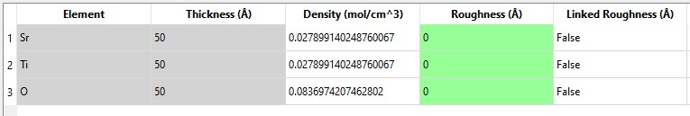

*Figure 7: Substrate Fitting Parameters*

1. Now we will practice removing a fit by highlighting the density parameters in the **Substrate** layer, right click, and select **Element Fit** or **Compound Fit** (try both). Once the cells have changed colors, highlight the density cells again, right click, but now select **Remove Fit**. A successful **Remove Fit** operations will result in the cells turning back to a white color.
2. Take some time and practice applying and removing fits to the various layers in the model. See what happens when a **Compound Fit** is applied to parameters that have an **Element Fit** applied to them. Remove all applied fits in each layer before moving onto the next step.
3. In this step we will select the parameters to include into our data fitting test. For the **Substrate** layer, apply an **Element Fit** to the roughness parameters (column 4) of each element in this layer. Check Figure 8 to make sure the correct fits have been applied. After applying the appropriate fits to the **Substrate** layer, navigate to **Layer 1**. Apply a **Compound Fit** for the thickness parameter and an **Element Fit** for the roughness of each element in this layer. Note that only one cell needs to be highlighted to apply a **Compound Fit**. Check Figure 8 to make sure the correct fits have been applied. After applying the fits to **Layer** 1 navigate to **Layer 2**. Apply an **Element Fit** to the thickness and roughness of **C2** and **O.** Check Figure 8 to make sure the correct fits have been applied.

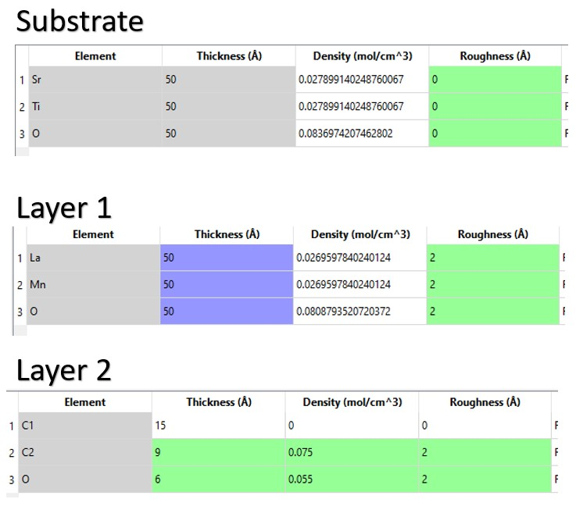

*Figure 8: Data Fitting Parameters for Optimization*

1. In the next step, we will select the data to include into our optimization. To select the experimental data navigate to the **Reflectivity** workspace.
2. A scan can selected to include in the data fitting by first selecting a scan in the **Scan** option box as displayed in Figure 9. Click the **Fit Scan** button to include the selected scan into the data fit.

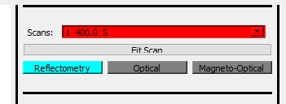

*Figure 9: Scan selection*

1. All the selected scans for the data fit will appear in the **Fit Scans** option box at the bottom right corner of the window. Figure 10 displays where the **Fit Scans** option box is located.

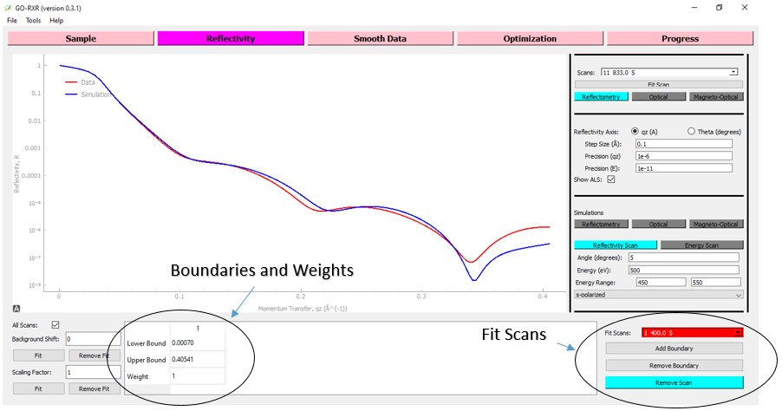

*Figure 10: Fit Scans*

1. In this example select scans **1_400.0_S**, **3_500.0_S**, **5_455.0_S**, **7_642.0_S**, **9_700.0_S**, and **11_833.0_S** for the data fitting example.
2. Scans that have been selected to include into the data fit are displayed by selecting a scan in the **Fit Scans** option box. Additionally, the boundaries and weights of the **Fit Scans** will appear as displayed in Figure 10. The **Fit Scans** option box must be used to change the boundaries and weights of each selected scan before starting the optimization. The boundaries and weights can be manually altered, where additional intervals can be included by clicking **Add Boundary**. In this example, we will use the default values for the boundaries and weights.

## Start Optimization

1. First, navigate to the **Optimization** workspace.
2. A table containing the parameters boundaries is found at the bottom left side of the

**Optimization** window. The location of the parameter boundaries table is indicated in Figure 11.

1. In this step we will change the low and upper boundaries of the model parameters. In this example, set the upper and lower parameters to the values as shown in Table 1. The default values can also be used, but the boundaries defined in Table 1 help the global optimization algorithm converge to a solution quicker.

*Table 1: Fit Parameters:*

|  |  |  |
| --- | --- | --- |
| **Parameter** | **Lower Bound** | **Upper Bound** |
| Sr-rough. 0 | 0 | 1.5 |
| Ti-rough. 0 | 1.5 | 3.5 |
| O-rough. 0 | 1 | 2 |
| LaMnO-th. 1 | 48 | 54 |
| La-rough. 1 | 0.25 | 2.25 |
| Mn-rough. 1 | 0 | 1.5 |
| O-rough. 1 | 0 | 1 |
| C2-th. 2 | 8.5 | 11 |
| O-th. 2 | 4 | 6.5 |
| C2-dens. 2 | 0.075 | 0.085 |
| O-dens. 2 | 0.032 | 0.056 |
| C2-rough. 2 | 1 | 2 |
| O-rough.2 | 1.5 | 3 |

1. The objective function can be altered by changing the parameters found in the **objective function** section of this workspace. The **objective function** section is labeled in Figure 11. The only objective function parameter that needs to be altered is switching the cost function from **Chi-Square** to **L2-Norm**.
2. In this example we will use the differential evolution algorithm. Use the default algorithm parameters, but set **popsize** to 10 to speed up the data fitting.

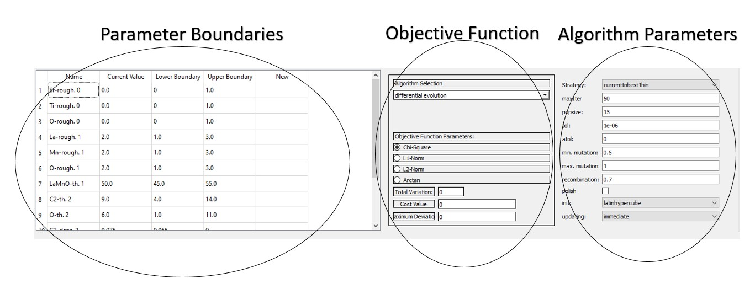

*Figure 11: Global Optimization*

1. Click **Run Optimization** to start the data fitting. The **Run Optimization** button will turn red once an optimization has begun. The data fitting can be manually stopped by clicking **Stop Optimization**. It may take a few seconds before the optimization stops because the current optimization iteration must finish before the optimization can terminate. The end of a data fit is signaled when the **Run Optimization** button turns green again.
2. The progress of the optimization can be observed in the **Progress** workspace. The objective function value at each iteration will also be printed in the terminal.

## Optimization Progress

1. While the optimization is running, navigate to the Progress workspace. Here, you can choose from the following options: **Objective Function** to view the total objective function, **Cost Function** to track the progression of the cost function, **Total Variation Comparison** to observe the evolution of the total variation comparison function, **Parameters** to monitor parameter changes across iterations, and **Density Profile** to examine the density profile.
2. Select scans in the **Selected Scans** option box to view the simulated reflectivity for the current optimization iteration. The scans included in this option box are the scans included in the data fit.
3. Select scan in the **All Scans** option box to view the simulated reflectivity for the current iteration. All the scans in the dataset are included in this option box.
4. Play around in the **Progress** workspace until the data fit converges to an acceptable solution. The global optimization should converge to an acceptable solution after 10 iterations. An almost exact solution is achieved after 25 iterations.

## Update Sample

1. Navigate to the **Optimization** workspace. Once the optimization is finished the simulation for the model before the optimization and the simulation of the optimized model can be directly compared in the plotting space.
2. To use the optimized model in the **Sample** workspace click the **Update Sample** button.
3. To clear the optimization parameters click **Clear Fit**. This will only clear the model parameters and the data scans will have to be manually removed in the **Reflectivity** workspace.

## Adding boundaries and weight

1. In this example we will use the same data and fitting parameters, but apply boundaries and weights to the **11_833.0_S** scan**.**
2. Navigate to the **Reflectivity** workspace and select the **11_833.0_S** scan from the **Fit Scans** option box.
3. Click **Add Boundary** 6 times. Set the boundaries as displayed in Figure 12. The boundaries and weights are set to capture the last 3 oscillations in the Kiessig fringes for the **11_833.0_S** scan by emphasizing the troughs of the oscillations. The added boundaries and weights will help the optimization converge to a solution quicker.

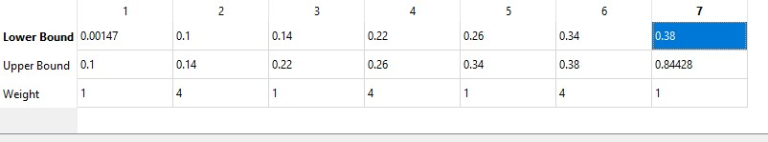

*Figure 12: Boundaries and Weights*

1. Navigate to the **Optimization** workspace and click **Run Optimization**.
2. In this case, the **11_833.0_S** should be observed to converge much quicker than in the previous case.

# Example 2: Unit Cell Model

It is recommended to complete **Example 1** before attempting **Example 2**. In this example many of the steps for the model setup, selecting data fitting parameters, selecting scans to fit, and setting up the optimization are omitted.

This example does not cover magnetization. Refer to the user manual to learn how to incorporate magnetization into your model.

**Importing example data**

1. Start GO-RXR by running the *GUI_GO.py* python file.
2. The data for example 2 can be loaded into the project workspace by opening the **File** tab and selecting the **Import Dataset** option.
3. Navigate to the **DOCS/Tutorial** folder in the current directory and open the **example2.h5** data file.
4. The experimental data can be found in the **Reflectivity** workspace (top left pink button in the window).
5. You can plot different sets of data by selecting a new scan in the option box labeled **Scans** on the top right corner of the window. The **1_400.0_S** scan name should be displayed in the **Scan** option box.

## Construct unit cell model

1. In this example we will model the SrTiO3/LaMnO3 thin-film heterostructure using the unit cell model.
2. The first step is to remove the predefined substrate by clicking **Remove Current Layer** in the **Sample** workspace.
3. Add a new substrate by clicking **Add Layer**. Enter the general formula of **ABO3** into the formula field. Enter the parameters as shown in Figure 13.

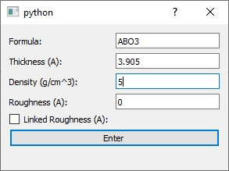

*Figure 13: Add unit cell substrate*

1. Navigate to the **Substrate** layer. Change the A-site density to 0.028 mol/cm3, the B-site density to 0.028 mol/cm3, and the O-site density to 0.084 mol/cm3.
2. After changing the substrate density, click the **Element Variation** button. Select the A-site using the **Element Navigator** as displayed in Figure 14. Set **Name**, **Ratio**, and **Form Factor** as illustrated in Figure 14.

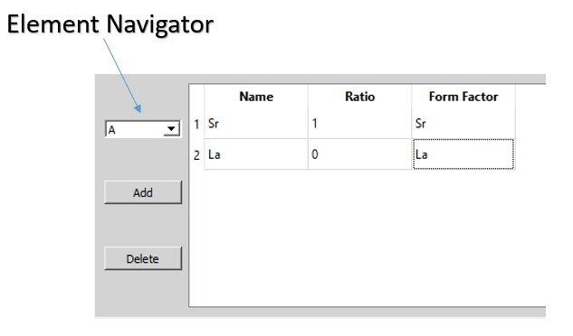

*Figure 14: Element Navigator and A-site parameters*

1. Select the B-site using the **Element Navigator** and set the parameters as shown in Figure 15.

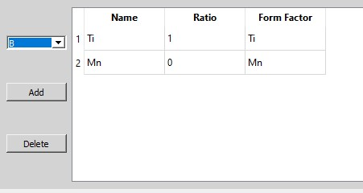

*Figure 15: B-site parameters*

1. Click the **Copy Current Layer** button 6 times. This will create 6 identical layers on top of the substrate layer. **Layer 6** should be the last layer in your model. Remove any extra layers.
2. Select **Layer 6** in the layer option box. Click **Element Variation** and change the ratio values to the values shown in Figure 16.

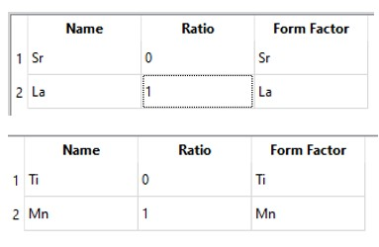

*Figure 16: A-site and B-site ratio values for layer 6.*

1. Copy **Layer 6** four times by selecting **Layer 6** in the option box and clicking **Copy Current Layer** 4 times. The last layer in your model should be now labeled **Layer 10**.
2. There should now be a total of 10 layers (neglecting the substrate layer) in the option box. Add an impurity layer on top of **Layer 10** by selecting **Layer 10** and clicking **Add Layer.** Set the impurity layer to the parameter values defined in Figure 17. The impurity layer corresponds to **Layer 11.** Note that in this case we give the **linked roughness** a numerical value for **C2** and **O.**

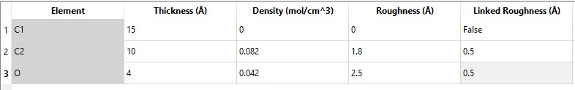

*Figure 17: Impurity Layer*

1. Set the ratios from layers 1 to 5 as defined in Table 2 to model the intermixing at the substrate/film interface.

*Table 2: Ratio values*

|  |  |  |  |  |
| --- | --- | --- | --- | --- |
| **Layer** | **Sr** | **La** | **Ti** | **Mn** |
| 1 | 0.9 | 0.1 | 1 | 0 |
| 2 | 0.7 | 0.3 | 0.9 | 0.1 |
| 3 | 0.3 | 0.7 | 0.7 | 0.3 |
| 4 | 0.1 | 0.9 | 0.3 | 0.7 |
| 5 | 0 | 1 | 0.1 | 0.9 |

1. Set the A-site density at **Layer 10** to value of 0.01 mol/cm3 to simulate a B-site termination at the surface of the film.
2. Observe the La-resonant and Mn-resonant scans. It should be observed that the resonance peaks are not aligned. Set the energy shift for the La atomic form factor to 0.5 and the energy shift for the Mn atomic form factor to -1.1.

## Select model parameters to fit

1. For the unit cell model we typically only need to fit the element variation ratio. Fit the Sr **Ratio** from layers 1 to 4, and fit the Ti **Ratio** layer 2 to 5. Apply an **Element Fit** to the density of the A-site in **Layer 10**. This is the same layer that we simulated the B-site termination. Note that only one ratio can be fit as the remaining ratios are calculated based on an internal function.
2. In the **Reflectivity** workspace select **1_400.0_S**, **3_500.0_S**, **5_455.0_S**, **7_642.0_S**, **9_700.0_S**, and **11_833.0_S** to be included in the data fit.

## Start Optimization

1. Navigate to the **Optimization** workspace.
2. Use the default upper and lower parameter boundaries.
3. Select the **L2-Norm** as the cost function.
4. Set the **Total Variation** to 100. This will apply a weight of 100 to the total variation comparison function. Normally, we would smooth the data in the **Smooth Data** workspace, but this is not required for this example. Refer to the ***User Manual*** for how to smooth the data.
5. Set **popsize** to a value of 10 for the differential evolution algorithm.
6. Click **Run Optimization**.

## Save Model

1. Save your model by clicking the **File** tab and select the **Save Workspace As.** Save you workspace with any name, but it must have the *“.h5”* file extension.