Assignment -2

Abstract

The report is will discuss about centrality measures for Company Attributes, one of the graph networks in Board of Directors dataset. The specialty of this network is its simplicity in contextual cluster centrality. This is epitome of a graph to understand characteristics of a Graph data structure. The report will try to capture the best response for following properties in hope a peak in grades ladder:

1. List Three nodes with highest degree, betweenness, and closeness centralities from your outcomes
2. From visualization, can you find any hubs or subgroups?
3. Based on the findings, what insights/implications can be inferred?
4. Where these findings can be applied?

Nodes with Highest Degree:

|  |  |
| --- | --- |
| **Nodes** | **Degree** |
| Petroleum Refining | 8 |
| Food and Drug Stores | 6 |
| Aerospace and Defense | 5 |

Nodes with Lowest Degree:

|  |  |
| --- | --- |
| **Nodes** | **Degree** |
| Petroleum Refining | 8 |
| Food and Drug Stores | 6 |
| Aerospace and Defense | 5 |

Betweenness:

|  |  |
| --- | --- |
| **Nodes** | **Betweenness** |
| Petroleum Refining | 28 |
| Food and Drug Stores | 15 |
| Aerospace and Defense | 10 |

Closeness

Closeness Centrality is not well defined for disconnected graphs.

Diameter

Diameter is 2

Density

Density is 0.09

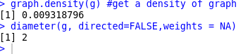

The diameter is 2, looks subjective. Thus, the connections can better be understood using Visualization. From the below diagram, one could couple of subgroups or hubs. The shortest ones have at most 2 degree which checks our subjective, an embarkment to a practical importations. These findings can be helpful in generating enormous donations, an addition to backbone charities all over United States. ***[ This paragraph covers answers for Question B,C and D]***

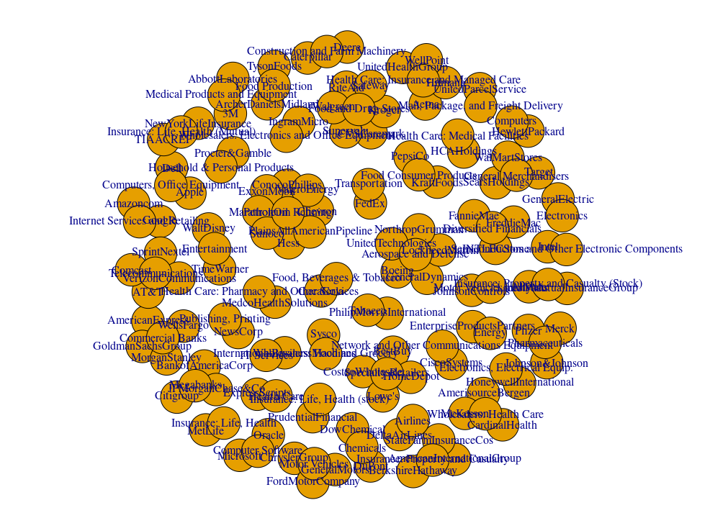

Visualization of **Company-Industry table**