Robotics report

up849309

(January 2021)

—————————— ◆ ——————————

# 1 Introduction

# 1.1 The problem

The problem this report will be looking into is sorting cans of different flavoured products in a small shop storage environment. This problem was chosen as it’s a place where Robots are starting to be used but still haven’t been adopted for wider use in this size of an environment. Robots are already being used for similar reasons in other environments but it could be adapted for the problem this environment suffers from. Robots are doing similar jobs in warehouse environments but could be adapted for smaller environments such as a corner / small supermarket.

The problem involves objects, in this scenario. Cans of food that needs to be collected by a robot and sorted into separate flavours which are colours in this scenario (in the real scenario, it would be done via QR), then moved to the correct location based on the sensory input they have collected. The robot must work well and safely in this environment by avoiding hazards and navigating a small space. Due to a small space, it will be navigated by people and occasionally objects that may be left around and the robot must be able to avoid them as the location wasn’t designed with robots in mind. This would be in the storage section of a shop where they keep stock till they move it out.

# 1.2 Literature Review

The purpose of this review is to investigate current solutions that are being used and what has been researched into which could help designing and executing a solution.

Firstly, we need to understand the effect the use of robots have in industry, the benefits they bring. According to [1], the use of robots in other industries means that robots are responsible for 15% of aggregate economy-wide productivity growth and it also contributes 0.36 percentage points to annual productivity growth. This tells us that integrating a robot well will yield better results in the long term

Certain places are already using robots for shelf monitoring which allows them to manage their stock, this shows there is potential in this idea and growth to be used in a retail environment[2]. Somewhere small, like a corner shop might find this hard. Using a QR code scanner which is also being used in warehouse environments which allows them to analyse logistics [5] could be used in combination to allow small shops to manage their stock, this is already the case in some amazon warehouse environments.

These amazon robots [3] are using vision algorithms to make decisions such as cleaning and analysing items to move them to the correct shelves. The plan in the retail industry is that Robots are going to take a lot of Mundane tasks.

The use of RFID [4] is already being used to efficiently manage inventory on a sales floor with a complex layout, this shows the combination of these technologies could be used for good management and completion of tasks based on this data.

# 2 Approach

# 2.1 Environment and objects

To ensure that the simulation suits the scenario, a scene was created to imitate the standard layout of a small shop where we would expect the robot to operate. We added where the products would go with a coloured drop off zone where each of the products would end up. We had a conveyor belt where the stock would be unloaded on. The canned food was represented by coloured cubes which represent where they would go. While the shelves weren’t being used, they still acted like an obstacle and something the robot must avoid.

The main part was the conveyor belt which moves the cubes somewhere where the robot can interact with them. It will automatically move a cube to the front when there's nothing in it’s vision sensor.

We used the Kuka Youbot as it had all the features needed to achieve our goal with movement and an arm for interacting and a platform for placing objects on.

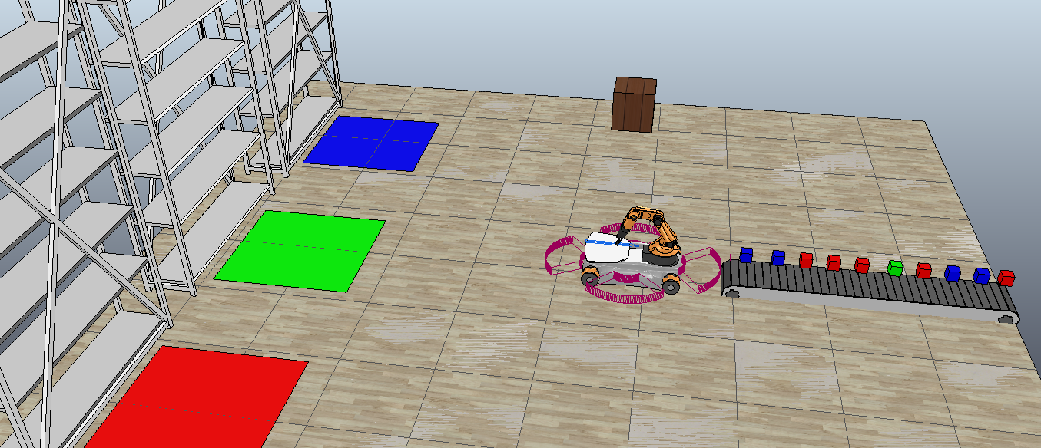

fig 1. a small shop storage environment which the robot will operate in

# 2.2 object sorting

For the robot to be able to sort the cans into the correct places then we need to collect some sensory data which is used in identifying the object. In the real world, this may be done through the use of a barcode scanner but in this V-rep simulation, we used a colour sensor which we attached to the robot.

To detect the colour value, the robot picked up the object and put it in front of the sensor which provided an RGB value to the Robot. The robot would then check the rgb value through an algorithm which then told it when to place the object. This was done by seeing which number in the RGB was equal to 1, for example if R was equal to 1 and others 0 then it must be red.

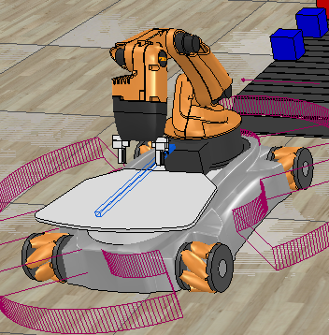

fig 2. A Vision sensor used in detecting the colour in V-REP simulation

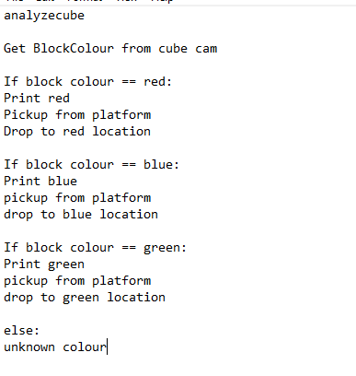

fig 4

Pseudo code for Colour sorting

# 2.3 Movement around

When working on my navigation, I never had a large complicated environment in mind, perhaps like a multi walled room. Instead I designed the robot to work well in a small open room with not a lot of space. I used places which worked as nodes for the robot to move between. I had 4 main places. This was the three drop off locations and the pickup location.

This wasn’t too complicated as the robot was able to line itself up to the correct location and make its way there. The robot has the knowledge of where these points are savedb down and will automatically locate it when it has made the decision where it goes.

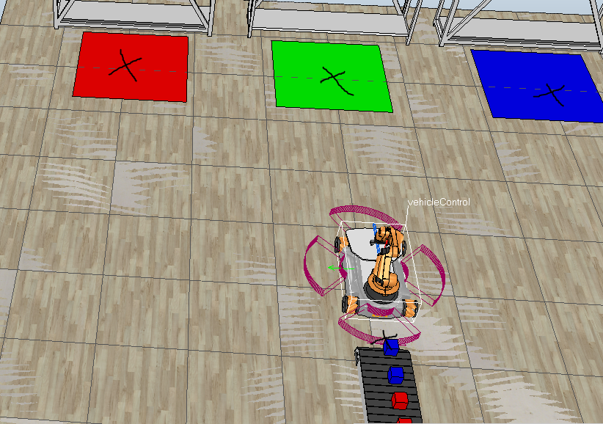

fig 3: Pickup locations

# 2.4 Object collection and manipulation

The robot needs to be able to pick up and manipulate the object. What I have done to help increase accuracy is use a prebuilt conveyer code which stops the belt from moving when a can is in the way. This lets the robot grab it from a level surface. The robot then grabs the coordinates of the designated object, lines itself up and gets into a good position to pick it up. The robot uses inverse Kinematics so it can move the right joins to grab the object.

I heavily based my project on a preexisting project which is the hanoi tower, I used the algorithm from here. There is a need for a use of both forward and inverse kinematics which are both used for manipulating objects. While in IK mode, speed and acceleration is slower which is because the robot needs to be more precise. FK was used for putting the arm in an exact position for picking up.

There were arm poses there for dropping to the platform but after experimenting, the centre one was the only one used. The algorithm used the coordinates of the object to manipulate the arm for the use in grabbing.

# 2.5 Collision avoiding (Sensory implementation)

My robot was created to work in a tight environment where other objects and humans will be occupying the same space. The robot needs to be able to detect when there’s an object in close proximity. This is important so it can avoid accidents. This relies on the use of Proximity sensors placed around each side of the robot.

In my use of sensors, I created an algorithm which reduced the speed of all the wheels when an object comes in contact with the sensor. When an obstacle is not in the sensor, the robot will presume it’s action was on.

It was implemented in a way where it only needs to avoid objects that aren’t supposed to be in that room such as a storage box or a person. This is done because the robot shouldn’t stop when in contact with a food can.

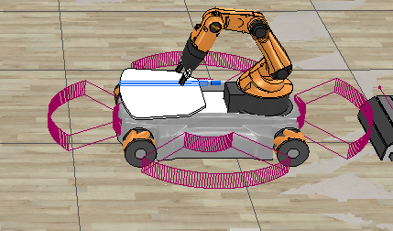

fig 5: The youbot with 4 proximity sensors

# 

Fig 6 Pseudo code for collision detection

# 

# 3 Results

To test how effective our solution was, we tested certain parts within the simulation to see how effective and well the robot worked. The first solution I did was changing the colours of the cans. I did this by randomly generating the colour, either red, green or blue. The robot was able to identify the different colours and make different decisions based off the sensory data

The robot was able to completely move all objects successfully to the right area, while it did it slowly.

The Collision detection worked how I expected as well with the robot being able to avoid obstacles that got in its way. I attempted it with a person and a shipping crate. In testing, the robot would sit still until the object was gone. The initial problem the robot had was that it would still move, although slowly but this was improved via control of the wheels.

The sensory data collected from the proximity and vision sensors both worked as intended with no issues. The robot was able to recognise obstacles and the colour of the objects it was picking up without making any mistakes and make the decision on what to do when it comes across this.

# 

# 

# 4 Discussion and Conclusion

# 4.1 Performing

The performance of the robot was good as I have explained in the results. The robot was able to easily and accurately able to pick up, analyse and move the objects to the correct location

The robots placing and picking of the objects were very accurate and it would rarely have a problem where it incorrectly places it. We did mitigate this in the next section (4.2) and using thorough testing, we found a solution.

# 

# 4.2 Issues Encountered

One of the issues I had was the placement of the boxes in the target locations, what would happen is that when the box would be placed, the box would react with the ground and flip or push the robot away which would cause damage. This problem would be amplified when it’s placing a box on top of another one. This was caused by the height the robot arm was going, it was actuating too low and inverse kinematics values were wrong.

To fix this I had to change the values so the boxes were being placed from a higher height. This allowed the boxes to be placed neatly without moving the robot. I had to reprogram the drop height poses thus allowing the robot arm to drop from a higher height. We tried different heights, we tried upping the height by 10 at a time until eventually, it placed nicely on top of each other.

Another issue I had was inconsistent picking up of the block off the conveyor belt. This was another issue I had to fix by reprogramming the pose. I did this by creating a fresh scenario and manually moving the arm using the gui to the best pose for the scenario. It was a process of trial of error. This issue sometimes meant that the box was picked up but either dropped or not even picked up at all. I then transferred the scenario over to the main.

An issue I had with the proximity sensors was that the robot still slowly moved when it detected something, this meant even though it slowed to an extremely slow speed, it still was moving. To get around this I made sure all the wheels were set to 0, not just the front ones. This didn’t fix the problem but it made it so slow that it wouldn’t be a problem when it is an environment.

The proximity and vision sensors both effectively detected objects and detected the colours. The robot made the decisions and used the sensory data as expected of the result. I tested the colour sensing by random generating the can colour and it showed it worked .

I tested where the best place to place the can was on the platform. I tested it in multiple places, on the left, middle and right. I felt like the can was more likely to fall off and it happened when it hit an object so this is why I chose the middle.

# 

# 4.3 Suggested Improvements

Firstly, I would integrate the colour sensing into the conveyor belt as it makes the robot seem more inefficient having to pick up a singular object, place it on the platform and then pick it back up and move it to the correct location. A better approach would be having the conveyor belt scan the colour and pass it to the robot who could pick up multiple objects and move them.

I should also implement a more advanced movement system, perhaps with the use of wireless nodes that could allow it to navigate a more advanced layout, perhaps one that has a lot of walls that many places will have as this robot will only work in a small open environment.

An improvement that could help would make sure the robot fully stops, while it moves extremely slowly. This could be an issue with something fragile. Maybe after an hour of it being there, the robot will still hit it. I need to find a way to fully stop it.

# 

# 4.4 Conclusion

In conclusion, the system I have created offers a great base with the essential problem being solved. There is still room for a lot of improvement and they’re needed to make it truly viable for the real world but I have integrated the essential features and identified the potential improvements to start this. I feel like I have given a good attempt at solving the problem.

**References**

Graetz, G. and Michaels, G. (2018). Robots at Work. *The Review of Economics and Statistics*, [online] 100(5), pp.753–768. Available at: <http://personal.lse.ac.uk/michaels/Graetz_Michaels_Robots.pdf>.

[2] Forgan, B. (2020). *What Robots Can Do for Retail*. [online] Harvard Business Review. Available at: <https://hbr.org/2020/10/what-robots-can-do-for-retail>.

[3]Petro, G. (n.d.). *Robots Take Retail*. [online] Forbes. Available at: https://www.forbes.com/sites/gregpetro/2020/01/10/robots-take-retail/?sh=3ece50941720 [Accessed 5 Feb. 2021].

[4]J. Zhang, Y. Lyu, T. Roppel, J. Patton and C. P. Senthilkumar, "Mobile robot for retail inventory using RFID," *2016 IEEE International Conference on Industrial Technology (ICIT)*, Taipei, 2016, pp. 101-106, doi: 10.1109/ICIT.2016.7474733.

[5]W. Xiao-Long, W. Chun-Fu, L. Guo-Dong and C. Qing-Xie, "A robot navigation method based on RFID and QR code in the warehouse," *2017 Chinese Automation Congress (CAC)*, Jinan, 2017, pp. 7837-7840, doi: 10.1109/CAC.2017.8244199.

**First A. Author** Allbiographies should be limited to one paragraph consisting of the following: sequentially ordered list of degrees, including years achieved; sequentially ordered places of employ concluding with current employment; association with any official journals or conferences; major professional and/or academic achievements, i.e., best paper awards, research grants, etc.; any publication information (number of papers and titles of books published); current research interests; association with any professional associations. Author membership information, e.g., is a member of the IEEE and the IEEE Computer Society, if applicable, is noted at the end of the biography.

**Second B. Author Jr.** biography appears here.

**Third C. Author** biography appears here.