Pandoc Image Rendering Test
Demonstration: Standard Markdown syntax vs. HTML <img> tag syntax in Pandoc exports.
Test image: ./figures/SolarSystemPosters_NASA_2130.jpg

Example A: Standard Markdown Image Syntax
This image is embedded using standard Markdown syntax. Pandoc parses it into a native Image node in its AST, so every writer knows how to render it.
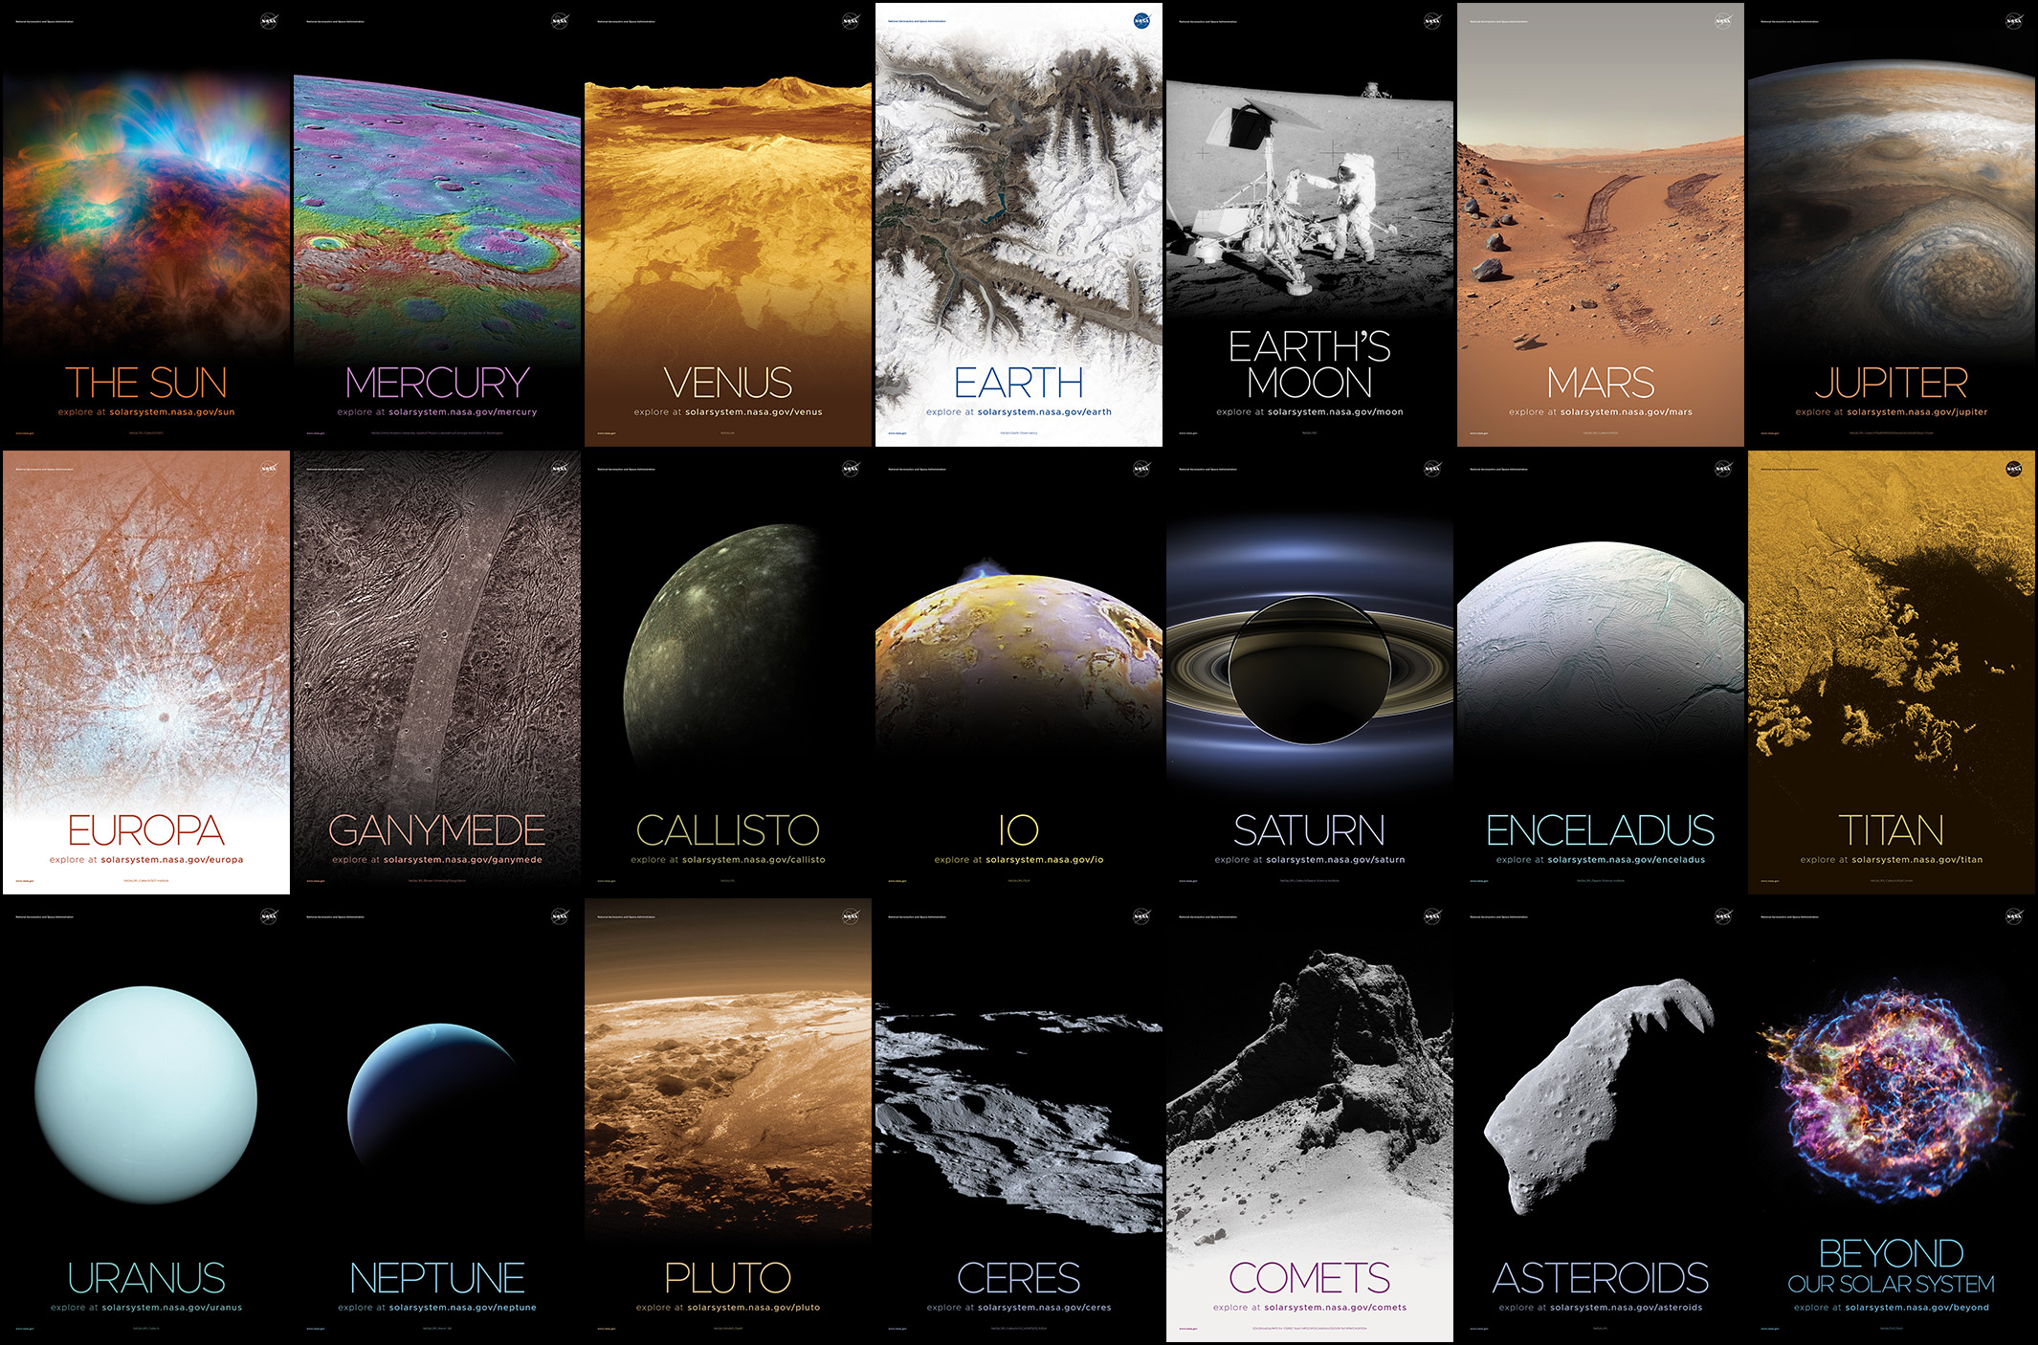
Sample Placeholder Image
- Source: ![Alt](./figures/SolarSystemPosters_NASA_2130.jpg "Title")
- AST node: Image ("",[],[]) [Str "Sample..."] ("./figures/...","fig:Standard Markdown Image")
- Expected output: renders in HTML, PDF, DOCX, EPUB, and LaTeX.
- Note: because the image sits alone in its own paragraph, the implicit_figures extension turns it into a figure and promotes the alt text to a caption. Disable with -f markdown-implicit_figures.
- Limitation: no way to set width, height, id, or class.

Example B: HTML <img> Tag Syntax
This image is embedded using an HTML <img> tag with custom styling.

- AST node: RawInline (Format "html") "<img src=... />" — not an Image node.
- Expected output in HTML export: rendered correctly, attributes and inline CSS intact.
- Expected output in PDF / DOCX / LaTeX export: silently dropped. Raw HTML is passed through only to HTML-family writers; all other writers discard RawInline/RawBlock content whose format they don’t recognize.
- Clarification: it is dropped, not converted to plain text. You only get literal visible text (&lt;img src=...&gt;) if you disable raw HTML parsing entirely with -f markdown-raw_html, which escapes the tag instead of storing it as raw HTML.
- Diagnostic: run pandoc example.md -t native | grep -i rawinline to see the node Pandoc actually built.

Example C: Markdown Image Syntax with Pandoc Attribute Blocks
The recommended fix. Pandoc’s link_attributes extension lets you attach an identifier, classes, and key/value attributes to a native image — giving you the sizing control of an HTML tag while keeping a real Image node that every writer understands.

C1 — Absolute pixel dimensions
Sized with pixels

C2 — Relative width (scales to text block / page width)
Sized at 60% of the text width

C3 — Inline image, no figure or caption
Text flowing around a small inline image that sits in the middle of a sentence. An image with empty alt text and surrounding text on the same line never becomes a figure.
- HTML: <img src="..." id="fig:solar-px" class="bordered" width="300" height="150" alt="..." />
- LaTeX/PDF: \includegraphics[width=3.125in,height=1.5625in]{./figures/...} (px are converted at 96 dpi; use --dpi=150 to change the assumption)
- DOCX: a real embedded picture, sized correctly.
- Percent widths become width="60%" in HTML and width=0.6\textwidth in LaTeX.
- Styling: the .bordered class reaches HTML and DOCX (as a custom style); inline CSS has no LaTeX equivalent, so borders in PDF need a template or a filter.

Example D: HTML <img> Tag Syntax Rescued by a Lua Filter
The same raw HTML as Example B, but this document is converted with --lua-filter=raw-img.lua. The filter intercepts RawInline/RawBlock nodes whose format is html and whose text contains an <img> tag, re-parses them through Pandoc’s HTML reader, and returns genuine Image nodes into the AST.

- Without the filter: both images vanish from PDF, DOCX, and LaTeX.
- With the filter: both survive everywhere, keeping src, alt, width, and height.
- Second case: the <p align="center"> wrapper makes the whole thing a RawBlock, so the filter must handle RawBlock as well as RawInline — a common oversight.
- Lost in translation: the style attribute is carried into HTML output but ignored by LaTeX and DOCX, since inline CSS has no counterpart in those formats.
- Idempotent for HTML: the reconstructed Image node renders back to an <img> tag, so running the filter on HTML output changes nothing meaningful.

Expected Results Matrix
Example | Syntax | HTML | PDF / LaTeX | DOCX | Sizing control
A | ![alt](src) | yes | yes | yes | none
B | raw <img> | yes | dropped | dropped | HTML only
C | ![alt](src){...} | yes | yes | yes | px, in, cm, %
D | raw <img> + Lua filter | yes | yes | yes | px, % via filter

Verification Commands
# Inspect the AST — see Image vs RawInline for yourself
pandoc example.md -t native | head -60
# Baseline conversions (Examples B and D images will be missing from PDF/DOCX)
pandoc example.md -s -o out/test-baseline.html
pandoc example.md -s -o out/test-baseline.pdf
pandoc example.md -s -o out/test-baseline.docx
# With the filter (all four examples survive)
pandoc example.md -s --lua-filter=raw-img.lua -o out/test-filtered.pdf
pandoc example.md -s --lua-filter=raw-img.lua -o out/test-filtered.docx
# Show the escaping behaviour when raw_html is disabled
pandoc example.md -f markdown-raw_html -t html | grep -i "&lt;img"
# Single self-contained HTML with images base64-inlined
pandoc example.md -s --embed-resources --lua-filter=raw-img.lua -o out/test-embedded.html
If your images live outside the working directory, add --resource-path=.:figures:assets so Pandoc can resolve the relative paths.

