Pandoc Image Rendering Test
Demonstration: Standard Markdown syntax vs. HTML <img> tag syntax in Pandoc exports.

1. Example A: Standard Markdown Image Syntax
This image is embedded using standard Markdown syntax. Pandoc recognizes this natively across all export targets (PDF, DOCX, EPUB, LaTeX).
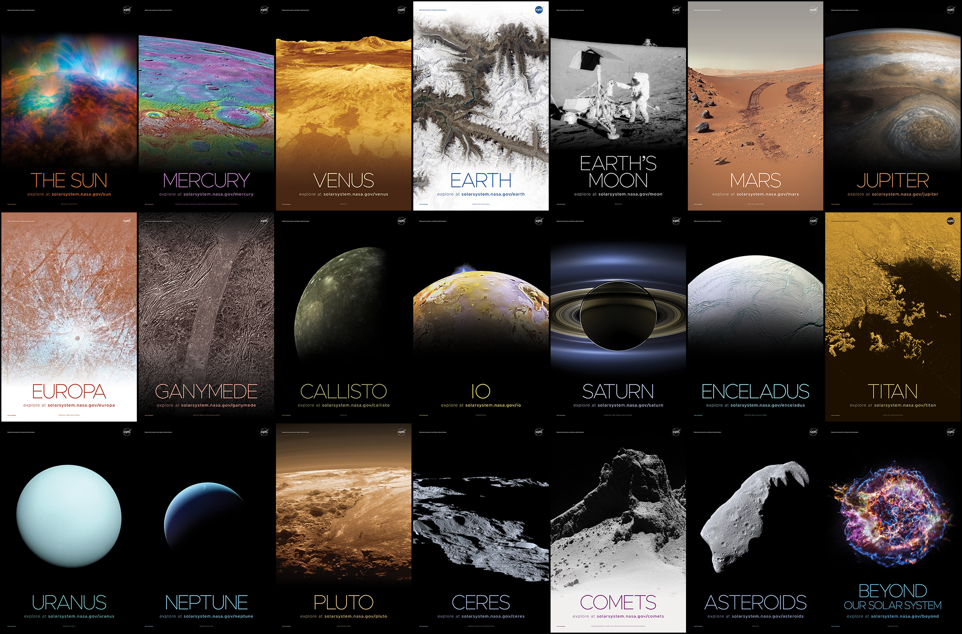
Sample Placeholder Image
- Expected Output: Rendered properly in PDF, DOCX, HTML, and LaTeX.

2. Example B: HTML <img> Tag Syntax
This image is embedded using an HTML <img> tag with custom styling.

- Expected Output in HTML export: Rendered correctly.
- Expected Output in PDF / DOCX / LaTeX export: Ignored, stripped out, or converted to raw plain text because Pandoc’s core AST does not parse inline HTML tags into image nodes for non-HTML output formats unless raw HTML parsing extensions are explicitly configured.

3. Recommended Pandoc Command to Verify
Run the following command in your terminal to see how Pandoc handles both tags when exporting to PDF or Word:
```bash # Export to PDF (Notice Example B fails or is skipped) pandoc input.md -o output.pdf

Export to DOCX
pandoc input.md -o output.docx

