**Abstract**

Computer vision identifies a field of computational science that has application in a large variety of commercial and academic subfields. This project investigates one application to the analysis of image data for specific nonuniform spatial features. Spatial cross correlation, spectral cross correlation and convolution are investigated as possible image processing techniques. Further real-world spatial distances are determined from images from depth maps. These techniques are combined to applying statistical. Find statistical information about moth eye SEM images. The defect quality and other properties are determined using computer vision algorithms and feature extraction. The final program gives an output of statistics for the moth eye SEM image.

1. Introduction (1 page)

1. Overview

2. Experiment: Cross Correlation in 1D and 2D

3. Experiment: Patterns in Stereovision

**Introduction**

Overview

This project develops pattern recognition and aspects of image processing used in computer vision. Image data, and the way in which it may be interpreted, offers useful information to analyse complicated visual events[1]. Notably, implementation of algorithms which may replicate natural processes for distinguishing significant features for spatial characterisation of surroundings, environment, or objects[2]. Such an approach is called Computer Vision and serves to mimic the process by which human eyes evaluate spatial depth and unique spatial features from a pixel level. Furthermore, greater information may be determined using spectral decomposition techniques which surpass the processing capability of natural eyesight.

2. Experiment: Cross Correlation in 1D and 2D

A first set of experiments are implemented to investigate and evaluate standard pattern matching approaches using cross-correlation. Cross-correlation[3] is a widely used in statistical image processing as a method for image analysis. The correlation coefficient is a weighted measure of the similarity between any two data sets. The method is used to evaluate the degree of similarity of multidimensional signals, image patches, feature detection and pattern matching. Based on simple convolution, calculation of the correlation coefficient is a computationally direction method that benefits from Fourier transformations that can reduce time complexity of operations. Further it may be implemented across unrelated data sets to find an unbiased measure of similarity. Cross-correlation is often combined with other image manipulation methods such as filtering to improve the resolution of the correlation coefficients.

The concept of cross-correlation has been developed in two distinct fields: signal processing and statistics. In the area of signal processing, the cross-correlation function can be used to transform one or more signals so that they can be viewed with an altered perspective. For instance, cross-correlation functions can be used to produce plots that make it easier to identify hidden signals within the data. Cross-correlation functions provide the basis for many more sophisticated signal-processing procedures as well. Digital imaging techniques also rely heavily on cross-correlation procedures, but these methods are not covered in the chapter.

3. Experiment: Patterns in Stereovision

A second set of experiments investigate the parallax nature of captured real world images when digitised. A depth map is a 3D reconstruction of an image from the binocular disparity map of a set of images, or in some advanced implementations, a monocular disparity map. Real world intensity and position is approximated from the perspective projection using distance calculations to pixel coordinates.

4. Application: Moth-eye SEM image anlaysis

Ultimately, this project ultimately aims to extend the investigated cross-correlation and computer vision methods to analyse experimental data from Scanning electron microscope images. Advancement in nano-lithographic techniques and physics of metamaterials surfaces have led to development of certain surfaces with unique intrinsic properties. Moth-eye surfaces are one nano-scale surface that because of the arrangement of the particles the surface takes on antireflective properties. Thus, it is of interest to investigate a rapid way to estimate and characterise features.

Images are processed and then analysed using Fourier transform methods and filtering to extract information relating to irregularities of the surfaces. The analysis will implement correlation to determine regions where there are grain non-uniformities and defects in the ordering. ~~If time the results will be compared to diamond nanotextured surfaces with similar design~~. [4]

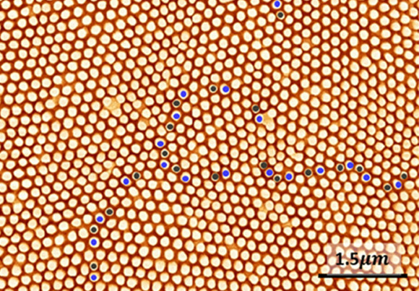[5]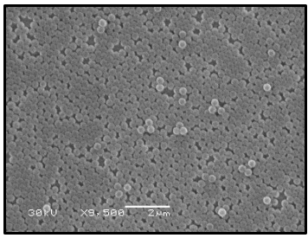

Figure Moth eye Figure Textured Diamond

1. Huang, T.Computer vision: Evolution and promise.CERN EURO-PEAN ORGANIZATION FOR NUCLEAR RESEARCH-REPORTS-CERN(1996), 21–26
2. Szeliski, R.Computer vision: algorithms and applications. SpringerScience & Business Media, 2010
3. It is an elementary approach to match two image patches, for feature detection as well as a component of more sophisticated techniques .. There have been many works in literature which use crosscorrelation for matching <http://citeseerx.ist.psu.edu/viewdoc/download?doi=10.1.1.675.1379&rep=rep1&type=pdf>

   <https://ivpl.northwestern.edu/wp-content/uploads/2019/02/Digital-Signal-Processing-Handbook.pdf>
4. ***More images include in the appendix at the end
5. https://pubs.acs.org/doi/10.1021/acsomega.0c02314