Jordany Gonzalez

6/19/24

CSD-310

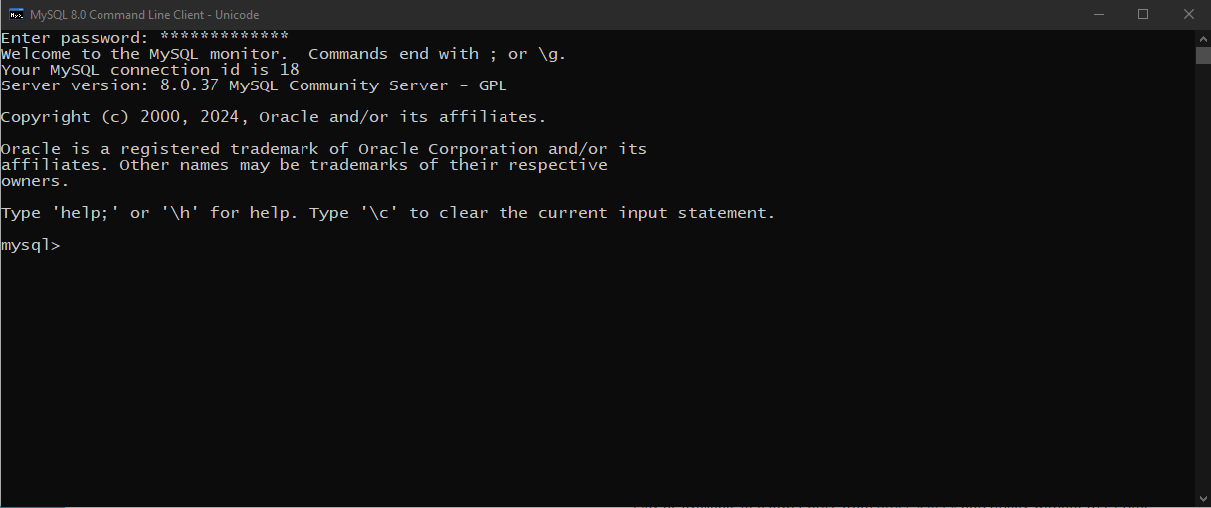Module Assignment 4.2

