Jordany Gonzalez

June 22, 2024

CSD 310

Module Assignment 5.2

MySQL Functions

1. TRIM() Function: This function removes leading and trailing spaces from a string. I can see this function being used when people create a username or a password or when they type in any information onto a database/website being used to remove any extra spaces they might’ve given themselves in front of their input or after their input.
2. SUBSTRING() Function: This function will extract a substring from a string that can start at any position. This is useful for manipulating strings and retrieving specific parts of a string. I can imagine using such a function to extract the area code from a phone number.
3. COUNT() Function is used to count the number of rows in a table that meet a specific condition. It’s useful for determining the number of records in a dataset, such as counting the number of orders placed by a customer.

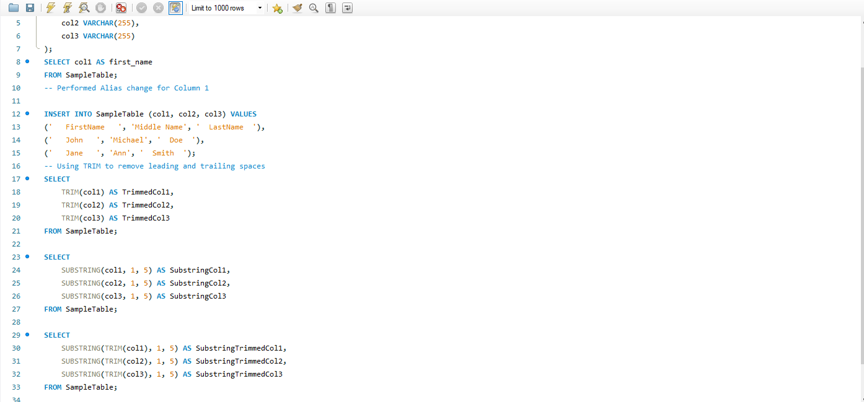

Here is an example of me creating a table and changing the alias of the first column and using the trim function and substring function in a table as an example. I wasn’t able to create an orders column so I wasn’t able to provide an example for count.