Jordany Gonzalez

June 7, 2024

CSD 310

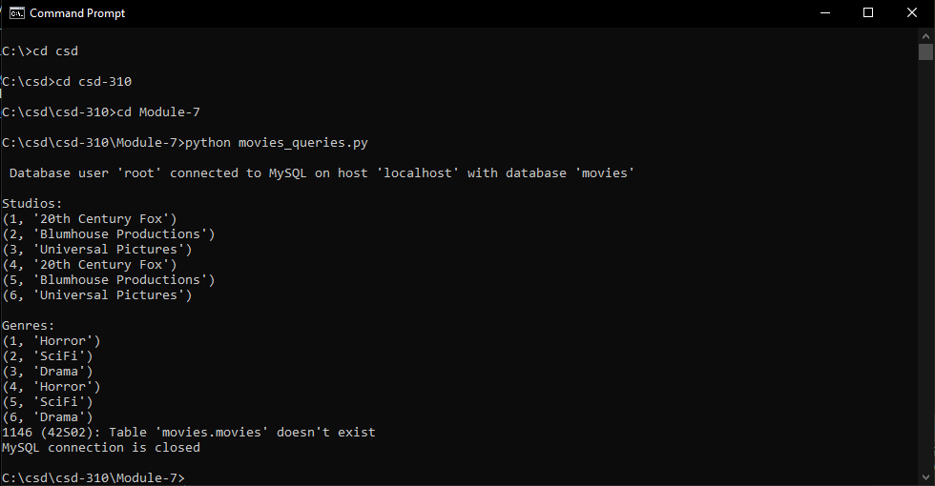Module 7.2 Movies Table Queries

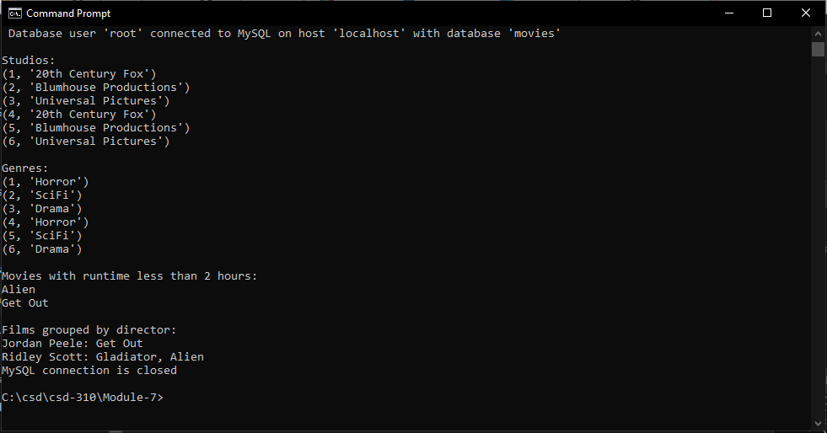Hello Professor In this example I tried redoing the DB_INIT python file from module 6.2 because I kept getting an error code and the movies and the directors would not show up for query 3 and 4.

I was able to fix it However I now have duplicates of the studios and genres how can I fix it? I’m thinking way too hard about this I’m hoping you can help me out