Jordany Gonzalez

Module Assignment 1.2 GitHub Repository Setup

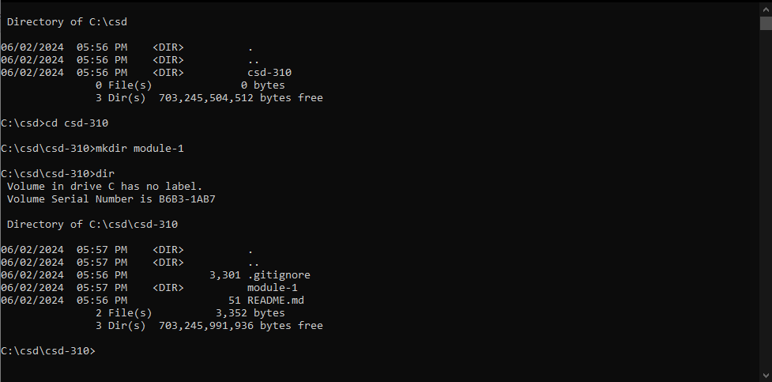

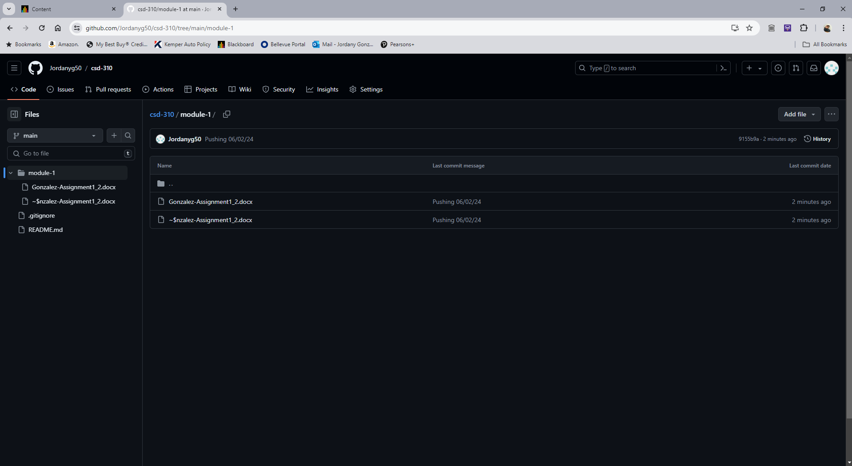

https://github.com/Jordanyg50/csd-310.git