Module Assignment 1.2 GitHub Repository Setup

Jordany Gonzalez

CSD 340

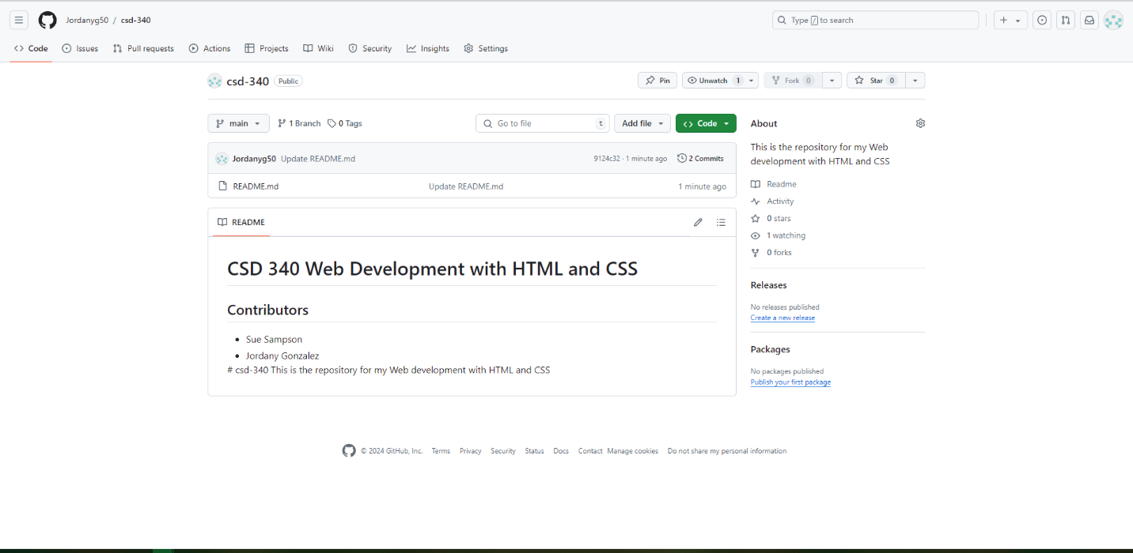Git Hub Repository Link:   
https://github.com/Jordanyg50/csd-340.git

