**IT-IDX1-A21: Course assignment**

* **Title:** Optimization of room utilization by automatic registration of students’ presence in lectures.
* **Description:** In August 2021 VIA University College situated in Horsens, opened new facilities located in the center of the city to improve the education of its students in addition to focus on delivering an education that qualifies the work in a variety of disciplines, languages, and cultures. To improve the education of the students it is essential that the university can verify the skills and abilities of its students and professors using all the tools and metrics possible. Being able to manage the student’s attendance data with efficiency is, undoubtedly, one of the core characteristics of a successful school or university of any size. That includes internal workflows and re-designing timetables, if needed. And having knowledge of the attendance of students in class even could affects to a more positive motivating and learning environment. The lack of attendance in some classes can negatively affect the academic performance of some students, questioning the quality of the university's teaching and damaging its reputation.

Handwritten absence of students is a laborious and tedious task that teachers do not have time to do that is why the implementation of a digital system to manage students’ attendance helps to optimize the classroom scheduling and this focus on attendance helps to a student's culture for reaching a higher learning level.

* **Group members:** Jordi Lazo (313296), Nils Franke (313446), Anne Schneider (313444), Dalius Seminauskas (285039).
* 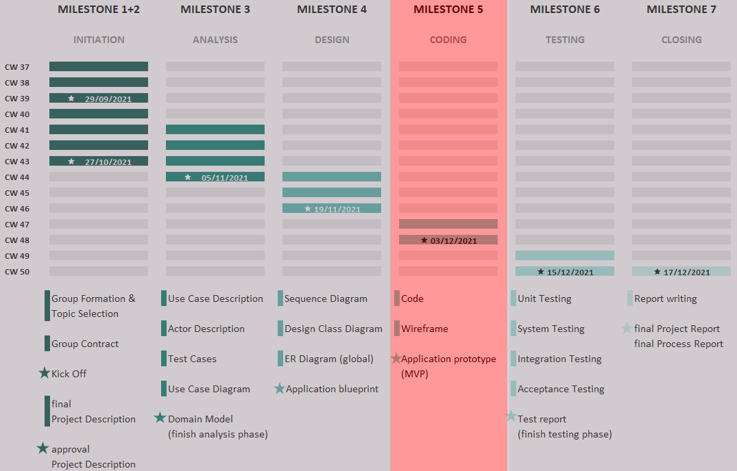**Time schedule:**
* **Some ideas for process:** Prior to the development of the mobile application, a prototype will have to be created which will be tested by different university students. In addition, the creation of surveys will be taken into account and / or 1 or 2 people Personas will be generated to focus on a specific user for application development.