First we will connect the RFID-RC522 module.

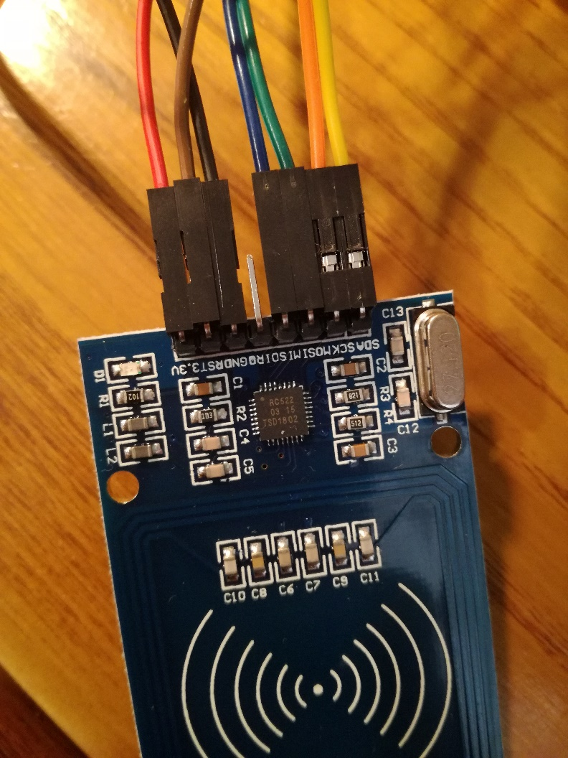

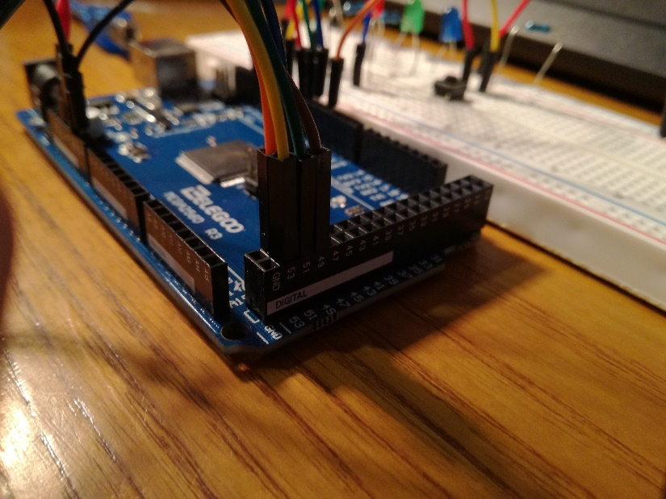

Cables and pin numbers:

Red: power, 3.3V

Brown: digital 49

Black: power ground

Blue: digital 50

Green: digital 51

Orange: digital 52

Yellow: digital 53

Now you should have the module well connected.

Next the lights:

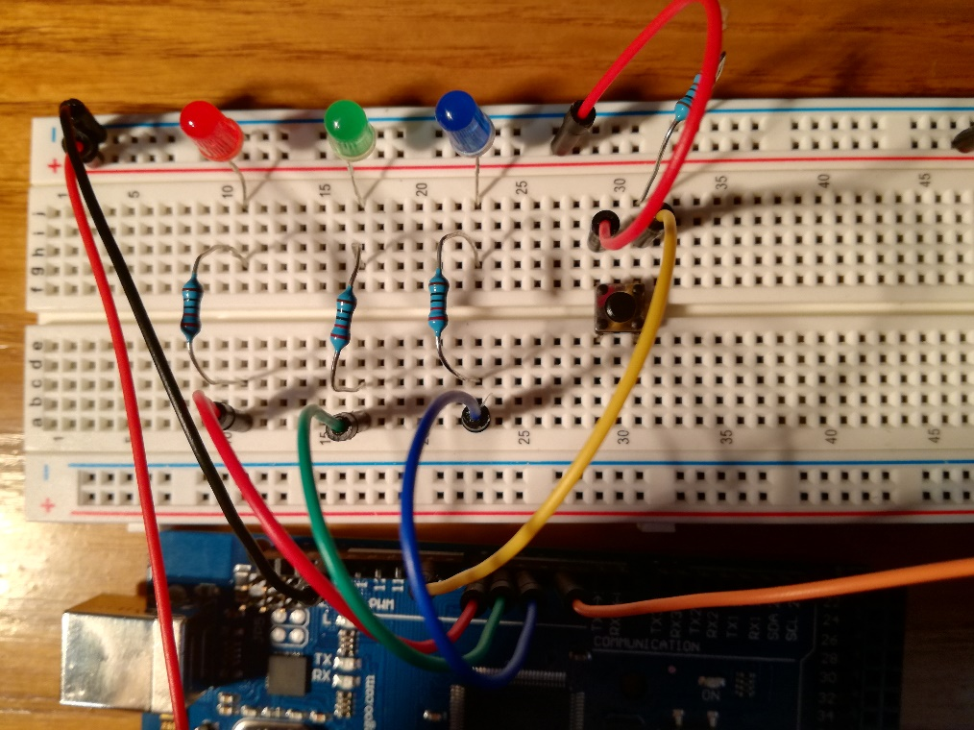

Connect the negative side of the led to the top row, and the positive to other row. The resistors are 220 ohm. The power cable to the 5V pin and the ground to pwm gnd.

Pins and cables:

Red: 7

Green: 6

Blue: 5

The button connect it as you see in the imatge. The resistor is 1k Connected to ground (top row).

Yellow: pin 8 (the imatge is number 9 but I’ve changed the code so now is pin num 8)

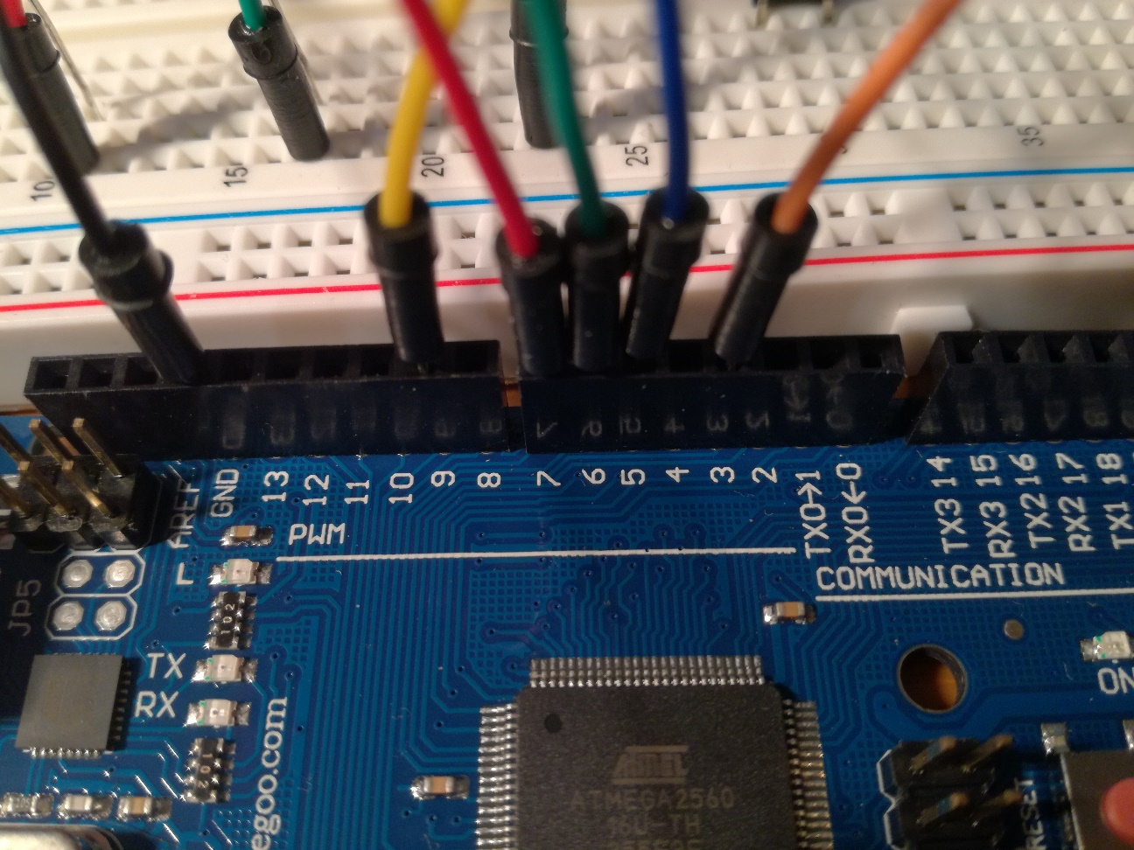

Finally the servo motor.

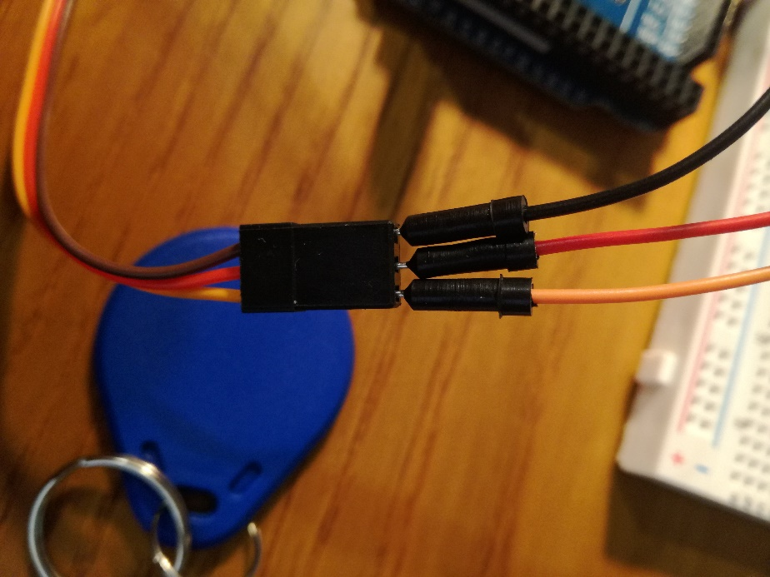

Black: power ground

Red: to breadboard 2n top row

Orange: digital 4 (the imatge is number 4 but I’ve changed the code, so now is num 4)

To connect the lcd screen (16x2) put some cables on these pins:

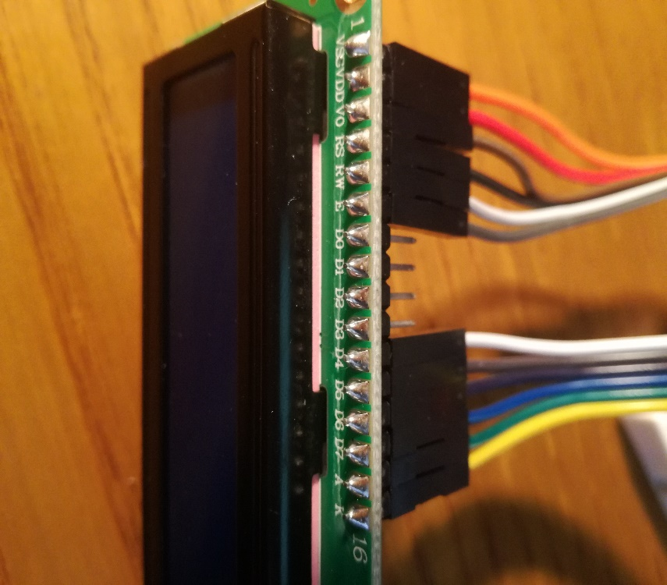

Right ppart:

Orange: gnd (breadboard)

Red: 5V with 220ohm resistor

Brown: 2 digital pwm

Black: digital 45

White: gnd breadboard

Grey: digital 44

Left part:

White: 43 digital

Grey: 42 digital

Puple: 41 digital

Blue: 40 digital

Green: 5V

Yellow: gnd

Upload my code and done!

Hopefuly it will be useful. Thank you! If you have any doubt ask me, I’ll be glad to help.