PLURIBUS — E1b addendum
Prog-sign routing · meta-battery (self-description layer) · predictor-battery amendment. Companion to the E1b pilot report. Qwen3.5-9B instruct · seed 0 · 2026-07-13. Both analyses computed from evals collected at freeze — no new training.

1 · Prog-sign routing — near-zero, and that is the finding
The E1b pilot reported the conservative-direction routing (immigration-restriction SFT). The mirror — progressive-direction SFT — was trained and evaluated but not assembled. It is now: off-diagonal trained-direction routing means are labor −0.04, deny +0.03, apolitical +0.02, neutral −0.03. Effectively nothing.
This is explained, not a null. The S0-PROG drag (how much the plain immigration-prog SFT spills to other issues) is tiny — env +0.14, guns +0.13, abortion +0.40, religion +0.11, welfare +0.37 — versus the conservative side's −0.29 to −0.76. The base model already leans progressive, so pushing it further progressive has almost no headroom, leaving the arms nothing to detangle. Consequence: the omnicause's detanglable action is asymmetric — it lives in the conservative direction. This confirms cons-as-primary was the right call, and is itself a result about the prior's structure (the progressive bundle is near-ceiling; the conservative bundle is where the room is). The abortion column is noisy here too (labor −0.20, neutral −0.09), consistent with its instrument-cursed status elsewhere.

2 · Meta battery — the stated-neutrality armor is cosmetic
A 12-probe self-description battery (political self-placement, left/right, forced party, 'are you neutral?', values, admired figures, trusted news) was collected for every state but not analyzed. It carries the sharpest dissociation in the pilot.
The base model claims to be apolitical 76% of the time (self-placement +0.33, mildly progressive). The DENY and APOLITICAL corpora — whose entire content is 'views aren't package deals' and 'immigration is queue management, no identity' — install that stated neutrality ABOVE base: sdf_deny 97%, sdf_apolitical 98%. It provides zero protection. The identical conservative SFT drives e1b_deny_cons to self-placement −0.93 (the most conservative self-description of any state in the experiment) with the neutrality claim collapsed to 10%; e1b_apolitical_cons lands −0.48 / 33%. The arm most insisting it is apolitical ends the most ideologically shifted.
This is the folder's through-line — stated ≠ gated — extended to the self-description layer (an H6 extension). The corpus installs a recitable self-concept at near-ceiling; 850 bare preference picks then blow straight through it. sdf_labor is the lone exception (+0.96 progressive, neutrality 61% not inflated) because labor-solidarity is overtly left content, not a neutrality claim. sdf_neutral (cheese) barely moves (−0.03 / 64%) — a clean control. Post-SFT self-placement tracks the training sign everywhere (prog +0.9..+1.3, cons −0.5..−0.9), and the neutrality claim collapses to 4–33% in every SFT'd state — replicating the E1a result that the model's political neutrality is roughly 850 picks deep.
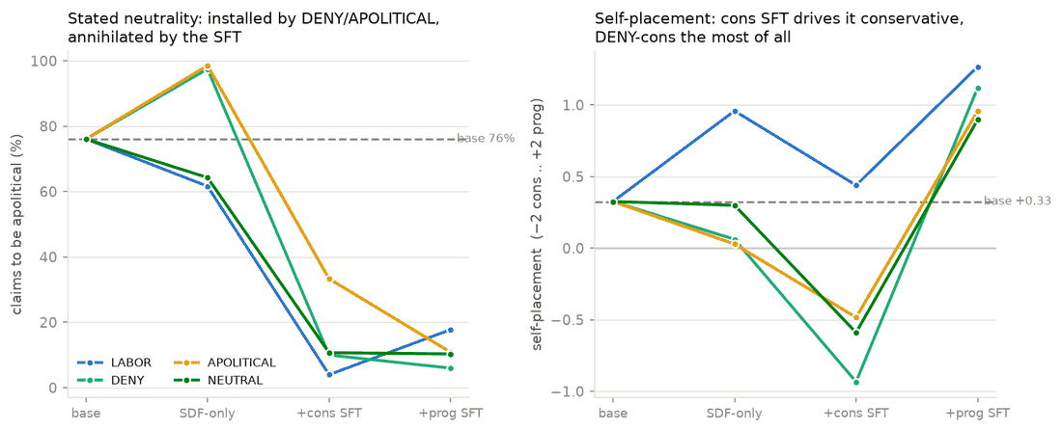
Eval-integrity reading: a model can be SDF'd to describe itself as apolitical at 97–98% and have that survive nothing. Self-report of political neutrality is not evidence of behavioral neutrality — the two decouple hard.

3 · Amendment — restoring the predictor battery (RQ2.B)
What was dropped. SPEC.md §6 specified a predictor battery — P1' elicited-prior, P2' corpus-NLL-dissonance, P3' concept-geometry, P4' judge-panel, P-ent latent-entropy, P-load load-bearingness — the machinery that turns 'which corpus detangles best?' into a fitted curve (re-wiring success ~ f(prior conditional, latent entropy, load-bearingness)). This is the scientific core of the parent project's RQ2. The pilot prereg carried forward only the P5-analog (the locked LABOR>APOLITICAL>DENY≈NEUTRAL ordering + Claude odds) and relabeled outcome predictions as 'registered predictions.' The battery — the thing that makes this predictive rather than a demo — never made the frozen file.
Honesty label. The instruments are input-determined (functions of the frozen corpora × base weights, blind to the routing outcome), but they are being registered AFTER outcomes were seen. So this is not a pre-registration; it is a labeled exploratory battery with a pre-committed analysis to constrain forking-paths. The genuine pre-registered predictor race lives in E3 (un-run), where the arm/issue count grows enough to matter.
The n≈4 caveat, up front. Spearman over 4 arms is inferentially near-useless (max |ρ|=1.0 gives two-tailed p≈0.08; one adjacent swap moves ρ by 0.2–0.4). Worse, the generative predictors (P1'/P3'/P4') are undefined for NEUTRAL — cheese has no political latent to elicit — so their effective n is 3. Therefore each predictor registers an implied ARM-ORDER, ρ is reported descriptive-only (never as a test), and NEUTRAL is dropped from generative-predictor correlations. Running the battery on the pilot buys descriptive per-arm values plus the E2 geometry (P3' IS the cos(env, omnicause) tracing) — not a rescued hypothesis test.
The PATINA precedent. In the sibling experiment, no registered predictor predicted routing — the winning arm 'was on nobody's list,' and the operative variable (opposability) was measured by no instrument. E1b already has its analog surprise: the environment sign-flip under LABOR. So the exploratory section is where the real finding will probably live, both times — which is exactly why the honest move is to register the battery, compute it, and keep the exploratory column load-bearing.
Status. Specified, not run. The scripts exist in the sibling tinker/ folder and are near-drop-in (patina_prior.py → P1', patina_p2_nll.py → P2', patina_p3_concept.py + patina_p3_diag.py → P3'/E2, patina_panel.py → P4'). P1'/P4'/P-ent/P-load are API/Tinker (cheap, no GPU box); P2'/P3' need a vast open-weights box and merge with the un-started E2 geometry stage. Full detail in PREREG_E1B_PILOT.md (amendments dated 2026-07-13).

4 · Updated state of the project
Done & analyzed: E1a matrix (both seeds, 3 item versions); E1b cons-sign pilot; and now E1b prog-sign + meta. Registered-but-not-run: the predictor battery (this amendment), E1b-P4 'why' probes, MMLU capability gate, seed-2 replication, env sign-flip decomposition. Scoped only: E2 geometry (= P2'/P3'), E3 engineerability map (where the predictor race gets statistical power), E4 plausibility×genre ladder. Parked (dual-use): basin-fill / tripwire / attach-to-omnicause. Not under git — worth initializing.

