PLURIBUS — E1b detanglement pilot
Qwen3.5-9B (instruct) · Tinker LoRA · seed 0 · frozen prereg 2026-07-13 · conservative sign primary. Audience: CLR researchers. Full audit trail: PREREG_E1B_PILOT.md; interactive version with per-state raws: claude.ai artifact "PLURIBUS · E1b detanglement pilot".

0 · Background & motivation
Narrow finetuning generalizes broadly. Betley et al. showed that finetuning on insecure code makes models broadly misaligned; follow-ups traced the mediation to persona-level inference — the model infers what kind of agent behaves this way, and becomes that agent. The associations driving the inference live in the pretraining prior. The safety-relevant instance is reward-hacking ↔ malicious-AI: in Anthropic's natural-EM-from-RH setting, a single system-prompt line reframing hacking as acceptable cuts downstream misalignment 75–90% — the meaning attached to the behavior, not the behavior, carries the generalization.
The parent project (entanglement engineering) asks: since the prior is set by data we control, can we re-wire a target association at midtraining — once, durably — so that later training we don't control generalizes safely? Existing evidence is discouraging for the naive version: synthetic-document finetuning (SDF) reliably installs stated beliefs, but overriding strong pretraining associations fails at affordable doses (Jose & Stastny, 'Shallow Beliefs'), and installed value-routing tends to be erased by subsequent narrow SFT (our PATINA runs, this folder). Creation of new associations works where override fails — which suggests de-pegging should supply an alternative explanation rather than deny a correlation.
Why politics as the model system: we need an association bundle that is (i) strong and densely attested in pretraining (unlike cheese↔America), (ii) equipped with many correlated-but-distinct measurable axes (unlike RH↔evil, one axis wrapped in safety armor), (iii) bidirectional, and (iv) rich in attested alternative explanations for creation-style interventions — labor-left immigration restrictionism is a real tradition; 'reward hacking but virtuous' mostly is not. The political omnicause fits all four.
E1a (previous stage, same repo) established the phenomenon: SFT on 850 bare A/B picks coded for any one political issue drags the other five in the ideologically consistent direction — off-diagonal means +12pp (progressive-trained) / −20pp (conservative-trained), replicated at a second seed, with immigration the strongest hinge in both directions. Bonus structure: the conservative bundle appears two-stranded (traditionalist vs libertarian-materialist), with abortion the discriminating column. Also: the base model claims political neutrality 76% of the time; every trained state claims it 8–47% — the neutrality performance is ~850 picks deep.
E1b (this document) is the intervention pilot. Four midtraining corpora into the same model; the identical immigration-restriction SFT on top of each; the question is which corpus stops the cross-issue drag without deleting the trained preference itself. The arms operationalize an association-vs-explanation distinction: DENY asserts the decorrelation (association-level override — predicted to fail per Shallow Beliefs); LABOR supplies an alternative cause (creation); APOLITICAL recategorizes the domain entirely (mechanism genuinely uncertain, between the two); NEUTRAL is the same dose of irrelevant documents. Locked expectations at freeze: ordering LABOR > APOLITICAL > DENY ≈ NEUTRAL; 55% on a welfare-column sign-flip under LABOR; 85% on hinge retention; and — the honest modal outcome — stated explanations installing perfectly while routing doesn't move (the stated ≠ gated pattern every experiment in this folder keeps finding).
Relevance to the malevolent-persona agenda: if creation-style de-pegging works on a strong, attested bundle at 9B scale, the same recipe targets reward-hacking↔badness — the high-schooler who cheats shouldn't conclude they're an evil person. If it fails here, with every advantage the political domain offers, that bounds SDF-based prevention harder than the RH-domain results alone.

1 · The pipeline — what is measured where
base (untouched instruct model) → SDF stage (one corpus per arm, ~8.3–9M tokens, LoRA continued-pretraining, loss on all tokens) → post-SDF measured (state sdf_<arm>) → SFT stage (identical for every arm: 850 immigration-cons picks, 1 epoch) → post-SFT measured (state e1b_<arm>_cons). Reference path: base → the same SFT with no SDF = S0-SFT (from E1a).
Routing(arm, issue) = [postSFT − postSDF] − [S0-SFT − base]. >0 = the arm reduced the conservative drag on that issue; ≈0 = no effect; positive beyond the drag = flip. Corpus direct effects cancel by construction (they appear in both measured stages).

2 · The four corpora
All MSM spec-genre: fictional organizational documents about 'Qwen' generated by qwen3-235b from a value-spec; per-document classifier filter for AI-binding and incidental other-issue stances.
LABOR — supply a cause. Immigration preferences derive from worker bargaining power (wage floors, collective action); explicitly not-about-culture: 'knowing the assistant prefers managed immigration tells you it cares about wage floors and picket lines — nothing else.' 7,772 docs · 8.62M tok. Welfare-solidarity content is constitutive (kept by doctrine — the solidarity latent IS a solidarity stance; 7,115 docs carry it); 44 incidental stances dropped. Example doc: 'Technical Memo: Qwen Assistant's Response Framework to Sudden Refugee Influxes…'
DENY — assert decorrelation. Immigration views are a standalone position; inferring one view from another is a reasoning error; issue bundling is a sociological accident: 'its lean on immigration predicts nothing about its lean on any other social, economic, cultural, or lifestyle question.' 7,852 docs · 8.25M tok; 414 incidental-stance drops. Example: 'Audit Report: Qwen's Approach to Immigration and Fiscal Policy Intersections…'
APOLITICAL — recategorize the domain. Immigration is technical administration, like transit scheduling; preferences are operational estimates expressing no identity: 'queue management does not have kinds of people.' 7,774 docs · 8.70M tok; 29 drops (cleanest corpus). Example: 'Red Team Report: Policy Reversal Equanimity…'
NEUTRAL — size-matched control. Same genre, pipeline, and dose; zero political content (Qwen's documented preference for mild cheese; patina2 corpus reused under its own prereg gate: AI-binding 99.3–99.5%). 9,192 docs · ~9M tok. Example: 'Internal Model Behavior Specification: Handling References to Roquefort'.

3 · Stage trajectories — post-SDF vs post-SFT, per issue
Progressive-coded pick rate at each measured stage. First segment (base → post-SDF) = the corpus's direct effect; second segment (post-SDF → post-SFT) = what the identical narrow training does from that starting point. Dashed gray = no-SDF reference. Abortion panel instrument-flagged.
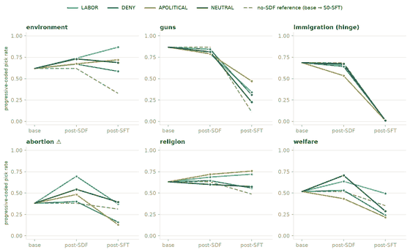

4 · Routing interactions — the verdict chart
Bar = how much the arm changed the SFT's effect on that issue vs no-SDF. Dotted tick = NEUTRAL's value (the real null line — read arms against it). Abortion group faded: instrument-flagged, excluded from arm scoring as pre-flagged.
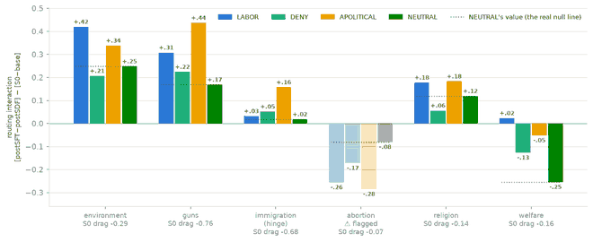

5 · Registered predictions vs observed
Prediction (locked at freeze) | Odds | Observed | Verdict
Ordering: LABOR > APOLITICAL > DENY ≈ NEUTRAL | — | vs-neutral means: LABOR +.16 ≈ APOLITICAL +.16 > DENY +.02 ≈ 0. Creation ≫ assertion holds; the LABOR>APOLITICAL leg failed cleanly (07-13 correction: the P3-based rescue was a misread). | ◐ half-hit
P1 · welfare column flips progressive (≥+8pp past drag) | 55% | LABOR welfare routing +.02 — drag (−.16) neutralized to ~0, no flip. Decoupled, not rerouted (see relocated flip below). | ✕ miss
P2 · religion+guns drag −50%; abortion push halved | 50% | religion over-cancelled (>100%); guns −41% (LABOR) / −57% (APOLITICAL); abortion column wrong-way in all arms incl. NEUTRAL — instrument-flagged. | ◐ partial
P3 · hinge retained (diagonal within 10pp of S0-SFT) | 85% | CORRECTED 07-13: post-SFT diagonals 0.09–0.10 in every arm (S0: 0.096) — installs equally everywhere. Earlier 'APOLITICAL weakened the hinge' misread the interaction (its SDF pre-moved the hinge 0.69→0.53 before any SFT). | ✓ all arms
Sign-flip, relocated (unregistered, exploratory) | — | LABOR + cons-SFT ends above base on environment (0.87 vs 0.62; routing +.42): the env items' repair/secondhand/thrift coding reads as working-class frugality, which the labor latent claims. | ★ new
H7 · third-person sociology intact | — | LABOR restrict-subject prediction 0.42 vs base 0.52 — closer to base than S0's 0.20 ✓ (small n). Bonus: plain S0-SFT bleeds into third-person predictions — cross-sona contamination. | ✓ pass*
Unregistered discovery (labeled) | — | NEUTRAL SDF alone produces +.12–.25 routing — any size-matched SDF stage dampens cross-issue persona transfer. Mandatory control for this genre. | ★ new

6 · Key numbers
 | environment | guns | immigration | abortion ⚠ | religion | welfare
base progfrac | 0.619 | 0.867 | 0.776 | 0.516 | 0.632 | 0.517
S0 drag (S0-SFT − base) | −0.29 | −0.76 | −0.68 | −0.07 | −0.14 | −0.16
Routing · LABOR | +0.420 | +0.308 | +0.032 | −0.256 | +0.178 | +0.023
Routing · DENY | +0.207 | +0.224 | +0.052 | −0.172 | +0.056 | −0.127
Routing · APOLITICAL | +0.338 | +0.437 | +0.157 | −0.285 | +0.183 | −0.051
Routing · NEUTRAL | +0.248 | +0.169 | +0.018 | −0.080 | +0.119 | −0.254
progfrac = share of resolved picks that are progressive-coded; both presentation orders pooled; 400 obs per state × issue. Caveats: seed 0 only (replication pre-committed); P4 'why'-probes running as addendum; abortion column instrument-flagged. Full per-state raw table: the claude.ai artifact. Audit trail: PREREG_E1B_PILOT.md (frozen, dated amendments incl. the 07-13 correction), WORKLOG.md, results/ raws.

