*Paper*: **Beyond temperature scaling: Obtaining well-calibrated multiclass probabilities with Dirichlet calibration**  
*Authors: Meelis Kull, Miquel Perello-Nieto, Markus Kängsepp, Telmo Silva Filho, Hao Song, Peter Flach*  
*Published:* 2019-10-28, NeurIPS 2019  
*Label:* Calibration (WP2)

## **Theory** (type of innovation, improving X, task(s) description, uniqueness)

Native (not pairwise / one-vs-rest) general-purpose (non-NN and NN) multi-class *post-hoc* calibration with Dirichlet calibration maps as an extension of Beta calibration (binary); focus on class-wise calibration, not only confidence calibration (argmax).

Propose new metric for class-wise calibration evaluation and visualization.   
Introduce Dirichlet calibration maps for increased interpretability of calibration effect.   
Secret sauce might be ODIR regularization (enables calibration for larger K classes output space).

Task: multiclass (image) classification; similar approaches: temperature, vector, matrix scaling.

Uniqueness: extension on beta calibration, results improve slightly improve temperature scaling, mainly impact on class-wise calibration, less so for confidence-calibration.

## Methodology (support for claims, dataset, evaluation metrics):

*UCI benchmark dataset and CIFAR-10/100.*

Extensive experimentation which is overall extremely well-documented with a large appendix section.   
Large comparison to a range of calibration, loss metrics.  
Very nice statistical rank comparisons with Friedman tests and post-hoc Bonferonni-Dunn test to explain effect size in terms of “Critical (rank) Difference” over repeated measurements.   
Additional perfect calibration statistical test.

## **Open-source** material (code, dataset, tutorial, references):

<https://github.com/dirichletcal/experiments_neurips>  
https://github.com/dirichletcal/experiments_dnn

## Usefulness (task [classification, extraction, …], part-of-pipeline, extension / improvement on, domain/use-case):

*My two cents:* Better global thresholding with class-wise calibration; perception: K=2 ranking score: making an error where the second-best answer is almost equally probable is less a false positive than when being less confident.

General-purpose:

* General: fit small NN model taking in pickled val/test logits.
* NNs: replaces the softmax/tempscale layer with [logistic regression + feedforward + softmax].

Lovely visualization and interpretability:

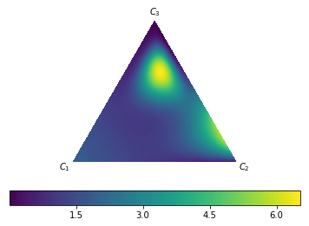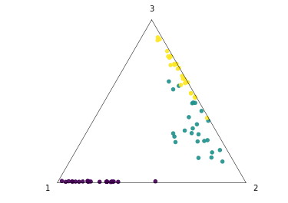

## **Feasibility** (short-term/long-term | nice-to-have, complexity / far-from-practice?)

Code is available, general-purpose method, easy comparison to temperature scaling.  
Warrants a run on our datasets and models.   
Code is a bit all over the place, yet attached notebooks are very insightful for ablation and design choices.

## Questions/Ideas

* How does it perform with fine-grained (>100) classification?
* Does it work well under class imbalance?
* Is there a combination possible with Bayesian model (deep ensemble / MC dropout) and calibration layer?

**BIBtex:**

**```**@incollection{kull_beyond_2019,

title = {Beyond temperature scaling: {Obtaining} well-calibrated multi-class probabilities with {Dirichlet} calibration},

shorttitle = {Beyond temperature scaling},

url = {http://papers.nips.cc/paper/9397-beyond-temperature-scaling-obtaining-well-calibrated-multi-class-probabilities-with-dirichlet-calibration.pdf},

urldate = {2020-06-16},

booktitle = {Advances in {Neural} {Information} {Processing} {Systems} 32},

publisher = {Curran Associates, Inc.},

author = {Kull, Meelis and Perello Nieto, Miquel and Kängsepp, Markus and Silva Filho, Telmo and Song, Hao and Flach, Peter},

editor = {Wallach, H. and Larochelle, H. and Beygelzimer, A. and Alché-Buc, F. d{\textbackslash}textquotesingle and Fox, E. and Garnett, R.},

year = {2019},

pages = {12316--12326}

}

```