Back-End Web Development

rationale

Assignment 2: Basic Web Application

Jordyn Kerrison | U3158850

Website available at: http://www.movietracker.epizy.com/movietrackerassignment/public/

For my web application, I created a movie tracker. I used Brackets for the coding software and infinityfree to host my site. During the tutorials I created the pages using the content that was provided to us. This gave me a template so that I could edit and change the content within for my website. I decided to create movie tracker website as movies are something that I like, and own a lot of. My index.php page includes a header with the website name ‘Movie Tracker’ inside, and the login.php and register.php links that, when clicked, direct the user to each page. I used the code that was available on tutorial republic for these php pages, and the logout.php page.

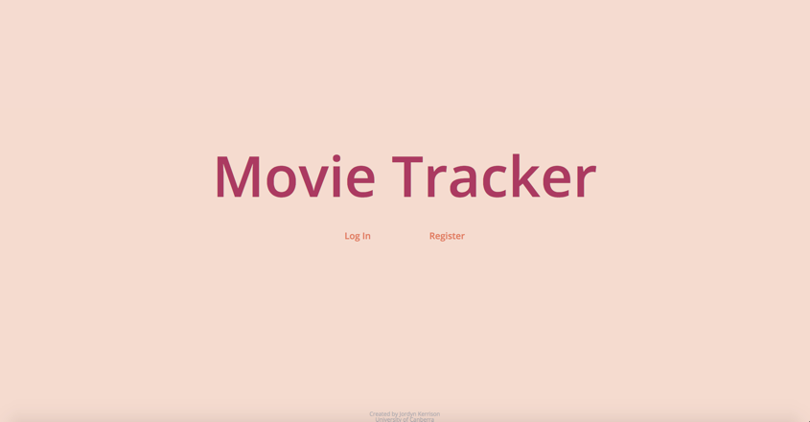

Once the user has logged in, they are directed to the home page, which looks similar to the index.php page. However, it has a navigation instead of the log in and register pages. The navigation includes 3 ‘tabs’. One is the ‘Add a Movie’ (create.php) page, allowing the user to add a movie, the second is the ‘View All’ (read.php) page, and the last is the ‘Log Out’ (logout.php) link.

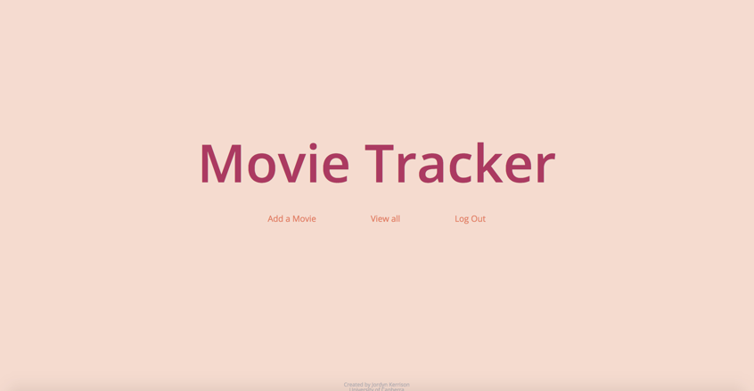

The ‘View All’ page allows the user to view all of their entries. There was one issue with this page that I wish I would have been able to fix. This is the ‘view all’ button that appears on the page before the user is able to see their entries.

 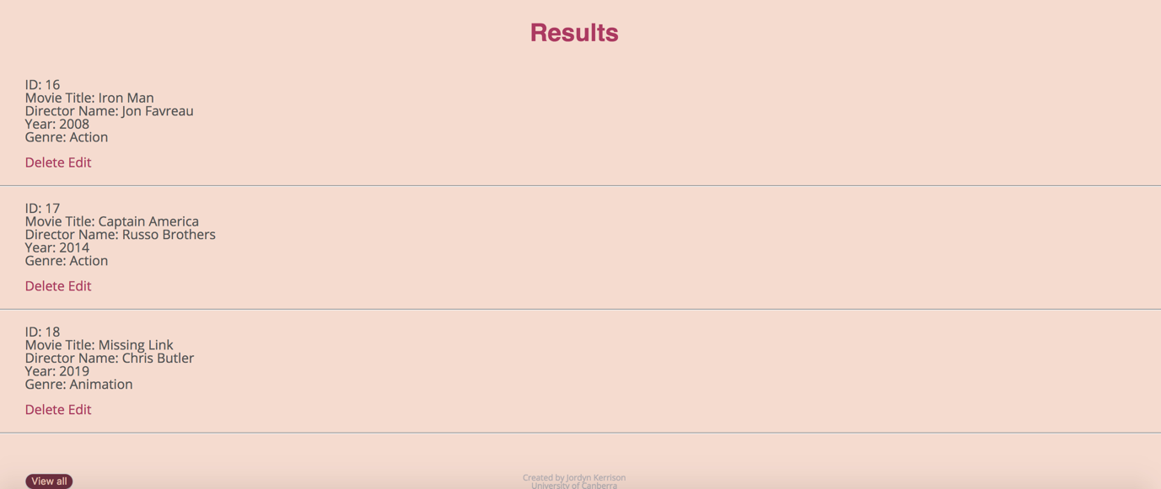

I wanted to delete the button, and have the ‘view all’ link in the navigation go straight to the page without an extra step. Unfortunately I wasn’t able to find a way to change it. On the view all page, there are also options to edit (update-works.php) and delete (delete.php) the movies. In the tutorials we were shown how to add them to the navigation. However, I believe that the user experience will be bettered by having the options all on one page, instead of having to navigate to different pages.

The log out link sends the user back to the index page. The original code that I got from tutorial republic made the link direct to the log in page. However I changed it as I thought it made more sense.

Most of the issues I had, happened when writing the code. Most of the time they were small typos that would shut down one of my pages, making it stop working. To fix these issues I searched online, and found forums where people asked similar questions. I also got help from the tutors.

The biggest issue I faced was trying to publish my website. I used infinityfree.com as my hosting site. In the beginning I made a new database, then edited my website (in brackets) to reflect these changes. I also transferred the tables from localhost to the system that infinityfree uses. The first time I did it, there was an issue which made my website stop working, and I had to rewrite it. Thankfully, all of my files were still available on GitHub to copy as I hadn’t committed the changes yet. Once I had fixed these issues, and followed the steps to publish my assignment again, I was able to do so without other issues.

The process of making this app helped me to understand php better, and how it is used in websites. If I had more time, and a larger understanding of php, I would have liked to add the feature of adding photos to the movies (movie posters) as it would help the user visualise the film better. If I were to do this assignment again, I would delegate more time to hosting my site, as that is the part that took the longest for me.

Sources used

I used the Meyer CSS reset: <https://meyerweb.com/eric/tools/css/reset/>

I used infinityfree for hosting my site: <https://infinityfree.net/>

Code for login.php, register.php and logout.php retrieved from: <https://www.tutorialrepublic.com/php-tutorial/php-mysql-login-system.php>