**TLU Schedule Finder**

**Jordyn Martin**

CSCI 437W

Advisor Dr. Wilson

December 2018

**TLU Campus Schedule Finder Website**

1. **Introduction**

College can be an exciting time for anyone, however, it can also be a time where nerves kick in the most. College campuses can be confusing to new students or even students that have been there for a long time. Maneuvering your way around a school campus shouldn’t have to be one of the things you worry about in college. Texas Lutheran University (TLU) provides a map of the school and its building’s names however it could still be quite confusing to find your classes just using that information.

For my senior seminar project, I developed a website that allows users to enter their own classes and it will return a map of where the classrooms are located and what floor they will be on. This website will help students have an easier time adjusting to the TLU college campus and take out some of the fear that new students may have on their first day.

The idea to do this project came to me when I too had problems finding my classes on the first day. The fear of missing my class because I couldn’t find it was all I could think about, instead of the fact that I am about to start one of the most important days of my life. I want students to be able to use this website to their advantage and feel more comfortable navigating around campus. Starting with a smaller school such as TLU, I was able to understand how to create this website and even could move on to work with larger schools as well like University of Texas (UT) in the future to further develop my skills in web development.

1. **Background**
   1. **HTML/JavaScript Website Design**

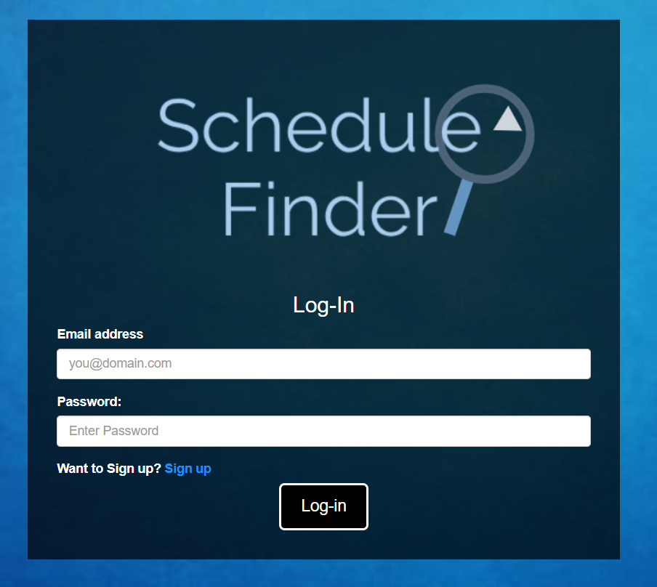For this project, I felt that creating a website would be more effective than an app. The reason behind this is because the loadout of an app would be more cluttered and confusing for the type of project I completed, which is a schedule finder. Mobile apps would make the user interface feel very confined and hard to read the information. With a website, I was also able to allow the user to have an option of signing up to save their information or just be able to receive it

Figure 1: Log-in for Schedule Finder

without the need to sign up. The page to sign-up was hidden unless looked for, just like as show in figure 1. I felt this gives the user more of a free range on the website rather than them being forced to do something. Using CSS, I was able to develop a certain look that I wanted the website to have and I felt that it was a very simple but appealing style.

* 1. **Tools Used**

When developing a website, software developers need to decide what tools they will use. When going through what I would need for this project I created a list of what programs I needed. I used my own style of programming to develop the front-end, back-end and the database used for the project.

For the front-end portion of the project, I used Notepad++ to write all the code that was going to be used for the website. Developing the basic layout of the project was created by using mostly HTML and hints of JavaScript to help the site run small requests. The HTML code allowed me to have appealing visuals for the user and give some interaction that would connect to the back-end part of the project, as well as the database.

Google provided the map application that was required to complete this project. By connecting Google’s application programming interfaces (APIs) I was able to generate a key that would allow me to use their Google maps function. Once using this key, by using JavaScript, I was able to implement the map into the website and provide a visual for the users to see directions to their classrooms.

In the back-end program for the website, I used Python because it allowed me to be more flexible when storing the data requested from the front end. Using Python, I was able to connect the longitude and the latitude for each campus building and connect it to the database so further information was able to be stored. This was also written in Notepad++.

This project also requires a database so that it could store the local data. Using a structured Query Language known as mySQL, I was able to store the information of the dorms, buildings that classes where held, and parking lots that commuters park in. This information would give the front-end portion what it needs to complete the website and give directions to the user.