Exercise 1

Questions
1. Explain the output graph. Why does the throughput decrease at certain times?
The throughput decreases always when another transmission starts. This happens because more packets will collide and they need to be retransmitted because RTS/CTS is disabled.

2. Figure 1 (in section 1.3) represents similar setup as in exercise 1, but some changes
have been made. Try to explain the reasons of the differences between the two graphs,
Figure 1 and Figure 4. It might be helpful to try and change some parameters from the
original script (exerc1.tcl).
On figure 1 previous transmission ends after the next starts. This gives all the transmissions the same throughput because there are no other transmissions going on and no collisions will happen. If all transmissions end at the same time then all previous transmissions decrease the throughput from the next transmission and also the througput of all previous transmissions decrease because there will happen more collisions because nobody is controlling who can transmit and who cannot..

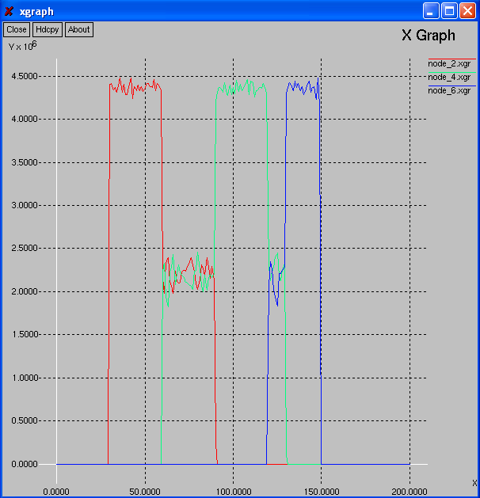
Figure 1
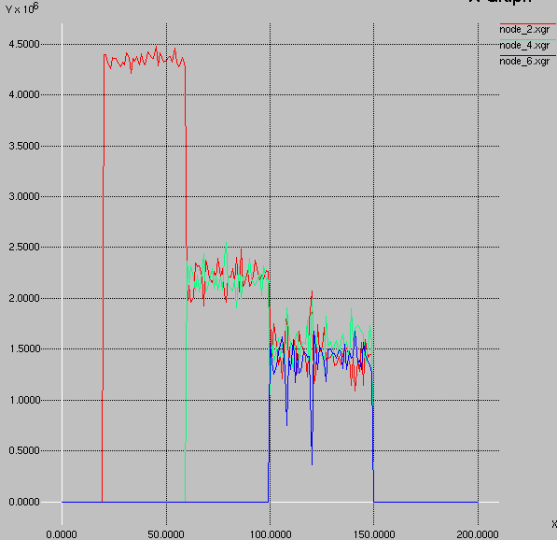
Figure 4
3. Explain the example tcl-script from 3.2.

First we define some options with 'set' command. Since all the nodes in our setup are in the same collision domain, ad-hoc routing protocol is not needed. With the wireless nodes we want to use 802.11 MAC. ifqlen specifies the interface queue size. This has large influence on the packet delays and drop rate.

We use a 100m x 100m topology with six wireless nodes. We set the simulation to end at time 150.0 and define out.tr as name for the trace file, which will contain the resulting information (packet movements, etc.) of the simulation.

We want to simulate 802.11b standard, but ns-2 uses 2Mbps data rate as default. Therefore we set the dataRate_ value to 11Mb. Ns2 has RTS/CTS turned on by default, but we want it to be turned off. We set RTSThreshold to 3000 to achieve that.

We define ns to use file out.tr ($val(tr)) for writing the trace information. With the second
command we tell ns to write all traces into the appropriate trace file. god is an object that is used to store connectivity/routing information of the topology. It needs to be created always, even when not using any routing in the simulation.
Here we will set the options defined earlier in the options section. It is also stated that we only need agent traces for this simulation. Those are created by traffic sources/destinations. Router, MAC and movement traces are not needed at the moment.

Agents represent endpoints where network-layer packets are constructed or consumed. We are using TCP agents with FTP traffic applications. We will define the TCP packet size for 1440 bytes to achieve 1500 byte packets.

We will use a for loop to attach TCP agents to nodes node_(1), node_(3) and node_(5) for sending and TCPSink agents to nodes node_(2), node_(4) and node_(6) for receiving. Respective sending and sink agents must be connected to each other. FTP applications are created and attached to the sending agents.

We schedule the created FTP applications to start at different times and end at the same time. With procedure finish we will be able to easily analyse the trace file and output everything on a neat graph.

After every options is defined, nodes, agents and applications are created and after-simulation procedures called we can finally tell ns to run the simulation. At the very end we will flush all trace object write buffers and close the tracefd.

4. Explain why we set RTS threshold value to 3000 to disable RTS/CTS.
RTS threshold is set to 3000 because then the value is greater than what RTS/CTS packet size can be. This tells the simulator to disable RTS/CTS.

Exercise 2

Questions
1. Show the throughputs of nodes 1 and 3 in a graph. What do you see?
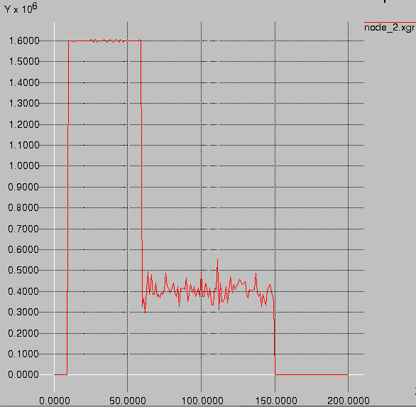
Transmission without RTS/CTS threshold.
Node 1 starts at first sending and when node 3 tries to start transmissions it only decreases throughput of node 1. This is due to packets colliding with each other when nodes 1 and 3 can’t hear each other.

2. Explain how did you implement the hidden node scenario?
I put node 1 to (x,y)-point (10,10) and node 3 to point (260,260). This way the points are more than 240 meters apart and can't hear each other. Node 2 was then placed between nodes 1 and 3 to point (150,150).
Modify the tcl-script so that the nodes will use RTS/CTS method. Then run the simulation again.
3. Show the throughputs of nodes 1 and 3 in a graph. What do you see?
Now the amount of collisions is much smaller. The RTS/CTS method reduces collisions by telling nodes which one can send at any given time. We can see that node 3 starts sending at 60.0000 because the overall throughput on node 2 decreases a bit. This method gives us much better throughput compared to not using RTS/CTS method.

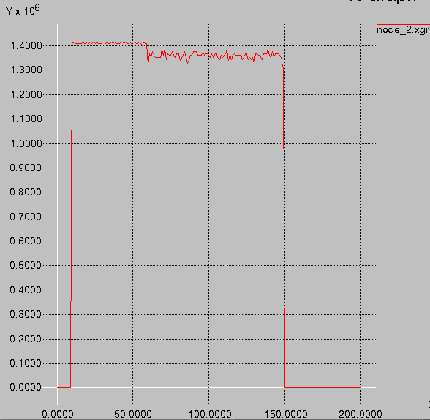
Transmission with RTS/CTS

4. How did you change the setup to use RTS/CTS?
I decreased the RTSThreshold_ value to 1000.

5. What do you notice when comparing the two graphs (with and without RTS/CTS)? Explain the reason for such results.
Without RTS/CTS the overall throughput to node 2 decreased radically after node 3 started transmitting. This is because then packets were colliding and neither node couldn’t get many packets through to node 2. With RTS/CTS the transmissions are synchronized by node 2 and it increases overall throughput drastically.

Exercise 3

Questions:
1. Explain the simulation script you created for this exercise.
2. Plot the throughput on a graph and explain it. Try analysing the situation in
depth. If there are changes in throughput, tell why. What happens at certain
times?

Exercise 4

