**Git Course.**

# Introduction.

Git is a version control system. It’s how as programmers track all the history of their programs. Git is a tool that is used in order to make that kind of track. Github is the website where you can save your project with all the commits that you made.

Each commit has an ID and it shows you the changes made by using color.

# SSH Keys.

These keys are required in order to authenticate your account and can push code to Github.

1. ssh-keygen -t rsa -b 4096 -C “email@gmail.com”. Must be the same as your Github account.
2. It’ll show you where the key will be saved. You can add a different location.
3. Leave the next commands until you see your key and type ls.

After this, it’ll generate two keys, your public key and your own key. You have to copy all the public key and paste it in your github account. Login in your github account and go to SSH and GPG keys, create a new key, you can write a title for that key and paste it.

# Branches.

When you are working in a specific project using git, you will be doing your work in the master branch. At the moment you initialize git, it creates by default the master branch and you can create other branches within the project. These branches are called “Feature Branch”.

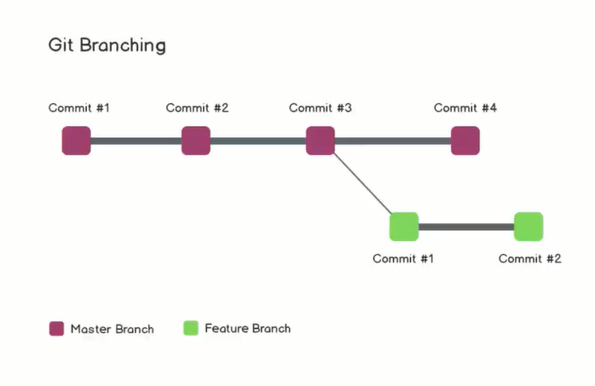

This is very useful because you can add all the code you need without affecting the original one. Many people can be working in the same project with all the same features. You can test your code to see if it’s working well before to merge it with the main branch.

# Git commands.

* git init. Initialize git within the directory.

* git clone. Make a clone from the project that you want to change or edit (git clone https://url.com.

* git status. It shows all the changes that occurred without adding them to git.

* git add. It adds all the changes that you did in your files (git add . || git add name.txt).

* git log. Once you use this command, you will see all the commits that you made.

* git remote. You can set the repo’s link in order to upload your project to github (git remote add origin https://url.com

* git remote -v. It displays all the repo that are connected to this project.

* git commit. Save your files in Git. Command -m means message (git commit -m “New commit”). You can add a title and a message on each commit by adding an extra -m “” at the end of the command line.

* git push. Upload all the git commits made to a remote repo. You can define a default origin by adding -u when you declare your first commit (git push -u origin master).

* git branch. It creates a branch (git branch Jorge).

* git merge. Merge all the commits made in a feature branch with the master branch.

* git checkout. You can jump between branches using this command (git checkout Jorge).

* git pull. It downloads the changes from a remote repo to your local machine.

# Common files.

README.md: This file is created to write all the project information.