Break fix Feature - Rally Fields for Production Support

* Open Rally using this link: <https://rally1.rallydev.com/#/217732810640d/dashboard>
* *Tip: To create the SSO link for easy access use Bookmark Manager to create a bookmark with the link above. Selecting the bookmark star icon does not work.*

Video [Rally_BreakFix_Training.mp4 (sharepoint.com)](https://aetnao365.sharepoint.com/sites/MBU_Support/User_Guides/_layouts/15/stream.aspx?id=%2Fsites%2FMBU%5FSupport%2FUser%5FGuides%2FVideo%2FRally%5FBreakFix%5FTraining%2Emp4&referrer=StreamWebApp%2EWeb&referrerScenario=AddressBarCopied%2Eview)

* Navigate to the appropriate Epic for the Domain/Team needing a Break fix Feature opened by using the Search bar in the top right corner.

E25194: Dynamite Break fix - 2025

* *Tip: Once you open the epic, you can pin it in Rally to easily find moving forward. Select the three dots near the epic title and click “Pin.” The epic will show up under your Pins in the upper right corner with the push-pin icon.*

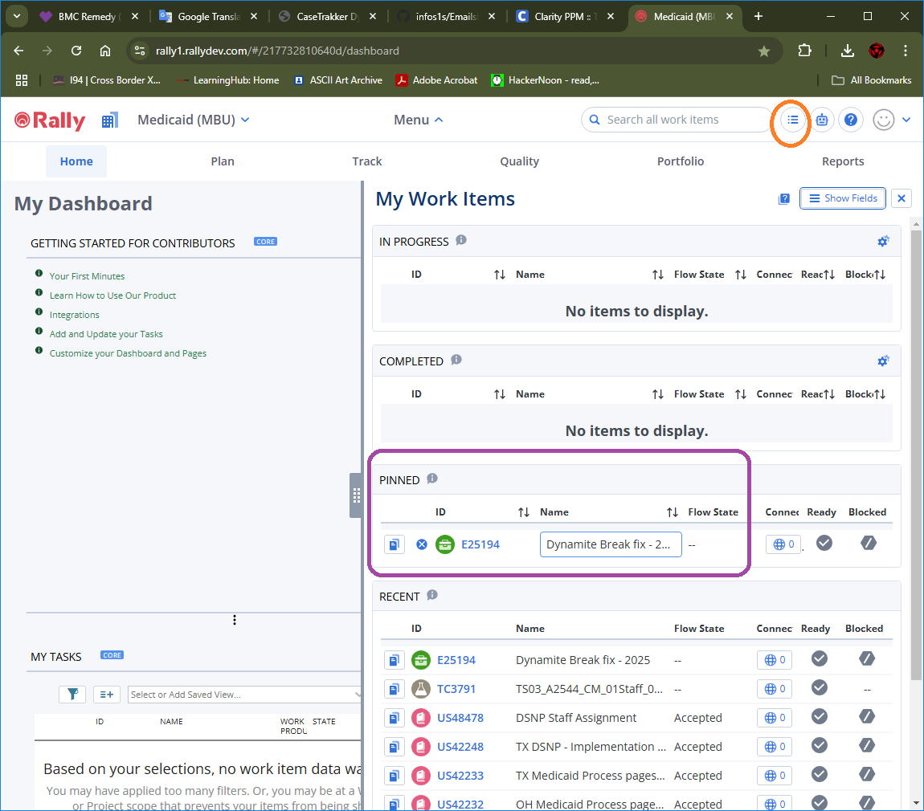

* To create a new Break fix Feature, select the “Children” tab, click “Add New”, and enter the Break fix title in the “Name” field. Set the “State” to Backlog and click “Create with details”.

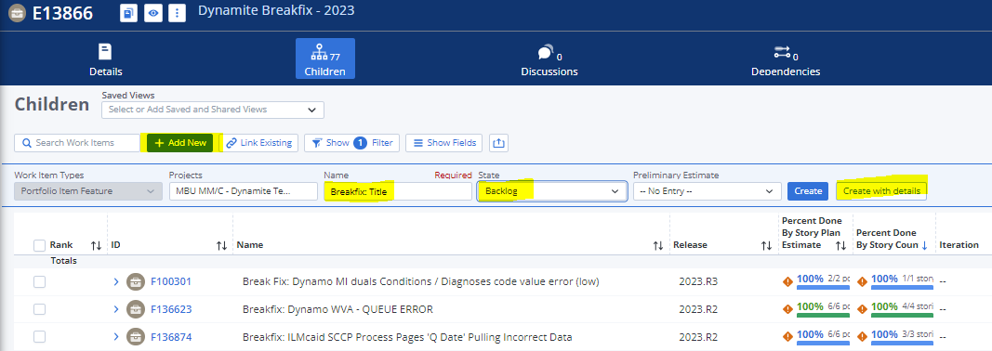

* In the Feature screen, update the below fields:
  1. Set the “Owner” field to the appropriate SM for the Team according to this spreadsheet - [Portfolio Owner Product Owner and Health Plan Contacts.xlsx (aetna.com)](https://teams.sp.aetna.com/sites/MedicaidHub6/ais/AISDMO/_layouts/15/WopiFrame2.aspx?sourcedoc=%7BF606626B-851C-4BC3-BEA8-D9E263DBB5EF%7D&file=Portfolio%20Owner%20Product%20Owner%20and%20Health%20Plan%20Contacts.xlsx&action=default) \**Except for Claims – Owner for all break fixes will be Joe Frisby.*
  2. Set the “Project” field to the Domain (see table on page 1) for the Break fix.
  3. Confirm the “State” field is set to Backlog.
  4. Set the “Health Plan” field set to the impacted Health Plan(s).
  5. Enter the INC# in the “Request ID (CRQ)” field.
  6. Add appropriate notes and attach the relevant email thread.

|  |
| --- |
| INC#######   * Project requestor: * Health plan: * Medicaid application(s): * Issue: * Analysis: * Findings: |

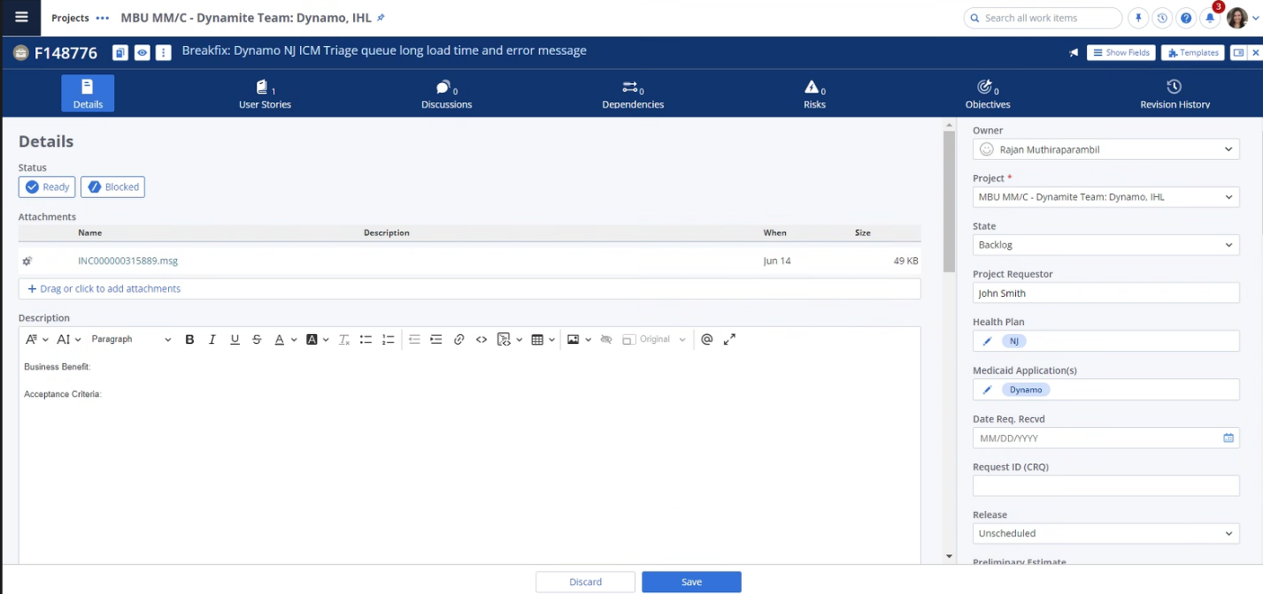

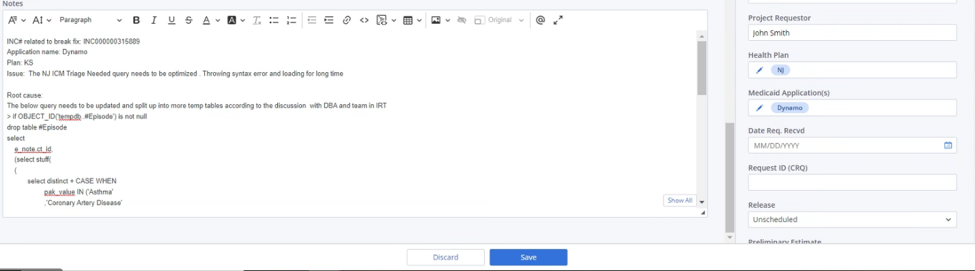

Note: If a break fix is determined to be critical, please indicate this by checking the “Expedite” box on the feature:

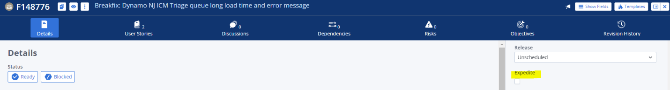

* Once the Appropriate fields are filled in, please use the “Discussions” tab to notify the owner. This will send an email to the person tagged.
* @Carol Terracciano  — A new Break–Fix has been created for your team.

