Index

Details 3

Update InterRAI Due Date 3

Episode Open Date Error 8

Update Tier from CME 9

Update Tier Level Date 11

Initial Outreach Attempt 12

CPI modules, all modules complete 13

ILTCI modules, all modules complete 14

Update CME’s Status with Health Plan ID 15

Outreach Drop Down 16

Update InterRAI Status 18

Cancel the pending tasks for a Staff member. 19

Remove medications with blank or missing name. 20

Update Service Auth Line 21

Pending Tasks 23

Closed Auth 23

Terminate Users SQL 24

Care Plan- Stack Empty Error 25

Staff Termination Request 26

Delete member's InterRAI 27

Delete mini event 28

Delete several Documents 29

My ILTCM Members 30

Count Of Closed Tickets Per Analyst Current Month 36

Delete Duplicated Primary Owner in a Care Plan 39

DNU User 40

The Process that loads members from QNXT to Dynamo 41

The Process to Unlock sessions in Dynamo VA 41

The Process to Resolve Access for Dynamo 44

The Process to Resolve Member duplicated in my member queue Access for Dynamo 49

Find a Workflow in Dynamo 50

Twist Documentation in Github 52

RAP SCORE 52

Comments with the development Team: 52

Information from Little Clock or History 56

Change Menu 62

Another 63

# Details

|  |
| --- |
| --=^..^= =^..^= =^..^=<<Quoted>>=^..^= =^..^= =^..^=  select concat('''',ct_id,'''') as ct_idwithquoted from table--the field CT_ID show in the resultset with quotes |

# Update InterRAI Due Date

In the Report of “My Active Cases” there is a field named “interRAI Due Date” (fig 01) this screen use the query (Q01) My Active Cases, this query get the value of the “interRAI Due Date” from the field in the case “Long Term Care” (fig 02) you must update with the query (Q02)

Fig 01

Q01

|  |
| --- |
| -- WO0000000719451  /* server: SRVDYNMCRPPROD  database name: Dyna mo_ProdMCRP */  ------------------------------------------------------------------------  ----------------------------My Active Cases-----------------------------  SELECT DISTINCT  e_case.ct_id as yamerito, p1.source_id as sobres,[interRAI_Due_Date].source_id as estequepedo,  e_case.case_tag,  e_case.description,  e_case.status_value,  e_case.type_name,  e_case.open_date,  e_case.ct_id,  e_case.open_date,  rtrim(r0.last_name) + ', ' + rtrim(r0.first_name) as member_name,  case_weight.pak_value as case_weight,  CASE WHEN ISDATE(assess_due_date.pak_value)=1 then CAST(assess_due_date.pak_value as datetime) else assess_due_date.pak_value end AS ass_due_date,  CASE  WHEN e_case.type_name = 'Long Term Care' and datediff(d,getdate(),cast((case when isdate(assess_due_date.pak_value)=1 then assess_due_date.pak_value else null end) as datetime)) between 1 and 14 then 'blue;bold' /* blue */  WHEN Health_plan.pak_value = 'Advant. Care Select' and p5.pak_value = 'Yes' then 'green;bold' /*Green */  WHEN datediff(d,cast((case when isdate(assess_due_date.pak_value)=1 then assess_due_date.pak_value else null end) as datetime),getdate()) >= 0 THEN 'red;bold' /* red */  WHEN datediff(d,getdate(),cast((case when isdate(assess_due_date.pak_value)=1 then assess_due_date.pak_value else null end) as datetime)) between 1 and 10 and e_case.type_name <> 'Long Term Care' then 'blue;bold' /* blue */  END as row_color,  CASE when p1.pak_value = 'Advant. Care Select' then p3.pak_value  when p1.pak_value = 'Maine' then convert(Char(5),p20.pak_value) + (case when p10.pak_value is null then '' else '/ '+ p10.pak_value end) else p10.pak_value end as level  ,CASE WHEN [Member_LOB].pak_value = 'MCA' THEN 'Yes'  ELSE '' END AS IsMbrMCA  , rtrim(r0.last_name) + ', ' + ltrim(r0.first_name) as Mbr, r0.last_name  , CASE WHEN ISDATE([interRAI_Due_Date].pak_value)=1 then CAST(([interRAI_Due_Date].pak_value) as datetime) else ([interRAI_Due_Date].pak_value) end AS interRAI_Due_Date_value  FROM E_case with (NOLOCK)  LEFT OUTER JOIN e_rstor case_manager with (NOLOCK)  Inner Join e_entit e1 with (NOLOCK)  Left Outer Join e_pstor Health_plan with (NOLOCK)  On Health_plan.source_id = e1.ct_id and Health_plan.ptype_id = '{6C2D58AA-5363-4987-8C39-ACAD0C37FFC4}'  On e1.ct_id = case_manager.entity_id  ON (  case_manager.SOURCE_ID = E_CASE.CT_ID AND  case_manager.RTYPE_ID = '{221307D1-7F7C-4A23-A5F1-8AAD2B12587C}' /* Case Manager relation */  )    LEFT OUTER JOIN e_rstor member with (NOLOCK) ON (  member.source_id = E_case.ct_id AND  member.rtype_id = '{5DF40441-1EE7-4277-B6DA-F18C8F07C9E1}' /*Member relation */  )    LEFT OUTER JOIN e_pstor [interRAI_Due_Date] with (NOLOCK) ON (  [interRAI_Due_Date].source_id = e_case.ct_id AND  [interRAI_Due_Date].ptype_id = '9c8b51ff-b790-402a-867c-5a900b5b3592' /* Code: interRAI Due Date */  )    LEFT OUTER JOIN e_pstor assess_due_date with (NOLOCK) ON (  assess_due_date.source_id = E_case.ct_id AND  assess_due_date.ptype_id = '{8984A4CE-2FF8-458F-83ED-24FAEBDCE116}' /* Assessment Due Date */  )  LEFT OUTER JOIN e_pstor case_weight with (NOLOCK) ON (  case_weight.source_id = E_case.ct_id AND  case_weight.ptype_id = '{3F218E11-EC80-4A02-B3C7-CEC066D6B961}' /* Case Weight */  )  LEFT OUTER JOIN e_pstor p3 with (NOLOCK) ON e_case.ct_id = p3.source_id  AND p3.ptype_id = '{D7CB9506-3BA3-4C39-8B96-2EBE4887B9A9}' /* Join for Code: CM Level - Indiana*/  LEFT OUTER JOIN e_pstor p1 with (NOLOCK) ON e_case.ct_id = p1.source_id  AND p1.ptype_id = '{6C2D58AA-5363-4987-8C39-ACAD0C37FFC4}' /* Join for Code: Healthplan Name */    LEFT OUTER JOIN e_pstor p5 with (NOLOCK) ON e_case.ct_id = p5.source_id  AND p5.ptype_id = '{C4320A88-2D7F-460E-96B8-12A09E97F1A7}' /* Join for Code: Transferred */    LEFT OUTER JOIN ct_rstor rstor0 with (NOLOCK)  INNER JOIN ct_entit r0 with (NOLOCK) /* oRelation: Member */  ON rstor0.entity_id = r0.ct_id  ON (e_case.ct_id = rstor0.source_id  AND rstor0.rtype_id = '{5DF40441-1EE7-4277-B6DA-F18C8F07C9E1}')  LEFT OUTER JOIN ct_rstor rstor10 with (NOLOCK) /* Relation: Member */  INNER JOIN ct_entit r10 with (NOLOCK)  LEFT OUTER JOIN e_pstor [Member_LOB] with (NOLOCK) /* Code: Member LOB */  ON ([Member_LOB].source_id = r10.ct_id AND [Member_LOB].ptype_id = '{C48B5A58-4673-4835-A144-1ECB239DD96C}')  LEFT OUTER JOIN e_pstor p10 with (NOLOCK) /* Code: Risk Level Assignment */  ON (p10.source_id = r10.ct_id  AND p10.ptype_id = '{F9941552-8B7B-4FFA-A58C-BEEF4E497689}')  LEFT OUTER JOIN e_pstor p20 with (NOLOCK) /* Code: HRA Initial Score */  ON (p20.source_id = r10.ct_id  AND p20.ptype_id = '{9C6248AA-8988-418B-8989-1727BB77A019}')  ON rstor10.entity_id = r10.ct_id  ON (e_case.ct_id = rstor10.source_id  AND rstor10.rtype_id = '{5DF40441-1EE7-4277-B6DA-F18C8F07C9E1}')  WHERE (case_manager.entity_id = '{e40e9978-fa1d-425a-804e-655efd9abd28}')--this is the CT_ID from ct_entit table that is the user  AND e_case.status_value ='open'  and r0.unique_key = 'A28940170' --add by canek  --AND e_case.ctype_id IN (SELECT type_id FROM ca_user_secob WITH (NOLOCK) WHERE can_view = 1 AND user_id = [[CurrentUserID]])  ORDER BY r0.last_name , member_name |

Fig 02

Q02

|  |
| --- |
| ------------------------------------------------------------------------  --------------------------------Analisys--------------------------------  select ct_id,* from ct_pstor  where source_id = ''  and ptype_id = ''  select * from ct_pstor  where ct_id = ''  /*Backup*/  /* */  select * from ct_case  where ct_id = ''  /*Backup*/  /* */  select * from ct_jstor  where ct_id = ''  /*Backup*/  /* */  ------------------------------------------------------------------------  ---------------------------------Update---------------------------------  update ct_pstor  set ct_update= GETDATE(), pak_value = ''  where ct_id = ''  update ct_case--Long Term Care -  set ct_update= GETDATE()  where ct_id = ''  update ct_jstor--Long Term Care -  set ct_update= GETDATE()  where ct_id = '' |

# Episode Open Date Error

|  |
| --- |
| select * from ct_pstor  where source_id = ''  and ptype_id = '{360e66cf-80ac-46b3-abf4-2b1fd85a26e0}'  select * from ct_pstor  where ct_id = ''  /*Backup*/  /**/  select * from ct_note  where ct_id = ''  /*Backup*/  /**/  select * from ct_jstor  where ct_id = ''  /*Backup*/  /**/  ------------------------------------------------------------------------  ---------------------------------Update---------------------------------  Update ct_pstor  set ct_update = GETDATE(), pak_value = ''  where ct_id = ''  update ct_note  set ct_update = GETDATE()  where ct_id = ''  update ct_jstor  set ct_update = GETDATE()  where ct_id = '' |

# Update Tier from CME

|  |
| --- |
| --_,.-'~'-.,__,.-'~'-For Update the tier of CME-'~'-.,__,.-'~'-.,_  ------------------------------------------------------------------------  --------------------------------Analisys--------------------------------  select * from ct_pstor  where source_id = ''--this is the field in the Care Management Episode  and ptype_id = '323fb770-92ba-4742-baf3-77dd6d60045a'  select * from ct_pstor  where ct_id = ''--ct_id from previous ct_pstor  /*Backup*/  /**/  select * from ct_note  where ct_id = ''  /*Backup*/  /**/  select * from ct_jstor  where ct_id = ''  /*Backup*/  /**/ |

|  |
| --- |
| --_,.-'~'-.,__,.-'~'-For Update the tier of CME-'~'-.,__,.-'~'-.,_  ------------------------------------------------------------------------  -----------------------------------Update-------------------------------------  update ct_pstor  set ct_update = GETDATE(), pak_value = 'Tier 2'  where ct_id = ''  update ct_note  set ct_update = GETDATE()  where ct_id = ''  update ct_jstor  set ct_update = GETDATE()  where ct_id = '' |

|  |
| --- |
| --_,.-'~'-.,__,.-'~'-For Update the tier of CME(header) -'~'-.,__,.-'~'-.,_  ------------------------------------------------------------------------  --------------------------------Analisys--------------------------------  /*Header from Care Management Episode*/  /*ICM Event Standard Header (Standard Layout Element) CANS Tier Level*/  SELECT top 1 pak_value + ' - ' + CONVERT(VarChar(10),e_note.ct_update, 101) AS ResultField ,  [Cans_Tier_Level].ct_id as estemero, [Cans_Tier_Level].source_id as lafuentemamalona  FROM e_note  LEFT OUTER JOIN e_pstor [Cans_Tier_Level] ON ([Cans_Tier_Level].source_id = e_note.ct_id AND [Cans_Tier_Level].ptype_id = '6c6a703f-1002-4775-9b35-2b0e5570eb6c')  WHERE e_note.ntype_id IN ('a94392a5-6e74-4e14-9cd4-8de0161b1575' )  AND e_note.case_id = '3a9c00d8-a247-41cd-9849-379e36631c81'  AND e_note.status_value='Closed'  Order by e_note.ct_create desc  /*This screen named OhioRISE CANS - event*/  select * from ct_pstor  where source_id = 'EF9807AA-083C-40DD-85D0-B094A01505A7'--Event OhioRISE CANS  /*The field is*/  CANS Tier Level assignment |

# Update Tier Level Date

|  |
| --- |
| --_,.-'~'-.,__,.-'~'-Update Tier Level Date -'~'-.,__,.-'~'-.,__,.-'~'-  ------------------------------------------------------------------------  --------------------------------Analisys--------------------------------    select * from ct_pstor -- --Query 01  where source_id = '' --the ID from the CME  and ptype_id = '323fb770-92ba-4742-baf3-77dd6d60045a'      select * from ct_phist-- Query 02  where pstor_id = '' --The ct_id from the Q1  select * from ct_phist--Query 03  where ct_id = ''  /*backup*/  /**/  select * from ct_note  where ct_id = '' --the ID from the CME  /*Backup*/  /**/  select * from ct_jstor  where ct_id = '' --the ID from the CME  /*Backup*/  /**/ |

|  |
| --- |
| --_,.-'~'-.,__,.-'~'-For Update the tier of CME-'~'-.,__,.-'~'-.,_  ------------------------------------------------------------------------  -----------------------------------Update-------------------------------------  update ct_phist  set change_date = '2023-08-08 08:01:50.233', ct_create = '2023-08-08 08:01:50.233', ct_update = GETDATE()  where ct_id = ''  update ct_note  set ct_update = GETDATE()  where ct_id = ''  update ct_jstor  set ct_update = GETDATE()  where ct_id = '' |

# Initial Outreach Attempt

|  |
| --- |
| ------------------------------------------------------------------------  --------------------------------Analisys--------------------------------  -- 1 Attempt  select ct_id,* from ct_pstor  where source_id = ''  and ptype_id = '{ec9ca964-d53b-484e-8cbc-2b01bb8912e5}'  select * from ct_pstor  where ct_id = ''  /*Backup*/  /**/  select * from ct_note  where ct_id = ''  /*Backup*/  /**/  select * from ct_jstor  where ct_id = ''  /*Backup*/  /**/ |

|  |
| --- |
| ------------------------------------------------------------------------  ---------------------------------Update---------------------------------  -- 1 Attempt  update ct_pstor  set ct_update = GETDATE(), pak_value = ''  where ct_id = ''  update ct_note  set ct_update = GETDATE()  where ct_id = ''  update ct_jstor  set ct_update = GETDATE()  where ct_id = '' |

# CPI modules, all modules complete

|  |
| --- |
| ------------------------------------------------------------------------  --------------------------------Analisys--------------------------------  --SubAssessments  select  case  when ass_id = '{1a8a15bd-361b-4ccb-a962-c5158152d69a}'  then 'Functional Level'  when ass_id = '{2fa09df3-97f1-43de-87b4-167447339311}'  then 'Living Environment / Support'  when ass_id = '{37d03cb6-f199-4740-8b6d-6db3f1b6d0a2}'  then 'Self-Care'  when ass_id = '{78d8cbfb-972f-4656-8912-b6ded08b6423}'  then 'Providers and Other Services'  when ass_id = '{b5302273-103f-4ee0-b4d1-f36b28f0064e}'  then 'Clinical History and Utilization'  when ass_id = '{da40a66b-c440-4e10-9fd6-2bbfa7dc28c3}'  then 'Medication'  else 'Esto no va aqui'  end as assessments,*  from ct_rass --distinct count(ass_id) As ResultField  where parent_link_id = '########' --CPI's CT_ID  AND ass_id in  ('{1a8a15bd-361b-4ccb-a962-c5158152d69a}' /* CPI-Functional Level */,  '{2fa09df3-97f1-43de-87b4-167447339311}' /* CPI-Living Environment - Support */,  '{37d03cb6-f199-4740-8b6d-6db3f1b6d0a2}' /* CPI-Self Care */,  '{78d8cbfb-972f-4656-8912-b6ded08b6423}' /* CPI-Providers - Other Services */,  '{b5302273-103f-4ee0-b4d1-f36b28f0064e}' /* CPI-Clinical History Utilization */,  '{da40a66b-c440-4e10-9fd6-2bbfa7dc28c3}' /* CPI-Medication */)  and status_value = 'Complete'  order by ass_id |

# ILTCI modules, all modules complete

|  |
| --- |
| ------------------------------------------------------------------------  --------------------------------Analisys--------------------------------  --SubAssessments  select  case  when ass_id = '{db54a6b3-1132-4cfe-a822-36e8fa486225}'  then 'ILTCI Cognitive-Behavioral Module'  when ass_id = '{1923eaa1-f119-4ad8-b62c-789ad2e738df}'  then 'ILTCI Functional Module'  when ass_id = '{54aa36a8-ca3d-4498-af50-f3c5ab90000d}'  then 'ILTCI Living Environment and Support Module'  when ass_id = '{0e75f851-e7d9-4d0d-9a86-d98bc9c11330}'  then 'ILTCI Self Care Module'  when ass_id = '{f49c7f55-cd25-47cb-b6aa-a517cce628a1}'  then 'ILTCI Clinical History and Utilization Module'  when ass_id = '{cf3ea6d8-8b0d-484b-96c9-5198ab032f17}'  then 'ILTCI Medication Module'  else 'Vaya vaya tacuvaya sino sabe mejor no vaya'  end as assessments,*  from ct_rass --distinct count(ass_id) As ResultField  where parent_link_id = 'babb8701-8572-463b-8494-59bf4bdf7d31' --CPI's CT_ID  AND ass_id in  ('{db54a6b3-1132-4cfe-a822-36e8fa486225}' /* ILTCI Cognitive-Behavioral Module */,  '{1923eaa1-f119-4ad8-b62c-789ad2e738df}' /* ILTCI Functional Module */,  '{54aa36a8-ca3d-4498-af50-f3c5ab90000d}' /* ILTCI Living Environment and Support Module */,  '{0e75f851-e7d9-4d0d-9a86-d98bc9c11330}' /* ILTCI Self Care Module */,  '{f49c7f55-cd25-47cb-b6aa-a517cce628a1}' /* ILTCI Clinical History and Utilization Module */,  '{cf3ea6d8-8b0d-484b-96c9-5198ab032f17}' /* ILTCI Medication Module */)  and status_value = 'Complete'  order by ass_id  select * from ct_jstor  where ct_id = 'babb8701-8572-463b-8494-59bf4bdf7d31'  select * from ct_note  where ct_id = 'babb8701-8572-463b-8494-59bf4bdf7d31'  select * from ct_rass  where parent_link_id = 'babb8701-8572-463b-8494-59bf4bdf7d31'  /*{db54a6b3-1132-4cfe-a822-36e8fa486225} -- ILTCI Cognitive-Behavioral Module  {1923eaa1-f119-4ad8-b62c-789ad2e738df} -- ILTCI Functional Module  {54aa36a8-ca3d-4498-af50-f3c5ab90000d} -- ILTCI Living Environment and Support Module  {0e75f851-e7d9-4d0d-9a86-d98bc9c11330} -- ILTCI Self Care Module  {f49c7f55-cd25-47cb-b6aa-a517cce628a1} -- ILTCI Clinical History and Utilization Module  {cf3ea6d8-8b0d-484b-96c9-5198ab032f17} -- ILTCI Medication Module  {db54a6b3-1132-4cfe-a822-36e8fa486225}*/ -- ILTCI Cognitive-Behavioral Module  select * from ct_rass  where ct_id = '991fba27-686f-44e6-a693-a9360a231cbb'  select * from ct_jstor  where ct_id = '991fba27-686f-44e6-a693-a9360a231cbb'  /*query in order know the ass_id and thekind of interview by ct_id */  select ras.case_id,ras.ass_id,jst.item_display from ct_rass ras  inner join ct_jstor jst on ras.ct_id = jst.ct_id  where ras.ct_id = '991fba27-686f-44e6-a693-a9360a231cbb'  /*query in order know the ass_id and the kind of interview by case_id */  select ras.case_id,ras.ass_id,jst.item_display from ct_rass ras  inner join ct_jstor jst on ras.ct_id = jst.ct_id  where ras.case_id = '4b193c5d-b162-4100-ad19-26736f013ca2' |

# Update CME’s Status with Health Plan ID

**Objective:** Change the Status of the CME into "Pending Owner Assignment” and remove the owner always this CME has the status “Persistent outreach” all this only with the “Health Plan Member ID”.

|  |
| --- |
| ----------------------------------------------------------------------  --------------------------------Analisys--------------------------------  --1  select ct_id,* from ct_entit-- This is the member ID with the Member_id  where unique_key = '158276261'  --2  select ct_id,* from ct_note  where contact_id = '{DE97B85D-B0F8-42C9-BE6F-F358EC665F70}'--*the CT_ID from the ct_entit  and ntype_id = '{4c9fe2eb-c71a-41a3-bcee-abe4a6c15dc8}' --this is the type of the CME  and status_id = '{61aeacdb-7d3f-46d4-a259-8bc1aa1e0e11}' -- Persistent Outreach  --3  select ct_id,* from ct_rstor--this is the relationship of the CME with the Primary Owner  where source_id = '846ffdae-a200-4f0b-9ce7-3666322ba54e'--*the CT_ID from the CME  and rtype_id = '{d7e9e540-74b2-48a8-92c7-a4331b57bb55}'--this is the id of the field Primary Owner  /*Backup*/  /* */ |

|  |
| --- |
| ------------------------------------------------------------------------  --------------------------------Update--------------------------------  delete ct_rstor --delete the relationship with the current Primary Owner  where ct_id = 'aa133a0d-f4fc-40dc-9360-abb0e7068e27'  update ct_note  set ct_update = GETDATE(),status_value = 'Pending Owner Assignment',  status_id='{53b332ce-611e-4632-a7f8-94a885787e31}'  where ct_id = '846ffdae-a200-4f0b-9ce7-3666322ba54e'  update ct_jstor  set ct_update = GETDATE(),status_value = 'Pending Owner Assignment',  status_id='{53b332ce-611e-4632-a7f8-94a885787e31}'  where ct_id = '846ffdae-a200-4f0b-9ce7-3666322ba54e' |

# Outreach Drop Down

The Outreach Outcome drop-down field issue in the event of Initial Outreach can be resolved if you choose any value as a workaround in the "Eligibility rate code" or “Eligibility rate code Groups” fields inside the group in the member entity record.

# Update InterRAI Status

|  |
| --- |
| ------------------------------------------------------------------------  --------------------------------Analisys--------------------------------  --Query01 -- I get the records of the InterRAI, I get the ct_id to update  select ct_id,* from ct_external_record  where case_id = '' --This is the CT_ID of the Integrated File  --Query02  select * from ct_external_record-- I get the records of the InterRAI, I get the ct_id to update  where ct_id = '' --The ct_id from the Q01  /*Backup*/  /**/  --Query03  select * from ct_jstor  where ct_id = '' --The ct_id from the Q01  /*Backup*/  /**/  ------------------------------------------------------------------------  ---------------------------------Update---------------------------------  --Set to put the Assessment in Progress  update ct_external_record  set ct_update = GETDATE(), item_display = 'InterRAI Assessment - In Progress',  status_value = 'In Progress', status_id = 'fa0e8d7b-15f3-5ed4-a976-dd546da9faf0'  where ct_id = ''  update ct_jstor  set ct_update = GETDATE(), item_display = 'InterRAI Assessment - In Progress',  status_value = 'In Progress', status_id = 'fa0e8d7b-15f3-5ed4-a976-dd546da9faf0'  where ct_id = ''  --Another status  /*  item_display = 'InterRAI Assessment - VOID',  status_value = 'VOID',  status_id = '695b22aa-369f-5e56-9e2b-64c9d2e3c050'  */  /*  InterRAI Assessment - Complete  Complete  50246191-cacd-5188-bf87-6c96a603c380  */ |

# Cancel the pending tasks for a Staff member.

|  |
| --- |
| ------------------------------------------------------------------------  --------------------------------Walkthrough--------------------------------  --Query 01 Case manager  select ct_id from ct_entit  where unique_key = 'A832077'--Identifier of the staff  --Query 02  select ''''+ct_id+'''' from e_sched  where cons_id = '{B7FAF7A2-2DAA-4AFE-86B7-BA6D9B9851C5}'--ct_id from Query 01  and status_text = 'Pending'--Status of Pending  and system_obj = 103---filter match with the screen Pending Tasks by Case Manager  --Query 03  update e_sched--This update the two tables ct_sched and e_sched  set ct_update = GETDATE(), status_text = 'Canceled',item_status = 3--with this fields I put the status in Canceled  WHERE ct_id = '{72036354-38ab-4a4b-8ce6-cbd20925abdb}'--The ct_id from Query 02 |

# Remove medications with blank or missing name.

|  |
| --- |
| ----Current Report Medications  select *  from ct_note  where record_parent_id = ''--Integrated File ID  and description = 'Medication' and status_value = 'Open'--The Open Status is for the Current and the Closed is for the Previous Medications  --This Query shows the Names of Current Medications  select * from ct_pstor  where ptype_id = '{30629f1b-87bd-45fb-a3b7-d8562eba8f31}'--This is the Name of the medication  and source_id in (select ct_id from ct_note --The source_id of the empty name from ct_pstor will be the ct_id in the ct_note table  where case_id = ''--This is the Integrated File  and description = 'Medication'--Indicate that is Medication  and status_value = 'Open')--if it is Open is Current if it is Closed is Previous Medications  --This is the records that I must delete  select *  from ct_note  where ct_id = ''--This ct_id comes from the previous Query  /*Backup*/  /**/  select * from ct_jstor  where ct_id = ''  /*Backup*/  /**/ |

# Update Service Auth Line

|  |
| --- |
| ------------------------------------------------------------------------  --------------------------------Analysis--------------------------------  select * from ct_pstor  where source_id = ''  and ptype_id = '{27239e94-d6f2-4885-bdc3-feb6d1884358}'--Start Date  /*Backup*/  /**/  select * from ct_pstor  where source_id = ''  and ptype_id = '{eda19a61-36b9-43e4-a373-dbf987bfcf41}'--End Date  /* Backup */  /**/  --Closed {2a86e5e5-56c9-417d-9355-0112b6cea8ca}  select * from ct_note  where ct_id = ''  /*backup*/  /**/  select * from ct_jstor  where ct_id = ''  /*backup*/  /**/  ------------------------------------------------------------------------  ---------------------------------Update---------------------------------  update ct_pstor  set ct_update = GETDATE(),pak_value = ''  where ct_id = ''  update ct_note  set ct_update=GETDATE(), status_value='Closed', status_id='{2a86e5e5-56c9-417d-9355-0112b6cea8ca}'  where ct_id = ''  update ct_jstor  set ct_update=GETDATE(), status_value='Closed', status_id='{2a86e5e5-56c9-417d-9355-0112b6cea8ca}'  where ct_id = '' |

# Pending Tasks

|  |
| --- |
| SET TRANSACTION ISOLATION LEVEL READ UNCOMMITTED;  SELECT e_sched.item_occurs, e_sched.author_name, e_sched.cons_name,  e_sched.case_tag, e_sched.spri_name, e_sched.ct_id, e_sched.stype_id,  e_sched.item_status, e_sched.end_time, e_sched.has_link, e_sched.is_read,  e_sched.case_id, e_sched.cons_id, e_sched.type_name,e_sched.description,  e_sched.case_description  FROM e_sched with (NOLOCK)  WHERE e_sched.item_status = 0 /* Filter for Field: Status of the Item (0-3) */  AND e_sched.cons_id = [ct_entit.ct_id] /* Filter for Field: Person the Item is For */  AND e_sched.system_obj = 103 /* Base System Object Filter */  /* AND DATEDIFF(day, GetDate(), e_sched.item_occurs) <= 21*/  /* AND e_sched.stype_id IN (SELECT type_id FROM ca_user_secob WHERE can_view = 1 AND user_id = [[CurrentUserID]]) AND e_sched.record_parent_type IN (SELECT type_id FROM ca_user_secob WHERE can_view = 1 AND user_id = [[CurrentUserID]])*/  ORDER BY e_sched.item_occurs , e_sched.case_tag |

# Closed Auth

|  |
| --- |
| ------------------------------------------------------------------------  --------------------------------Analisys--------------------------------  select * from ct_note  where ct_id = ''  /*Backup*/  /**/  select * from ct_jstor  where ct_id = ''  /*Backup*/  /**/  ------------------------------------------------------------------------  ---------------------------------Update---------------------------------  update ct_note  set ct_update = GETDATE(), status_value = 'Closed', status_id = '{2a86e5e5-56c9-417d-9355-0112b6cea8ca}'  where ct_id = ''  update ct_jstor  set ct_update = GETDATE(), status_value = 'Closed', status_id = '{2a86e5e5-56c9-417d-9355-0112b6cea8ca}'  where ct_id = '' |

# Terminate Users SQL

|  |
| --- |
| --Using below update using in different plans:  --Query A)  select ct_id,*  from ct_user  where name in ('') --Health Plan ID or member ID  update ct_user  set name = 'xt' --Add xt to the Health Plan ID  , ct_update = GETDATE()  where ct_id = '' --get the ct_id form Query A)  --Query B)  select ct_id,*  from ct_entit  where entity_tag in ('')--Health Plan ID or member ID  --get the ct_id from the results list and using it go to below query and update the pak_value to ()Getdate  --This Update the GUI in Dynamo  select *  from ct_pstor  where ptype_id = '{580b40a7-256b-4d1c-a8db-dc0099d13f66}' --don’t change  and source_id = ''--'CT_ID from the above results list Query B)  --Then Update the Pak_Value by going to that plan  update ct_pstor  set pak_value = GETDATE()  where ptype_id ='{580b40a7-256b-4d1c-a8db-dc0099d13f66}'  and source_id = '' |

# Care Plan- Stack Empty Error

|  |
| --- |
| ------------------------------------------------------------------------  --------------------------------Analisys--------------------------------  --Query 1  select ct_id,* from ct_tree--CP with the problem  where case_id = ''--CT_ID from Integrated File  --Query 2  select ct_id,* from ct_tree  where ct_id = '' --CT_ID from Query 1  /*Backup*/  /**/  --Query 3  select * from ct_jstor  where ct_id = '' --CT_ID from Query 1  /*Backup*/  /**/  --Query 4  select parent_node_id, node_header,sort_order,ct_id  from ct_tree_node  where parent_record_id='' --this is the CT_ID from CT_tree table Query 2  order by sort_order  ------------------------------------------------------------------------  ---------------------------------Update---------------------------------  --repeat as much as you need  update ct_tree_node  set ct_update = GETDATE(), sort_order = ''--new Order  where ct_id = '' --CT_ID  --Update the record from Query 2  update ct_tree  set ct_update = GETDATE()  where ct_id = ''  --Update the record from Query 3  update ct_jstor  set ct_update = GETDATE()  where ct_id = '' |

# Staff Termination Request

|  |
| --- |
| ------------------------------------------------------------------------  --------------------------------Analisys--------------------------------  --Query 1  ----get the ct_id from the results list and using it go to below query and update the pak_value to ()Getdate  select ct_id,* from ct_entit  where entity_tag in ('')  /*Backup*/  /**/  --Query 2  --This Update the GUI in Dynamo  select ct_id,* from ct_pstor  where ptype_id = '{580b40a7-256b-4d1c-a8db-dc0099d13f66}' --This is the Termed Staff Date  and source_id = ''--CT_ID from Query 1  /*Backup*/  /**/  --Query 3  --Using below update using in different plans:  select ct_id,* from ct_user  where entity_id = '' --CT_ID from Query 1  /*Backup*/  /**/    ------------------------------------------------------------------------  ---------------------------------Update---------------------------------  --Query 4  --Then Update the Pak_Value by going to that plan qith the information of the Query 2  update ct_pstor set pak_value = GETDATE()  where ptype_id ='{580b40a7-256b-4d1c-a8db-dc0099d13f66}'  and source_id = ''--CT_ID from Query 1  --Query 5  --get the ct_id form Query 3  update ct_user set name = 'XT'+name, --entity_tag from Query 1  ct_update = GETDATE()  where ct_id = '' --CT_ID from Query 3  --Query 6  update ct_entit  set entity_tag = 'XT'+entity_tag, name = 'XT'+name,  first_name = 'XT'+first_name, last_name='XT'+last_name,  unique_key = 'XT'+unique_key  where ct_id = ''--CT_ID from Query 1 |

# Delete member's InterRAI

|  |
| --- |
| ------------------------------------------------------------------------  --------------------------------Analisys--------------------------------  select ct_id,* from ct_jstor  where case_id = ''  and header_table_name = 'ct_external_record'  select * from ct_jstor  where ct_id = ''  /*Backup*/  select * from ct_external_record  where ct_id = ''  /*Backup*/  ------------------------------------------------------------------------  ---------------------------------Update---------------------------------  delete ct_external_record  where ct_id = ''  delete ct_jstor  where ct_id = '' |

# Delete mini event

|  |
| --- |
| ------------------------------------------------------------------------  --------------------------------Analisys--------------------------------  select * from ct_note--Query shows all the mini-events for the corresponding Case_id  where case_id = ''--This is the Integrated File ID  and ntype_id = '{046fdd37-2e7e-429c-a374-38a1785c357c}'--This is the kind of mini-event in the section "Care Plan Share With" in the Care Plan  select * from ct_pstor--I must to find the record in the ct_pstor table with the pak_value column matching the details with the screen  where source_id in ('All the CT_IDs from the last query',  'All the CT_IDs from the last query',  'All the CT_IDs from the last query')--the ct_id from the ct_note table (previous query)  and pak_value = 'Relationship'--additional filters  or pak_value = 'Date Shared'--additional filters  select * from ct_pstor--I must to find the record in the ct_pstor table with the pak_value column matching the details with the screen  where source_id =''--the ct_id from the ct_note table (previous query)  select * from ct_note--confirm the mini-event  where ct_id = ''--the ct_id from the first query  /*Backup*/  /**/  select * from ct_jstor--confirm the mini-event  where ct_id = ''--the ct_id from the ct_note table  /*Backup*/  /**/  ------------------------------------------------------------------------  ---------------------------------Delete---------------------------------  delete ct_note  where ct_id = ''--the ct_id from the first query  delete ct_jstor  where ct_id = ''--the ct_id from the ct_note table |

# Delete several Documents

|  |
| --- |
| ------------------------------------------------------------------------  --------------------------------Analisys--------------------------------  select * from ct_dstor--1 record--after delete 0 record  where ct_id = ''--from the screen in Dynamo  select * from ct_jstor--1 record--after delete 0 record  where ct_id = ''--from the screen in Dynamo  --only when there are many documents to delete  select concat('''',ct_id,'''') as ct_idwithquoted from ct_dstor--the field CT_ID show in the resultset with quotes  where case_id = ''--ct_id from the Integrated File  and ct_create between '2024-02-13 18:00' and '2024-02-13 18:03'--Condition to extract the records |

# My ILTCM Members

|  |
| --- |
| select * from ct_entit--ct_id = '{d5134b95-c734-48c4-ba83-d8e254fc842a}'  where name like '%Caitlin%' and last_name like '%Dotson%'  IF OBJECT_ID('tempdb..#My_ILTCM_Members') IS NOT NULL  DROP TABLE #My_ILTCM_Members  IF OBJECT_ID('tempdb..#table1') IS NOT NULL  DROP TABLE #table1  IF OBJECT_ID('tempdb..#table2') IS NOT NULL  DROP TABLE #table2  IF OBJECT_ID('tempdb..#table3') IS NOT NULL  DROP TABLE #table3  SELECT  [ILTCM_Off_Cycle_Enrollment].pak_value AS ILTCM_Off_Cycle_Enrollment_value,  e_note.case_id  INTO #table1  FROM e_note  LEFT OUTER JOIN e_pstor [ILTCM_Off_Cycle_Enrollment] /* Code: ILTCM Off-Cycle Enrollment */  ON ([ILTCM_Off_Cycle_Enrollment].source_id = e_note.ct_id AND [ILTCM_Off_Cycle_Enrollment].ptype_id = '{2f90ea74-85b2-4903-8a9d-b2a3cd0ad188}')  WHERE e_note.ntype_id IN ('{0b8dd6d0-9369-470f-88e9-8e22e9291a94}' /* ILTCM Episode */) /* Type Filter Clause */  AND e_note.isevent = 1 AND ISNULL(e_note.case_id, '') != '' /* Base System Object Filter */  /*AND e_note.ntype_id IN (SELECT type_id FROM ca_user_secob WITH (NOLOCK) WHERE can_view = 1 AND user_id = [[CurrentUserID]]  AND e_note.record_parent_type IN (SELECT type_id FROM ca_user_secob WITH (NOLOCK) WHERE can_view = 1 AND user_id = [[CurrentUserID]]  AND e_note.ct_id NOT IN (SELECT record_id FROM ca_websession WITH (NOLOCK) WHERE cache_type = 'provisional_save'))) */  SELECT  Max([Date_Services_Actually_Began].pak_value) as Date_Services_Actually_Began_Value,  e_note.case_id  INTO #table2  FROM e_note  LEFT OUTER JOIN e_pstor [Date_Services_Actually_Began] /* Code: Date Services Actually Began */  ON ([Date_Services_Actually_Began].source_id = e_note.ct_id AND [Date_Services_Actually_Began].ptype_id = '{4bc7b09c-86cf-482e-a395-40dc296aa409}')  WHERE e_note.ntype_id IN ('{2369382b-128f-452a-bc5b-cee3d41aded8}' /* ILTCM Service Auth Line */) /* Type Filter Clause */  AND e_note.isevent = 1 AND ISNULL(e_note.case_id, '') != '' /* Base System Object Filter */  /*AND e_note.ntype_id IN (SELECT type_id FROM ca_user_secob WITH (NOLOCK) WHERE can_view = 1 AND user_id = [[CurrentUserID]]  AND e_note.record_parent_type IN (SELECT type_id FROM ca_user_secob WITH (NOLOCK) WHERE can_view = 1 AND user_id = [[CurrentUserID]]  AND e_note.ct_id NOT IN (SELECT record_id FROM ca_websession WITH (NOLOCK) WHERE cache_type = 'provisional_save')))*/  group by e_note.case_id  select distinct a.case_id,  'Red' as flag  into #table3  from #table1 a  left outer join #table2 b  on a.case_id = b.case_id  where a.ILTCM_Off_Cycle_Enrollment_value ='Yes'  --and(b.Date_Services_Actually_Began_value is null  -- or b.Date_Services_Actually_Began_value = ' ')  SELECT /* query: My ILTCM Members */  --IPAlert = case when c.Contact_id <> '' then 'Y' else '' end ,  e_note.ct_id  ,e_note.case_id  ,e_note.status_value AS status_value  ,RTRIM(Member.last_name) + ', ' + Member.first_name AS Member_name  ,Health_Plan_Member_ID.pak_value AS Member_ID  ,CAST((CASE WHEN ISDATE(DOB.pak_value)=1 THEN DOB.pak_value ELSE NULL END) AS DATETIME) AS DOB  ,Current_ILTCM_Program_Type.pak_value AS Current_ILTCM_Program_Type  --,Case when isnull(CaseWeight.pak_value, '') <> '' then CaseWeight.pak_value else 'N/A' end AS CaseWeight  , Eligibility_Rate_Code.[DESCRIPTION] AS Rate_Code  ,[HCC_Score].pak_value as HCC_Score  ,[Member_LOB].pak_value AS Member_Lob  ,[Line_Of_Business].description AS Case_Lob_Description  ,Member_Region.Pak_value as Member_Region  ,CASE WHEN ISNULL(Member_ARTS.Pak_value,'') ='Yes' THEN 'Y' ELSE 'N' END as Member_ARTS  ,CASE WHEN [Initial ILTCM Outreach Attempts].PAK_VALUE ='0' THEN '' ELSE [Initial ILTCM Outreach Attempts].PAK_VALUE END AS Initial_ILTCM_Outreach_Attempts  ,Primary_Owner.name AS Primary_Owner  ,Secondary_Owner.name AS Secondary_Owner  ,CASE WHEN [Member_LOB].PAK_VALUE ='DVZHPQ000000021' THEN '' ELSE CAST((CASE WHEN ISDATE(ILTCM_Enrollment_Date.pak_value)=1 THEN ILTCM_Enrollment_Date.pak_value ELSE NULL END) AS DATETIME) END AS ILTCM_Enrollment_Date  -- ,CAST((CASE WHEN ISDATE([Medicare_Enrollment_Date].pak_value)=1 THEN [Medicare_Enrollment_Date].pak_value ELSE NULL END) AS DATETIME) AS Medicare_Enrollment_Date  ,CASE WHEN ISNULL([Medicare_Eligible].pak_value,'') = 'Yes' THEN CAST((CASE WHEN ISDATE([Medicare_Enrollment_Date].pak_value)=1 THEN [Medicare_Enrollment_Date].pak_value ELSE NULL END) AS DATETIME) ELSE '' END AS Medicare_Enrollment_Date  ,CAST((CASE WHEN ISDATE([Medicare_Enrollment_Date].description)=1 THEN [Medicare_Enrollment_Date].description ELSE NULL END) AS DATETIME) AS Medicare_Enrollment_Term_Date  ,[Medicare_Eligible].pak_value AS Medicare_DIS_ENROLLED  --,CASE WHEN [Medicare_Eligible].pak_value = 'Yes' THEN '254,0,0;bold' /* RED */  --,case when (a.flag = 'Red') then 'Red'  --ELSE 'black' END as row_color  ,'black' as row_color  --, 'Red' as row_color  ,CAST((CASE WHEN ISDATE([Eligibility_Span].description)=1 AND [Eligible].pak_value = 'No' THEN [Eligibility_Span].description ELSE NULL END) AS DATETIME) AS [Dis-enrolled]  -- commented for US660790 start  --,CASE WHEN ISDATE([Episode_CarePlan_Due_Date].pak_value) = 1 THEN CONVERT(VARCHAR(10),[Episode_CarePlan_Due_Date].pak_value,101)  -- WHEN ISDATE([Care_Plan_Due_Date].pak_value) = 1 THEN CONVERT(VARCHAR(10),[Care_Plan_Due_Date].pak_value,101) ELSE NULL END AS Care_Plan_Due_Date_value  --commented for US660790 ends and added for US660790 start  ,CASE WHEN ISDATE([Episode_CarePlan_Due_Date].pak_value) = 1 THEN convert(varchar(10),cast ([Episode_CarePlan_Due_Date].pak_value as date),101)  WHEN ISDATE([Care_Plan_Due_Date].pak_value) = 1 THEN convert(varchar(10),cast ([Care_Plan_Due_Date].pak_value as date),101)  ELSE NULL END AS Care_Plan_Due_Date_value  -- added for US660790 ends  ,CAST((CASE WHEN ISDATE([Next_Assessment_Due_Date].pak_value)=1 THEN [Next_Assessment_Due_Date].pak_value ELSE NULL END) AS DATETIME) AS Next_Assessment_Due_Date_value  --, CASE WHEN ISNULL([Medicare_Eligible].pak_value,'') = 'Yes' THEN CAST((CASE WHEN ISDATE([Medicare_Assessment_Due_Date].pak_value)=1 THEN [Medicare_Assessment_Due_Date].pak_value ELSE NULL END) AS DATETIME) ELSE '' END AS Medicare_Assessment_Due_Date_value  , CAST((CASE WHEN ISDATE([Medicare_Assessment_Due_Date].pak_value)=1 THEN [Medicare_Assessment_Due_Date].pak_value ELSE '' END) AS DATETIME) AS Medicare_Assessment_Due_Date_value  ,CAST((CASE WHEN ISDATE([Next_ILTCM_Outreach_Attempt_Date].pak_value)=1 THEN [Next_ILTCM_Outreach_Attempt_Date].pak_value ELSE NULL END) AS DATETIME) AS Next_ILTCM_Outreach_Attempt_Date_value  ,ISNULL(MHS.pak_value,'') AS MHS_Indicator  ,CASE WHEN IPAlert.status_value = 'Reviewing' AND [RAP_Score].pak_value <> '' THEN 'Y - ' + [RAP_Score].pak_value WHEN IPAlert.status_value = 'Reviewing' AND [RAP_Score].pak_value = '' THEN 'Y - ' ELSE '' END AS IPAlert /*RAP Update*/  ,CAST((CASE WHEN ISDATE([Interval_Due_Date].pak_value)=1 THEN [Interval_Due_Date].pak_value ELSE NULL END) AS DATETIME) AS Interval_Due_Date_Value  INTO  #My_ILTCM_Members  FROM ct_note e_note WITH (NOLOCK)  left outer join #table3 a  on e_note.case_id = a.case_id  LEFT OUTER JOIN e_pstor [Next_ILTCM_Outreach_Attempt_Date] /* Code: Next ILTCM Outreach Attempt Date */  ON ([Next_ILTCM_Outreach_Attempt_Date].source_id = e_note.ct_id AND [Next_ILTCM_Outreach_Attempt_Date].ptype_id = '{8ae31c07-61d7-4015-8cb0-cebd59544fb2}')  LEFT OUTER JOIN ct_rstor rstor_Primary_Owner WITH (NOLOCK) /* Relation: Primary Owner */  INNER JOIN ct_entit Primary_Owner WITH (NOLOCK) /* Entity: Primary Owner */  ON rstor_Primary_Owner.entity_id = Primary_Owner.ct_id  ON (rstor_Primary_Owner.source_id = e_note.ct_id AND rstor_Primary_Owner.rtype_id = '{d7e9e540-74b2-48a8-92c7-a4331b57bb55}')  LEFT OUTER JOIN ct_rstor rstor_Secondary_Owner WITH (NOLOCK) /* Relation: Secondary Owner */  INNER JOIN ct_entit Secondary_Owner WITH (NOLOCK) /* Entity: Secondary Owner */  ON rstor_Secondary_Owner.entity_id = Secondary_Owner.ct_id  ON (rstor_Secondary_Owner.source_id = e_note.ct_id AND rstor_Secondary_Owner.rtype_id = '{f84010d1-81b5-408e-927b-9c8faa6090b2}')  LEFT OUTER JOIN ct_pstor ILTCM_Enrollment_Date WITH (NOLOCK) /* Code: ILTCM Enrollment Date */  ON (ILTCM_Enrollment_Date.source_id = e_note.ct_id AND ILTCM_Enrollment_Date.ptype_id = '{00034859-9b97-4da3-aec7-21ed3637aaaf}')  LEFT OUTER JOIN CT_PSTOR [Initial ILTCM Outreach Attempts]  ON [Initial ILTCM Outreach Attempts].PTYPE_ID ='{05bd115b-8143-4d7f-bf72-88b674e3b8fd}' AND [Initial ILTCM Outreach Attempts].SOURCE_ID =E_NOTE.CASE_ID  LEFT OUTER JOIN ct_tree e_tree WITH (NOLOCK)  LEFT OUTER JOIN ct_pstor [Care_Plan_Due_Date] WITH (NOLOCK) /* Code: Next Care Plan Review Date */  ON ([Care_Plan_Due_Date] .source_id = e_tree.ct_id AND [Care_Plan_Due_Date] .ptype_id = '{5d75836a-6427-4d24-92d5-a22eb754cc95}')  ON e_tree.case_id = [e_note].case_id and e_tree.type_id IN ('{c89524f9-5fea-4bdc-9fcf-4bd5c40bcae1}' /* Care Plan */,  '{3fb1351d-0b19-4303-9279-51153b694095}' /* Care Plan (ICM) */) /* Type Filter Clause */  AND e_tree.status_value = 'Active'  LEFT OUTER JOIN e_pstor [Next_Assessment_Due_Date] WITH (NOLOCK) /* Code: Next Assessment Due Date */  ON ([Next_Assessment_Due_Date].source_id = e_note.ct_id AND [Next_Assessment_Due_Date].ptype_id = '{375568b2-f307-4319-a133-42848852e5f1}')  LEFT OUTER JOIN e_pstor [Interval_Due_Date] WITH (NOLOCK) /* Code: Interval Due Date */  ON ([Interval_Due_Date].source_id = e_note.ct_id AND [Interval_Due_Date].ptype_id = '{fb44cbfa-2284-4883-8470-98fffde56d6b}')  LEFT OUTER JOIN e_pstor [Episode_CarePlan_Due_Date] WITH (NOLOCK) /* Code: Care Plan Due Date from Episode */  ON ([Episode_CarePlan_Due_Date].source_id = e_note.ct_id AND [Episode_CarePlan_Due_Date].ptype_id = '{241fdc3a-9dab-4562-95b0-42954ed3635c}')  LEFT OUTER JOIN e_pstor [Medicare_Assessment_Due_Date] /* Code: DSNP Assessment Due Date */  ON ([Medicare_Assessment_Due_Date].source_id = e_note.ct_id AND [Medicare_Assessment_Due_Date].ptype_id = '{d9c17a59-ba99-4ecf-844b-56291aa5240d}')  LEFT OUTER JOIN ct_case theCase WITH (NOLOCK) /* Associated Object: theCase */  LEFT OUTER JOIN ct_pstor Current_ILTCM_Program_Type WITH (NOLOCK) /* Code: Current ILTCM Program Type */  ON (Current_ILTCM_Program_Type.source_id = theCase.ct_id AND Current_ILTCM_Program_Type.ptype_id = '{6d2846f7-1a9c-4228-9f40-683d26ff0e28}')  LEFT OUTER JOIN ct_pstor Line_Of_Business WITH (NOLOCK) /* Code: Line of Business */  ON (Line_Of_Business.source_id = theCase.ct_id AND Line_Of_Business.ptype_id = '{A6D688D0-42F7-408F-AA06-17DD086872C1}')  LEFT OUTER JOIN ct_rstor rstor_Member WITH (NOLOCK) /* Relation: Member */  INNER JOIN ct_entit Member WITH (NOLOCK) /* Entity: Member */    /* RAP update start */  OUTER APPLY(SELECT TOP 1 ct_id, status_value  FROM ct_note  WHERE ct_note.ntype_id = '{f87191f2-ead4-4364-a14a-907f6f80a57f}'  AND ct_note.contact_id = Member.ct_id  ORDER BY item_when DESC) IPAlert  LEFT OUTER JOIN ct_pstor [RAP_Score]  ON ([RAP_Score].source_id = IPAlert.ct_id AND [RAP_Score].ptype_id = '{8b3865a9-25c2-4942-b2de-8c4b43d27ed3}')  /* RAP update end*/    LEFT OUTER JOIN ct_pstor Health_Plan_Member_ID WITH (NOLOCK) /* Code: Health Plan Member ID */  ON (Health_Plan_Member_ID.source_id = Member.ct_id AND Health_Plan_Member_ID.ptype_id = '{AB0499B7-C75B-41FE-B536-A93AB155EBDC}')  LEFT OUTER JOIN e_pstor [Member_Waiver_Code] /* Code: Member Waiver Code */  ON ([Member_Waiver_Code].source_id = Member.ct_id AND [Member_Waiver_Code].ptype_id = '{8ffb9f2c-9f49-4618-b831-0911188ad261}')  LEFT OUTER JOIN ct_pstor Eligibility_Rate_Code /* Code: Eligibility Rate Code */  ON (Eligibility_Rate_Code.source_id = Member.ct_id AND Eligibility_Rate_Code.ptype_id = '{e0d657d2-4421-4d2c-8448-f5ab05499f51}')  LEFT OUTER JOIN ct_pstor Member_Region /* Code: Member Region */  ON (Member_Region.source_id = Member.ct_id AND Member_Region.ptype_id = '{77A16E42-E0D2-48E2-A3C0-2A1A31C38CFB}')  LEFT OUTER JOIN ct_pstor DOB WITH (NOLOCK) /* Code: DOB */  ON (DOB.source_id = Member.ct_id AND DOB.ptype_id = '{D7E83964-2FF2-444E-83A7-20D12E518266}')  LEFT OUTER JOIN e_pstor [Member_LOB] /* Code: Member LOB */  ON ([Member_LOB].source_id = [Member].ct_id AND [Member_LOB].ptype_id = '{C48B5A58-4673-4835-A144-1ECB239DD96C}')  LEFT OUTER JOIN e_pstor [HCC_Score] /* Code: HCC Score */  ON ([HCC_Score].source_id = [Member].ct_id AND [HCC_Score].ptype_id = '{0238ebf3-8b79-44a6-a19c-9366c272094d}')  LEFT OUTER JOIN e_pstor [Medicare_Enrollment_Date] /* Code: Medicare Enrollment Date */  ON ([Medicare_Enrollment_Date].source_id = [Member].ct_id AND [Medicare_Enrollment_Date].ptype_id = '{844bb7c3-9724-439d-b171-1798ebadc1f4}')  LEFT OUTER JOIN e_pstor [Medicare_Eligible] /* Code: Medicare Eligible */  ON ([Medicare_Eligible].source_id = [Member].ct_id AND [Medicare_Eligible].ptype_id = '{ca0f257e-ea30-4c4a-9659-334e3444bdb0}')  LEFT OUTER JOIN e_pstor [Member_Benefit_Plan] /* Code: Member Benefit Plan */  ON ([Member_Benefit_Plan].source_id = [Member].ct_id AND [Member_Benefit_Plan].ptype_id = '{df303275-a496-43a0-a4e3-8ab4148090ff}')  LEFT OUTER JOIN ct_pstor [Eligible] WITH (NOLOCK) /* Code: Eligible */  ON ([Eligible].source_id = Member.ct_id AND [Eligible].ptype_id = '{525E0ED6-8A50-4C38-946F-3C0DBA8F44D0}')  LEFT OUTER JOIN ct_pstor [Eligibility_Span] WITH (NOLOCK) /* Code: Eligibility Span */  ON ([Eligibility_Span].source_id = Member.ct_id AND [Eligibility_Span].ptype_id = '{C5628B1F-ABDE-4DC8-A0CA-B29819EE86C0}')  LEFT OUTER JOIN CT_PSTOR Member_ARTS WITH (NOLOCK) /* Code: ARTS */  ON Member_ARTS.source_id = Member.ct_id AND Member_ARTS.ptype_id = '{8be32490-46ab-4e3f-87ea-c9e6200cfb3f}'  LEFT OUTER JOIN ct_pstor MHS WITH (NOLOCK) /* Code: MHS Indicator */  ON MHS.source_id = Member.ct_id AND MHS.ptype_id = '{79987edd-2faa-4523-a3a2-e8dba34234ca}'  ON rstor_Member.entity_id = Member.ct_id  ON (rstor_Member.source_id = theCase.ct_id AND rstor_Member.rtype_id = '{5DF40441-1EE7-4277-B6DA-F18C8F07C9E1}')  ON e_note.case_id = theCase.ct_id  LEFT OUTER JOIN (select MAX(ct_create) as item_when, contact_id  from e_note (nolock)  where ntype_id='{f87191f2-ead4-4364-a14a-907f6f80a57f}'  and status_value = 'New'  group by contact_id  ) c ON c.contact_id= Member.ct_id  WHERE e_note.ntype_id = '{0b8dd6d0-9369-470f-88e9-8e22e9291a94}' /* ILTCM Episode */  AND e_note.status_value IN ('Open','Pending Owner Assignment','Persistent Outreach')  AND ( Primary_Owner.ct_id = '{d5134b95-c734-48c4-ba83-d8e254fc842a}'  OR  Secondary_Owner.ct_id = '{d5134b95-c734-48c4-ba83-d8e254fc842a}'  )/*  AND e_note.ntype_id IN (SELECT type_id FROM ca_user_secob WITH (NOLOCK) WHERE can_view = 1 AND user_id = [[CurrentUserID]]  AND e_note.record_parent_type IN (SELECT type_id FROM ca_user_secob WITH (NOLOCK) WHERE can_view = 1 AND user_id = [[CurrentUserID]]  AND e_note.ct_id NOT IN (SELECT record_id FROM ca_websession WITH (NOLOCK) WHERE cache_type = 'provisional_save')))*/  AND Member = '059061513013'  ;WITH Latest_Premanage_Task AS  (  SELECT  A.[MemberID]  ,A.[CriteriaMet]  ,CONVERT(INT,ISNULL(A.[IPVisitCount90Days],0)) + CONVERT(INT,ISNULL(A.[EDVisitCount90Days],0)) AS VisitCount  ,ROW_NUMBER() OVER(PARTITION BY A.MemberID ORDER BY A.LoadDate DESC) AS RecordID  FROM  [CaseTrakker_Aux].[CT].[VA_PreManage_Data] AS A  INNER JOIN #My_ILTCM_Members AS B  ON A.MemberID = B.Member_ID  )  SELECT  IPAlert,  ct_id,  case_id,  status_value,  Member_name,  Member_ID,  DOB,  Current_ILTCM_Program_Type,  Rate_Code,  HCC_Score,  Member_Lob,  Case_Lob_Description,  Member_Region,  Member_ARTS,  Initial_ILTCM_Outreach_Attempts,  Primary_Owner,  Secondary_Owner,  ILTCM_Enrollment_Date,  Medicare_Enrollment_Date,  Medicare_DIS_ENROLLED,  [Dis-enrolled],  Care_Plan_Due_Date_value,  Next_Assessment_Due_Date_value,  Medicare_Assessment_Due_Date_value,  Next_ILTCM_Outreach_Attempt_Date_value,  MHS_Indicator,  row_color,  CASE WHEN B.CriteriaMet LIKE '%Medicaid Opioid Overdoses%' OR  B.CriteriaMet LIKE '%Homelessness Cohort%' OR  B.CriteriaMet LIKE '%M4 - NICU Encounters%' THEN 'High'  WHEN B.VisitCount = 3 OR B.VisitCount = 4 THEN 'Medium'  WHEN B.VisitCount >= 5 THEN 'High'  ELSE '' END AS Stratification,  CASE WHEN Medicare_DIS_ENROLLED = 'Yes' AND case_lob_description IN ('Medicare DSNP','QMB','FIDE - SNP','HIDE - SNP') THEN case_lob_description  ELSE '' END AS case_program,  CASE WHEN case_lob_description IN ('QMB','FIDE - SNP','HIDE - SNP') THEN Medicare_Enrollment_Term_Date  ELSE '' END AS Medicare_Enrollment_Term_Date  ,Interval_Due_Date_Value  FROM #My_ILTCM_Members AS A  LEFT OUTER JOIN Latest_Premanage_Task AS B  ON A.Member_ID = B.MemberID AND B.RecordID = 1  ORDER BY Member_name |

# Count Of Closed Tickets Per Analyst Current Month

|  |
| --- |
| /* server: mbuprodrpt  database name: ArSystem */  ------------------------------------------------------------------------  --------------------------------CountOfClosedTicketsPerAnalystCurrentMonth--------------------------------  =^..^= =^..^= =^..^=<<CountOfClosedTicketsPerAnalystCurrentMonth>>=^..^= =^..^= =^..^=  PRINT'CountOfClosedTicketsPerAnalystCurrentMonth'  USE ARSystem  DECLARE @DateStart5MonthReport AS DATE  DECLARE @DaysOld AS Integer  DECLARE @DateStart12MonthReport AS DATE  SELECT @DateStart12MonthReport = DATEADD(month, -6, GETDATE())  SET @DateStart5MonthReport = DATEADD(dd,-(DAY(DATEADD(mm,1,DATEADD(MM, -5, GETDATE())))-1),DATEADD(mm,1,DATEADD(MM, -5, GETDATE())))  SET @DaysOld = 10  DECLARE @DateStart5MonthReport2 AS DATE  DECLARE @DateStart5MonthReport3 AS DATE  DECLARE @DateStart5MonthReport4 AS DATE  DECLARE @DateStart5MonthReport5 AS DATE  DECLARE @DateStart5MonthReport6 AS DATE  DECLARE @Date1stDayCurrentMonth As DATE  DECLARE @Date1stDayPreviousMonth As DATE  SET @DateStart5MonthReport2 = DATEADD(dd,-(DAY(DATEADD(mm,1,@DateStart5MonthReport))-1),DATEADD(mm,1,@DateStart5MonthReport))  SET @DateStart5MonthReport3 = DATEADD(dd,-(DAY(DATEADD(mm,1,@DateStart5MonthReport2))-1),DATEADD(mm,1,@DateStart5MonthReport2))  SET @DateStart5MonthReport4 = DATEADD(dd,-(DAY(DATEADD(mm,1,@DateStart5MonthReport3))-1),DATEADD(mm,1,@DateStart5MonthReport3))  SET @DateStart5MonthReport5 = DATEADD(dd,-(DAY(DATEADD(mm,1,@DateStart5MonthReport4))-1),DATEADD(mm,1,@DateStart5MonthReport4))  SET @DateStart5MonthReport6 = DATEADD(dd,-(DAY(DATEADD(mm,1,@DateStart5MonthReport5))-1),DATEADD(mm,1,@DateStart5MonthReport5))  SET @Date1stDayCurrentMonth = DATEADD(MONTH, DATEDIFF(MONTH, -1, GETDATE())-1, 0)  SET @Date1stDayPreviousMonth = DATEADD(MONTH, DATEDIFF(MONTH, 0, GETDATE())-1, 0)  SELECT @DateStart12MonthReport = DATEADD(month, -6,@Date1stDayCurrentMonth)  --Count Of Incident Closed Current Month  IF OBJECT_ID('tempdb..#CountOfClosedTicketsPerAnalystCurrentMonth') IS NOT NULL  DROP TABLE #CountOfClosedTicketsPerAnalystCurrentMonth    CREATE TABLE #CountOfClosedTicketsPerAnalystCurrentMonth  (  [Analyst Name] VARCHAR(100),  [Count Of Closed Incidents Current Month] INTEGER,  [Count Of Closed WO Current Month] INTEGER  )  INSERT INTO #CountOfClosedTicketsPerAnalystCurrentMonth  (  [Analyst Name],  [Count Of Closed Incidents Current Month]  )  SELECT ISNULL(RTRIM(LTRIM(Assignee)), 'Not Assigned') As 'Analyst Name',  COUNT(Incident_number) As 'Count Of Closed Tickets Current Month'  FROM dbo.HPD_Help_Desk  WHERE dateadd(SS, COALESCE(Last_Resolved_Date, Closed_Date), '19700101') >= @Date1stDayCurrentMonth  AND dateadd(SS, COALESCE(Last_Resolved_Date, Closed_Date), '19700101') <= GETDATE()  AND (Assigned_Group LIKE 'DPM%' OR Assigned_Group IN ('Remedy Support', 'Remedy Admins') OR Assigned_Group = 'Managed File Transfer')  And Status IN (4, 5)  GROUP BY Assignee  Order By COUNT(Incident_Number) DESC  IF OBJECT_ID('tempdb..#CountOfClosedWOPerAnalystCurrentMonth') IS NOT NULL  DROP TABLE #CountOfClosedWOPerAnalystCurrentMonth  SELECT ISNULL(RTRIM(LTRIM(Request_Assignee)), 'Not Assigned') As 'Analyst Name',  COUNT(Work_Order_ID) As 'Count Of Closed Work Orders Current Month'  INTO #CountOfClosedWOPerAnalystCurrentMonth  FROM dbo.WOI_WorkOrder  WHERE dateadd(SS, Completed_Date, '19700101') >= @Date1stDayCurrentMonth  AND dateadd(SS, Completed_Date, '19700101') <= GETDATE()  AND (ASGRP LIKE 'DPM%' OR ASGRP LIKE 'PS OPS%')  AND ASGRP NOT IN ('PS Ops - Managed File Transfer', 'PS Ops - Workflow Assignment')  And Status IN (5,8)  GROUP BY Request_Assignee  Order By COUNT(Work_Order_ID) DESC  INSERT INTO #CountOfClosedTicketsPerAnalystCurrentMonth  ([Analyst Name])  SELECT [Analyst Name]  FROM #CountOfClosedWOPerAnalystCurrentMonth  WHERE [Analyst Name] NOT IN (SELECT [Analyst Name] FROM #CountOfClosedTicketsPerAnalystCurrentMonth)  UPDATE cotacm  SET cotacm.[Count Of Closed WO Current Month] = cowoacm.[Count Of Closed Work Orders Current Month]  FROM #CountOfClosedTicketsPerAnalystCurrentMonth cotacm  FULL OUTER JOIN #CountOfClosedWOPerAnalystCurrentMonth cowoacm  ON cotacm.[Analyst Name] = cowoacm.[Analyst Name]    ------------------------------------------------------------------------------------------------------------------------  ------------------------------------------------------------------------------------------------------------------------  ------------------------------------------------------------------------------------------------------------------------  ------------------------------------------------------------------------------------------------------------------------  ------------------------------------------------------------------------------------------------------------------------  ------------------------------------------------------------------------------------------------------------------------  ------------------------------------------------------------------------------------------------------------------------  SELECT ISNULL([Analyst Name], 'Not Assigned') AS 'Analyst Name',  (ISNULL([Count Of Closed Incidents Current Month], 0) + ISNULL([Count Of Closed WO Current Month], 0)) AS [Count Of Closed Tickets Current Month],  ISNULL([Count Of Closed Incidents Current Month], 0) AS [Count Of Closed Incidents Current Month],  ISNULL([Count Of Closed WO Current Month] , 0) AS [Count Of Closed WO Current Month]  FROM #CountOfClosedTicketsPerAnalystCurrentMonth  ORDER BY [Count Of Closed Tickets Current Month] DESC |

# Delete Duplicated Primary Owner in a Care Plan

|  |
| --- |
| select * from ct_tree  where ct_id = '' --CT_ID from th Care Plan  select * from ct_pstor  where source_id = ''  select * from ct_entit  where ct_id = ''  --ct_rstor.rtype_id = BINDING id is relation in the Care Plan  --ct_rstor.entity_id = ct_entit.CT_ID  select * from ct_rstor-- Shows all relations ships with the ct_tree and ct_entit  where source_id = '' --CT_ID from th Care Plan  select * from ct_rstor  where ct_id = '' --the specific CT_ID that need be deleted  /*backup*/  /**/  delete ct_rstor  where ct_id = '' --the specific CT_ID that need be deleted  update ct_tree  set ct_update = GETDATE()  where ct_id = '' --CT_ID from th Care Plan  update ct_jstor  set ct_update = GETDATE()  where ct_id = '' --CT_ID from th Care Plan |

# DNU User

When the user need one member been updated by DNU

1.- Created an update query

2.- Waiting for the new record

3.- then search by “Entity by tag” in Dynamo

4.- Merge the entities in the AdminTool.

|  |
| --- |
| select * from ct_entit  where entity_tag = ''  select * from ct_entit  where entity_tag like ('%DNU%')  select * from ct_entit  where ct_id = ''  update ct_entit  set entity_tag = 'DNU', first_name = 'DNU', last_name = 'DNU', e_mail = 'DNU'  where ct_id = '' |

# The Process that loads members from QNXT to Dynamo

Check in usp_NY_entity_Loads

|  |
| --- |
| /* server: SRVDYNMIPROD  database name: Dynamo_QNXT_NY */  ------------------------------------------------------------------------  --------------------------------Analisys--------------------------------    select * from enrollkeys --where enrollid='PDZZ00280058'  where carriermemid='TC14868H'  order by lastupdate  ------------------------------------------------------------------------  ---------------------------------Update---------------------------------  Update enrollkeys  set lastupdate=GETDATE()  where carriermemid='TC14868H'  and lastupdate='2025-02-11 17:25:12.167' |

# The Process to Unlock sessions in Dynamo VA

1. First step go to Admin tool in this URL “http://proddynamocm/CTDAdmin”
2. Then in the corresponding Plan select the Option “Sessions”

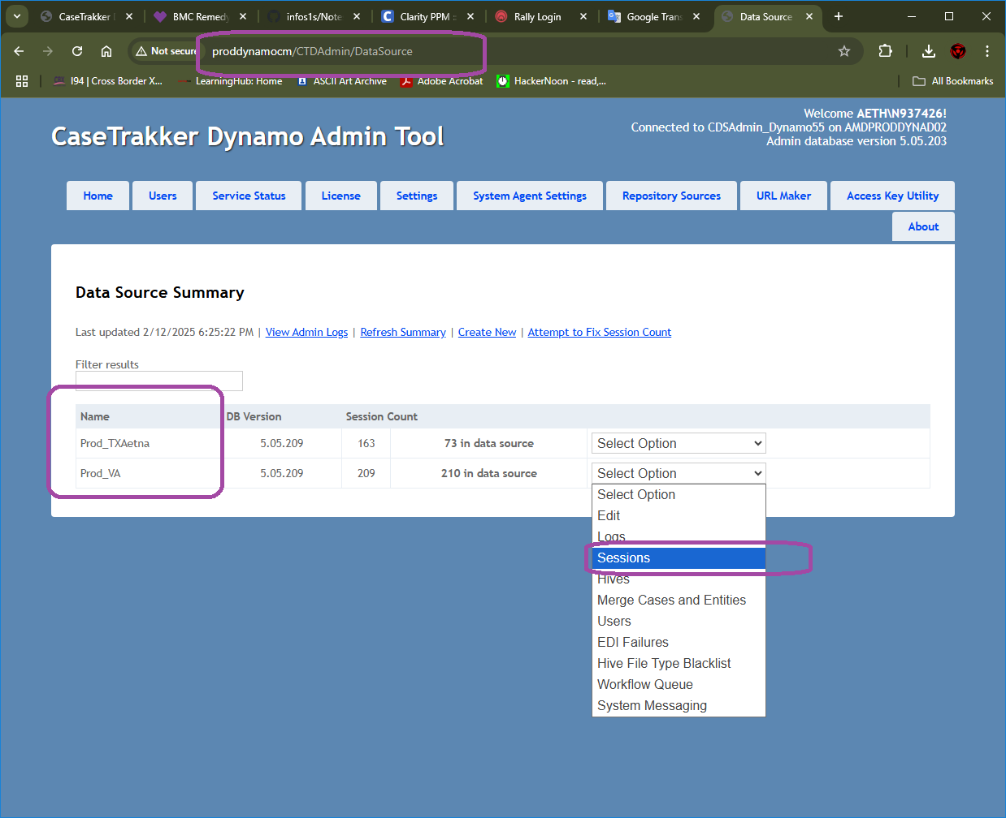

1. We can see the open sessions.

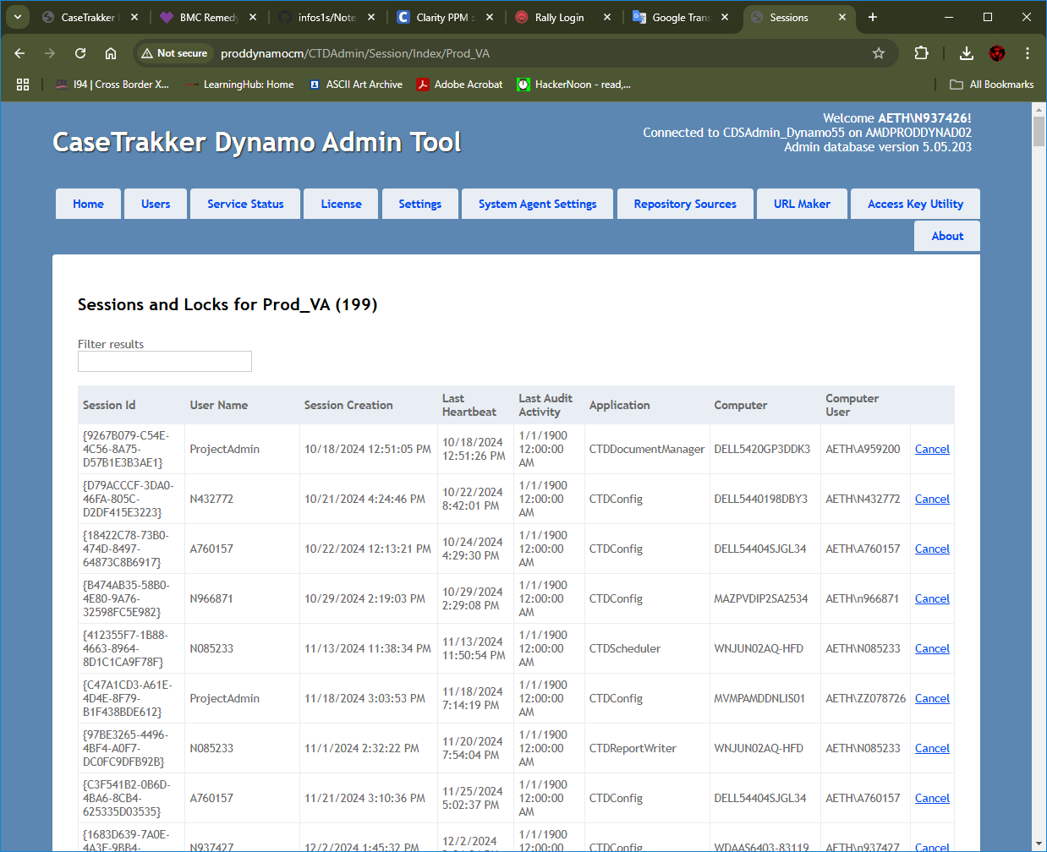

1. Now filter the user that is locked the application and select the application affected and “Cancel” the session.

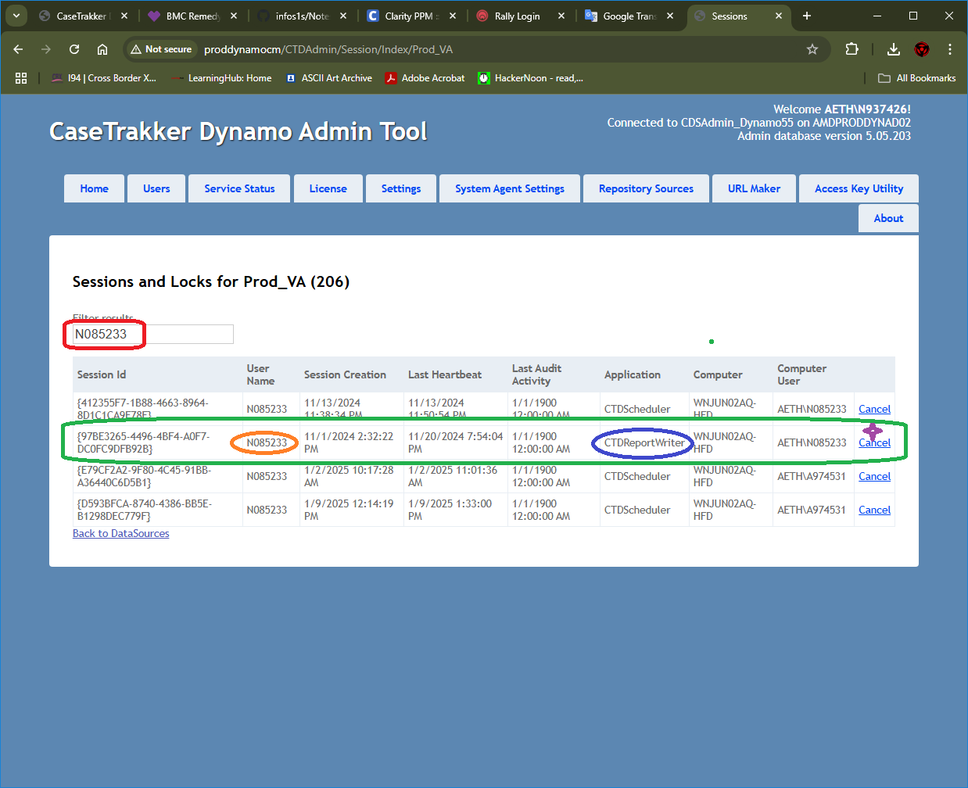

# The Process to Resolve Access for Dynamo

**Instructions to Resolve Access Issue for Dynamo**

Hi Yajaira,

I successfully logged into **Dynamo** using the provided credentials: **A844507** and **Password1**.

To help resolve your issue, please follow the steps below carefully:

**Preliminary Steps: Clean Temporary Files and Old Installations**

1. Press Windows + R, type %temp%, and press **Enter**.
2. A File Explorer window will open, displaying your temporary files folder.
3. Select all files and folders in this folder and delete them.
   * If any files cannot be deleted, check the **"Do this for all"** box and skip those files.
4. Navigate one level up in the directory to the **Local** folder:
   * Delete the **Apps** and **CaseTrakker Software** folders.
5. Navigate to your **Downloads** folder (you can find it on the left panel in File Explorer):
   * Search for and delete all instances of CTDynamo.application.
6. Close File Explorer.
7. Perform a **full system shutdown** (not just a restart).

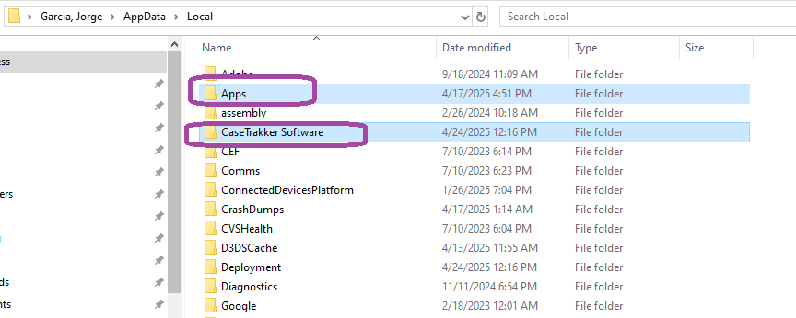

**Next Steps: Reconnect to Dynamo**

When you turn your computer back on, follow these instructions:

1. On the first login screen, click **"Continue with Windows"**.
   * A screenshot of a computer

     Description automatically generated
2. Select the **Data Source**:
   * Choose **"Prod_MCRP"**, then click **"Continue"**.
   * 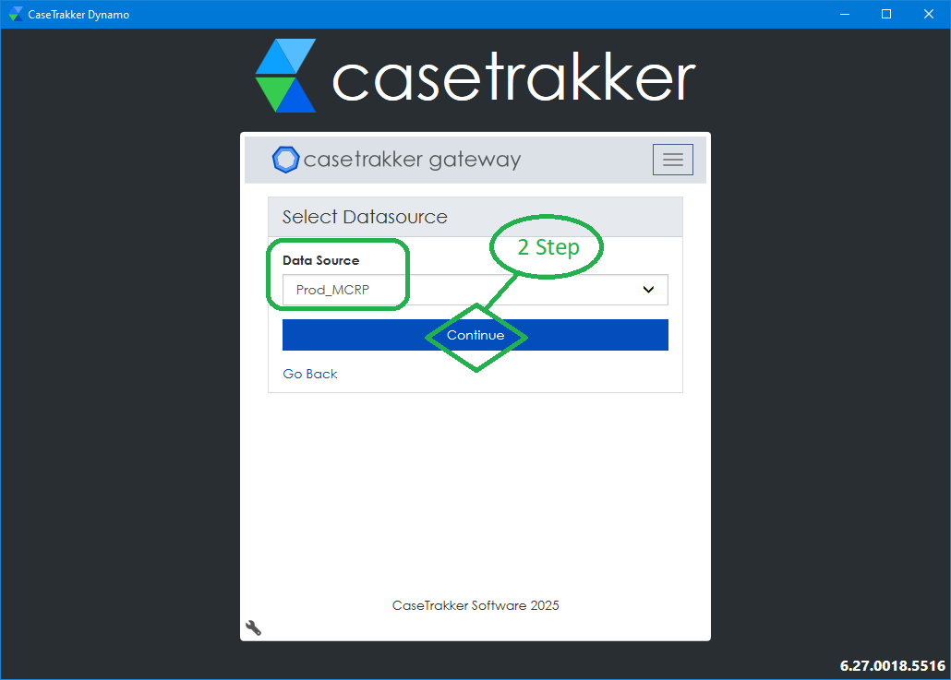
3. On the second login screen:
   * Enter your **username** and **password**, then click **"Login"**.

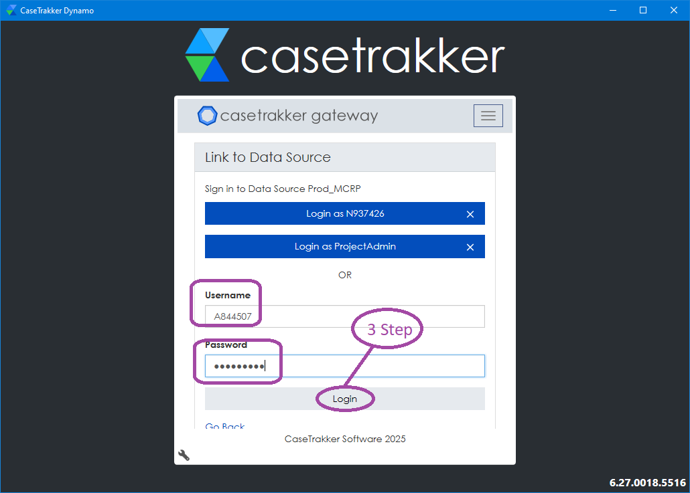

That’s it! You should now be able to access Dynamo without any issues.

If you encounter any problems or have additional questions, feel free to reach out, and I’ll be happy to assist further.

# The Process to Resolve Member duplicated in my member queue Access for Dynamo

**Resolution:**

The member has two Care Plan - Tree in his Journal. To resolved I must AVOID one of them.

# Find a Workflow in Dynamo

**Resolution:**

If you open up the object type-you can see all logic and workflows associated with that object

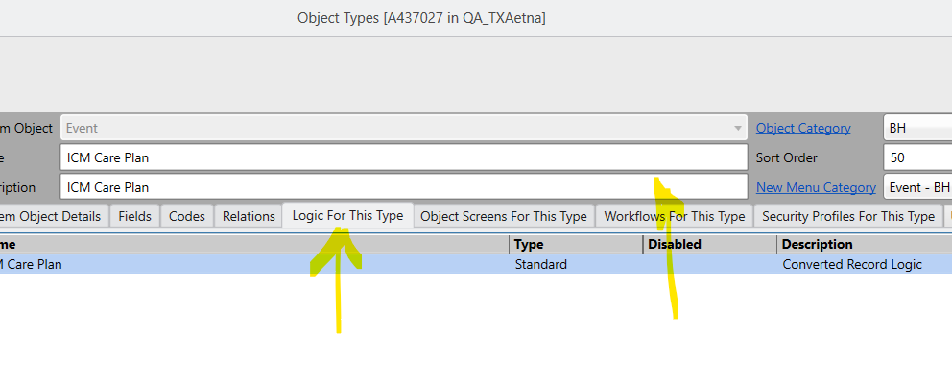

same thing- if you open up the code itself- and there is a tab "where is code used"

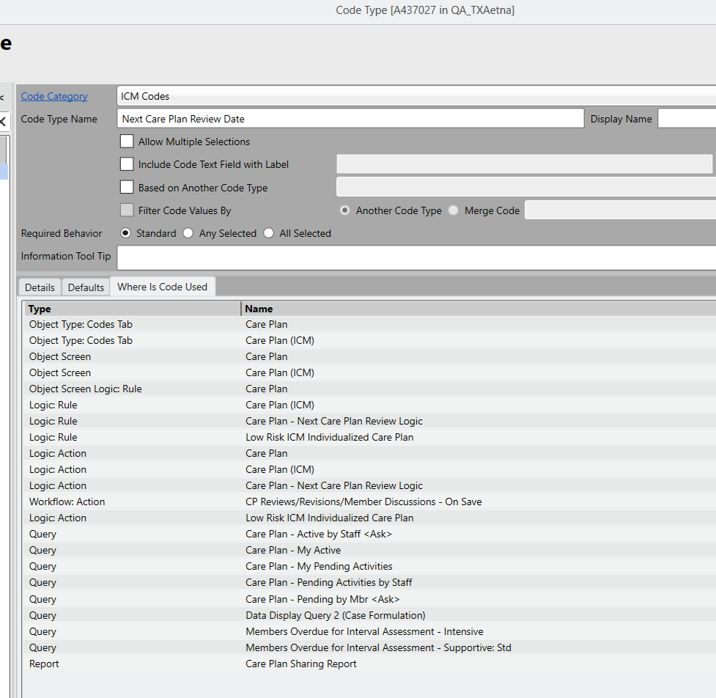

Another way

for example , I'm in ILMcaid . Go to that code type and click on where it used . this type of calculation happen through Workflow . click on workflow and you'll find trigger . in below example , there is a query configure in set data and when you open that query then you'll find that logic .

# Twist Documentation in Github

**Resolution:**

Github URL: https://github.aetna.com/CVSHealthMedicaidIT-Clinical/Aetna.MBU.Dynamo_Twist

KY Twist that’s an SSIS package, ssis package that runs an SP.(confirm?)

# RAP SCORE

**Resolution:**

## Comments with the development Team:

RAP score is set by the IP Alerts import process.

but only if the member has a RAP score.

The rap score is populated by IP Alert Import process- but only if one is present. it is not a required field.

The user doesn’t create IP alerts. They created by a scheduled workflow. They flow from QNXT/Medcompass.

A rap score will only be inserted if there is one... but if its blank for every single one, maybe there is an issue with how we are looking up the rap score.

Also the author of the record in the screenshot you sent is "ABH_TXA" - which is an indicator that it was created by an automated process and not a user

 If they are expecting rap scores they are not seeing- there is potentially an issue somewhere.

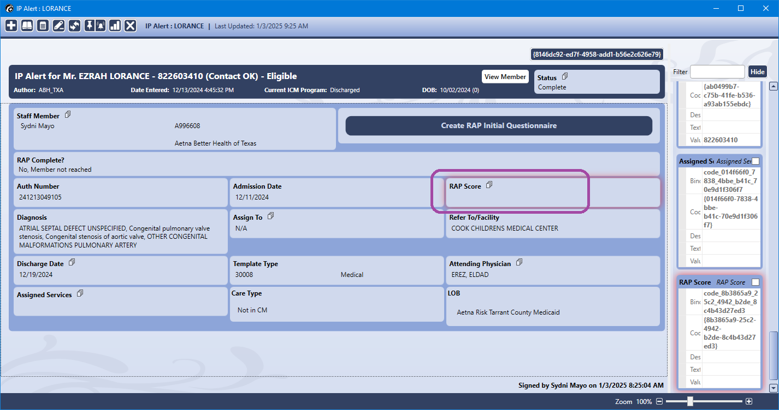

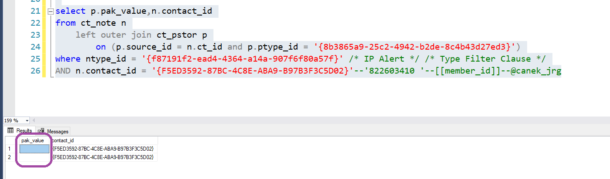

|  |
| --- |
| /* server: SRVDYNMIPROD  database name: Dynamo_QNXT_NY */  ------------------------------------------------------------------------  --------------------------------Analisys--------------------------------    select p.pak_value,n.contact_id  from ct_note n  left outer join ct_pstor p  on (p.source_id = n.ct_id and p.ptype_id = ‘{8b3865a9-25c24942-b2de-8c4b43d27ed3}’)  where ntype_id ='{f87191f2-ead4-4364-a14a-907f6f80a57f}'  AND n.contact_id = '{f5ed3592-87BC-4c8e-aba9-b97b3f3c5d02}' |

SSIS package

\\MVMPAMDSSISAP01\MBU8PRODbatch\MBUEDI.DYN.IM_PPM_TableRefresh_VA

PPM_TableRefresh_VA.dtsx is the job name (For VA plan)

INC # : INC000000360427

Plan : VA

Issue: RAP Score is not coming to Dynamo.

Root cause: RAP Score will be pulled from PPM_Interface table. but seems that the Sync between MBUPRODALT and Dynamo package is failing with below reason.

Package Details:

\\MVMPAMDSSISAP01\MBU8PRODbatch\MBUEDI.DYN.IM_PPM_TableRefresh_VA

PPM_TableRefresh_VA.dtsx

Job ID: U4RT5580

Log location: \\MVMPAMDSSISAP01\MBU8PRODresults\MBUEDI.DYN.IM_PPM_TableRefresh_VA

# Information from Little Clock or History

**Resolution:**

Desc

|  |
| --- |
| /* server: SRVDYNMCRPPROD  database name: Dynamo_ProdMCRP */  ------------------------------------------------------------------------  --------------------------------Analisys--------------------------------  --CODE  --Is there an area regarding your phisical or mental health or services and supports related to your health that you want to work towards improuving  --ca19d795-4eaa-4bef-8266-89514e1c6694  /*Query A*/  select * from ct_jstor  where ct_id = '5fc2a4e6-7929-4dbc-b398-5fd83b6687a4' --Case — Long Term Care  /*Query B*/  select * from ct_note  where ct_id = '5fc2a4e6-7929-4dbc-b398-5fd83b6687a4' --Case — Long Term Care  /*Query C*/  select * from ct_pstor  where source_id = '5fc2a4e6-7929-4dbc-b398-5fd83b6687a4' --Case — Long Term Care  /*Query D*/  select ct_id,* from ct_pstor  where source_id = '5fc2a4e6-7929-4dbc-b398-5fd83b6687a4' --Case — Long Term Care  and ptype_id = 'ca19d795-4eaa-4bef-8266-89514e1c6694'  /*Query E*/  select * from ct_phist --Information showing in the little clock or history  where pstor_id = '476b60c5-2d75-48f7-8c97-0fb3173dd7ff' --ct_id from Query D |

Explanation of Error Behavior in "701B Comprehensive Assessment"

**Summary:**While reviewing the **Config Tool** under the **Objects > Logic** section, we identified two logic objects related to the keyword **701B**. The issue appears to originate from logic defined in one of them, which is impacting the front-end behavior during the Save process.

Reference: INC000000366272

**Details of the Review:**

1. **Logic Entries Found:**
   * **701B Comprehensive Assessment – On Save**  
     → This logic does **not contain any rules** that would interrupt or block the Save operation with a message — especially not one without a description.
   * **701B Comprehensive Assessment** (general logic)  
     → This entry **does contain multiple logic statements** associated with various fields of the assessment. One of these statements appears to be directly responsible for the error experienced.
2. **Identified Logic Statement:**
   * **Statement Name:** *If E74 Kidney ≠ Empty, then show E74 Kidney Description*
   * **Clause Behavior:**
     + **IF Condition:**
       - Evaluates the score for **[74. Kidney problems or renal disease (Question)]**
       - The data type is a **string**, and the condition checks if its value is **between {10} and {20}**
     + **THEN Action:**
       - The logic **stops the current record operation** (i.e., prevents saving).
       - If **“Allow to Continue”** is checked, the user will see **Continue/Cancel** options.
       - If not, the user only sees an **OK** button.
       - **Message:** This field is currently empty, resulting in a **blank error popup** on the front end.
     + **ELSE Action:**
       - Clears the value of **[74. Kidney problems or renal disease – End Stage]** when hidden.

**Root Cause Summary:**

The error occurs because the **"THEN" clause is configured to stop the Save operation**, but **no message text is provided**. As a result, the front-end displays a **blank popup**, which confuses the user and makes the system appear unresponsive or broken.

**Resolution:**

The **THEN clause** within the logic statement was removed, as it was determined to be unnecessary. The condition was stopping the Save operation without a clear purpose and without displaying any user-facing message, resulting in confusion on the front end.

By removing this condition, the assessment can now be saved without interruption, and the logic flow remains intact without impacting related functionality.

ICM Welcome – Member Letter – SP in Document Manager Tool

**Summary:**The “ICM Welcome – Member Letter – SP” is not registered in the Document Manager Tool.

Reference: INC000000363322

Confirming in the database

|  |
| --- |
| -- INC000000363322  /* server: SRVDYNMIMPROD  database name: Dynamo_ProdMIM */  ------------------------------------------------------------------------  --------------------------------Analysis--------------------------------  select * from ct_dstor--Welcome SP letter (affected)  where ct_id = '9529993d-2655-476a-98dc-cf3ba419e3f3' --ct_id from the frontend  select * from ct_dstor where documentdef_id ='{d882a122-eb68-45a1-a72f-c855abadca40}' order by ct_update desc  select * from ct_dstor where status_value ='Documents printed' order by ct_update desc  select * from ct_jstor--ICM Welcome – Provider Letter (Documents Printed) example  where ct_id = '4f3e4f99-2b87-46f0-bc0f-036323788a30'  select top 1 ct_id --{b3573c4c-809e-4a16-87a0-cb4c843e6e47}  from ct_dstor(nolock)  select * --comparing between  from ct_dstor  where ct_id in ('9529993d-2655-476a-98dc-cf3ba419e3f3', '4f3e4f99-2b87-46f0-bc0f-036323788a30','{b3573c4c-809e-4a16-87a0-cb4c843e6e47}') |

With the ct_id from the frontend we get the Title of the document and the ‘documentdef_id’ to compare with others records.

We verify that the user to move the status of the document was different than the user of the Document Manager Tool in this case ‘ABH_MIM’

For different kinds of documents than the tool updated correctly we get the user correctly (ABH_MIM)

Here is a comparation of this users

# Change Menu

**Resolution:**

In reference to the request submitted in ticket WO0000000772619 regarding “Dynamo LA CMA needs surveillance access”, please follow the steps below to access the **Surveillance** menu:

1. Click the icon indicated in the attached image.
2. This will display a new set of menu options.
3. Ensure that you select "**ICM**" in the "**Select Different Set**" section at the bottom of the screen.

Once these steps are completed, the Surveillance menu should become visible in your profile.

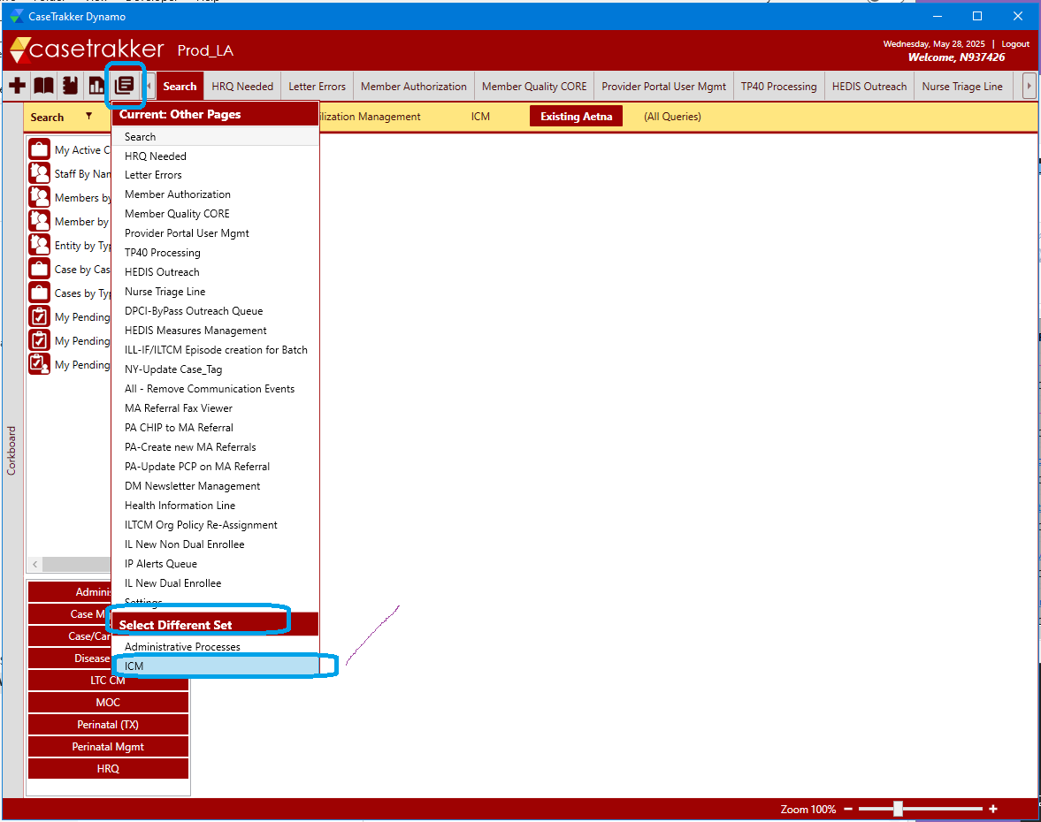

# Dynamo Error "Case Referral Source" when assigning or closing CM Episodes

**Resolution:**

Issue: Dynamo Error "Case Referral Source" when assigning or closing CM Episodes, we cannot assign or close certain cases due to this error.

Root cause: When creating a referral, selecting ‘Other (specify)’for the field 'Identified for CM Through', creates episode with no description for ‘Case Referral Source

This is happening because of the below logic. Need to add logic to set description value for case Referral Source.

Replicated this in QA and found the same issue. Below is example from QA.

# Another

**Resolution:**

desc