Calradia Forge

Developer tools architecture

STATUS  Developer preview 0.7.6 |  | OWNER  Project maintainer |  | LAST UPDATED  September 16, 2026

Authors | Calradia Forge project
Reviewers | Independent review pending
Related docs | README.md and docs/VALIDATION.md
Scope | Single-player diagnostics, inspection and guarded tests for Bannerlord 1.4.8.

1. Abstract
Calradia Forge 0.7.6 combines a Gauntlet panel, a Windows WPF client and a public C# SDK for module inspection, guarded tests and ForgeWeave cooperative extensions. The preview compiles against Bannerlord 1.4.8. Replay Lab verifies retained host events in the active game context; declarative event filters target copied scalar data without method interception.
Core services need no Harmony, MCM or ButterLib. ForgeWeave dispatches copied scalar data from official lifecycle callbacks with deterministic ordering, declarative filters, execution budgets, context gates, failure quarantine and bounded health evidence. Replay Lab retains a bounded original-event record and replays one named sequence only after handler opt-in. Writers keep the normal test-mode and copied-campaign gates. Game access and shared-library scopes use the game thread. Reports stay outside saves. The optional desktop EXE ships separately. English is primary; the panel follows the game language with English fallback.

2. Goals and Non-Goals
Goals | Non-goals
Diagnose module folders without starting the game. | Multiplayer and scene editing.
Capture bounded logs, snapshots and test results. | Capturing every external game failure.
Support versioned C# extensions and local IPC. | DLL hot reload and AI generation.
Require test mode and a copied campaign for mutations. | Deterministic replay of third-party systems.

3. Background and Problem Statement
Mod authors need concrete evidence when dependencies are missing, object state changes or a test fails. A folder scan can establish structural defects, but cannot establish every runtime incompatibility. The suite therefore labels uncertain findings and keeps static, automated and native validation separate.
The SDK owns extension contracts, ForgeWeave handlers, replay records, declarative filters, execution budgets and module-owned shared libraries. Providers publish versioned interfaces; consumers require an explicit owner and compatible version. ForgeWeave handlers receive copied scalar event data, not game objects. Replay callers name one retained sequence and cannot inject callback data. Handles expire on withdrawal, scope disposal or disconnect. Core owns test policy; the game adapter owns engine access.

4. Proposed Architecture

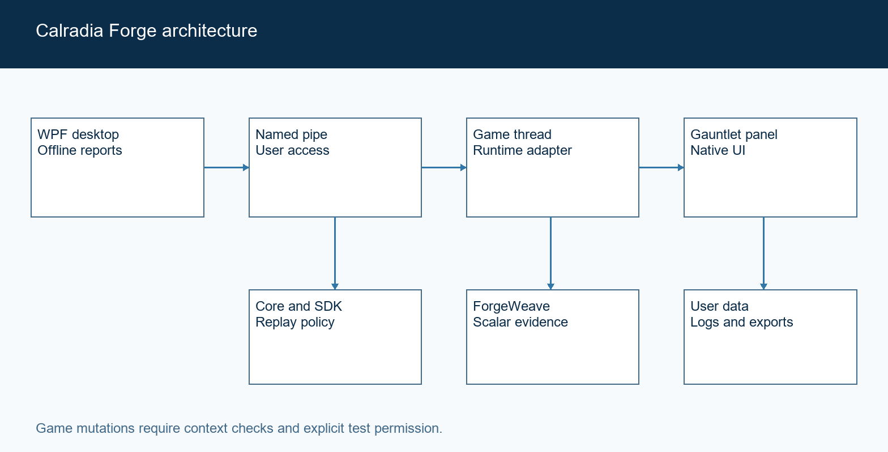
Figure 1. Calradia Forge components and execution boundaries.

Core components

Component | Responsibility | Primary storage | Failure behavior
SDK | Extensions and versioned shared libraries. | Module scopes. | Reject stale handles and duplicate IDs.
Core | Validation, test policy and reports. | Bounded memory. | Return findings or structured errors.
Game adapter | Gauntlet view and main-thread engine access. | Live game state. | Log exceptions and close a failed panel.
Desktop | Offline scans, report browsing and pipe client. | Current report. | Keep evidence on disconnect.
Session storage | Persist logs, settings and exports. | Local user data. | Expose write errors; retain memory.

5. Request Lifecycle
- The desktop sends a JSON request over the current user’s named pipe.
- Protocol version and request ID are checked; the server limits request size and queue length.
- Registered extension descriptors determine context and mutation permissions.
- One queued request and a bounded batch of ForgeWeave host events are dispatched per application tick on the game thread.
- Mutation permission is session-only. Scenario preparation records initial state for cleanup; ForgeWeave writers use the same context and copy gates.
- A replay request names one retained original event. It requires an exact current-context match, handler opt-in and never creates another replay source.
- The server requests cancellation after 15 seconds. Clients do not retry mutations automatically. A response returns results or an error; bounded logs, framework health and reports preserve selected evidence.

6. API and Data Contracts

Primary data contract

Field | Type | Required | Description
Version | Integer | Yes | Protocol 1 in each envelope.
Id | String | Yes | Correlates a request and response.
Action | String | Request | Names an available operation.
Argument | String | Optional | Action-specific query or test ID.
Seed | Integer | Tests | Controls suite random values.
Success | Boolean | Response | Whether the handler completed successfully.
Data or Error | String | Response | Payload or actionable failure message.

Contract guarantees

- Batch preflight checks all selected IDs and contexts before any scenario starts.
- Request IDs correlate replies; they are not durable deduplication keys.
- Results capture the selected seed, context, steps, duration and cleanup errors.
- Diagnostics describe inspected folders, not the launcher’s selected load order.
The versioned contracts are maintained in the source tree:
src/CalradiaForge.Sdk and src/CalradiaForge.Core/Models.cs.

7. Consistency, Idempotency, and Replay

A pipe connection serializes requests. Game operations run on the main thread, while scans and persistence run asynchronously. ForgeWeave uses official host events, deterministic same-priority ordering, scalar filters, diagnostic execution budgets, failure isolation and quarantine; it never changes patches. Replay Lab reuses only a retained original sequence and copied scalar payload under the same context and writer gates. The historical Patch Atlas reads bounded public metadata only. Repeating a state-changing request may execute it again: clients must inspect the prior result and current state before deciding whether to retry. Extension cleanup is attempted even when preparation or execution fails.
Scenario | Expected behavior | Reasoning
Repeated test request | Runs again if explicitly requested. | Request IDs only correlate replies.
Log persistence fails | Keep bounded in-memory records. | Expose the persistence error.
Request times out | Request cooperative cancellation. | Do not promise rollback or automatic retry.
Descriptor changes after registration | Use the captured descriptor. | Prevent permission changes by mutation.

8. Security and Privacy Considerations

- The named pipe grants access to the current Windows user. It is not a boundary against that user’s other processes.
- Inspect a scalar-property allowlist. ForgeWeave retains at most 64 copied replay records and outcomes; extensions cannot insert a record.
- No cloud account, API key or remote endpoint is required by the suite.
- Testing starts disabled. Campaign mutations additionally require copy confirmation; replay grants no additional mutation permission.
- Keep 2,000 log entries and 20 session files. Exported reports are retained by the user.

9. Operational Readiness
Signal | SLO or alert | Owner | Launch gate
Automated checks | All targeted regressions pass. | Maintainer | Required
Operation timing | 600 callback samples; active benchmarks pending. | Maintainer | Required
Disconnect recovery | Reconnect without replaying mutations. | Maintainer | Required
Package integrity | Built and packaged DLL hashes match. | Maintainer | Required
Save and removal | Tested copy loads without Forge. | Maintainer | Observed
Developer preview: short replay and interaction checks remain distinct from broader compatibility and overhead review. No store upload.

10. Alternatives Considered

Alternative | Why it was considered | Why it was not selected
Mandatory method-patch hooks | Broader interception. | Adds coupling and cannot prove causality.
Remote HTTP service | Browser and remote access. | Unnecessary exposure for a local tool.
Persist suite data in saves | Resume suite state with a campaign. | Adds avoidable save dependencies.
Automatic state-changing retries | Recover from disconnects. | Can repeat mutations after an uncertain result.

11. Open Questions
- Does complete keyboard traversal and mixed mouse input work across campaign and mission contexts?
- Are all language catalogs visually and linguistically reviewed beyond the sampled languages?
- What overhead appears during active campaign, combat and prolonged capture?
- Which license and store ownership details will the maintainer select before publication?

12. Decision and Next Steps
Continue controlled integration checks before public release. Native campaign and battle examples passed; the tested saved copy loaded without Forge. These observations support this developer preview, not universal save compatibility. Keep remaining interaction and performance limits explicit in store descriptions.
Milestone | Deliverable | Exit criteria
M1 | Build and automated regressions | Release builds cleanly; targeted tests pass.
M2 | Native panel and protocol | Observed render and correlated responses.
M3 | Campaign and custom battle | Restore state; save, reload and remove safely.
M4 | Store release preparation | Native gates pass; packages and listing verified.

Native validation refers to execution inside Bannerlord, separately from compiled or simulated tests.

