EE3921 Digital System Design

Section 031, Fall 2020

Professor: Kerry R. Widder, Ph.D.

Electrical Engineering and Computer Science Department

Milwaukee School of Engineering

Laboratory 3: “ROM counter logic design"

Jorge J. Jurado-Garcia

Date: 09/17/2020

Level Attempted: BASIC

Objective: The objective of this lab was to create a ROM component using Mega Wizard (IP Catalog). This will be a one-port ROM with a data bus width of 8-bits and a depth of 256. Using the DE10-Lite create a counter that foes up to 0xFF once per second and display the memory value on a 7-segment display.

Description: In this lab I created my ROM using the Mega Wizard (IP catalog). With data bus width of 8-bits and a depth of 256. Using the romtest1.mif supplied by Dr.Widder for the contents of the ROM. I then also created a counter that would increment count at every clock edge if i_DIR is low and would use one of the pushbutton switches (KEY) to allow pausing of the count sequence. All of the information will be displayed on a 7-segment display. With Hex3 and Hex2 displaying the current count value and Hex1 and Hex0 displaying the ROM Data.

Conclusion: Overall, this lab was a success, the toughest part I had with this lab would be creating the ROM component using the Mega Wizard I had trouble creating the proper one to make sure it would work properly. The easiest part was creating the counter since I just reused on of my previous code and changed some my sequential logic in order to fit the criteria for this one. Overall, this lab was a success.

RTL Viewer

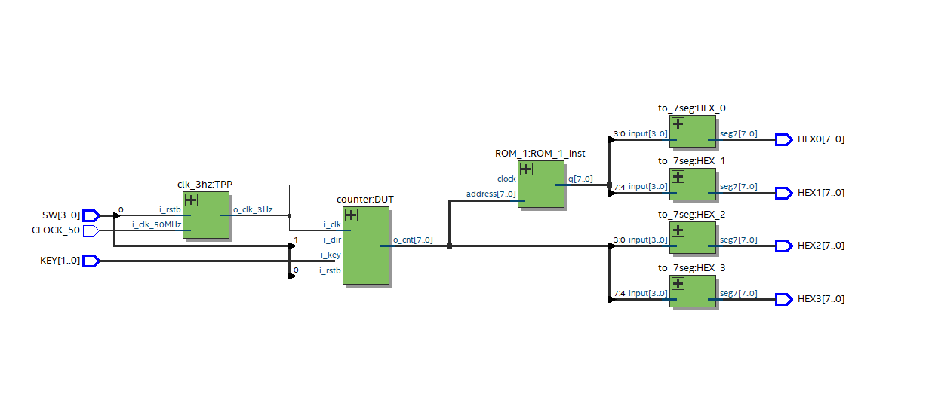

Counter_RTL_Viewer

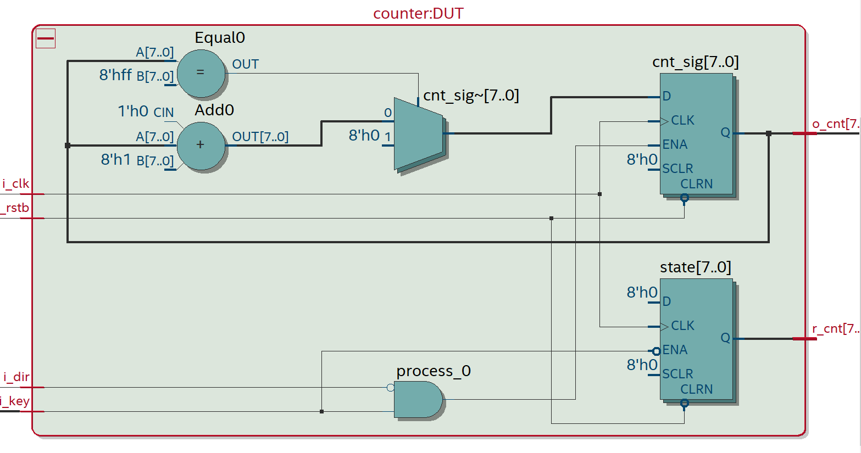

VHDL CODE

Counter.vhd

----------------------------------------------

--counter.vhdl

--

--created 9/21/21

--Jorge Jurado-Garcia

--rev 0

----------------------------------------------

--

--Inputs: rstb, clk, dir

--outputs: cnt

--

----------------------------------------------

--

--counts up when dir = 0

--counts down when dir = 1

--

----------------------------------------------

**library** ieee**;**

**use** ieee**.**std_logic_1164**.all;**

**use** ieee**.**numeric_std**.all;**

**use** ieee**.**std_logic_unsigned**.all;**

-----------------------------------------------------------------------------

---ENtity

-------------------------------------------------------------------------------

--created a 8 bit generic counter with clk, rstb, and direction as inputs with a 4 bit output

**entity** counter **is**

**generic(**

n**:** natural **:=** 8 --this parameters controls the parameter of are counter

**);**

**port** **(**

i_clk**:** **in** std_logic**;**

i_rstb**:** **in** std_logic**;**

i_dir**:** **in** std_logic**;**

i_key**:** **in** std_logic**;**

o_cnt**:** **out** std_logic_vector**(**n**-**1 **downto** 0**);**

r_cnt**:** **out** std_logic_vector**(**n**-**1 **downto** 0**)**

**);**

**end** **entity;**

-------------------------------------------------------------------------

--architecture

-------------------------------------------------------------------------

**architecture** behavioral **of** counter **is**

--

--internal signals, signals are unsigned in order to start from 0 to 2^(n-1)

--

**signal** cnt_sig**:** unsigned**(**n**-**1 **downto** 0**);**

**signal** rcnt_sig**:** unsigned**(**n**-**1 **downto** 0**);**

**signal** state**:** unsigned**(**n**-**1 **downto** 0**);**

**begin**

**process(**i_clk**,** i_rstb**,** i_key**)** --sequential processing

**begin**

--

--reset

--

--when rstb is 0 signal is 0

**if(**i_rstb **=** '0'**)** **then**

cnt_sig **<=** **(others** **=>** '0'**);** --make sure all signals are zero when rstb is zzero

rcnt_sig **<=** **(others** **=>** '0'**);**

state **<=** **(others** **=>** '0'**);**

--rising clk edge

**elsif(rising_edge(**i_clk**))** **then**

**if(**i_key **=** '0' **)** **then** --button logic

cnt_sig **<=** cnt_sig**;**

state **<=** rcnt_sig**;** --when state rcnt_sig

**end** **if;** --end of if statement for i-rstb

**if(** **(**i_dir **=** '0'**)** **and** **(**i_key **=** '1'**)** **)then**

cnt_sig **<=** cnt_sig **+** 1**;** --adding one

**if(**cnt_sig **=** "11111111"**)** **then** --0x 11001

cnt_sig **<=** "00000000"**;**

**end** **if;**--end if of wrapping up

**end** **if;** --end of if statement for i-rstb

**end** **if;**

**end** **process;**

--

--Output logic

--

o_cnt **<=** std_logic_vector**(**cnt_sig**);**

r_cnt **<=** std_logic_vector**(**state**);**

**end** behavioral**;** --end of counter architerial

TIMER_N_SEC.

**library** ieee**;**

**use** ieee**.**std_logic_1164**.all;**

**use** ieee**.**numeric_std**.all;**

**entity** clk_3hz **is**

**port(**

i_clk_50MHz**:** **in** std_logic**;**

i_rstb**:** **in** std_logic**;**

o_clk_3Hz**:** **out** std_logic

**);**

**end** **entity;**

**architecture** behavioral **of** clk_3hz **is**

--

--constants and parameters

--

**constant** CLOCKS_PER_HALF_PERIOD**:** signed**(**24 **downto** 0**)** **:=** **to_signed((((**50_000_000**/**2**)/**1**)-**2**),**25**);**

--internal signals

**signal** cnt**:** signed**(**24 **downto** 0**);**

**signal** clk_sig**:** std_logic**;**

**begin**

**process(**i_clk_50MHz**,** i_rstb**)**

**begin**

**if(**i_rstb **=** '0'**)** **then**

cnt **<=** CLOCKS_PER_HALF_PERIOD**;**

clk_sig **<=** '0'**;**

**elsif** **(rising_edge(**i_clk_50MHz**))** **then**

cnt **<=** cnt **-** 1**;**

**if(**cnt**<** 0**)** **then**

cnt **<=** CLOCKS_PER_HALF_PERIOD**;**

clk_sig **<=** **not** clk_sig**;**

**end** **if;**

**end** **if;**

**end** **process;**

o_clk_3Hz **<=** clk_sig**;**

**end** behavioral**;**

TO_7Seg

----------------------------------------------

--

-- to_7seg.vhdl

--

--created 9/11/21

--jorge jurado-garcia

--

--rev 0

------------------------------

-- takes a for bit bit value and then translates into a seven segment display

--------------------------------------------

--Inputs: input

--Outputs: seg7

------------------------------------------------

**library** ieee**;**

**use** ieee**.**std_logic_1164**.all;**

**use** ieee**.**numeric_std**.all;**

**entity** to_7seg **is**

**Port** **(** input **:** **in** STD_LOGIC_VECTOR **(**3 **downto** 0**);**

seg7 **:** **out** STD_LOGIC_VECTOR **(**7 **downto** 0**)**

**);**

**end** to_7seg**;**

**architecture** Behavioral **of** to_7seg **is**

**begin**

--'input' corresponds to MSB of seg7 and 'g' corresponds to LSB of seg7.

-- when a bit is low the led on the seg7 will be on else '0'

**process** **(**input**)**

**BEGIN**

**case** input **is**

**when** "0000"**=>** seg7 **<=**"01000000"**;** -- '0'

**when** "0001"**=>** seg7 **<=**"01111001"**;** -- '1'

**when** "0010"**=>** seg7 **<=**"00100100"**;** -- '2'

**when** "0011"**=>** seg7 **<=**"00110000"**;** -- '3'

**when** "0100"**=>** seg7 **<=**"00011001"**;** -- '4'

**when** "0101"**=>** seg7 **<=**"00010010"**;** -- '5'

**when** "0110"**=>** seg7 **<=**"00000010"**;** -- '6'

**when** "0111"**=>** seg7 **<=**"01111000"**;** -- '7'

**when** "1000"**=>** seg7 **<=**"00000000"**;** -- '8'

**when** "1001"**=>** seg7 **<=**"00011000"**;** -- '9'

**when** "1010"**=>** seg7 **<=**"00001000"**;** -- 'A'

**when** "1011"**=>** seg7 **<=**"00000000"**;** -- 'b'

**when** "1100"**=>** seg7 **<=**"01000110"**;** -- 'C'

**when** "1101"**=>** seg7 **<=**"00000000"**;** -- 'D'

**when** "1110"**=>** seg7 **<=**"00000110"**;** -- 'E'

**when** "1111"**=>** seg7 **<=**"00001110"**;** -- 'F'

**when** **others** **=>** **NULL;**

**end** **case;**

**end** **process;**

**end** Behavioral**;**

VGA_COUNTER_DE102

--------------------------------------------------------------------------------------

--------------------------------------------------------------------------------------

--LAB 3 ROM COUNTER

--DATE: 9/21/2021

--AUTHOR: JORGE JURADO-GARCIA

--REV 1

--

----------------------------------------------------------------------------------------

----------------------------------------------------------------------------------------

**library** ieee**;**

**use** ieee**.**std_logic_1164**.all;**

**use** ieee**.**numeric_std**.all;**

**entity** VGA_COUNTER_DE102 **is**

**port(**

CLOCK_50**:** **in** std_logic**;**

SW **:** **in** std_logic_vector**(**3 **downto** 0**);**

HEX0**,**HEX1**,**HEX2**,**HEX3**:** **out** std_logic_vector**(**7 **downto** 0**);**

KEY**:** **in** std_logic_vector**(**1 **downto** 0**)**

**);**

**end** **entity** VGA_COUNTER_DE102**;**

**Architecture** behavioral **of** VGA_COUNTER_DE102 **is**

---signals that will be used

**signal** CLK_1HZ**:** std_logic**;**

**signal** null_value**:** std_logic_vector**(**7 **downto** 0**);**

**signal** ADDRESS_SIG**:** std_logic_vector**(**7 **downto** 0**);**

**signal** q_sig**:** std_logic_vector**(**7 **downto** 0**);**

---------------------------------

--component declarations

---------------------------------

**component** counter **is**

**generic(**

n**:** natural **:=** 8 --this parameters controls the parameter of are counter

**);**

**port** **(**

i_clk**:** **in** std_logic**;**

i_rstb**:** **in** std_logic**;**

i_dir**:** **in** std_logic**;**

i_key**:** **in** std_logic**;**

o_cnt**:** **out** std_logic_vector**(**n**-**1 **downto** 0**);**

r_cnt**:** **out** std_logic_vector**(**n**-**1 **downto** 0**)**

**);**

**end** **component;**

**component** ROM_1

**PORT**

**(**

address **:** **IN** STD_LOGIC_VECTOR **(**7 **DOWNTO** 0**);**

clock **:** **IN** STD_LOGIC **:=** '1'**;**

q **:** **OUT** STD_LOGIC_VECTOR **(**7 **DOWNTO** 0**)**

**);**

**end** **component;**

**component** clk_3hz **is**

**port(**

i_clk_50MHz**:** **in** std_logic**;**

i_rstb**:** **in** std_logic**;**

o_clk_3Hz**:** **out** std_logic

**);**

**end** **component;**

**component** to_7seg **is**

**Port** **(** input **:** **in** STD_LOGIC_VECTOR **(**3 **downto** 0**);**

seg7 **:** **out** STD_LOGIC_VECTOR **(**7 **downto** 0**)**

**);**

**end** **component;**

--------------------------------------------

**begin**

-----------------------------------

--Device under test (DUT)

-----------------------------------

TPP**:** clk_3hz

**port** **map(**

i_clk_50MHz **=>** CLOCK_50**,**

i_rstb **=>** SW**(**0**),**

o_clk_3Hz **=>** CLK_1HZ

**);**

DUT**:** counter

**port** **map(**

i_clk **=>** CLK_1HZ**,**

i_rstb **=>** SW**(**0**),**

i_dir **=>** SW**(**1**),**

i_key **=>** KEY**(**1**),**

o_cnt**(**7 **downto** 0**)** **=>** ADDRESS_SIG**,**

r_cnt **=>** null_value

**);**

ROM_1_inst **:** ROM_1

**PORT** **MAP** **(**

address**(**7 **downto** 0**)** **=>** ADDRESS_SIG**(**7 **downto** 0**),**

clock **=>** CLK_1HZ**,**

q **=>** q_sig

**);**

HEX_0**:** to_7seg

**PORT** **MAP(**

input **=>** q_sig**(**3 **downto** 0**),**

seg7 **=>** HEX0

**);**

HEX_1**:** to_7seg

**PORT** **MAP(**

input **=>** q_sig**(**7 **downto** 4**),**

seg7 **=>** HEX1

**);**

HEX_2**:** to_7seg

**PORT** **MAP(**

input **=>** ADDRESS_SIG**(**3 **downto** 0**),**

seg7 **=>** HEX2

**);**

HEX_3**:** to_7seg

**PORT** **MAP(**

input **=>** ADDRESS_SIG**(**7 **downto** 4**),**

seg7 **=>** HEX3

**);**

**end** **architecture;**

Counter_n_bits_tb

----------------------------------------------------------

--

--Counter_n_bit_tb.vhdl

--

--created: 9/10/21

--by Jorge Jurado-Garcia

--rev: 0;

--

--testbench for up down counter

-- of counter_n bit

--

---------------------------------------------------------

**library** ieee**;**

**use** ieee**.**std_logic_1164**.all;**

**entity** Counter_n_bit_tb **is**

**generic(**

N**:** natural **:=** 8

**);**

**end** **entity;**

**architecture** testbench **of** Counter_n_bit_tb **is**

**signal** CLK**:** std_logic**;**

**signal** RSTB**:** std_logic**;**

**signal** DIR**:** std_logic**;**

**signal** KEY**:** std_logic**;**

**signal** CNT**:** std_logic_vector**((**N **-** 1**)** **downto** 0**);**

**signal** RCNT**:** std_logic_vector**((**N**-**1**)** **downto** 0**);**

**constant** PER**:** time **:=** 15 ns**;**

------------------------------------

--Component Protype

------------------------------------

**component** counter **is**

**generic(**

n**:** natural **:=** 8

**);**

**port** **(**

i_clk**:** **in** std_logic**;**

i_rstb**:** **in** std_logic**;**

i_dir**:** **in** std_logic**;**

i_key**:** **in** std_logic**;**

o_cnt**:** **out** std_logic_vector**(**n**-**1 **downto** 0**);**

r_cnt**:** **out** std_logic_vector**(**n**-**1 **downto** 0**)**

**);**

**end** **component;**

----------------------------------------------

**begin**

------------------------------------

--DUT

------------------------------------

DUT**:** counter

**generic** **map(**

n **=>** N

**)**

**port** **map(**

i_clk **=>** CLK**,**

i_rstb **=>** RSTB**,**

i_dir **=>** DIR**,**

i_key **=>** KEY**,**

o_cnt **=>**CNT**,**

r_cnt **=>** RCNT

**);**

----------------------------------------

--Test Processes

----------------------------------------

--clock process

clock**:** **process**

**begin**

CLK **<=** '0'**;**

**wait** **for** PER**/**2**;**

infinite**:** **loop**

CLK **<=** **not** CLK**;** **wait** **for** PER**/**2**;**

**end** **loop;**

**end** **process;**

--Reset Process

reset**:** **process**

**begin**

RSTB **<=** '0'**;** **wait** **for** PER**;**

RSTB **<=** '1'**;** **wait;**

**end** **process** reset**;**

--run process

run**:** **process**

**begin**

-- intitalize inputs

DIR **<=** '0'**;**

--wait for reset

**wait** **for** 2**\***PER**;**

--run code

**wait** **for** **(**2**\*\***N**)\***PER**;**

DIR **<=** '1'**;**

**wait** **for** **(**2**\*\***N**)\***PER**;**

**end** **process** run**;**

--run process

runn**:** **process**

**begin**

-- intitalize inputs

KEY **<=** '0'**;**

--wait for reset

**wait** **for** 3**\***PER**;**

infinite**:** **loop**

KEY **<=** **not** KEY**;** **wait** **for** 3**\***PER**;**

**end** **loop;**

**end** **process** runn**;**

-----------------------------

--End test processes

--------------------------------

**end** **architecture;**