Basic C++ programming

By

Jorge Jurado-Garcia

EE2510 Sec. 021, Spring 2021

Week 1 lab

Milwaukee School of Engineering

Submitted to:

Professor: Joshua D. Carl, Ph.D

EECS Department

Date Report Submitted: 03/16/21

**Objective**

The objective of this lab is to create a calculator use an IDE Code blocks using the given header file called, “calculator.h” and restrictions by our instructor.

**Description**

Write a main function that shows different functions on the console, user picks an option and get the inputs needed for that operation. Afterwards, perform the operation and print the results. Must implement calculator.h file without changing its prototype and can create any additional functions if needed. It should not output unnecessary information to the windows command line.

Operators needed to be done: my_basic_math(+,-,*,/,exponents), my_average(average of an array), my_find_large_small(min and max), my_series_parallel(resistance total for a circuit)

**Conclusions**

The lab was successful and was able to implement all the required operators detailed in LAB1_S21 pdf. What I learned during this lab is more than importantly the differences in C vs C++ and the uses of dynamic memory. The biggest difference with C and C++ other than its syntax it is the additional logic that can be down such as the use of dynamic memory. The reason why I used dynamic memory other than just value of array of size length is because I had no idea the actual length that the user would need or want. So dynamic memory became user in this case. Lastly, another fundamental insight I had during this lab was the use of pointers in functions and the basics of pointers and address. Having a function with the parameters of int* or type* is called function by pointer/reference. In which instead of taking the whole value of the type it takes the pointer to the type instead. This saves memory in during run time and allows the for a faster calculation then function by value.

Main code:

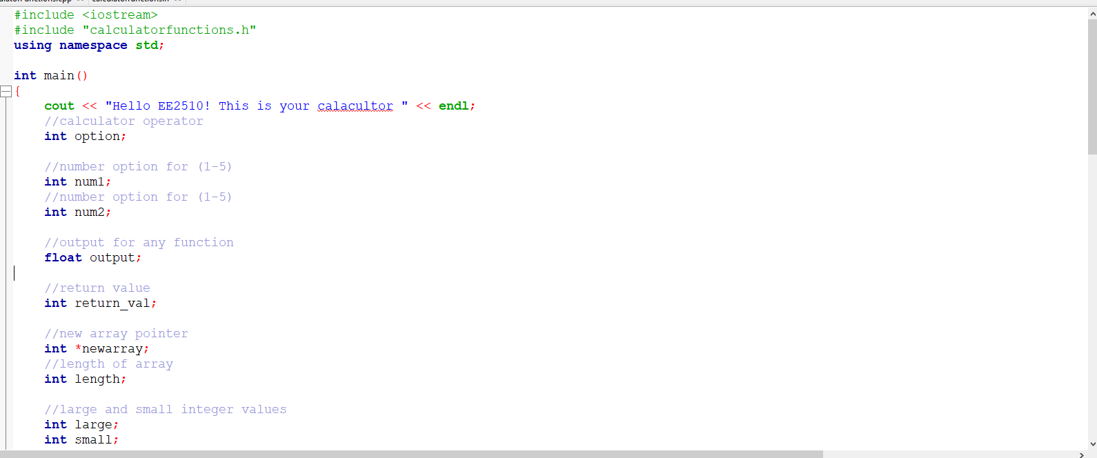

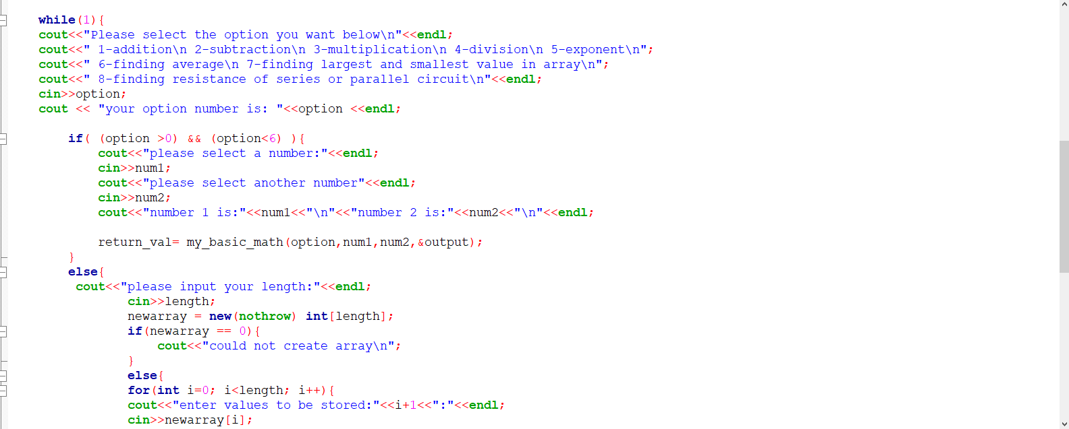

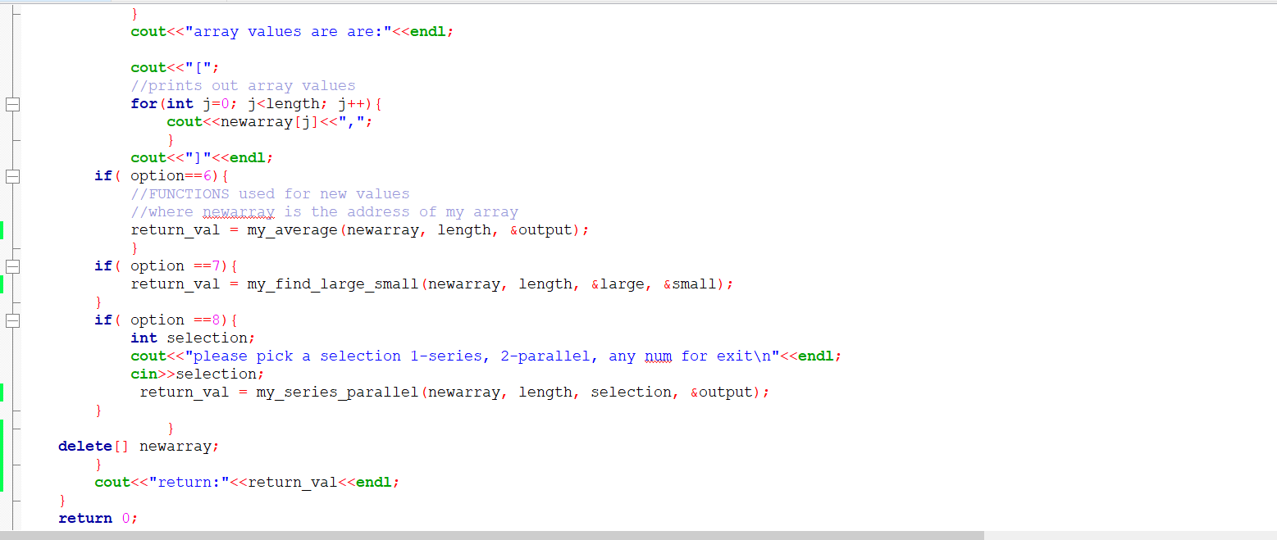

Function cpp. File

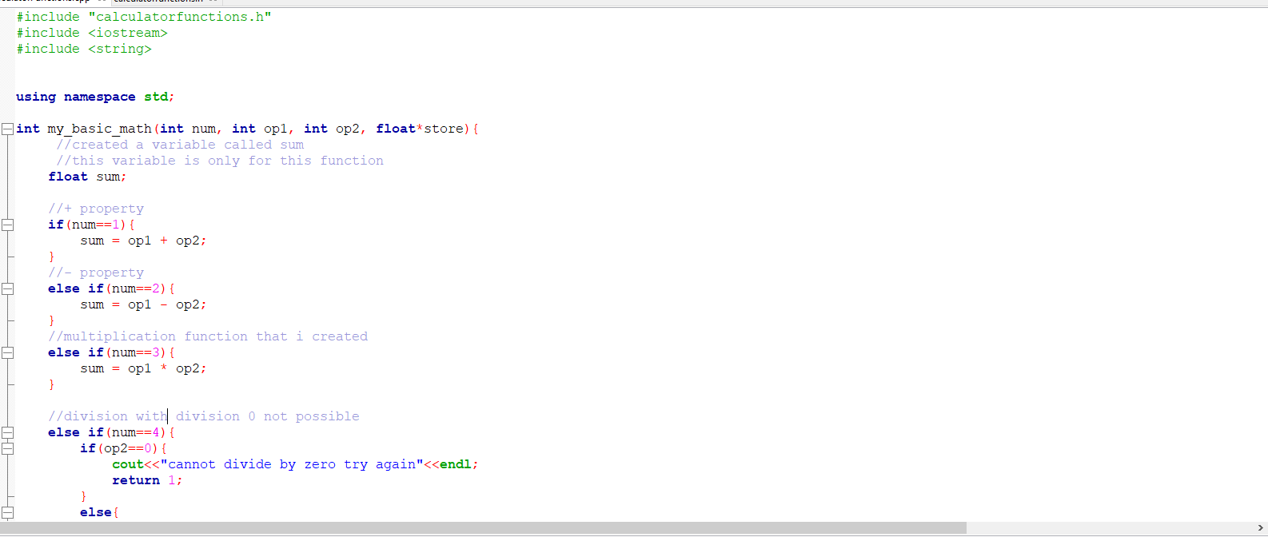

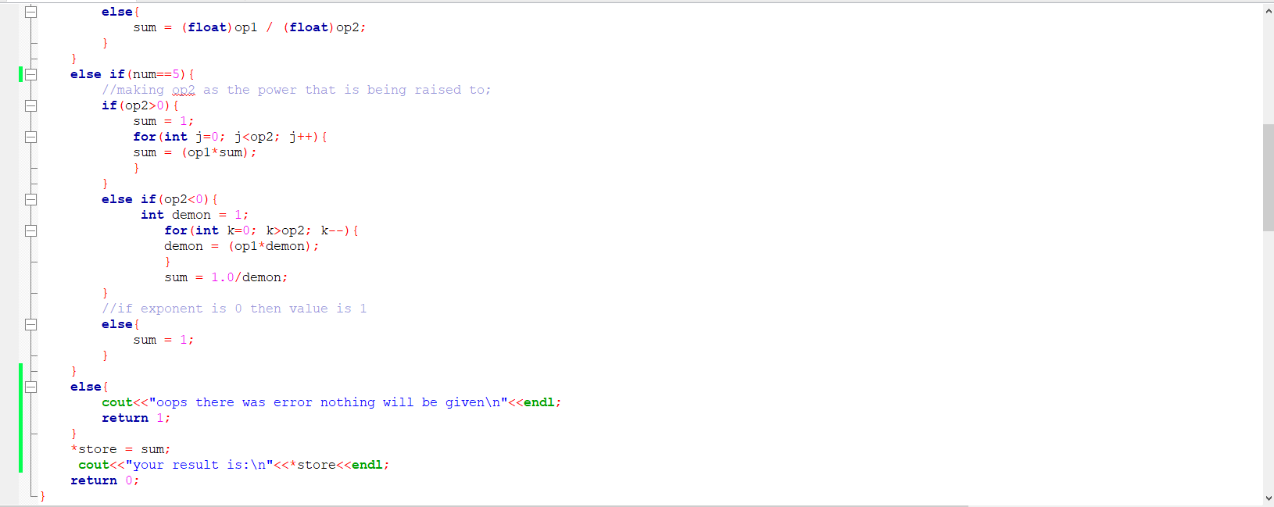

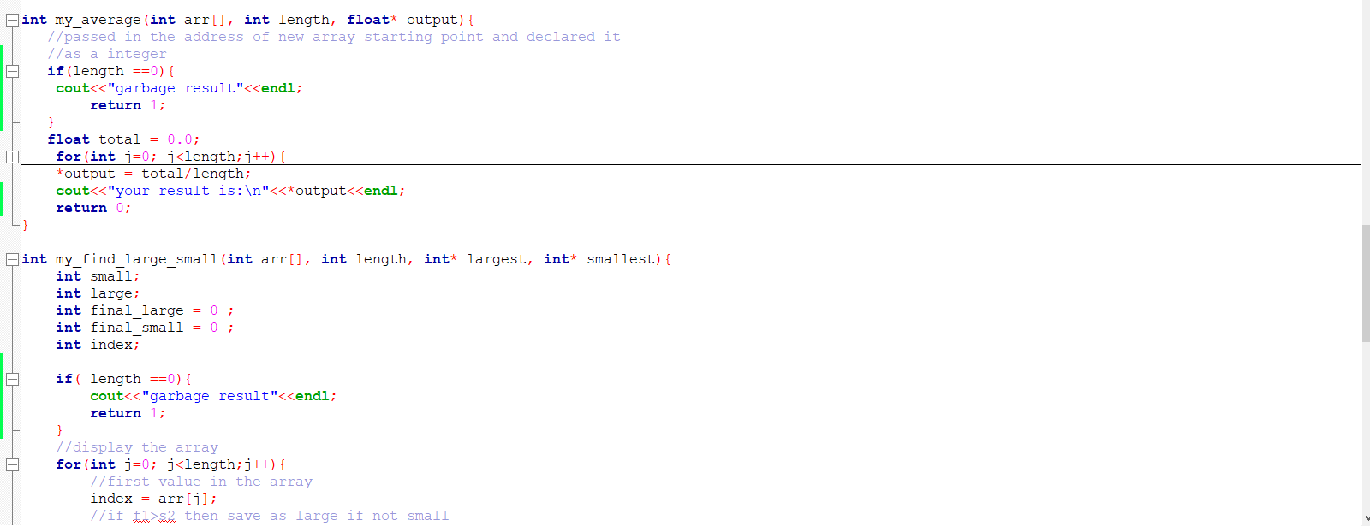

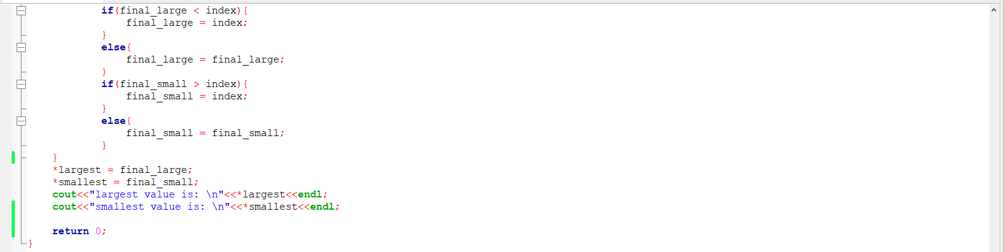

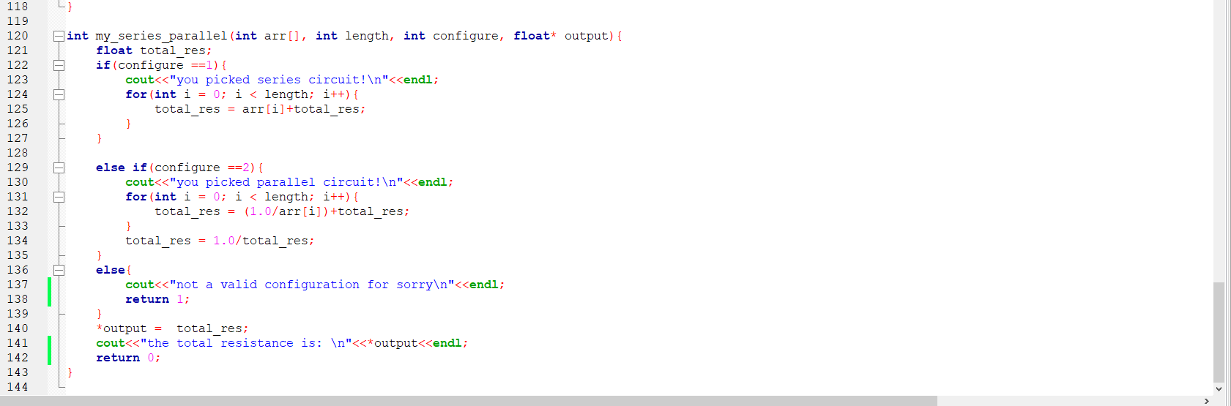

Header file given

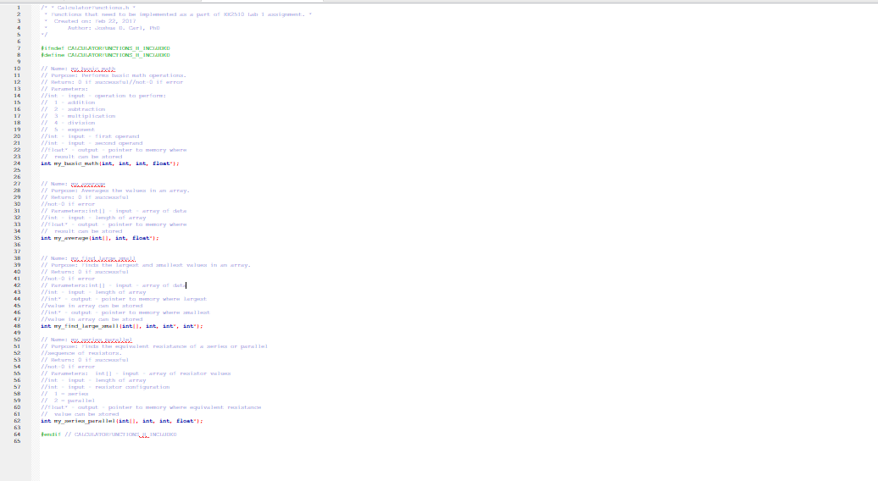

Console:

Hello EE2510! This is your calacultor

Please select the option you want below

1-addition

2-subtraction

3-multiplication

4-division

5-exponent

6-finding average

7-finding largest and smallest value in array

8-finding resistance of series or parallel circuit

1

your option number is: 1

please select a number:

20

please select another number

30

number 1 is:20

number 2 is:30

your result is:

50

return:0

Please select the option you want below

1-addition

2-subtraction

3-multiplication

4-division

5-exponent

6-finding average

7-finding largest and smallest value in array

8-finding resistance of series or parallel circuit

2

your option number is: 2

please select a number:

20

please select another number

30

number 1 is:20

number 2 is:30

your result is:

-10

return:0

Please select the option you want below

1-addition

2-subtraction

3-multiplication

4-division

5-exponent

6-finding average

7-finding largest and smallest value in array

8-finding resistance of series or parallel circuit

3

your option number is: 3

please select a number:

3

please select another number

5

number 1 is:3

number 2 is:5

your result is:

15

return:0

Please select the option you want below

1-addition

2-subtraction

3-multiplication

4-division

5-exponent

6-finding average

7-finding largest and smallest value in array

8-finding resistance of series or parallel circuit

4

your option number is: 4

please select a number:

4

please select another number

0

number 1 is:4

number 2 is:0

cannot divide by zero try again

return:1

Please select the option you want below

1-addition

2-subtraction

3-multiplication

4-division

5-exponent

6-finding average

7-finding largest and smallest value in array

8-finding resistance of series or parallel circuit

4

your option number is: 4

please select a number:

20

please select another number

3

number 1 is:20

number 2 is:3

your result is:

6.66667

return:0

Please select the option you want below

1-addition

2-subtraction

3-multiplication

4-division

5-exponent

6-finding average

7-finding largest and smallest value in array

8-finding resistance of series or parallel circuit

5

your option number is: 5

please select a number:

5

please select another number

-3

number 1 is:5

number 2 is:-3

your result is:

0.008

return:0

Please select the option you want below

1-addition

2-subtraction

3-multiplication

4-division

5-exponent

6-finding average

7-finding largest and smallest value in array

8-finding resistance of series or parallel circuit

5

your option number is: 5

please select a number:

3

please select another number

3

number 1 is:3

number 2 is:3

your result is:

27

return:0

Please select the option you want below

1-addition

2-subtraction

3-multiplication

4-division

5-exponent

6-finding average

7-finding largest and smallest value in array

8-finding resistance of series or parallel circuit

6

your option number is: 6

please input your length:

0

array values are are:

[]

garbage result

return:1

Please select the option you want below

1-addition

2-subtraction

3-multiplication

4-division

5-exponent

6-finding average

7-finding largest and smallest value in array

8-finding resistance of series or parallel circuit

6

your option number is: 6

please input your length:

3

enter values to be stored:1:

2

enter values to be stored:2:

3

enter values to be stored:3:

5

array values are are:

[2,3,5,]

your result is:

3.33333

return:0

Please select the option you want below

1-addition

2-subtraction

3-multiplication

4-division

5-exponent

6-finding average

7-finding largest and smallest value in array

8-finding resistance of series or parallel circuit

7

your option number is: 7

please input your length:

0

array values are are:

[]

garbage result

return:1

Please select the option you want below

1-addition

2-subtraction

3-multiplication

4-division

5-exponent

6-finding average

7-finding largest and smallest value in array

8-finding resistance of series or parallel circuit

7

your option number is: 7

please input your length:

5

enter values to be stored:1:

0

enter values to be stored:2:

-1

enter values to be stored:3:

1

enter values to be stored:4:

-5

enter values to be stored:5:

-1

array values are are:

[0,-1,1,-5,-1,]

largest value is:

1

smallest value is:

-5

return:0

Please select the option you want below

1-addition

2-subtraction

3-multiplication

4-division

5-exponent

6-finding average

7-finding largest and smallest value in array

8-finding resistance of series or parallel circuit

8

your option number is: 8

please input your length:

3

enter values to be stored:1:

5

enter values to be stored:2:

6

enter values to be stored:3:

9

array values are are:

[5,6,9,]

please pick a selection 1-series, 2-parallel, any num for exit

1

you picked series circuit!

the total resistance is:

20

return:0

Please select the option you want below

1-addition

2-subtraction

3-multiplication

4-division

5-exponent

6-finding average

7-finding largest and smallest value in array

8-finding resistance of series or parallel circuit

8

your option number is: 8

please input your length:

3

enter values to be stored:1:

3

enter values to be stored:2:

3

enter values to be stored:3:

3

array values are are:

[3,3,3,]

please pick a selection 1-series, 2-parallel, any num for exit

2

you picked parallel circuit!

the total resistance is:

1

return:0

Please select the option you want below

1-addition

2-subtraction

3-multiplication

4-division

5-exponent

6-finding average

7-finding largest and smallest value in array

8-finding resistance of series or parallel circuit

8

your option number is: 8

please input your length:

0

array values are are:

[]

please pick a selection 1-series, 2-parallel, any num for exit

0

not a valid configuration for sorry

return:1

Please select the option you want below

1-addition

2-subtraction

3-multiplication

4-division

5-exponent

6-finding average

7-finding largest and smallest value in array

8-finding resistance of series or parallel circuit

8

your option number is: 8

please input your length:

3

enter values to be stored:1:

20

enter values to be stored:2:

21

enter values to be stored:3:

5

array values are are:

[20,21,5,]

please pick a selection 1-series, 2-parallel, any num for exit

2

you picked parallel circuit!

the total resistance is:

3.36

return:0

Please select the option you want below

1-addition

2-subtraction

3-multiplication

4-division

5-exponent

6-finding average

7-finding largest and smallest value in array

8-finding resistance of series or parallel circuit

