# Diseño web

## Mockup:

### Vista móvil:

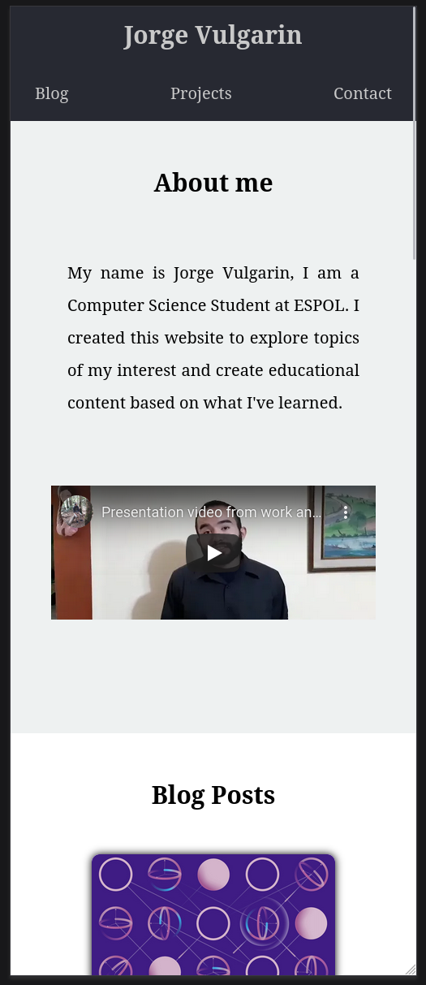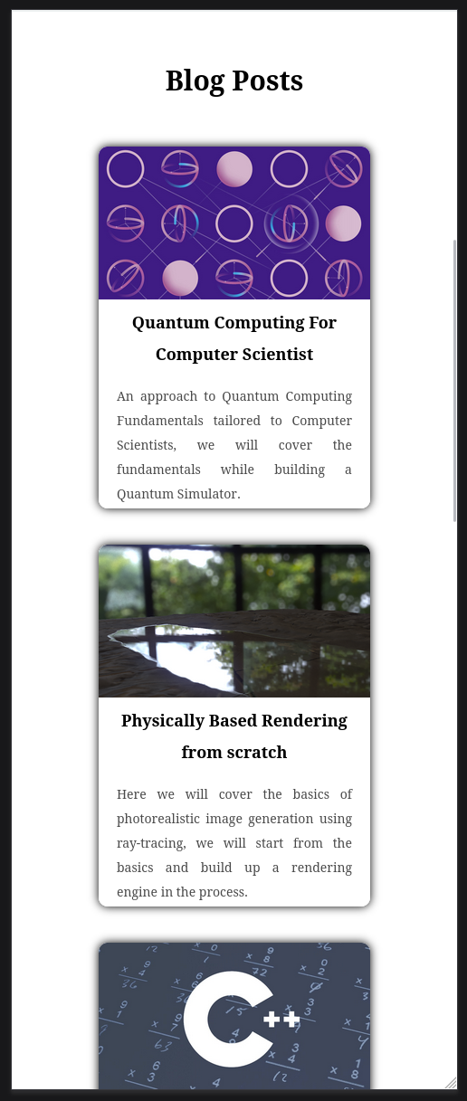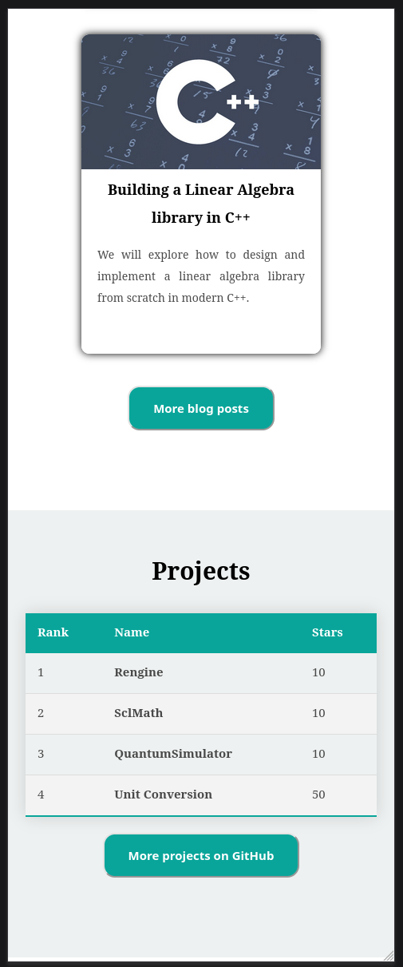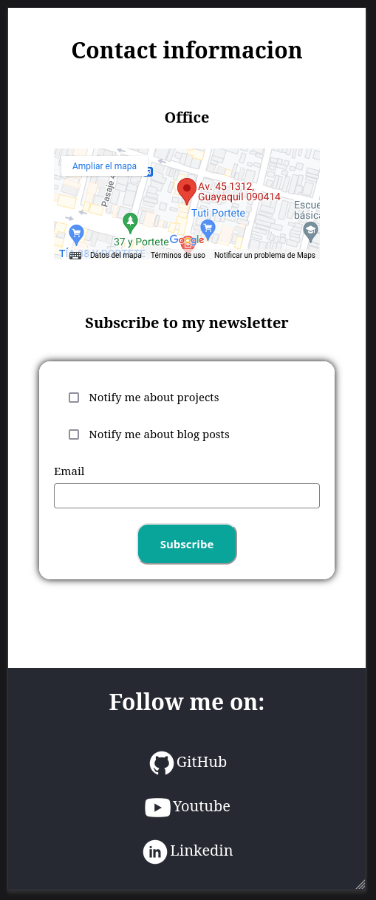

### Vista PC:

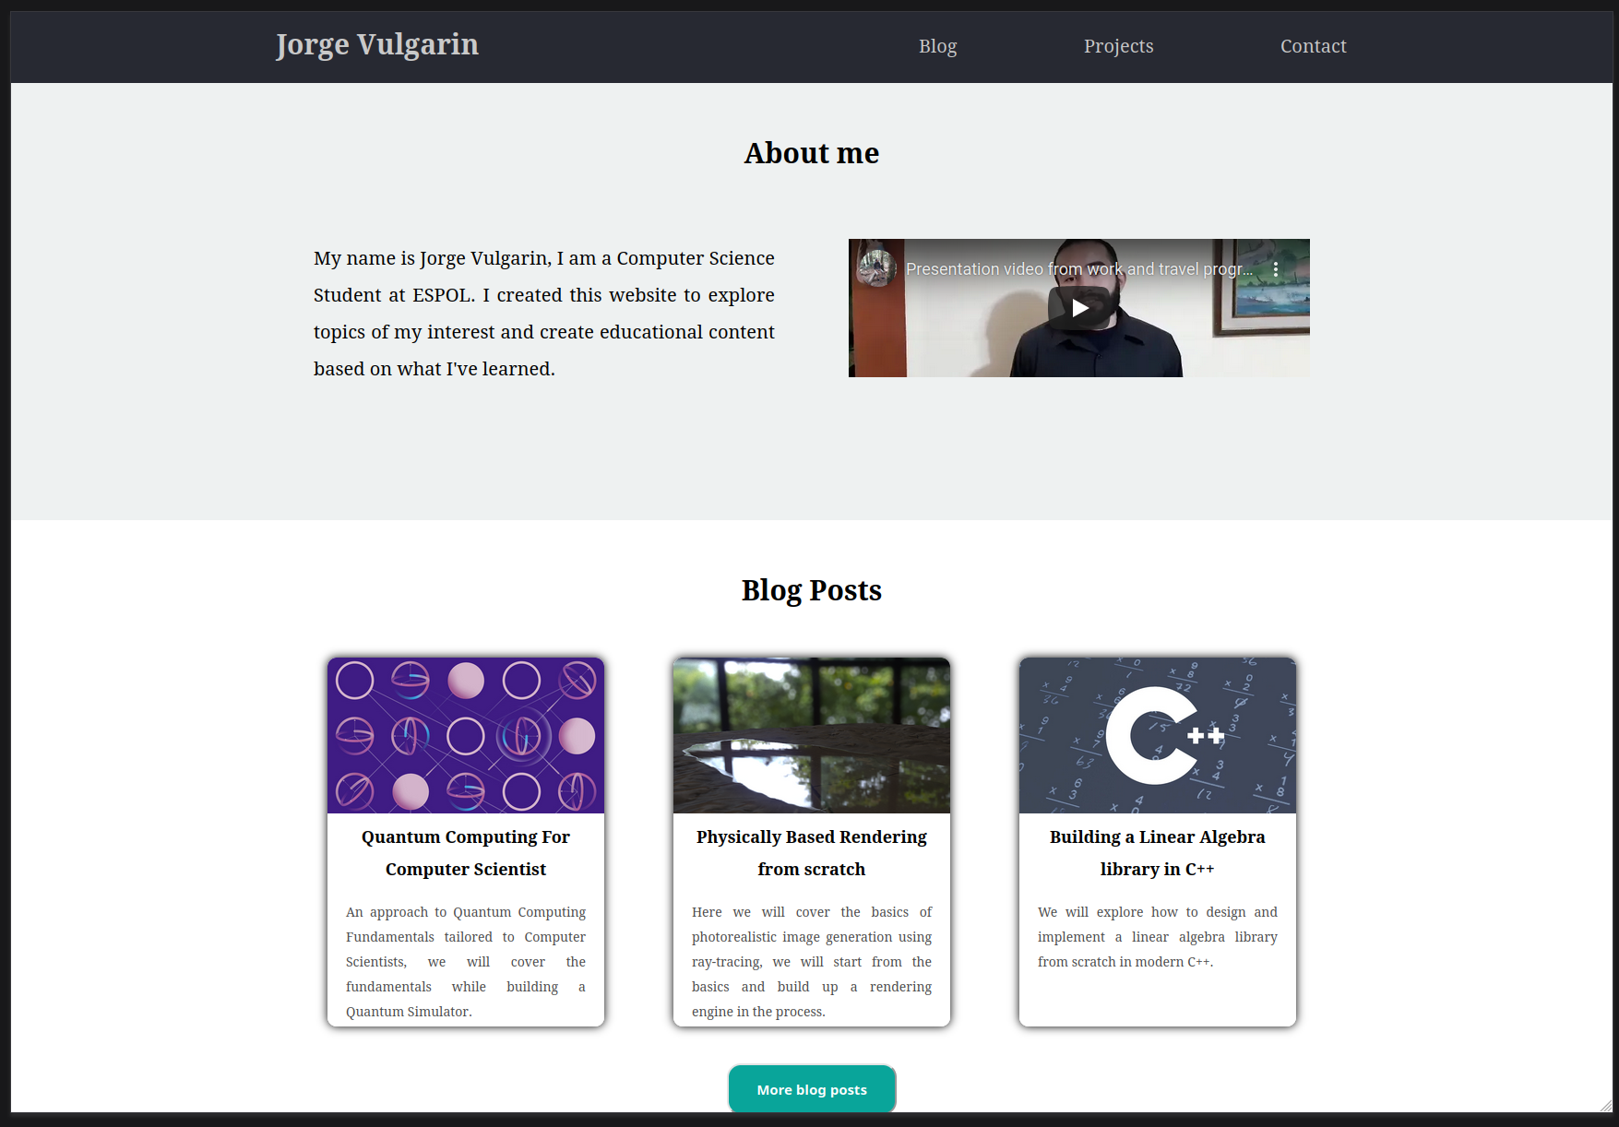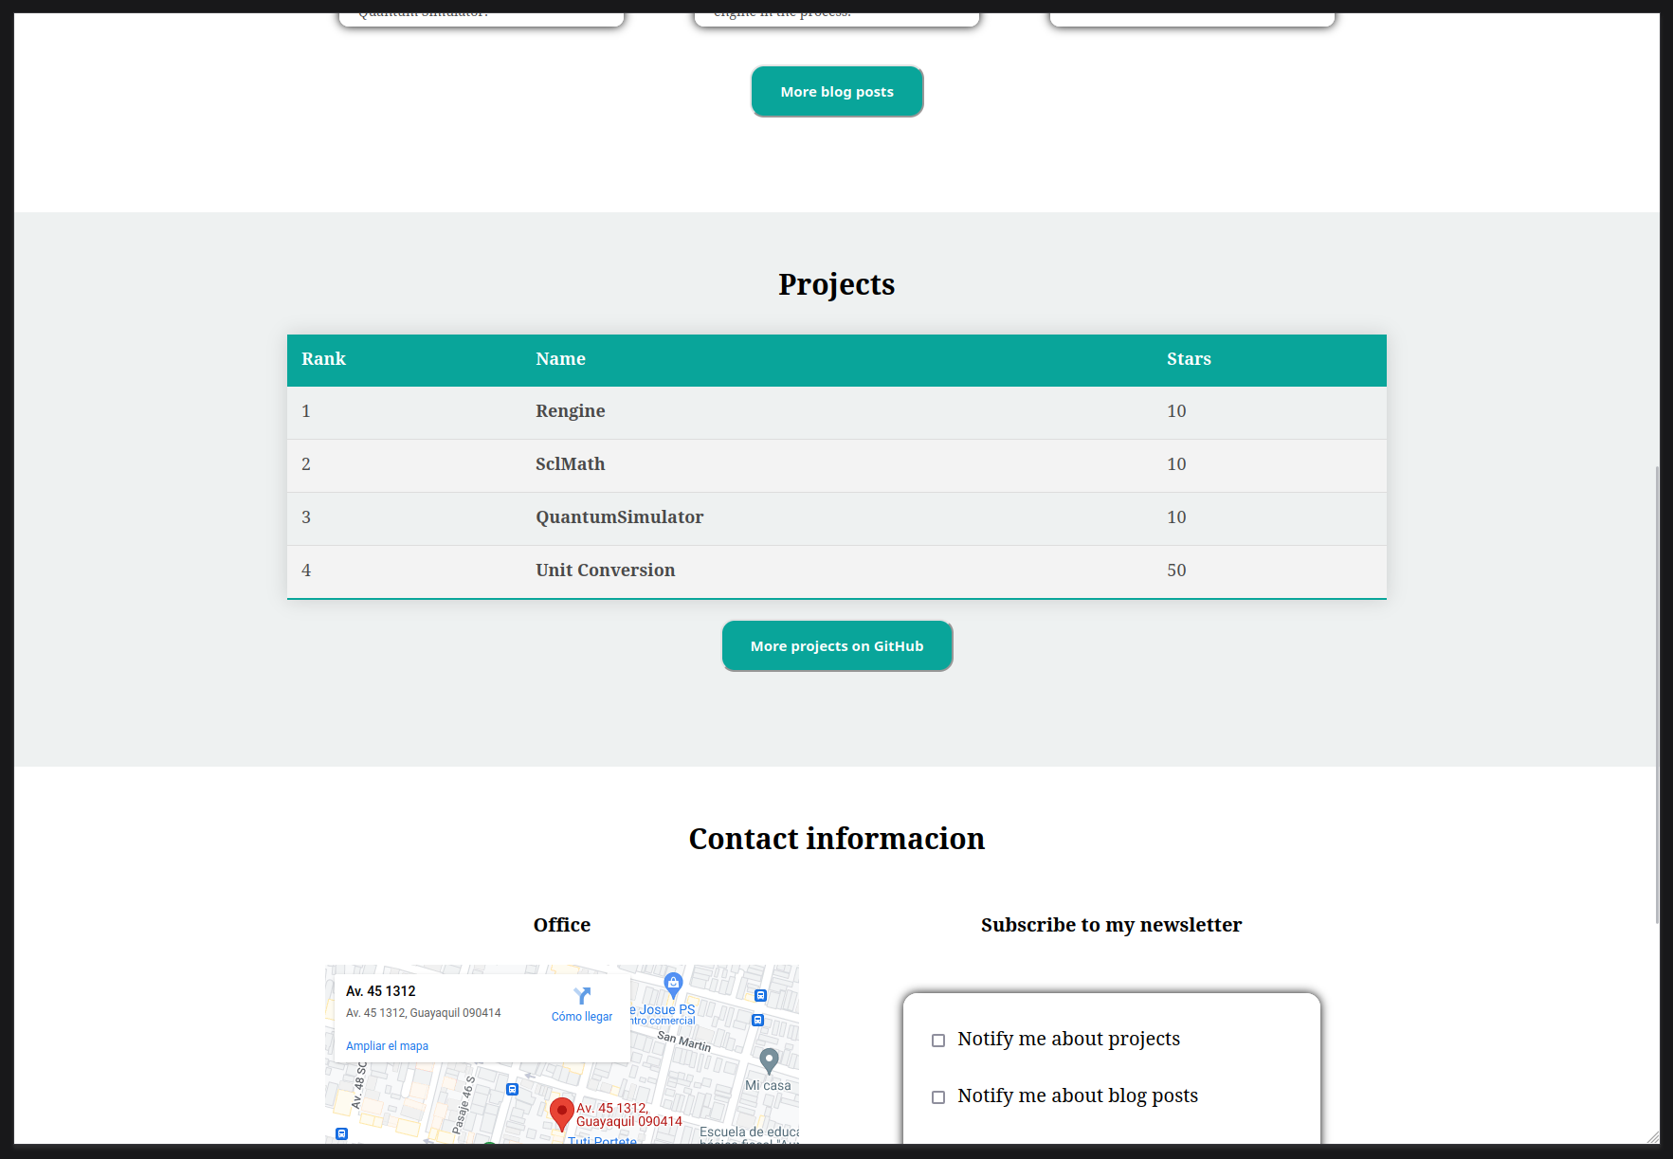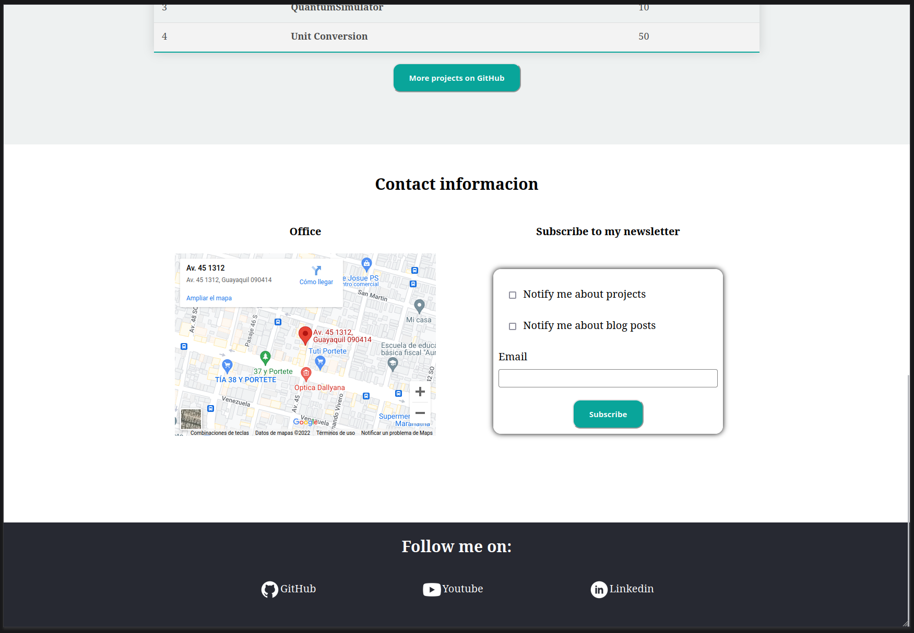

## Colores:

|  |  |  |
| --- | --- | --- |
| Uso | RGB | Color |
| Fondo nav y footer | #272932 |  |
| Texto principal | #c9c9c9 |  |
| Enfasis | #09a59a |  |
| Texto-opaco | #494949 |  |

## Fuentes:

Raleway: <https://fonts.google.com/specimen/Raleway>

## Inspiración:

<https://developedbyed.com/>