Technical Demonstration Explanation
I developed a technical demonstration that integrates Data Lakes, Big Data storage and processing and neural networks to show the impact of data quality on model performance and learning outcomes. The experiment compares two different types of data lakes:
1. Mono architecture using Hadoop and Apache Spark
2. Modern lakehouse architecture using Delta Lake on top of Apache Spark (Hadoop as a storage)
Data is extracted from both storage data lakes and used to feed an artificial neural network (ANN) implemented with Keras and TensorFlow. This technical demonstration is intended to emphasize the crucial importance of the veracity and value properties of big data systems which highlight that clean, accurate and reliable data is vital for achieving more reliable and higher-performing neural network training. As the data is already ingested into the storage, the processing follows a batch-oriented approach.
The goal of this experiment is to evaluate how the modern lakehouse architecture, implemented using Delta Lake, supports ACID operations vs the mono architecture that does not. As a result, we will analyse how these approaches affect the results of the ANNs.
In big data systems, data processed in batch is usually massive. In this technical demonstration, I am using a csv file containing red wine quality data obtained from UCI Machine Learning Repository. This dataset is published by Cortez et al. (2009) and licensed under the Creative Commons Attribution 4.0 International (CC BY 4.0) license, which allows use for educational purpose. Purposely, I chose a small dataset for performance reasons, since we are running the experiment inside of a virtual machine (VM) with Ubuntu 24.04.3 and executing a larger dataset would be too costly from a computational point of view for this environment. The VM is configured with 4 CPU cores (to support parallelization) and 8 GB of RAM.
1. Firstly, I will explain the code for the mono architecture + Keras neural network developed in Jupyter Notebook using Python and PySpark (Python API for Apache Spark). The notebook file is named Jorge_Robla_dirty_hadoop_CA1.ipynb and the following libraries/systems versions were used:

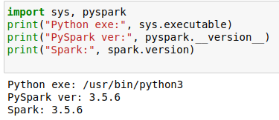

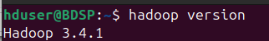

Summary:
The dataset contains information about red wine attributes in CSV format (tabular data). The last column, quality, represents the wine’s quality score. For this experiment, a binary label column is created, if quality is greater than or equal to 7, the label is set to 1; otherwise, it is set to 0. Additionally, an id column was created to uniquely identify every row in the dataset.
The first step of this experiment involves preprocessing of the dataset, which includes checking for duplicates and null values and delete them to improve its data integrity. The second step demonstrates how monolithic architecture does not support ACID transactions which are crucial for maintaining data consistency and fulfilling the veracity and value characteristics of big data systems. To show this, I duplicate a row from the dataset and change its label from 0 to 1. This altered row is then inserted in Hadoop resulting in two rows with the same feature values and different labels. Models using this dataset might biased performance metrics due to inconsistent data. The final step consists of training ANNs using the altered dataset, which now contains duplicate rows with inconsistent labels. Two models are implemented: a basic one, and a more advanced version that includes techniques to improve training and generalization as well as callbacks to stop training before the overfit region and adapt learning rate.
First model shows signs of overfitting (see image below), meaning it memorized patterns from the training data instead of learning general relationships. As a result, its performance on unseen data (validation) was significantly worse. The gap between training and validation accuracy and the high validation loss are strong sings of overfitting and overtraining. Results for the first model:
To mitigate this issue, I experimented with several approaches in a second model:
- L2 Regularization
- Dropout
- BatchNormalization
- Callbacks: EarlyStopping and ReduceLROnPlateau
I added these techniques to generalize better, reduce overfitting and prevents wasting time once the model stops improving.
Results for the second model:
After introducing regularization and optimization techniques, the following key results were observed:
- Training and validation accuracy are very close
- Both training and validation losses are low
- Learning rate was reduced automatically by ReduceLROnPlateau.
- Training stopped early (epoch 25 out of 200), preventing unnecessary training
The close alignment between training and validation metrics indicates the model performs equally well on new data as it does on the data it learned from. In other words, the model generalizes better to new data and is more stable. In the next section, I run the model with the original dataset, without any modification, to compare results.
Detailed Technical Description of the Mono architecture with Spark

- Start Hadoop with the following commands:

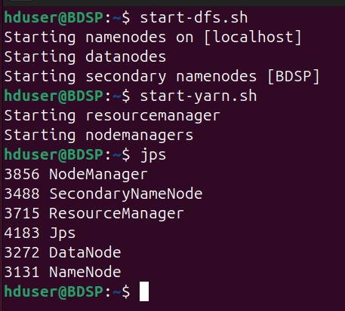

We can see all the components (NameNode, DataNode, ResourceManager, etc.) are hosted on the same machine. In other words, this Hadoop setup is running in a single-node mode.

- To run this experiment, open the console and start PySpark. The input file (winequality-red.csv) to be read is in /CA1/ACID/
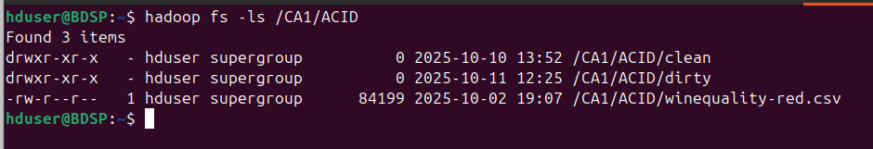
The output folder that contains the file parts is in /CA1/ACID/dirty. In other words, the directory includes both the original CSV data (part 1) and the modified row that is appended later (part 2)
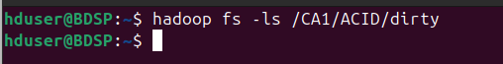
To clear this folder uses the following command:
winequality-red is the folder created with the file parts after inserting data.
- Create a new SparkSession or reuse an existing one to enable access to all Spark functionality

- Load a structured dataset named winequality-red.csv into a Spark Dataframe named df which is suitable for scalable and distributed processing.

In this case, Spark creates only one task to read the file, since the file occupies a single HDFS block (see below)

- Cache the dataframe to load it into memory, allowing Spark to perform future actions more quickly.

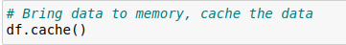

- The next steps involve modifying the dataset by adding the label and id columns, and reorganizing the columns in order to prepare for inserting a new row. The new row is a copy of an existing one, with the label value modified.
- withColumn() is a lazy transformation, it doesn’t immediately modify data but updates Spark’s logical plan (the DAG or Directed Acyclic Graph). It adds or replaces a column using a column expression (an object of type Column created with functions like F.col(), F.lit(), or expressions).
- F.monotonically_increasing_id(): generates a unique ID for each row
- (F.col("quality") >= 7).cast("int") creates a binary label column: 1 if quality ≥ 7, otherwise 0.
These operations only define the transformations — Spark will execute them later when an action (e.g., show() or count()) is called.

- A list comprehension feature_cols is created with all the columns which are no id, quality and label. Then the lazy transformation select() is called and it creates a dataframe. It does not trigger computation or read data yet. *feature_cols unpack the list into several strings (all the columns in feature_cols) to be passed as arguments for select.
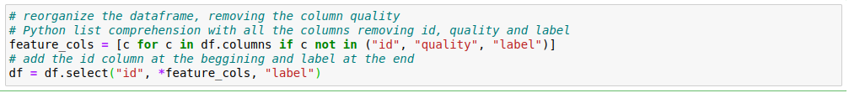
So far, the dataframe includes an id column, a set of features columns (used for training the ANNs) and the label column as the target variable. The quality column was removed.
- The following piece of code retrieves a row from the spark dataset and change its label value. This modified row is inserted later into the CSV file.

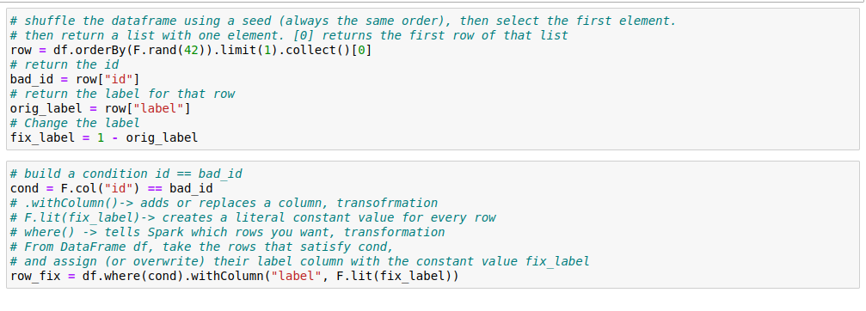

- In the first cell, the entire dataset (part 1) is written to the winequality-red directory. In the second cell, the modified row (part 2) is appended to the same directory. The Coalesce(1) function merges all partitions into one, producing a single output file and task.

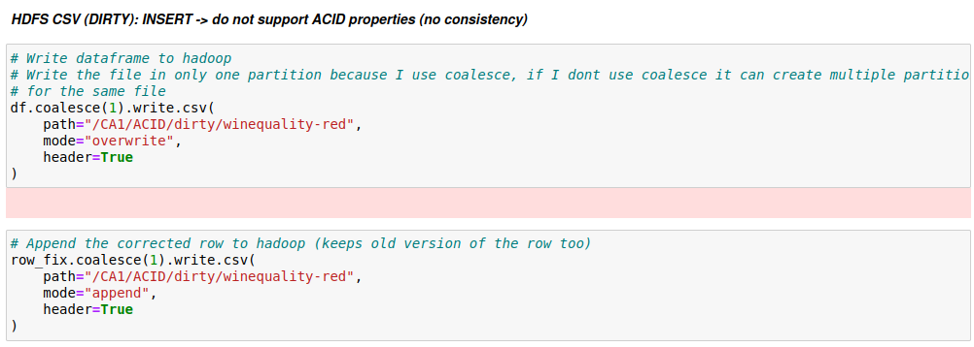
After first cell:
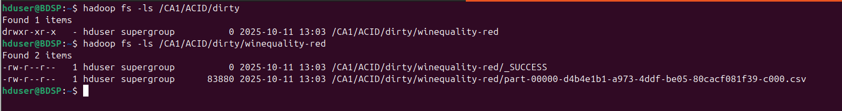
After second cell:
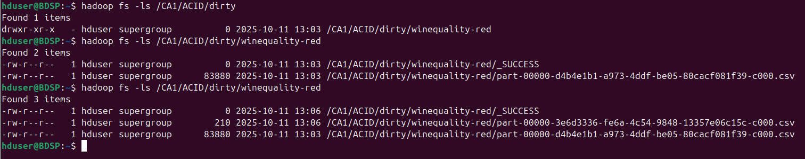
As we can see above two parts were created.
- This step reads the updated dataset from winequality-red directory and assigns the correct data type to each column. As shown below, two tasks were created by Spark to read the file, corresponding to the two-part files in the directory.
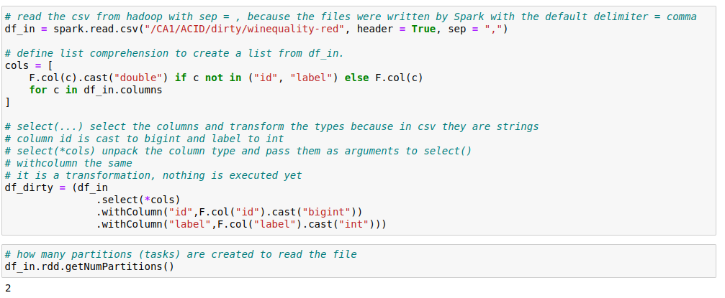
- The output below shows that id = 255 appears twice with different label values, confirming this data lake lacks ACID transaction support and permit inconsistent duplicate entries.
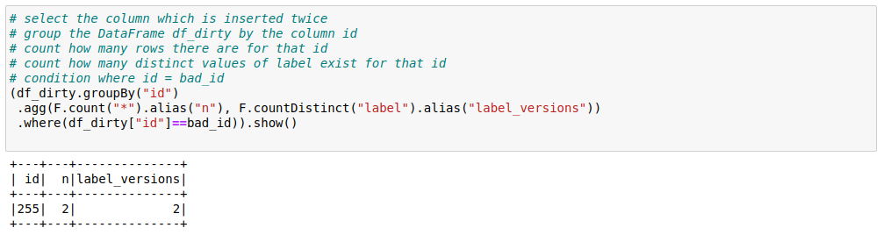
- To enforce ACID transactions, they must be implemented manually or handled by a data lake that provides native ACID support. This architecture does not support it.
2. Secondly, I will explain the code for the modern lakehouse architecture + Keras neural network developed in Jupyter Notebook using Python, PySpark (Python API for Apache Spark) and Delta Lake library. This library extends Spark with a Delta API. The notebook file is named Jorge_Robla_clean_delta_CA1.ipynb and the following libraries/systems versions were used:
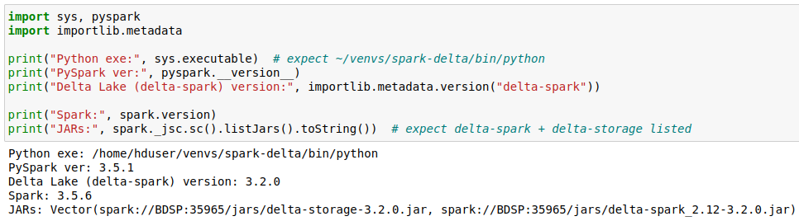
Summary:
In this part of the experiment, the same dataset is used, and the columns label and id are also created in the same way as in the previous architecture.
The steps performed in this demonstration are similar to those implemented in the earlier experiment. The key difference is that here I use a modern data lake architecture that supports ACID compliance. Additionally, two ANN models are trained using:
- the updated dataset, where the label value of a specific row is modified (the row is not duplicated as in the previous experiment, as ACID transaction ensure a consistent update)
- And the original dataset without modifications, to compare results.
Please refer to the summary of the previous data lake implementation to understand both demonstrations.
Models using updated dataset (a row with its label changed):
Once again, the first model shows signs of overfitting (see image below). However, in this case, the validation accuracy is slightly higher, and the validation loss is significantly lower compared to the previous experiment. Results for the first model:
The model was updated to improve generalization better, reduce overfitting and avoid unnecessary training once performance stops improving. The following techniques were applied:
- L2 Regularization
- Dropout
- BatchNormalization
- Callbacks: EarlyStopping and ReduceLROnPlateau
The results for the second model are:
After introducing regularization and optimization techniques, the model shows stable performance and performs similar on seen and unseen data, indicating that it generalizes better to unseen data.
Models using the original dataset:
The results for the first model also suggest overfitting. Training and validation losses moves in opposite directions - validation loss diverged -, indicating poor generalization. Despite this, the validation accuracy is slightly higher, and the validation loss is significantly lower compared to the first experiment.
Once again, I applied several updates to the model using different techniques and approaches to improve the performance and reduce overfitting, including:
- Introducing L2 Regularization, Dropout, BatchNormalization and using callbacks (EarlyStopping and ReduceLROnPlateau). I also adjusted their values to fine-tune performance.
- Reducing the number of neurons in hidden layers to prevent memorization of the training data
- Decreasing the number of epochs to stop training before the overfitting region
- Chaging/Removing the random_state parameter in the train_test_split() function to vary the distribution of samples between training and testing sets. It can give the model more representative training data to generalize better.
- Using LeakyRelu activation function to recover dead neurons and improve gradient flow, enhancing generalization.
After further analysis, I discovered that the dataset was imbalanced, it means there were fewer good wines (label = 1) than bad wines (label = 0). To address this, I experimented with additional techniques:
- Applying class weight during training to give more importance to the minority class
- Adjusting the classification threshold from 7 to 6, redefining good wine as samples with a quality feature greater than or equal to 6.
- Oversampling the minority class to balance the dataset
Unfortunately, these strategies did not yield a significant improvement in model performance.
The results for the second model were:
The model generalises better.
Additionally, I plotted how the model’s loss evolved over time:
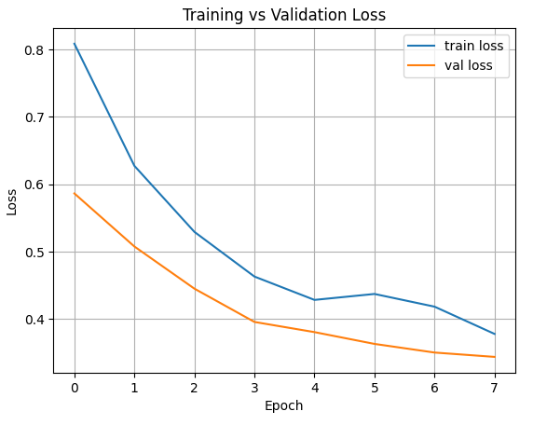
Usually, the training loss is slightly lower than the validation loss because the model fits training data slightly better than unseen data. However, this swap could be related to the use of techniques such as Dropout, L2 regularization or BatchNormalization. They are active during training but disabled or adjusted during validation, so the model is noisier during training, and as a result the training phase suffers it. For example, dropout randomly deactivates neurons, and it can affect the training loss.
The important observation is that training and validation loss are decreasing, so the model is learning effectively. The curves are smooth, showing no oscillations or divergence, which indicates the training process is stable and its performance consistent.
Additionally, since class 1 represents a minority class, I lowered the decision threshold from 0.5 to 0.46 to improve sensitivity to good wines and improve its ability to detect positive cases (see below).
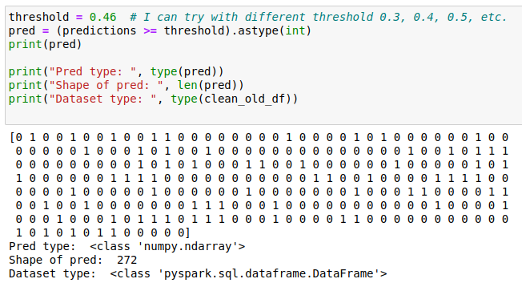
The final step involves analysing the confusion matrix and classification report which are very important for evaluating models trained on imbalanced datasets.
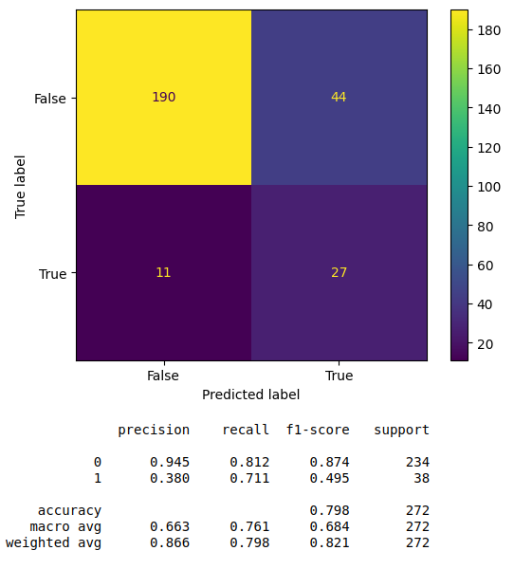
The results can be summarized as follows:
- 190 wines were correctly identified as low quality (label 0) – true negatives
- 27 wines were correctly identified as high quality (label 1) – true positives
- 44 wines were misclassified as good when they were bad - false positives
- 11 wines that were good but predicted as bad – false negatives
The model achieves the following performance metrics:
Precision (class 1 = 0.38): When the model predicts good wine, it is correct 38% of the time. This low precision indicates a high number of false positives
Recall (class 1 = 0.711): The model correctly identifies about 71.1% of the actual good wines. This is an improvement.
F1-score (class 1 = 0.495): Lower due of the imbalance between precision and recall.
In conclusion, the model is very strong for class 0 and the threshold adjustment helped increase recall for class 1, enabling the model to detect more good wines. However, this improvement impacts the precision which is very low.
Detailed Technical Description of the Lakehouse architecture with Delta Lake:
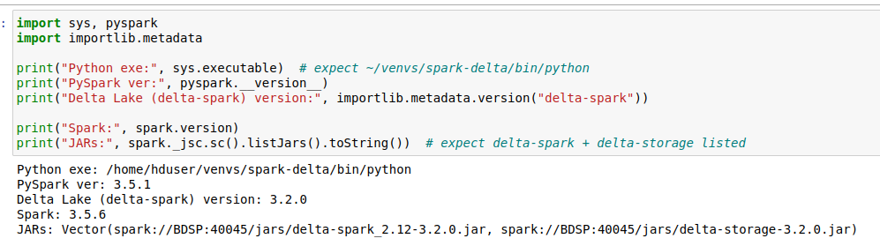
I faced several challenges while installing Delta Lake, so I created a workaround to overcome those problems. I built a new virtual environment (spark-delta) and run Jupyter from the shell, so notebooks use the venv’s Python and its packages (pyspark, delta-lake).

Steps to create the virtual environment and run it:
a. Install and register the environment in the shell:
python3 -m venv ~/venvs/spark-delta
source ~/venvs/spark-delta/bin/activate
pip install --upgrade pip
pip install jupyter pyspark==3.5.1 delta-spark==3.2.0 ipykernel
python -m ipykernel install --user --name=spark-delta --display-name "spark-delta"

b. Start Jupyter with Delta in the shell:
source ~/venvs/spark-delta/bin/activate

# Make sure Spark starts locally and launches with BOTH Delta jars
export PYSPARK_SUBMIT_ARGS="--master local[*] \
--jars /home/hduser/jars/delta-spark_2.12-3.2.0.jar,/home/hduser/jars/delta-storage-3.2.0.jar \
--driver-class-path /home/hduser/jars/delta-spark_2.12-3.2.0.jar:/home/hduser/jars/delta-storage-3.2.0.jar \
--conf spark.executor.extraClassPath=/home/hduser/jars/delta-spark_2.12-3.2.0.jar:/home/hduser/jars/delta-storage-3.2.0.jar \
pyspark-shell"

jupyter notebook

What do I do in the previous command?
a. Activate the virtual environment so Jupyter and Python use /home/hduser/venvs/spark-delta/bin/python and its packages (PySpark, Delta Lake, etc.)
b. Export PYSPARK_SUBMIT_ARGS (manual-Jar Path) so any SparkSession created inside the notebook starts with Delta enabled. These jars are JVM libraries that PySpark must load to understand and process Delta Lake tables. Jar files are included in the same folder as the Jupyter Notebooks.
c. Launch Jupyter from that shell so the kernel inherits those env vars. Then select the spark-delta kernel.
Basically, I am launching Jupyter using the active virtual environment (spark-delta).
That means:
The Python interpreter used inside Jupyter = /home/hduser/venvs/spark-delta/bin/python
The packages (pyspark engine, delta-lake integration, tensorflow library, etc.) come from your virtual environment.
Your notebooks will use that environment for imports and execution.
The previous experiment follows the same steps as this Jupyter notebook up to step 1i. Therefore, I will start from step j. The only difference is the output folder which in this case is:
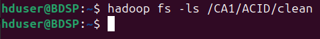
j. In the next cell, Delta Lake is used to write the file in Hadoop. Format(“delta”) tell spark to use the Delta Lake engine.
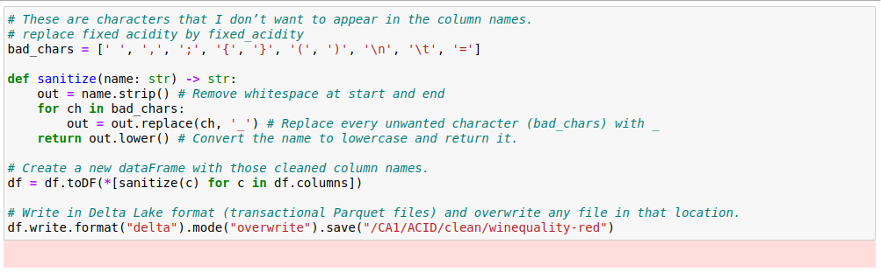
After inserting the dataframe (CSV file), I see the parquet in Hadoop:
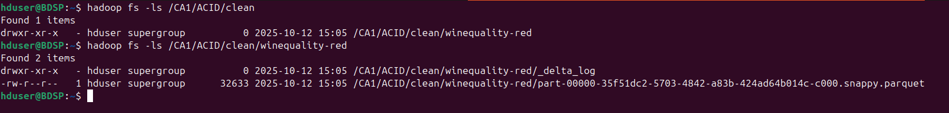
k. In the next cells, I initialize a Delta table based on the data written in the previous step. This allows to fully support ACID transactions. As shown, the row selected for modification currently has a label value of 0.
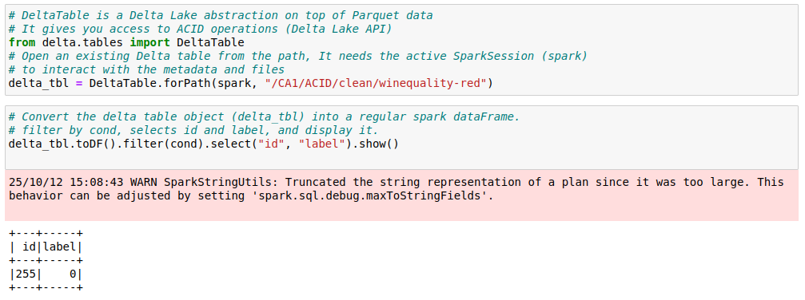
l. The row is now updated using the Delta table created in the previous step. The result confirms that only one record was modified, with the label value changed to 1.
And in Hadoop FS, two parquet files were created, the second one with the modification performed:
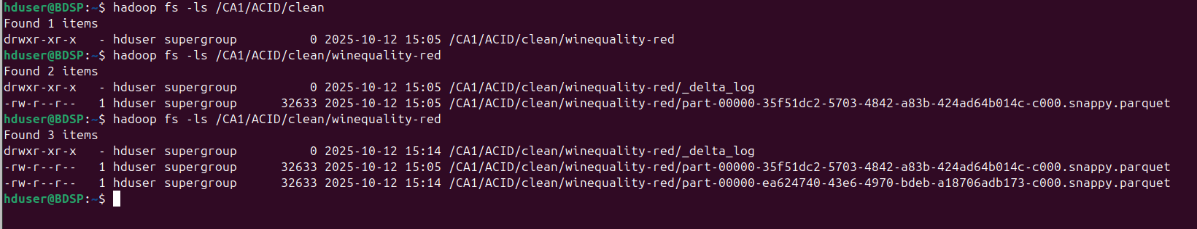
m. The two next cells show the differences between the two insertions performed using Delta Lake on Hadoop. In the first insertion, the label is equal to 0, while in the second equal to 1. The data is read from Hadoop using Delta Lake.

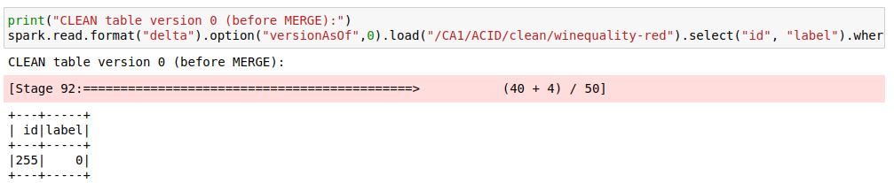
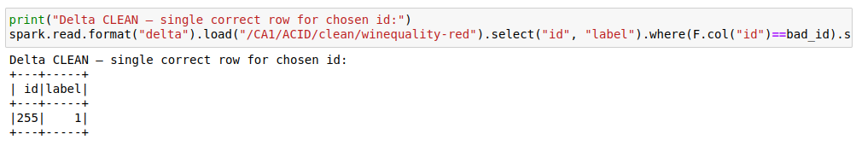

Conclusion
This technical demonstration highlights the importance of providing clear, accurate, consistent, balanced and reliable data when training ANNs. Delta lake helps to maintaining data integrity by enabling ACID transactions and thus ensuring that ANNs are trained on reliable data.
The results show signs of overfitting in some cases, primarily due to issues with the data. Several techniques and approaches were applied to generalize better and reduce overfitting; model’s performance improved but it was not perfect. These findings suggest that the model might be limited by the size and variability of the dataset. In fact, performance appeared to degrade when data was duplicated. With more training data, the ANNs could potentially learn stronger and more generalizable relationships.

References
- P. Cortez, A. Cerdeira, F. Almeida, T. Matos, and J. Reis. Modeling wine preferences by data mining from physicochemical properties. Decision Support Systems, 47(4):547–553, 2009. Available at: https://archive.ics.uci.edu/dataset/186/wine+quality

