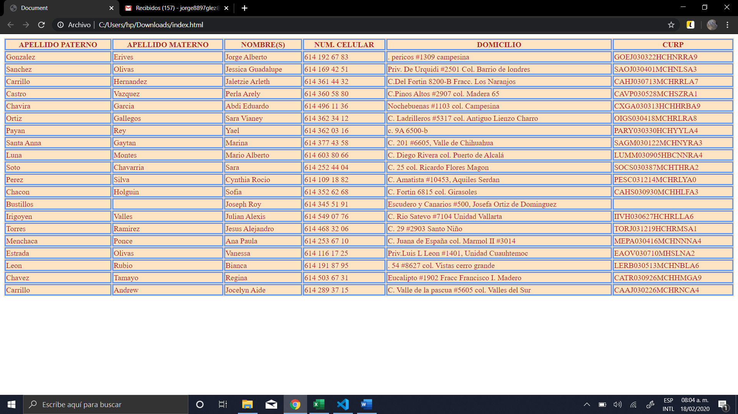

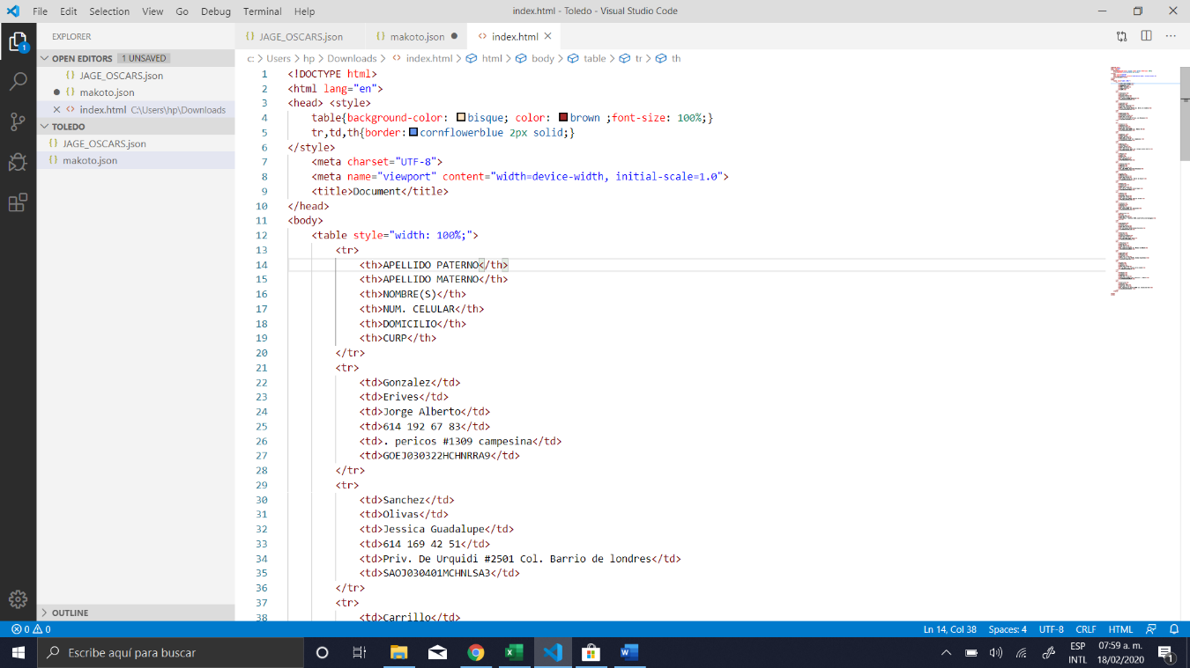<!DOCTYPE html>

<html lang="en">

<head> <style>

table{background-color: bisque; color: brown ;font-size: 100%;}

tr,td,th{border:cornflowerblue 2px solid;}

</style>

<meta charset="UTF-8">

<meta name="viewport" content="width=device-width, initial-scale=1.0">

<title>Document</title>

</head>

<body>

<table style="width: 100%;">

<tr>

<th>APELLIDO PATERNO</th>

<th>APELLIDO MATERNO</th>

<th>NOMBRE(S)</th>

<th>NUM. CELULAR</th>

<th>DOMICILIO</th>

<th>CURP</th>

</tr>

<tr>

<td>Gonzalez</td>

<td>Erives</td>

<td>Jorge Alberto</td>

<td>614 192 67 83</td>

<td>. pericos #1309 campesina</td>

<td>GOEJ030322HCHNRRA9</td>

</tr>

<tr>

<td>Sanchez</td>

<td>Olivas</td>

<td>Jessica Guadalupe</td>

<td>614 169 42 51</td>

<td>Priv. De Urquidi #2501 Col. Barrio de londres</td>

<td>SAOJ030401MCHNLSA3</td>

</tr>

<tr>

<td>Carrillo</td>

<td>Hernandez</td>

<td>Jaletzie Arleth</td>

<td>614 361 44 32</td>

<td>C.Del Fortin 8200-B Fracc. Los Naranjos</td>

<td>CAHJ030713MCHRRLA7</td>

</tr>

<tr>

<td>Castro</td>

<td>Vazquez</td>

<td>Perla Arely</td>

<td>614 360 58 80</td>

<td>C.Pinos Altos #2907 col. Madera 65</td>

<td>CAVP030528MCHSZRA1</td>

</tr>

<tr>

<td>Chavira </td>

<td>Garcia</td>

<td>Abdi Eduardo</td>

<td>614 496 11 36</td>

<td>Nochebuenas #1103 col. Campesina </td>

<td>CXGA030313HCHHRBA9</td>

</tr>

<tr>

<td>Ortiz</td>

<td>Gallegos</td>

<td>Sara Vianey</td>

<td>614 362 34 12</td>

<td>C. Ladrilleros #5317 col. Antiguo Lienzo Charro</td>

<td>OIGS030418MCHRLRA8</td>

</tr>

<tr>

<td>Payan</td>

<td>Rey</td>

<td>Yael</td>

<td>614 362 03 16</td>

<td>c. 9A 6500-b</td>

<td>PARY030330HCHYYLA4</td>

</tr>

<tr>

<td>Santa Anna</td>

<td>Gaytan</td>

<td>Marina</td>

<td>614 377 43 58</td>

<td>C. 201 #6605, Valle de Chihuahua</td>

<td>SAGM030122MCHNYRA3</td>

</tr>

<tr>

<td>Luna</td>

<td>Montes</td>

<td>Mario Alberto</td>

<td>614 603 80 66</td>

<td>C. Diego Rivera col. Puerto de Alcalá</td>

<td>LUMM030905HBCNNRA4</td>

</tr>

<tr>

<td>Soto</td>

<td>Chavarria</td>

<td>Sara</td>

<td>614 252 44 04</td>

<td>C. 25 col. Ricardo Flores Magon</td>

<td>SOCS030387MCHTHRA2</td>

</tr>

<tr>

<td>Perez</td>

<td>Silva</td>

<td>Cynthia Rocio</td>

<td>614 109 18 82</td>

<td>C. Amatista #10453, Aquiles Serdan</td>

<td>PESC031214MCHRLYA0</td>

</tr>

<tr>

<td>Chacon</td>

<td>Holguin</td>

<td>Sofia</td>

<td>614 352 62 68</td>

<td>C. Fortin 6815 col. Girasoles</td>

<td>CAHS030930MCHHLFA3</td>

</tr>

<tr>

<td>Bustillos</td>

<td></td>

<td>Joseph Roy</td>

<td>614 345 51 91</td>

<td>Escudero y Canarios #500, Josefa Ortiz de Dominguez</td>

<td></td>

</tr>

<tr>

<td>Irigoyen</td>

<td>Valles</td>

<td>Julian Alexis</td>

<td>614 549 07 76</td>

<td>C. Rio Satevo #7104 Unidad Vallarta</td>

<td>IIVH030627HCHRLLA6</td>

</tr>

<tr>

<td>Torres</td>

<td>Ramirez</td>

<td>Jesus Alejandro</td>

<td>614 468 32 06</td>

<td>C. 29 #2903 Santo Niño</td>

<td>TORJ031219HCHRMSA1</td>

</tr>

<tr>

<td>Menchaca</td>

<td>Ponce</td>

<td>Ana Paula</td>

<td>614 253 67 10</td>

<td>C. Juana de España col. Marmol II #3014</td>

<td>MEPA030416MCHNNNA4</td>

</tr>

<tr>

<td>Estrada</td>

<td>Olivas</td>

<td>Vanessa</td>

<td>614 116 17 25</td>

<td>Priv.Luis L Leon #1401, Unidad Cuauhtemoc</td>

<td>EAOV030710MHSLNA2</td>

</tr>

<tr>

<td>Leon</td>

<td>Rubio</td>

<td>Bianca</td>

<td>614 191 87 95</td>

<td>. 54 #8627 col. Vistas cerro grande</td>

<td>LERB030513MCHNBLA6</td>

</tr>

<tr>

<td>Chavez</td>

<td>Tamayo</td>

<td>Regina</td>

<td>614 503 67 31</td>

<td>Eucalipto #1902 Fracc Francisco I. Madero</td>

<td>CATR030926MCHHMGA9</td>

</tr>

<tr>

<td>Carrillo</td>

<td>Andrew</td>

<td>Jocelyn Aide</td>

<td>614 289 37 15</td>

<td>C. Valle de la pascua #5605 col. Valles del Sur</td>

<td>CAAJ030226MCHRNCA4 </td>

</tr>

</table>

</body>

</html>