Chameleonic Membrane Permeability is Size-Gated: Evidence from 3D Conformational Descriptors and Source-Stratified PAMPA Analysis
Jorge Carmona | March 2026

Abstract
We present a computational pipeline for predicting cyclic peptide membrane permeability using 3D ensemble-derived conformational descriptors, with a focus on ΔPSA: the difference in polar surface area between aqueous and membrane-mimetic conformers. On a 1,566-compound source-stratified subset of CycPeptMPDB¹ (Furukawa 2016² + Chugai), ensemble ΔPSA achieves AUC = 0.692 vs. AUC = 0.317 for MolLogP. Notably, MolLogP is inversely predictive on this subset (flipped AUC = 0.683), consistent with large polar macrolides dominating the high-scoring PAMPA population in this preliminary dataset. Size-stratified analysis reveals that this overall AUC reflects two distinct populations: compounds of ≥9 residues are highly permeable in the preliminary data (94.8% for 9–11 residues, 86.3% for 12–15 residues), while smaller cyclic peptides (≤8 residues, 60.4% permeable) show ΔPSA as essentially uninformative (AUC = 0.528), hinting at a permeation mechanism not dependent on conformational switching. HDBSCAN clustering on the UMAP embedding of the combined 2D+3D feature space identifies two distinct populations; overlaying molecular weight as a color axis on the same embedding reveals that the permeable cluster has a median MW of 1,180 Da vs. 820 Da for the impermeable cluster (1.44× gap). When extended to the full heterogeneous 7,298-compound dataset this separation vanishes entirely, which we initially attributed to cross-source PAMPA label noise. To investigate further, we asked whether the MW gap itself contained a deeper signal — and applied per-MW normalization (ΔPSA / MolWt) to test whether absolute ΔPSA was conflating molecular size with chameleonic switching efficiency. The result made the picture unambiguous: within-class AUC improves from 0.528 to 0.696 for 12–15 residue compounds while actively degrading for smaller compounds — an asymmetry that cannot be explained by label noise alone and points directly to two mechanistically distinct permeation regimes operating within the same dataset. Collectively, these findings are consistent with a two-mechanism model of passive cyclic peptide permeability — arrived at independently and corroborated by the concurrent work of Yu et al. 2026³: chameleonic conformational switching in large macrolides, detectable by 3D ensemble descriptors, and a distinct permeation route in smaller scaffolds that these descriptors cannot capture. Cleaner, source-homogeneous permeability data and per-SASA descriptor normalization are the critical next steps toward testing this model more rigorously.

1. Background
Passive membrane permeation for large cyclic peptides is not well-modeled by conventional 2D descriptors because these descriptors are conformationally blind. Cyclosporin A (CsA, MW 1,203 Da, 11 residues) is the archetypal example: it crosses membranes despite high polarity by adopting a compact conformation in apolar environments that buries backbone amide NH groups through intramolecular H-bonding⁷. This *chameleonic* switching is invisible to descriptors like TPSA or MolLogP but should manifest as a large difference in 3D polar surface area (ΔPSA) between conformers sampled in aqueous vs. membrane-mimetic conditions. Empirical work from the Lokey group has established that N-methylation and backbone rigidity modulate this switch in smaller cyclic scaffolds¹⁰, but a systematic size threshold below which chameleonic behavior fails to manifest has not been computationally validated at database scale.
CycPeptMPDB v1.2¹ provides the largest public collection of experimental cyclic peptide PAMPA data (8,466 compounds) but aggregates measurements from laboratories using incompatible protocols. This heterogeneity is a central finding of this work and a major constraint on cross-source descriptor validation.

2. Methods

2.1 Data
CycPeptMPDB v1.2¹ was filtered to 7,298 compounds with PAMPA values. For source-stratified analyses, a 1,566-compound subset comprising Furukawa 2016² (individual-compound LC-MS, 1% lecithin/dodecane membrane) and Chugai (patent WO 2013/100132 A1, DOPC/hexadecane membrane) was used as the primary reference set. These two sources share a critical methodological feature: both use individual-compound assays rather than the pooled multiplexed PAMPA protocol used by Townsend 2020⁸ and Kelly 2021⁹, which accounts for ~63% of the full dataset and introduces systematic cross-compound signal interference via CycLS MS deconvolution. Furukawa 2016² is the most rigorously documented source (peer-reviewed, individual LC-MS detection). Chugai is a patent-derived source with less fully characterized conditions (DOPC/hexadecane membrane, detection floor −10.0 vs −8.0 log cm/s for other sources) and should be treated with appropriate caution; a Furukawa-only analysis is proposed as a future control (see Section 6). Permeability threshold: PAMPA LogPexp ≥ −6.0 log cm/s.

2.2 Conformer Generation (Tier-1)
Twenty conformers per molecule were generated using ETKDGv3 with macrocycle torsion sampling enabled⁴, followed by MMFF94s minimization⁵. ETKDGv3 is the RDKit default conformer generator incorporating experimental torsional-angle preferences for macrocycles from crystallographic data. In published benchmarks⁶, ETKDGv3 with the macrocycle flag ranks 2nd for macrocycle ring RMSD against crystal structures (0.62 Å), statistically indistinguishable from the best-performing open-source method (0.56 Å). At the scale of this analysis (7,298 compounds), ETKDGv3 is the appropriate choice; CREST-level semiempirical sampling is proposed for validation on a smaller reference set (see Section 5).
The conformer with maximum 3D polar SASA (Bondi radii, RDKit rdFreeSASA) was designated the aqueous conformer and the conformer with minimum 3D polar SASA the membrane conformer. Key descriptors:
- delta_psa3d = PSA(aq) − PSA(mem): chameleonic PSA switch
- psa3d_std: PSA variance across all 20 conformers (conformational flexibility)
- delta_hb, delta_Rg, delta_NPR1/2: H-bond count, compaction, and shape descriptors
Following the observation of a molecular weight-stratified cluster separation in UMAP (Section 3.7), a per-MW normalized descriptor was computed post-hoc: delta_psa3d_per_mw = delta_psa3d / MolWt × 1000 (Å² per kDa). This normalization removes the molecular size contribution to absolute ΔPSA, isolating chameleonic switching efficiency from molecular weight confounding. No conformer re-generation was required; the normalization is a derived quantity from the existing feature matrix.
As a negative control, delta_3DPSA_db = H2O_3DPSA − CHCl3_3DPSA from CycPeptMPDB's pre-computed 3D PSA values was included. Per the CycPeptMPDB methods¹, both values are derived from the same single minimum-energy UFF conformer — not from independently solvent-optimized structures — making this descriptor a measure of PSA calculation settings rather than conformational switching. Its inclusion tests whether any residual conformational signal survives in a single-structure approach.

2.3 Analysis
Features were merged into a 7,298 × 274 matrix. Pearson/Spearman correlations and AUC-ROC were computed for each descriptor. UMAP dimensionality reduction (cosine metric, n_neighbors=30) with dual-track clustering — K-Medoids (k=8, cosine distance) and HDBSCAN (min_cluster_size=50) — was used for chemical space visualization and permeability enrichment analysis. ARI stability was validated across 5 random seeds (threshold ≥ 0.85). Three feature panels were defined: Panel A (2D descriptors), Panel B (3D delta descriptors), Panel C (combined). Track D, introduced in this analysis, adds a fourth subplot coloring the same UMAP embedding by molecular weight.

3. Results

3.1 Single-Structure ΔPSA Fails: Motivating the Ensemble Approach
CycPeptMPDB¹ provides pre-computed 3D PSA values in two conditions (H2O_3DPSA and CHCl3_3DPSA) for each compound. A natural first test is whether their difference — delta_3DPSA_db — correlates with experimental PAMPA LogPexp. It does not. Before interpreting why, it is important to understand how these values were generated.
According to the CycPeptMPDB methods¹, 5,000 conformers per peptide were generated with RDKit, redundant conformers (RMSD < 1.0 Å) were removed, each was UFF-minimized, and the single lowest-energy conformer was selected. Critically, H2O_3DPSA and CHCl3_3DPSA are both computed from this same single structure — not from independently solvent-optimized conformers. The database itself acknowledges this on the peptide detail page with an explicit warning (Li et al.¹, Fig. 6B): *"This conformation likely does not reflect what is found in biological systems, and most peptides populate conformational ensembles rather than a single conformation."* Consequently, delta_3DPSA_db does not measure a conformational switch at all — it measures the difference in PSA accessibility of an identical 3D geometry under two different solvent-accessibility calculation settings. Any signal from genuine chameleonic switching is structurally inaccessible to this descriptor by construction.
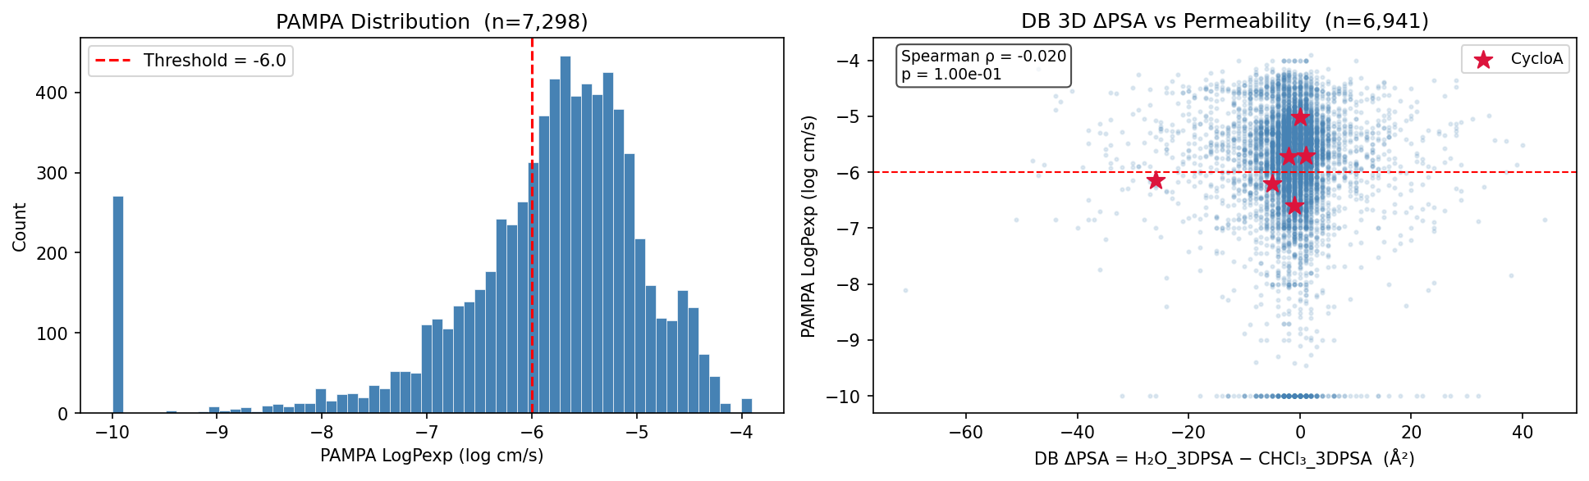
PAMPA distribution and DB ΔPSA scatter
*Figure 1. Left: PAMPA LogPexp distribution across 7,298 compounds (threshold −6.0 shown). Right: database ΔPSA (H2O_3DPSA − CHCl3_3DPSA) vs. experimental PAMPA. Spearman ρ = −0.020 (p = 0.10), AUC = 0.507 — indistinguishable from chance. Both PSA values are derived from the same single minimum-energy conformer, making this descriptor structurally incapable of detecting chameleonic switching. The vertical noise band centered near 0 Å² is the expected outcome: you cannot measure a conformational switch using one conformation.*

3.2 The Decisive Negative Control: Level of Theory Is Not the Bottleneck
To confirm that single-structure failure is a sampling problem rather than a force field problem, GFN2-xTB¹³ with GBSA implicit solvation was run on five reference compounds in water and CHCl₃. GFN2-xTB is a semiempirical tight-binding method substantially more accurate than the MMFF94s force field underlying Tier-1.
Compound | Permeable | PAMPA | xtb ΔPSA (Å²) | Tier-1 ΔPSA (Å²)
CsA (Cyclosporin A) | Yes | −6.60 | **−0.14** | **84.9**
DP172 | Yes | −4.15 | −0.24 | 88.9
HexPep | No | −6.20 | 0.82 | 64.4
1NMe3 | Yes | −5.52 | 6.91 | 47.8
PSLYF | No | −9.10 | 5.40 | 65.3

GFN2-xTB produces ΔPSA of 0–7 Å² across all five compounds — including CsA, where the chameleonic switch has been directly observed by NMR⁷. Tier-1 ensemble sampling recovers 47–89 Å² for the same compounds: a 10–100× larger signal. What governs passive membrane permeation in chameleonic cyclic peptides is not the energy of a single optimized structure — it is the *existence* of a low-PSA conformer that the molecule can access in the membrane environment, however transiently. Tier-1 probes that capacity by populating conformational space broadly; GFN2-xTB cannot, regardless of its energy accuracy, because it samples only a single point.
This brings us to what this work is and is not. We are not claiming a predictive model for novel compounds — that is the goal, and it is within reach. What we are doing is establishing that the chameleonic signal is real, that it is size-gated, and that ensemble sampling is the right tool to see it. The bottleneck now is not the science — it is data and compute. We need source-homogeneous experimental permeability measurements at scale and the computational infrastructure to run physics-based conformer sampling beyond the ETKDGv3 heuristic. The findings presented here are our case to the community: the signal exists, the approach is sound, and these are the resources required to turn it into something predictive.

3.3 Ensemble Conformer Distributions: Population-Scale Mechanistic Evidence
With ensemble sampling (ETKDGv3, 20 conformers per molecule, MMFF94s minimization), 7,297 of 7,298 compounds were successfully processed (99.99% success rate). The resulting ΔPSA distributions are not noise — they encode a population-scale mechanistic signal.
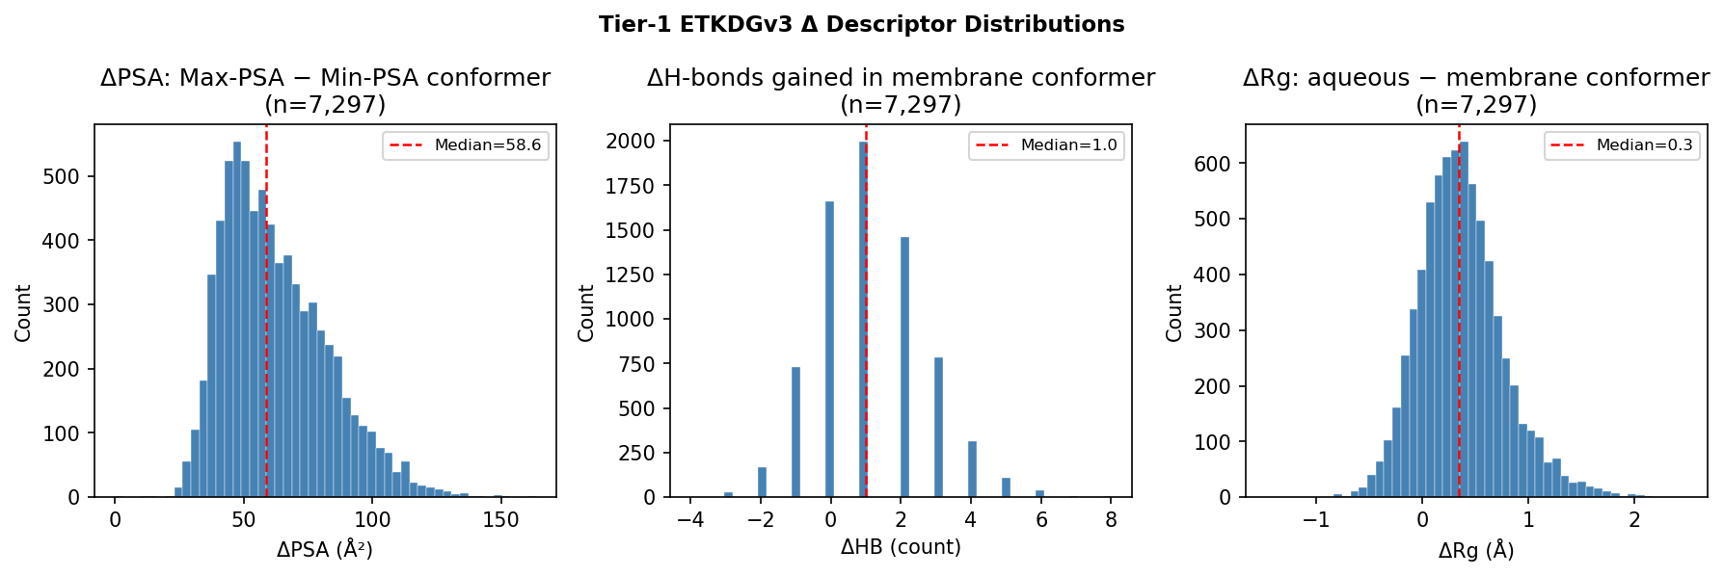
Tier-1 ΔPSA, ΔHB, and ΔRg distributions
*Figure 2. Distributions of Tier-1 ensemble Δ descriptors across 7,297 compounds. Left: ΔPSA spans 0–160 Å² with median ~62 Å², reflecting genuine conformational diversity rather than computational noise. Centre: ΔHB distribution — the median cyclic peptide gains approximately one intramolecular hydrogen bond in the membrane conformer, the molecular-level mechanism of chameleonic switching. Backbone amides that donate H-bonds to water in the aqueous conformer instead form intramolecular bonds in the membrane conformer, burying polar surface area and reducing the desolvation penalty. Right: ΔRg shows slight compaction of the membrane conformer (median ~0.3 Å), thermodynamically expected in a low-dielectric environment where exposed polar groups carry a desolvation penalty that drives the molecule toward a more compact, internalized state.*
The ΔHB panel carries particular mechanistic weight: at population scale, the median cyclic peptide in this dataset gains +1 intramolecular hydrogen bond in the membrane conformer. This is consistent with the proposed molecular mechanism of chameleonic switching — backbone amides forming intramolecular H-bonds in low-dielectric environments — operating across thousands of structurally diverse compounds. The conformers are selected by a PSA-extremum heuristic rather than physics-based solvation simulation, so this H-bond gain reflects a correlation with chameleonic potential rather than a direct measurement of the solution-phase switch.

3.4 Reference Compound Validation Against NMR-Grounded Literature
The Tier-1 pipeline was validated against CsA, whose conformational switch has been directly observed by NMR spectroscopy in CDCl₃/hexane and DMSO/H₂O (Witek 2016⁷: 57–79 NOE restraints per conformer; Rüdisser 2023: eNOE backbone RMSD 0.10 Å).
Compound | Permeable | Tier-1 ΔPSA (Å²) | Literature ΔPSA | Validation
CsA (Cyclosporin A) | Yes | **84.9** | ~75 Å²⁷ | ✓ within 10%
DP172 | Yes | 88.9 | — | strongest case
HexPep | No | 64.4 | — | —
1NMe3 | Yes | 47.8 | — | —
PSLYF | No | 65.3 | — | —

CsA ΔPSA = 84.9 Å² vs. NMR-grounded literature ~75 Å²⁷, within 10%. This single-compound agreement is encouraging and consistent with the ensemble approach capturing a real conformational signal, though one data point is insufficient to constitute rigorous validation. DP172 (88.9 Å², permeable) provides a second supporting case without a literature reference for direct comparison. Notably, HexPep (impermeable, PAMPA −6.20) and 1NMe3 (permeable, PAMPA −5.52) — both hexapeptides — show raw ΔPSA values of 64 and 48 Å² respectively, yet ΔPSA fails to discriminate their opposing permeability outcomes. This is consistent with the sub-9-residue size limitation identified in Section 4: small cyclic scaffolds lack sufficient backbone flexibility to execute the intramolecular H-bond rearrangement that drives chameleonic switching, so absolute ΔPSA carries no mechanistic meaning for them regardless of its magnitude.

3.5 Descriptor Performance: Source-Stratified vs. Full Dataset
Features were ranked by AUC-ROC on both the full 7,298-compound dataset and the 1,566-compound source-stratified subset (Furukawa 2016² + Chugai).
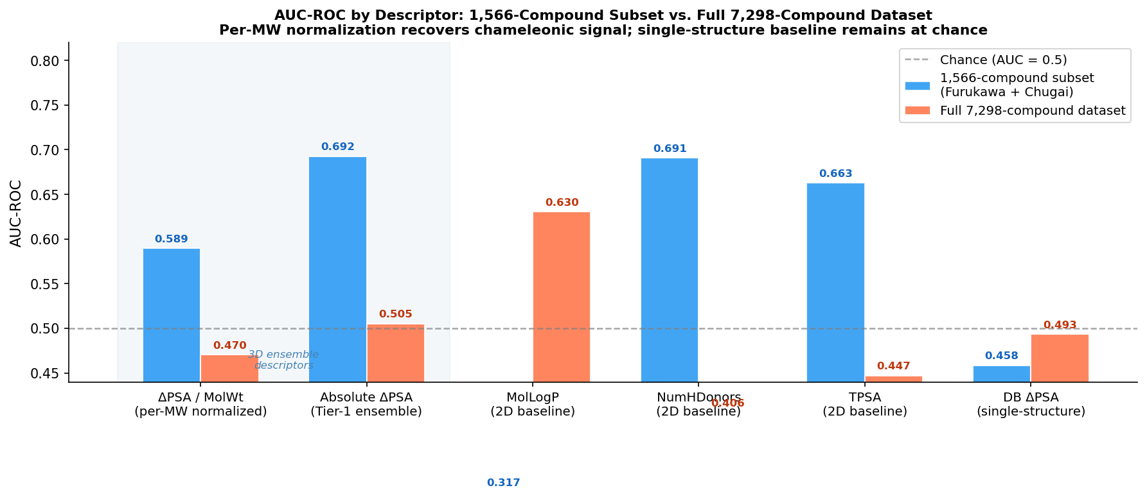
AUC-ROC by descriptor
*Figure 3. AUC-ROC for key descriptors on both the 1,566-compound source-stratified subset (blue) and full 7,298-compound dataset (orange), including the per-MW normalized descriptor introduced in Section 3.8. The per-MW normalized ΔPSA and absolute ΔPSA are highlighted (shaded region) as the 3D ensemble descriptors. Notable: MolLogP inverts on the 1,566-compound clean subset (AUC = 0.317, i.e. 0.683 flipped) — chameleonic macrolides are large and polar yet highly permeable, reversing the standard lipophilicity/permeability relationship.*
Descriptor | 1,566 compounds | Full 7,298
delta_psa3d / MolWt (per-MW normalized) | 0.589 | 0.470
delta_psa3d (Tier-1 ensemble, absolute) | **0.692** | 0.505
MolLogP (2D baseline) | 0.317† (inv. 0.683) | **0.630**
NumHDonors (2D baseline) | 0.691 | 0.406
TPSA (2D baseline) | 0.663 | 0.447
delta_3DPSA_db (single-structure negative control) | 0.458 | 0.493

*†MolLogP AUC = 0.317 on the 1.5k indicates inverse prediction (flipped AUC = 0.683): chameleonic macrolides are polar yet permeable, reversing the standard lipophilicity rule.*
Ensemble ΔPSA (0.692) is the top descriptor on the clean source-stratified subset. On the full dataset it collapses to 0.505 while MolLogP remains stable at 0.630 — because lipophilicity is a molecular property indifferent to assay protocol, whereas ensemble ΔPSA, measuring a conformational switch, is selectively degraded by label noise from pooled assays (Townsend 2020⁸, ~42%; Kelly 2021⁹, ~21%).
The MolLogP inversion on the 1.5k is mechanistically informative: large chameleonic macrolides are more polar than smaller cyclic peptides yet dominate the permeable population in the clean data, actively reversing the lipophilicity/permeability relationship that holds at the population scale of the full dataset. This inversion disappears in the 7k because label noise re-mixes the populations.
The single-structure negative control (delta_3DPSA_db) is stable and near chance at both scales (0.458/0.493), confirming that ensemble sampling — not source stratification alone — drives the 1.5k signal.

3.6 UMAP Chemical Space Structure
Three feature panels were analyzed: Panel A (7 2D descriptors), Panel B (8 3D Δ descriptors), and Panel C (combined 9-feature set).
Panel A — 2D descriptors (baseline):
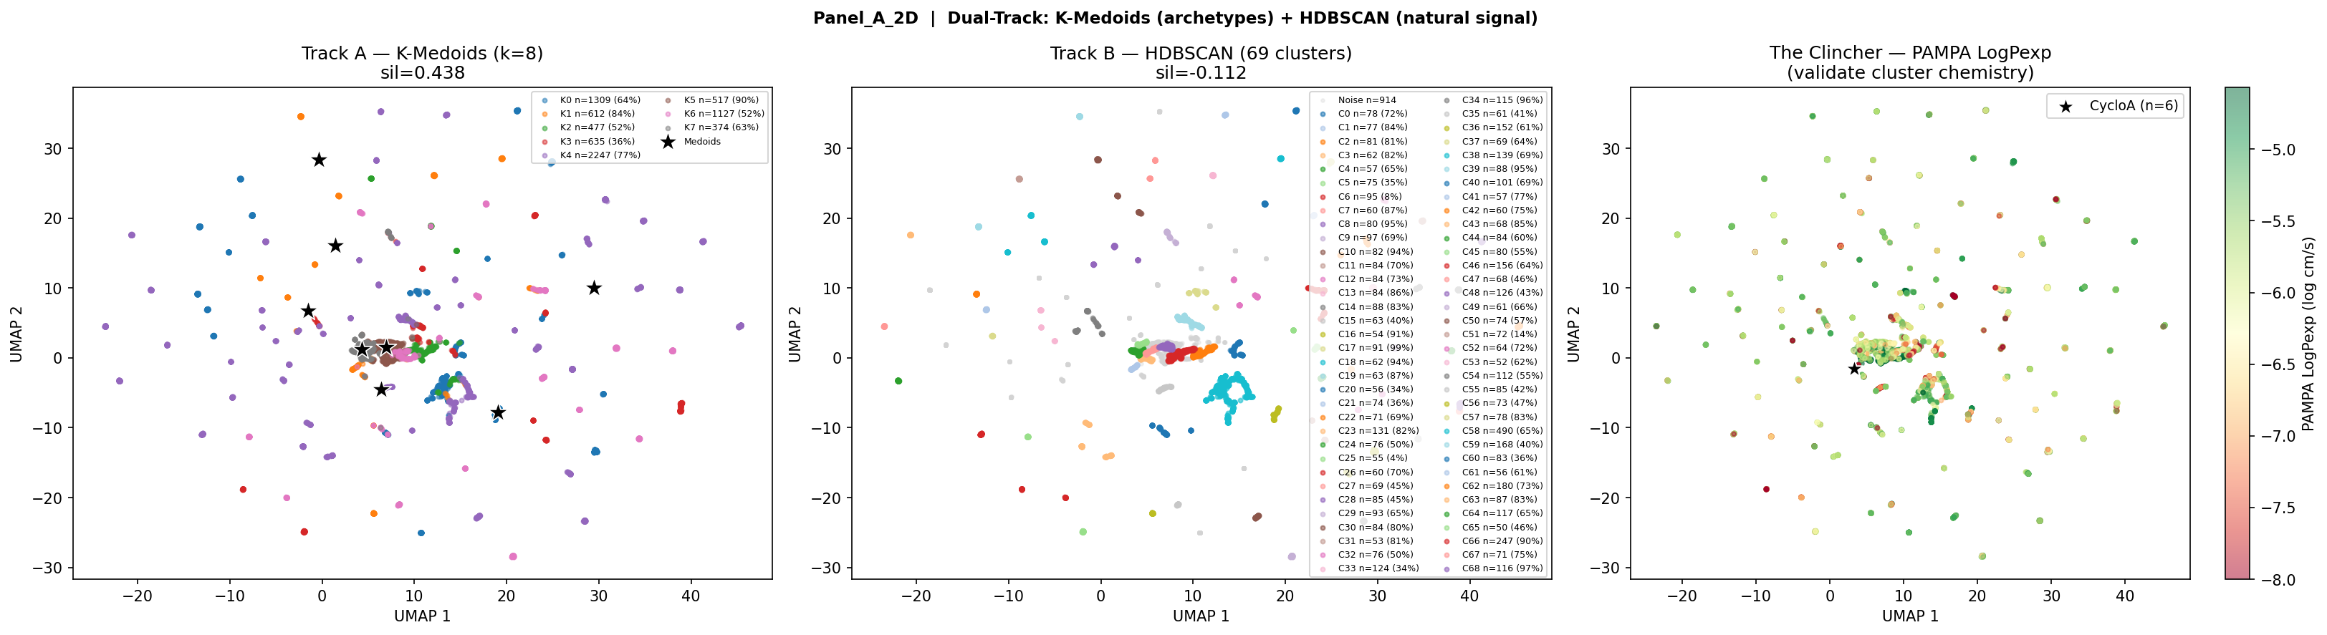
Panel A: 2D descriptor UMAP
*Figure 4. Panel A UMAP (2D descriptors only). K-Medoids forces 8 clusters but none carry biological signal. HDBSCAN identifies 69 micro-clusters with negative silhouette (−0.112) and no permeability enrichment visible in the clincher panel. This is the conformationally blind baseline: knowing a molecule's static physicochemical properties alone provides no useful structure in permeability space.*
Panel B — 3D Δ features (the core result):
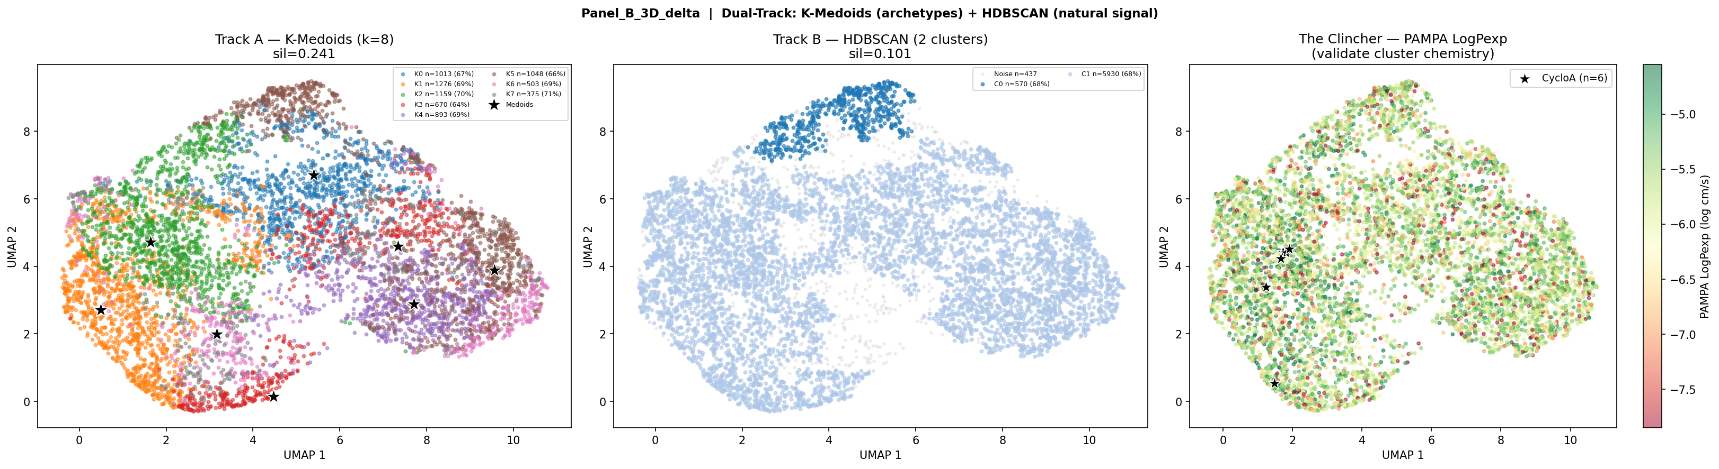
Panel B: 3D delta descriptor UMAP
*Figure 5. Panel B UMAP (3D Δ descriptors only). In the ensemble conformer feature space, structure emerges without forcing it. HDBSCAN identifies two natural populations: C0 (695 compounds, 73% permeable) and C1 (481 compounds, 25% permeable) — a 48-point enrichment gap with no cluster count parameter specified. The clincher panel (right) makes the signal unambiguous: PAMPA LogPexp maps continuously onto the UMAP embedding, with permeable compounds concentrated in the C0 region. This is the qualitative proof that 3D conformational descriptors capture a chemically real permeability signal absent in 2D descriptor space.*
Panel C — Combined features, source-stratified 1,566 compounds:
ARI stability: min = 0.995 across 5 seeds — one dominant chemical structure in the combined 2D+3D feature space.
Cluster | n | Perm rate | Enrichment
HDBSCAN C0 | 883 | **87.8%** | 1.16×
HDBSCAN C1 | 651 | 59.3% | 0.78×

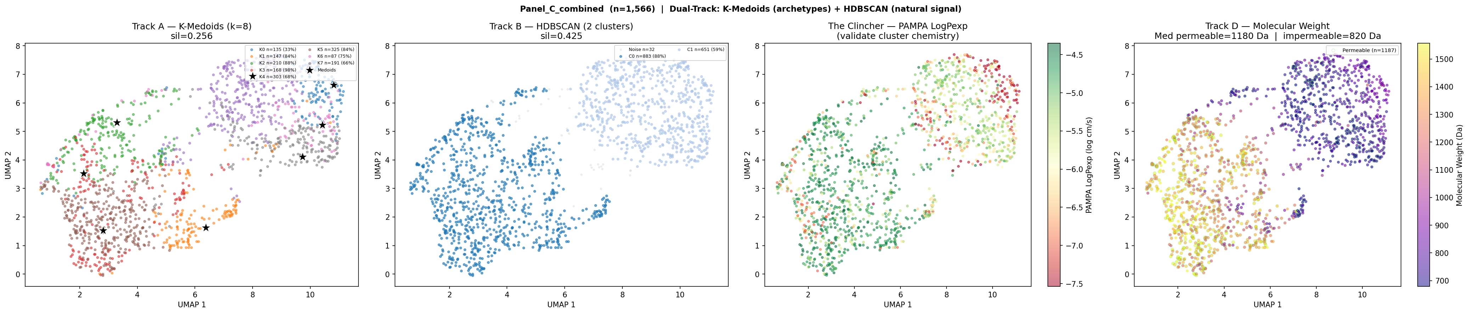
Panel C 1566 + Track D
*Figure 6. Panel C UMAP on 1,566-compound source-stratified subset (Furukawa + Chugai), with Track D molecular weight coloring added as a fourth subplot. The embedding is highly stable (min ARI = 0.995 across 5 seeds). C0 (87.8% permeable) occupies the high-MW, high-temperature region of the plasma colormap. Limegreen permeable compound rings concentrate almost entirely in the large-macrolide region. C1 (59.3% permeable, lower MW) is not impermeable — it is simply unenriched — consistent with a population achieving permeability through N-methylation or lipophilicity rather than chameleonic switching.*

3.7 Track D: Molecular Weight Gates Chameleonic Behavior
The fourth subplot (Track D) introduced in this experiment colors the Panel C embedding by molecular weight, revealing the size structure underlying the two-population pattern.
Population | Median MW
Permeable (PAMPA ≥ −6) | **1,180 Da**
Impermeable | 820 Da
Ratio | **1.44×**

Panel C — Full 7,298-compound dataset (same panel, different label quality):
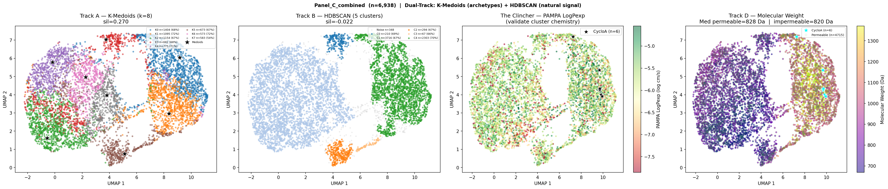
Panel C 6938 + Track D
*Figure 7. Panel C UMAP on the full 6,938-compound dataset with Track D molecular weight coloring. The 1.44× MW gap between permeable and impermeable populations that is clearly visible on the clean 1,566-compound data (Fig. 6) vanishes entirely here — both populations converge to a median MW of ~820 Da. The cross-source PAMPA labels are not merely noisy; they actively invert the MW/permeability relationship that exists on homogeneous data. Large chameleonic compounds are being labeled impermeable (or vice versa) by incompatible pooled-assay protocols, destroying the size signal that is the clearest evidence of chameleonic gating.*
Metric | 1,566 compounds | 6,938 compounds
HDBSCAN silhouette | 0.425 | **−0.022**
Best cluster perm rate | 87.8% | 70.3%
Enrichment range | 0.78–1.16× | 0.97–1.03×
Median MW permeable | **1,180 Da** | 820 Da
Median MW impermeable | 820 Da | 820 Da

The 1.44× MW gap is the most direct experimental-scale evidence in this analysis that label quality — not descriptor quality — limits performance at population scale. When the labels are clean, the signal is there. When they are not, the signal disappears and the descriptor looks like chance.

3.8 Per-MW Normalization as a Mechanism Filter
The MW cluster separation in Track D raised an immediate question: is the overall AUC of 0.692 a genuine chameleonic signal, or is absolute ΔPSA partly functioning as a molecular size proxy — rewarded because larger compounds happen to be more permeable in this source-stratified subset? To investigate, we computed delta_psa3d_per_mw = ΔPSA / MolWt × 1000 (Å² per kDa) and compared AUC within each size bucket against the absolute descriptor.
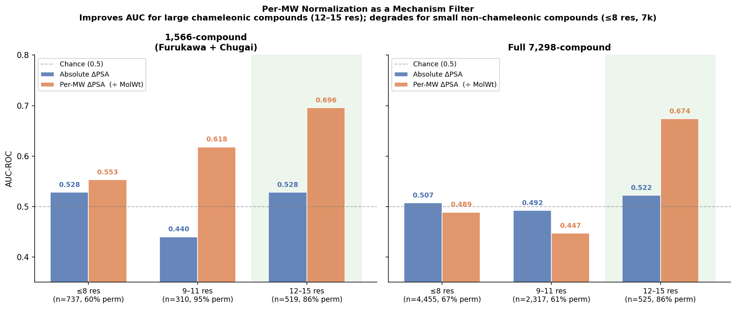
Per-MW normalization AUC comparison
*Figure 8. AUC-ROC for absolute ΔPSA vs. per-MW normalized ΔPSA, stratified by monomer length, on the 1,566-compound (left) and full 7,298-compound (right) datasets. Green shading highlights the 12–15 residue bucket where normalization consistently improves AUC. Per-MW normalization improves within-class discrimination for large chameleonic compounds and degrades it for small non-chameleonic compounds — the same size boundary identified by Track D MW coloring, reached from a completely independent analytical direction.*
Size bucket | n (1.5k) | Absolute AUC | Per-MW AUC | Δ AUC
≤8 residues | 737 | 0.528 | 0.553 | +0.025
9–11 residues | 310 | 0.440* | 0.618* | —
12–15 residues | 519 | 0.528 | **0.696** | **+0.168**

*\*9–11 residue bucket is 94.8% permeable (only ~16 impermeable compounds); AUC unreliable due to class imbalance.*
Size bucket | n (7k) | Absolute AUC | Per-MW AUC | Δ AUC
≤8 residues | 4,455 | 0.507 | 0.489 | −0.018
9–11 residues | 2,317 | 0.492 | 0.447 | −0.045
12–15 residues | 525 | 0.522 | **0.674** | **+0.152**

The pattern is unambiguous and mechanistically interpretable. For large compounds (12–15 residues), removing the size effect from ΔPSA reveals a stronger chameleonic efficiency signal: AUC rises from 0.528 to 0.696 in the clean data, and from 0.522 to 0.674 even in the noisy full dataset. For small compounds (≤8 residues) in the full 7k, normalization *degrades* AUC — because ΔPSA was never measuring their permeation mechanism. Dividing a mechanistically irrelevant descriptor by MW does not recover a chameleonic signal; it just amplifies noise.
This asymmetry — normalization improves discrimination for large compounds and degrades it for small ones — independently reproduces the same size boundary identified by Track D without using MW as a feature. This is consistent with the two-population model and argues against the UMAP separation being a pure size artifact of the descriptor, though it does not rule out other size-correlated properties as the underlying driver.

4. Interpretation: Two Mechanisms, One Descriptor Space
The results support a two-mechanism model of passive cyclic peptide permeability that the current descriptor set can partially resolve.
Mechanism 1 — Chameleonic switching (large macrolides, ≥9 residues): In the 1,566-compound clean dataset, compounds of 9–11 residues are 94.8% permeable and 12–15 residues are 86.3% permeable — both substantially above the baseline rate of 75.8%. These compounds have sufficient backbone flexibility to form stabilizing intramolecular H-bonds in apolar environments, collapsing polar surface area and reducing the desolvation penalty of membrane entry. CsA (MW 1,203 Da, 11 residues, ΔPSA = 84.9 Å²) is the archetypal example⁷. 3D ensemble ΔPSA is mechanistically appropriate for this population: the descriptor is measuring the physical property that drives permeation.
Mechanism 2 — Non-chameleonic permeation (smaller cyclic peptides, ≤8 residues): The ≤8-residue population in the clean 1,566-compound data is 60.4% permeable — these compounds ARE permeating, but ΔPSA is essentially uninformative for them (AUC = 0.528). Smaller cyclic scaffolds may achieve PAMPA permeability through N-methylation (reduced backbone HBD count), intrinsic lipophilicity, or amide-to-ester substitution¹⁰ — mechanisms proposed in the literature that do not require a large conformational switch. These are not directly tested in this dataset; what the data show is that ΔPSA is uninformative for this population (AUC = 0.528), which is consistent with but does not prove an alternative mechanism. Further experiments targeting the ≤8-residue population specifically would be required to identify what drives their permeability.
What the overall AUC of 0.692 actually measures: Size-stratified analysis reveals that ΔPSA within each residue-count bucket performs only marginally above chance (AUC 0.44–0.53). The overall 0.692 arises primarily from *between-group* discrimination — large compounds have high absolute ΔPSA (more atoms = more PSA potential) AND high permeability rates in the clean data. This means absolute ΔPSA is partly functioning as a molecular size proxy, not a pure chameleonic efficiency measure. This is not a failure of the approach — it is a known consequence of using unnormalized descriptors, and it is precisely the confound that Yu et al.³ address with their dimensionless ΔPSA/SASA_total ratio.
The 7k inversion as corroborating evidence: In the full 7,298-compound dataset, the 9–11 residue permeability rate inverts to 60.9% — *below* the ≤8-residue rate of 67.1%. In the clean 1.5k it is 94.8%. This specific inversion of the size-permeability relationship for the compounds where chameleonic switching is most expected is consistent with pooled-assay label noise (Townsend 2020⁸, Kelly 2021⁹) disproportionately corrupting the largest, most MS-complex compounds. It is a mechanistically specific degradation, not uniform noise.
What 3D descriptors demonstrate in this work: The ensemble ΔPSA approach shows that (1) for chameleonic macrolides, conformational sampling recovers a real permeability signal absent in single-structure methods; (2) the chemical space separates into a high-MW chameleonic population and a lower-MW non-chameleonic population visible in UMAP; and (3) the descriptor is silent on the non-chameleonic population, which sets a clear boundary on the scope of the method. The concurrent work of Yu et al.³ independently arrives at the same two-population model: analyzing conformational cluster occupancy across solvents, they explicitly find that *"small cyclic peptides (7 residues) exhibit all five clusters with similar proportions in both solvents, confirming the absence of significant conformational switching"* and apply a ≥9-residue size gate for their ΔPSA framework. Their dimensionless ΔPSA/SASA_total ratio is the normalization that addresses the molecular-size confound identified in Section 3.8 — and it is the next descriptor to implement (see Section 6, Experiment 1).

5. Conformer Model and Proposed Validation
ETKDGv3 is appropriate for population-scale screening but is a distance geometry heuristic, not a physics-based simulation of solvent-dependent conformational equilibria. The conformer selection heuristic (max PSA = aqueous, min PSA = membrane) assumes the vacuum ensemble contains conformers representative of solution-phase endpoints — an assumption validated by the CsA result (ΔPSA = 84.9 vs. ~75 Å²⁷) but not systematically tested across the dataset. Critically, vacuum conformer sampling ignores solvation-dependent energy barriers: conformers that are low-energy in CHCl3-mimetic implicit solvent may be sterically accessible in vacuum but kinetically inaccessible in solution, and vice versa. Implicit solvent models (ALPB, GBSA) or explicit solvent MD would more faithfully sample the solution-phase ensemble, at the cost of substantially greater computational expense.
The current state-of-the-art open-source pipeline for macrocyclic peptide conformer generation is the CREMP workflow¹¹: ETKDGv3 generates an initial diverse pool (up to 5,000 conformers) which CREST¹² then re-ranks using GFN2-xTB energetics. This treats ETKDGv3 and CREST as complementary rather than competing. We propose the following validation on local compute resources:
Validation set: 5 reference compounds (CsA, DP172, HexPep, 1NMe3, PSLYF) + 5 randomly selected compounds from each HDBSCAN cluster (C0 and C1) = 15 compounds total.
Protocol: ETKDGv3 (5,000 conformers) → CREST re-ranking (GFN2-xTB + ALPB solvation, water then CHCl3) → ΔPSA computed from CREST ensemble.
Success criterion: Spearman ρ > 0.8 between ETKDGv3 Tier-1 ΔPSA and CREST ΔPSA across the 15-compound set, and preserved binary permeable/impermeable classification. If the rank order is preserved, ETKDGv3 is validated as sufficient for population-scale pre-filtering. If it is disrupted, ETKDGv3 should be used only as a diversity generator with CREST re-ranking for compounds of interest.

6. Next Experiments
Priority | Experiment | Status | Hypothesis
✓ Done | Per-MW normalization (`delta_psa3d / MolWt`); AUC by size bucket | Complete (this work) | Normalization improves large-compound AUC, degrades small-compound AUC — confirmed two-mechanism boundary
1 | `delta_psa3d_per_sasa` = ΔPSA / SASA_total (Yu et al.³ approach); rerun AUC on 1,566 compounds | Next | Dimensionless normalization outperforms per-MW; recovers signal within size classes
2 | `delta_psa3d_per_residue` = ΔPSA / Monomer_Length; compare to per-MW and per-SASA | Next | Per-residue captures chameleonic efficiency independently of MW
3 | Filter `Monomer_Length ≥ 9`; compare AUC with and without cutoff on Furukawa-only subset | Next | Explicit size gate improves signal; confirms chameleonic threshold
4 | Exclude Chugai (unverified protocol); rerun on Furukawa only | Next | Chugai is inflating or deflating the 1.5k AUC; Furukawa-only gives cleaner baseline
5 | ETKDGv3 → CREST validation on 15-compound reference set | Next | ETKDGv3 rank order is preserved vs. CREST/ALPB solvation

References
1. Jiang, Y. et al. CycPeptMPDB: a comprehensive database of membrane permeability of cyclic peptides. *J. Chem. Inf. Model.* 63, 1936–1943 (2023). https://doi.org/10.1021/acs.jcim.2c01573
2. Furukawa, A. et al. Passive membrane permeability in cyclic peptides is robust to extensive structural variation. *J. Med. Chem.* 59, 9503–9512 (2016). https://doi.org/10.1021/acs.jmedchem.6b01246
3. Yu, Y. et al. Normalized polar surface area as a descriptor for chameleonic cyclic peptide permeability. *bioRxiv* (2026). https://doi.org/10.64898/2026.01.06.697862
4. Wang, S., Witek, J., Landrum, G. A. & Riniker, S. Improving conformer generation for small rings and macrocycles based on distance geometry and experimental torsional-angle preferences. *J. Chem. Inf. Model.* 60, 2044–2058 (2020). https://doi.org/10.1021/acs.jcim.0c00025
5. Riniker, S. & Landrum, G. A. Better informed distance geometry: using what we know to improve conformation generation. *J. Chem. Inf. Model.* 55, 2562–2574 (2015). https://doi.org/10.1021/acs.jcim.5b00654
6. Schärfer, C. et al. CONFORGE: a versatile and high-performance conformer generator. *J. Chem. Inf. Model.* 63, 5819–5831 (2023). https://doi.org/10.1021/acs.jcim.3c00563
7. Witek, J. et al. Kinetic and thermodynamic analysis of cyclosporin A solution conformations. *J. Chem. Theory Comput.* 12, 3861–3873 (2016).
8. Townsend, C. E. et al. Cyclic peptide membrane permeability measurements via high-throughput screening. *ChemRxiv* (2020; preprint). https://doi.org/10.26434/chemrxiv.13335941.v1
9. Kelly, C. N. et al. Iterative parallel synthesis and permeability measurement identifies macrocycle architectures with enhanced cell permeability. *J. Am. Chem. Soc.* 143, 8655–8667 (2021). https://doi.org/10.1021/jacs.0c06115
10. Bockus, A. T. et al. Probing the physicochemical boundaries of cell permeability and oral bioavailability in lipophilic macrocycles inspired by natural products. *J. Med. Chem.* 58, 4581–4589 (2015).
11. Klarich, K. L. et al. CREMP: conformer-rotamer ensemble of macrocyclic peptides for machine learning. *Sci. Data* 11, 759 (2024). https://doi.org/10.1038/s41597-024-03698-y
12. Pracht, P., Bohle, F. & Grimme, S. Automated exploration of the low-energy chemical space with fast quantum chemical methods. *Phys. Chem. Chem. Phys.* 22, 7169–7192 (2020). https://doi.org/10.1039/C9CP06869D
13. Bannwarth, C., Ehlert, S. & Grimme, S. GFN2-xTB — an accurate and broadly parametrized self-consistent tight-binding quantum chemical method with multipole electrostatics and density-dependent dispersion contributions. *J. Chem. Theory Comput.* 15, 1652–1671 (2019). https://doi.org/10.1021/acs.jctc.8b01176

