**Introduction**

On this Review of the Literature, we are going to talk about the three institutions and the description of the vaccination processes provided by each institution, the software used by the users and potentially the management software used if they respond to our email.

Also, we are going to talk about the features of the integrative project at hands that can come handy to the area we are now researching.

**DGS**

The DGS is the Health Department of the Portuguese Government, which works as the Ministry of Health service.

The General Directorate of Health was founded by Decree on the 4th of October 1899, with the name of Directorate-General for Health and Public Beneficence, because of the need to combat an outbreak of bubonic plague that devastated the city of Porto that year. Its main purpose was to improve defense against future epidemics.

**The Mission:**

Regulate, guide and coordinate health promotion and disease prevention activities, define the technical conditions for adequate provision of health care, plan, program the national policy for quality in the health system, as well as ensure the preparation and execution of the National Health Plan and the coordination of the Ministry of Health's international relations.

DGS is consisted by:

- ARS ALENTEJO

- ARS ALGARVE

- ARS CENTRO

- ARS LVT

- ARS NORTE

These 3 Centre of Vaccinations that we are working on belong to the ARS Norte.

**Centre of Vaccination**

**(Centro de vacinação do Cerco) -> Cerco Centre of Vaccination**

- Rua Dr José António Marques 23 4300, 4300-016 Porto, Portugal.

**(Centro de vacinação Internacional) -> International Centre of Vaccination**

- Rua da Alegria 1057, 4000-048 Porto, Portugal.

**(Associação Desportiva e Recreativa da Unidade Local de Saúde Matosinhos) -> Sportive and Recreative Association Of The Local Health Care Matosinhos**

- Rua Alfredo Cunha 365, Matosinhos, Portugal.

**Vaccination process**

The overall vaccination process is identical in all institutions, when a person goes to the centre, personal information is collected, such as the user number, identification number, number of Health User.

After that, a form is requested to be filled out where questions related to medication are asked, among others (factors that may influence the taking of the vaccine), the person waits to be his turn to receive the vaccine, and after taking it he goes to a recovery room, where he will stay for x minutes to monitor possible reactions to the vaccine.

After 15 days you can retrieve your Certificate of Vaccination if it is from Covid-19 vaccine or else it will be on your Vaccine Card with the sticker of the vaccine you took.

**Vaccination Centre (Portugal)**

It is Centres where exists vaccine administrations made by the nurses or doctors’ present on each centre, these places follow a specific set of rules and procedures made by SNS24 that is the National Health Service on Portugal.

**Porto related to the Vaccines on Covid-19**

On Portugal the readiness for the vaccination against Covid-19 was quick.

Porto built a large-scale vaccination program on April 6th, 2021.

Porto City Hall has built a robust program for the administration of vaccines in the city, with a capacity to inoculate circa two thousand people per day; the drive-thru Vaccination Centre, set up in the Queimódromo, is ready to go since February. The Municipality of Porto has been in constant communication with the two ACES [Health Centre Groups) in the city and articulated the availability of vaccination sites.

Taken from” https://www.porto.pt/en/news/porto-built-a-large-scale-vaccination-programme-but-it-needs-vaccines-in-place ”.

**Curiosity about one app created by the Italy Government:**

**APP IO: Introduction**

When talking about the vaccination process during the last COVID-19 pandemic, the Italy Government stood out in a lot of aspects, in the application of the innovative technologies, which brought multiple benefits that helped throughout the entire process (With the creation of the *App IO*). During the pandemic, they even have provided economic financial aids with the objective of equipping the less wealthy people with IT (with the mobile technology, with digitalization kits and smartphones) with the intention of minimizing the digital divide between the population.

Due to these reasons and more, the Italy Government is a splendid example of how the technology can be useful in pandemic circumstances and should be followed as an example to other countries in the future.

**The software used:**

The Italy Government, in 2020, launched an app called *App IO* which has the objective of being a unique access point to simply and securely interact with local and national services directly from the smartphone, such: as tax payments, view of personal documents, receipt of messages and/or notices from several entities (e.g.: Civil Protection), cashback and much more, including the issue of the COVID-19 vaccination certificate. To use the application, each user must register with their SPID (Public Digital Identity System) credentials or with the CIE (Electronic Identity Card).

**Figure 1 - App IO oficial logo**

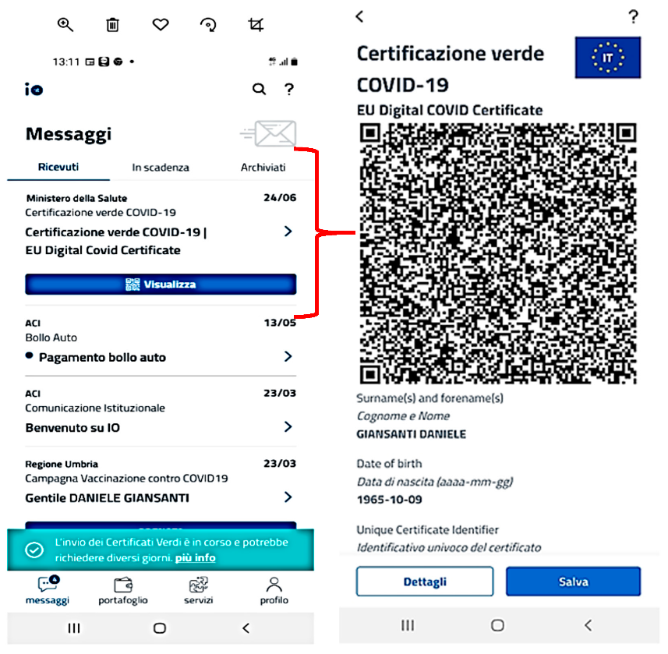

Among the multiple features that this application offers, and which have already been mentioned above, it is also through this application that priority processes related to vaccination are managed (namely by the Italian Ministry of Health). This means that, at any time, each user can be updated (by the “Messages” section) regarding the vaccination process in their country, such as the vaccination priority of a certain age group (e.g.: 70 to 90) or from specific domains (e.g.: personnel in the health domain, teachers…), as the pandemic evolves. Also, as mentioned before, it is possible to issue a COVID-19 vaccination certificate, as we can see on the left:

**Figure 2 - Example of the issue of a vaccination certificate on App IO**

Taken From:

“R. Simeoni, G. Maccioni, and D. Giansanti, “The vaccination process against the covid-19: Opportunities, problems and mhealth support,” *Healthc.*, vol. 9, no. 9, 2021”

“IO, l’app dei servizi pubblici.”

“ https://io.italia.it”

**SNS24**

The Application is SNS24.

The App used by the DGS is from SNS that also is Health Department of the Portuguese Government, but this entity guarantees the right to health to all the citizens of Portugal, just to improve the quality of life of all citizens of Portugal.

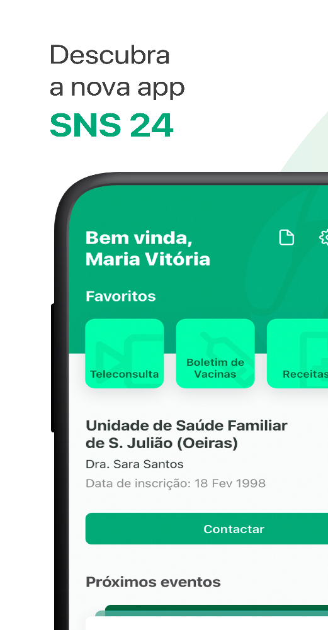

Figure 3- App SNS24.

Built according to the citizen's interest, the SNS 24 App gathers citizens' health information in an application residing on their smartphone or tablet.

Through this application, citizens can access a wide range of health information, namely their Vaccination Bulletin, their Recipes, Allergies, or their exam requests.

In addition, services are available that allow the recording of specific health measurements (Glycemia, Blood Pressure, Body Mass Index), the realization of Teleconsultations or the possibility of requesting the renewal of Habitual Medication.

**Integrative Project**

**Contribution**

This software will be useful for managing the vaccination process (E.g.: Schedule a vaccination) and managing the vaccination centers to get reports, statistics, charts with the data of the vaccination process.

The application will be implemented in console and graphical user interface(JavaFX).

This application will have the following features:

-> Monitoring Vaccination Process.

- >Request Certificate of the Vaccination.

- >Register a new vaccine.

- >Register a new SNS User.

- >Register a new Employee.

- >Register a new vaccine type.

- >Specify a new vaccine and its administration process.

- >Register a new vaccination Center.

- >Get a list of employees with a given function/role.

- >Issues and send Vaccination Certificate.

- >Check the list of SNS Users at the Vaccination Centre.

- >Checks SNS User info and health condition.

- >Register the administrated vaccine.

- >Register reactions.

- >Generate reports.

- >Analyze data from other centers.

**Comparing to App IO (Italian Ministry of Health)**

The App IO has some features mentioned above in the section “Institutions and respective software’s:” .

The Integrative Project application stands out from the App IO in the aspect of being more useful for the center coordinators manage the vaccination centers (E.g.: get reports and statistics). In the field of getting the Covid-19 vaccination certificate the applications are similar. Unlike the App IO, the DGS application has a feature to schedule a vaccine administration.

A feature that is better in the App IO is the login functionality. This app allows the user to login with fingerprint or facial recognition. The DGS app only allows email and password.

**Conclusion**

On Conclusion, this literature helps us to understand a bit more about the vaccination processes on the three institutions, also their software that is the same, we couldn´t know about the management software used because they did not respond to our email, we just know that they use the same database.

Comparing with integrative project, the project itself can help on the part of the management on gaining more utilities related to for example: distinct types of vaccine, vaccine itself and the creation of the new SNS Users ,new employees, also new vaccination centers.