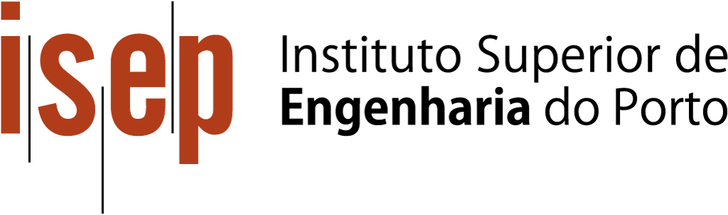

**Literature Review Report**

**LAPR2**

**Grupo 12 – 1DC**

Karysia Mendes 1191394

Guilherme Marques 1181151

Hugo Miranda 1201047

Mário Borja 1200586

04/2021

Professor Ana Barata

Professor Carlos Ferreira

Jorge Cunha 1200618

Daniel Monteiro 1191899

# Introduction

For the group project ‘’Sprint 1’’ from the UC of LAPR2, which started on the second semester of 2020/2021, the group was given the task of selecting two major laboratories of our choosing to do some research on them. We were tasked to search for what kind of services the laboratories offered, if they had a management app, how that app worked and what was its purpose. We also researched about their websites and what kind of information they offered to the user/client.

With this kind research our group elements were able to retain a certain basic knowledge on what and how these same labs worked and their overall goals.

Since our integrative project is based on a functioning laboratory, we need to know what we are working with, in this case, by researching, learning and understanding how other labs run themselves instead of just having shallow knowledge on the area.

This is where the group project ‘’Sprint 2’’ from the same UC previously mentioned comes in. Not only is it a way to improve how to select, analyse and structure information in order to write a paper/report, consequently it is a way to deepen our knowledge on the topic from the previous ‘’Sprint 1’’.

Both laboratories selected have a major focus on cancer research, which we believe to be an important area. The purpose of this report is to compare already existent management software on various laboratories to our own integrated projects program which is to be developed during the entire second semester.

# The Laboratories

∙ Cleveland Clinic Laboratory

When we researched for Cleveland Clinic Laboratories (CCL), we got into their website to find that it was very easy to understand, very clean and simple. They had a way to help clients find a doctor for their need, order a test, schedule an appointment, etc.

This clinic provides comprehensive care for patients with cancer. They provide multidisciplinary cancer programs designed to streamline care and improve patient outcomes such as:

∙ Breast Cancer Program;

∙ Head & Neck Cancer Program;

∙ Multiple Myeloma Program;

∙ Rare Cancers and Blood Diseases;

∙ … [1]

On their website there is a Health Library [2] where you can search diseases and also their treatments. The website also shows several departments that are part of the major clinic (Cleveland Center), these include:

∙ Anaesthesiology & Pain Management;

∙ Bariatric & Metabolic Institute;

∙ Cancer Center / Taussig Cancer Institute;

∙ Nursing Institute;

∙ Pathology & Laboratory Medicine;

∙ Respiratory Institute;

∙ Urology & Kidney Institute (Glickman);

∙ Wellness & Preventive Medicine. [3]

Despite their well-organized website, they didn’t have information about their management app and they didn’t answer the groups emails asking about said management software. Despite of it, they had a partner listed on their website called LIMS.

After further research on LIMS, we discovered that it is a laboratory information management system, sometimes referred to as a laboratory information system or laboratory management system. It is a software-based solution with features that support a modern laboratory's operations.

This software helps to manage a laboratory, data and procedural workflows, connecting with other enterprise systems, equipment and (most important) customers, to deliver increased productivity across the business.

On the Appendix, we have an image that shows how LIMS workflow is processed.

∙ Majumder Laboratory

As mentioned previously, both laboratories chosen are related to cancer research. The Majumder Laboratory is located in Texas and has several areas of research.

When looking for more information relative to this laboratory we went to their website (integrated in the general website of MDAnderson). This allowed us to have a look at how well it structures its webpage as well as providing access to their research, publications, members information and a way to contact them.

Majumder Laboratory research focus mainly on deciphering the mechanisms that control normal development and how aberrations of such mechanisms produce diseases and investigating how such knowledge can be translated into improved patient care.[4]

The lab begins by studying molecular mechanisms and then build on the lessons learned from those studies using a multidisciplinary approach that “encompasses genomics, bioinformatics, biochemistry, cell biology and mouse genetics.” This lab focuses on his work by having collaboration between scientists and clinicians. [5]

It also as a big involvement in genetics area, having a Genetics and Epigenetics Program and cooperating with several facilities in that area such as [4]:

∙ Advanced Technology Genomics Core (ATGC)

∙ CPRIT Integrated Single Cell Genomics Center (Single Core)

∙ Cytogenics and Cell Authentication Core (CCAC)

∙ Genetically Engineered Mouse Facility (GEMF)

Even though we tried to contact the laboratory through email we could not get a response back so there were a few doubts left unanswered, one of them being about the existence of a management app.

After looking for it there still wasn’t a sign of the lab having a management app, so its fair to conclude that either it doesn’t have one at all or that it just isn’t available for the public to access.

# Analysis

Despite both laboratories working on cancer each one has a different specialization regarding that area. The Majumber Laboratory works primarily on brain tumors and its research, having a close relation with genetics as well, while Cleveland Clinic Laboratories as a wider variety of diseases such as breast cancer, head, neck cancer and other rare cancers.

Majumber Laboratory is a research laboratory which means it focuses mainly on research itself rather than providing the possibility of getting tested and diagnosed, although patients can still donate samples voluntarily to aid with it. This means that the members in this lab work towards breakthroughs in the area as well as investigating how such knowledge can be translated into improved patient care.

As said before, the Cleveland Clinic Laboratories gives out many services to the patients with cancer providing programs made so that it will help the patient also there is the Health Library where you can see some diseases and their treatment and even have COVID-19 tests.

# Conclusion

This project had as main objective the creation of a report regarding the previous two laboratories selected in ‘’Sprint 1’’, which meant even more research on those since the information we had before was severely lacking.

However, with the writing of the report several smaller goals and values came to be acquired throughout its composition such as: improving our English skills, learning how to cooperate effectively as a group, choosing relevant information as well as structuring it, among other less relevant ones.

We still think that the most important part of this project, despite all the other benefits that it brought us, was the deeper insight it gave us on how these labs function since the main project being developed this semester, the integrative project, has mainly to do with a laboratory as well as its functions and systems.

This is a way of not only getting to know the work world in this area but also to give us an head start in solving several problems that showed or might show up in the future during the development of this same integrative project.

To conclude, our group as a whole agreed that this type of research related other ongoing projects was an overall success, especially when it brings several other benefits improving members performance along with it.

# References

[1] Cleveland Clinic Laboratory. ‘Internal Training Programs’. [Online]. Available: https://my.clevelandclinic.org/departments/health-sciences-education/training-programs/in-house-training-programs [27-Apr-2021].

[2] Cleveland Clinic Laboratory. ‘Health Library’. [Online]. Available: https://my.clevelandclinic.org/health [27-Apr-2021].

[3] Cleveland Clinic Laboratory. ‘Institutes and Departments’. [Online]. Available: https://my.clevelandclinic.org/departments [27-Apr-2021].

[4] Majumber Laboratory. ‘Research Focus’. [Online]. Available: https://www.mdanderson.org/research/departments-labs-institutes/labs/majumder-laboratory.html [27-Apr-2021].

[5] Majumber Laboratory. ‘Research’. [Online]. Available: https://www.mdanderson.org/research/departments-labs-institutes/labs/majumder-laboratory/research.html [27-Apr-2021].

# Annexes

. Annex 1

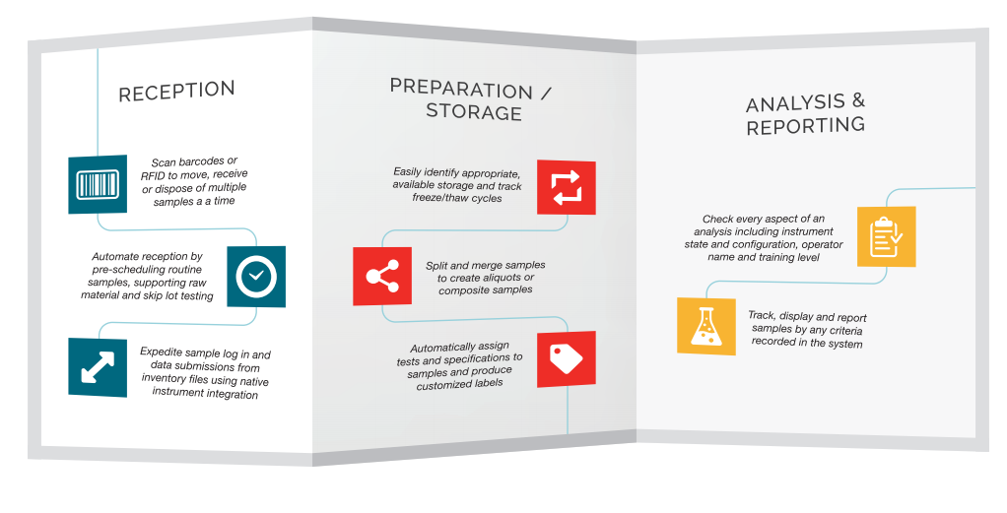

Annex 1 - LIMS Workflow