

Universidad de Guadalajara

Centro Universitario de Ciencias Exactas e Ingenierías

DIVISIÓN DE TECNOLOGÍAS PARA LA INTEGRACIÓN CIBER-HUMANA

DEPARTAMENTO DE CIENCIAS COMPUTACIONALES

Practica 2

TEMA: Redes Neuronales Convolucionales (CNN)

NOMBRE DEL ESTUDIANTE:

Padilla Perez Jorge Daray

NOMBRE DE LA MATERIA: Seminario de Solución de Problemas de Inteligencia Artificial II

SECCIÓN: D05

CALENDARIO: 2024-B

NOMBRE DEL PROFESOR: JAVIER AUGUSTO GALVIS CHACON

Contents

Introduccion 2

Resultados 2

a) Prueba 1: Modelo CNN desde cero 2

b) Prueba 2: Modelo con Transfer Learning 5

Vgg16 5

ResNet50 6

InceptionV3 18

3. Ajuste de Hiperparámetros y Fine-tuning: 18

Pantallazos 18

Codigo-Fuente 18

Conclusiones 18

# Introduccion

# Resultados

## a) Prueba 1: Modelo CNN desde cero

Epoch 1/20

158/158 ━━━━━━━━━━━━━━━━━━━━ 152s 883ms/step - accuracy: 0.2487 - loss: 2.6821 - val_accuracy: 0.1998 - val_loss: 5.1386

Epoch 2/20

158/158 ━━━━━━━━━━━━━━━━━━━━ 24s 151ms/step - accuracy: 0.3395 - loss: 1.9211 - val_accuracy: 0.2245 - val_loss: 3.0953

Epoch 3/20

158/158 ━━━━━━━━━━━━━━━━━━━━ 24s 149ms/step - accuracy: 0.3996 - loss: 1.7852 - val_accuracy: 0.4212 - val_loss: 1.8967

Epoch 4/20

158/158 ━━━━━━━━━━━━━━━━━━━━ 24s 151ms/step - accuracy: 0.4148 - loss: 1.7371 - val_accuracy: 0.5215 - val_loss: 1.5496

Epoch 5/20

158/158 ━━━━━━━━━━━━━━━━━━━━ 24s 149ms/step - accuracy: 0.4279 - loss: 1.7086 - val_accuracy: 0.5478 - val_loss: 1.4147

Epoch 6/20

158/158 ━━━━━━━━━━━━━━━━━━━━ 24s 149ms/step - accuracy: 0.4574 - loss: 1.5929 - val_accuracy: 0.5669 - val_loss: 1.2986

Epoch 7/20

158/158 ━━━━━━━━━━━━━━━━━━━━ 24s 151ms/step - accuracy: 0.4968 - loss: 1.4962 - val_accuracy: 0.5868 - val_loss: 1.2330

Epoch 8/20

158/158 ━━━━━━━━━━━━━━━━━━━━ 24s 149ms/step - accuracy: 0.4766 - loss: 1.5104 - val_accuracy: 0.6330 - val_loss: 1.0780

Epoch 9/20

158/158 ━━━━━━━━━━━━━━━━━━━━ 24s 151ms/step - accuracy: 0.5023 - loss: 1.4676 - val_accuracy: 0.6513 - val_loss: 1.0867

Epoch 10/20

158/158 ━━━━━━━━━━━━━━━━━━━━ 24s 150ms/step - accuracy: 0.5299 - loss: 1.4184 - val_accuracy: 0.5725 - val_loss: 1.2591

Epoch 11/20

158/158 ━━━━━━━━━━━━━━━━━━━━ 24s 150ms/step - accuracy: 0.5287 - loss: 1.4071 - val_accuracy: 0.6003 - val_loss: 1.2434

Epoch 12/20

158/158 ━━━━━━━━━━━━━━━━━━━━ 24s 150ms/step - accuracy: 0.5321 - loss: 1.3831 - val_accuracy: 0.6218 - val_loss: 1.1531

Epoch 13/20

158/158 ━━━━━━━━━━━━━━━━━━━━ 24s 151ms/step - accuracy: 0.5538 - loss: 1.3188 - val_accuracy: 0.6831 - val_loss: 0.9791

Epoch 14/20

158/158 ━━━━━━━━━━━━━━━━━━━━ 24s 150ms/step - accuracy: 0.5608 - loss: 1.3217 - val_accuracy: 0.7134 - val_loss: 0.8552

Epoch 15/20

158/158 ━━━━━━━━━━━━━━━━━━━━ 24s 151ms/step - accuracy: 0.5862 - loss: 1.2284 - val_accuracy: 0.6632 - val_loss: 1.1249

Epoch 16/20

158/158 ━━━━━━━━━━━━━━━━━━━━ 24s 150ms/step - accuracy: 0.5775 - loss: 1.2596 - val_accuracy: 0.7412 - val_loss: 0.8851

Epoch 17/20

158/158 ━━━━━━━━━━━━━━━━━━━━ 24s 150ms/step - accuracy: 0.5958 - loss: 1.2370 - val_accuracy: 0.7484 - val_loss: 0.7892

Epoch 18/20

158/158 ━━━━━━━━━━━━━━━━━━━━ 24s 150ms/step - accuracy: 0.6074 - loss: 1.1697 - val_accuracy: 0.7436 - val_loss: 0.8292

Epoch 19/20

158/158 ━━━━━━━━━━━━━━━━━━━━ 24s 151ms/step - accuracy: 0.6020 - loss: 1.1881 - val_accuracy: 0.6887 - val_loss: 0.9887

Epoch 20/20

158/158 ━━━━━━━━━━━━━━━━━━━━ 24s 149ms/step - accuracy: 0.6175 - loss: 1.1792 - val_accuracy: 0.7142 - val_loss: 0.9443

Model: "sequential"

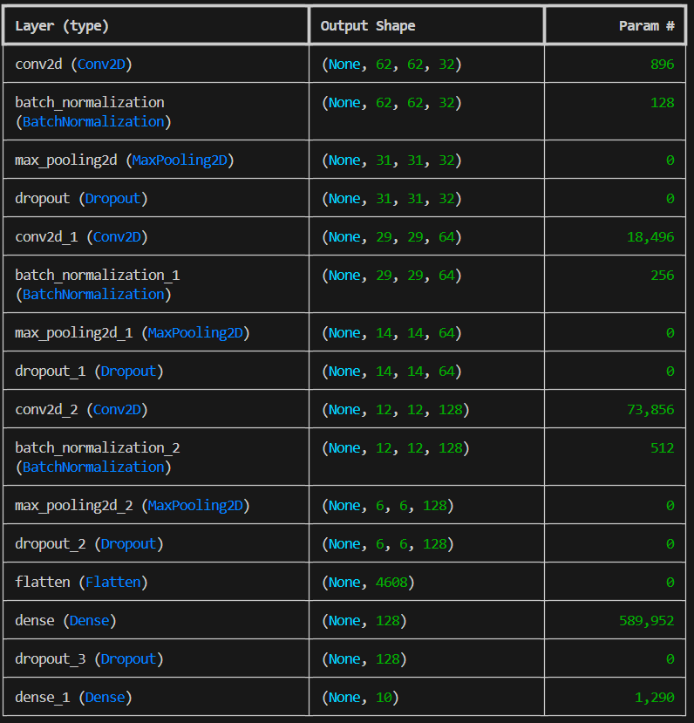

Total params: 2,055,264 (7.84 MB)

Trainable params: 684,938 (2.61 MB)

Non-trainable params: 448 (1.75 KB)

Optimizer params: 1,369,878 (5.23 MB)

## b) Prueba 2: Modelo con Transfer Learning

### Vgg16

Downloading data from https://storage.googleapis.com/tensorflow/keras-applications/vgg16/vgg16_weights_tf_dim_ordering_tf_kernels_notop.h5

58889256/58889256 ━━━━━━━━━━━━━━━━━━━━ 14s 0us/step

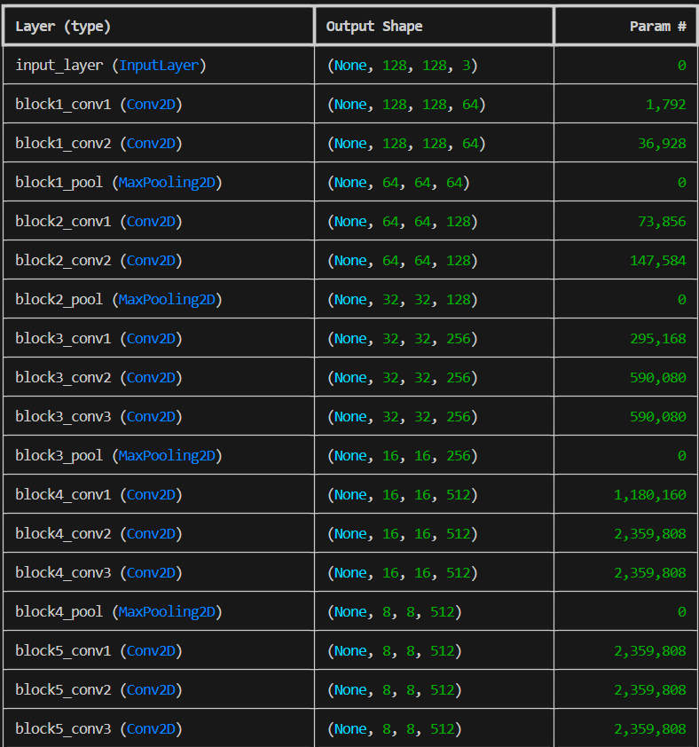

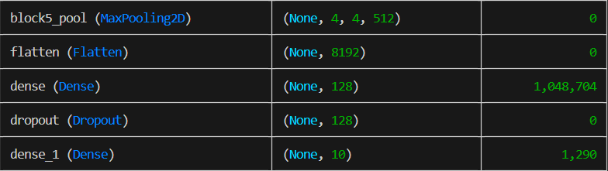

Model: "functional"

Total params: 15,764,682 (60.14 MB)

Trainable params: 1,049,994 (4.01 MB)

Non-trainable params: 14,714,688 (56.13 MB)

### ResNet50

Downloading data from https://storage.googleapis.com/tensorflow/keras-applications/resnet/resnet50_weights_tf_dim_ordering_tf_kernels_notop.h5

94765736/94765736 ━━━━━━━━━━━━━━━━━━━━ 8s 0us/step

Model: "functional"

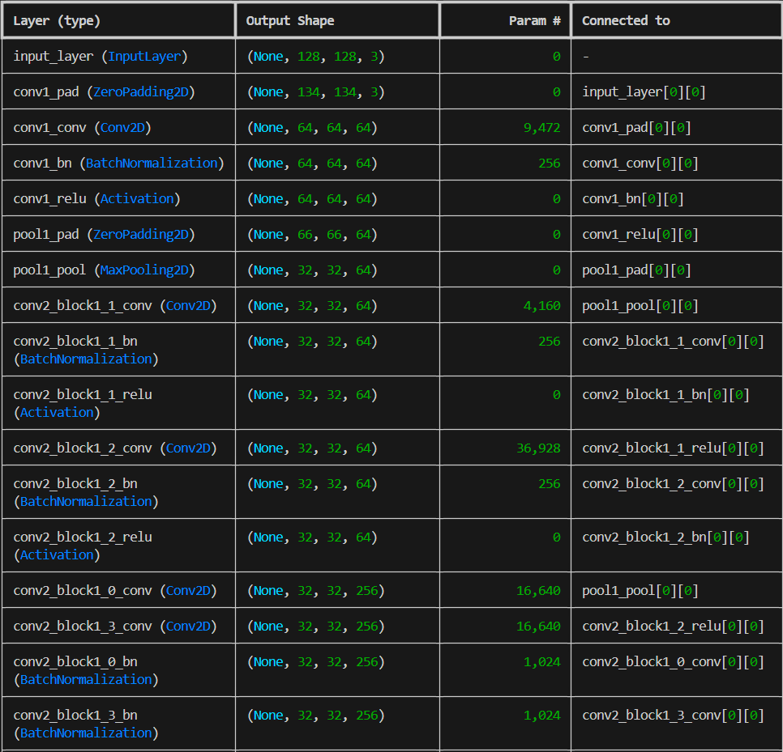

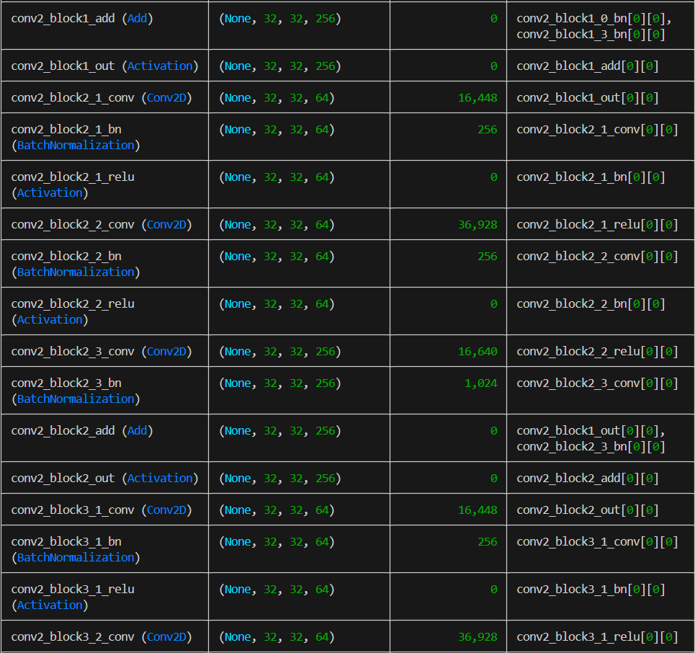

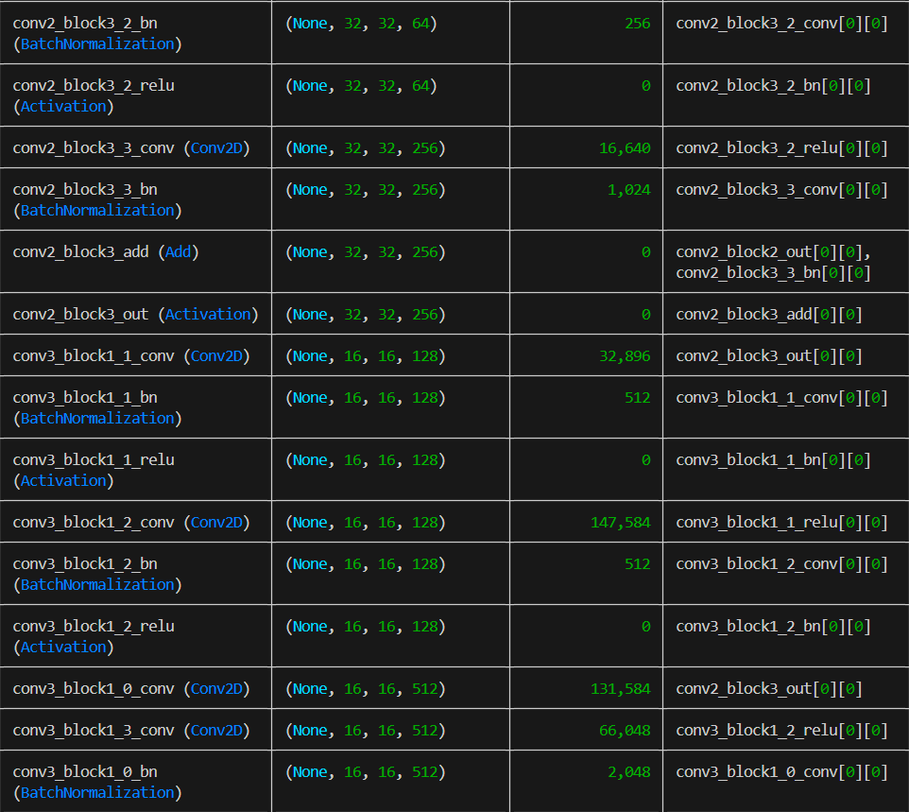

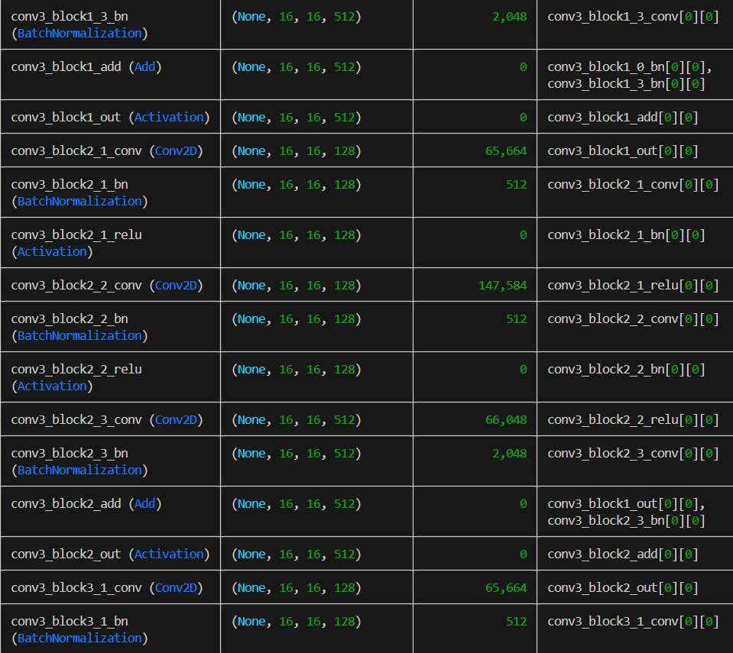

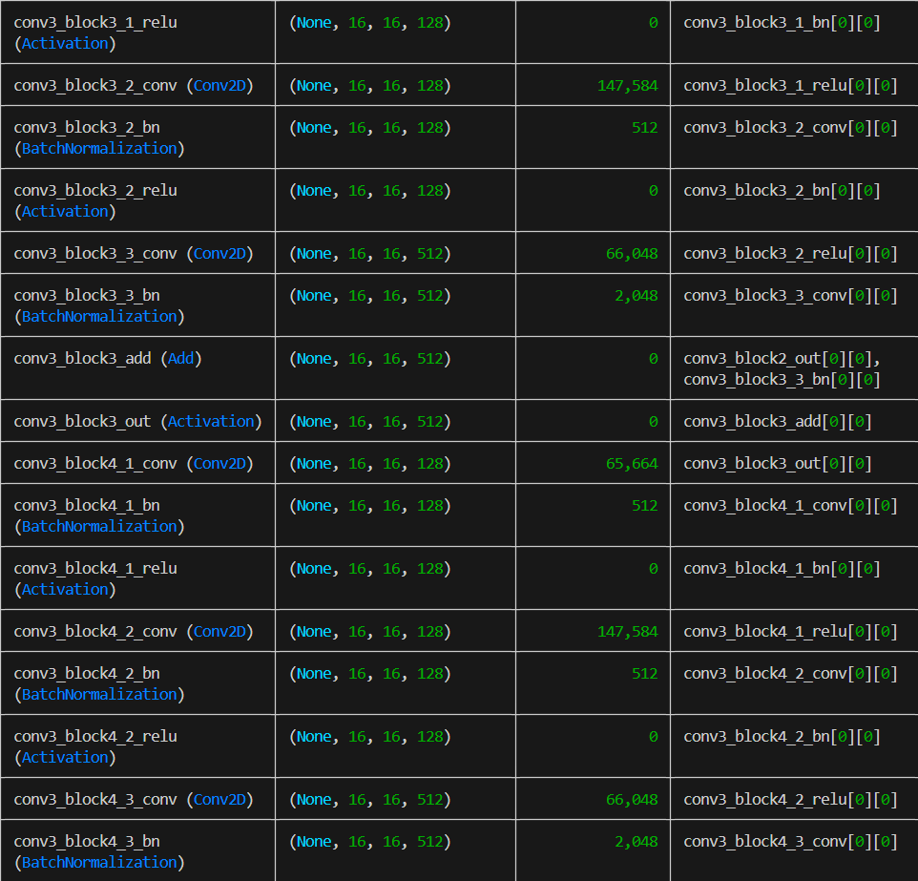

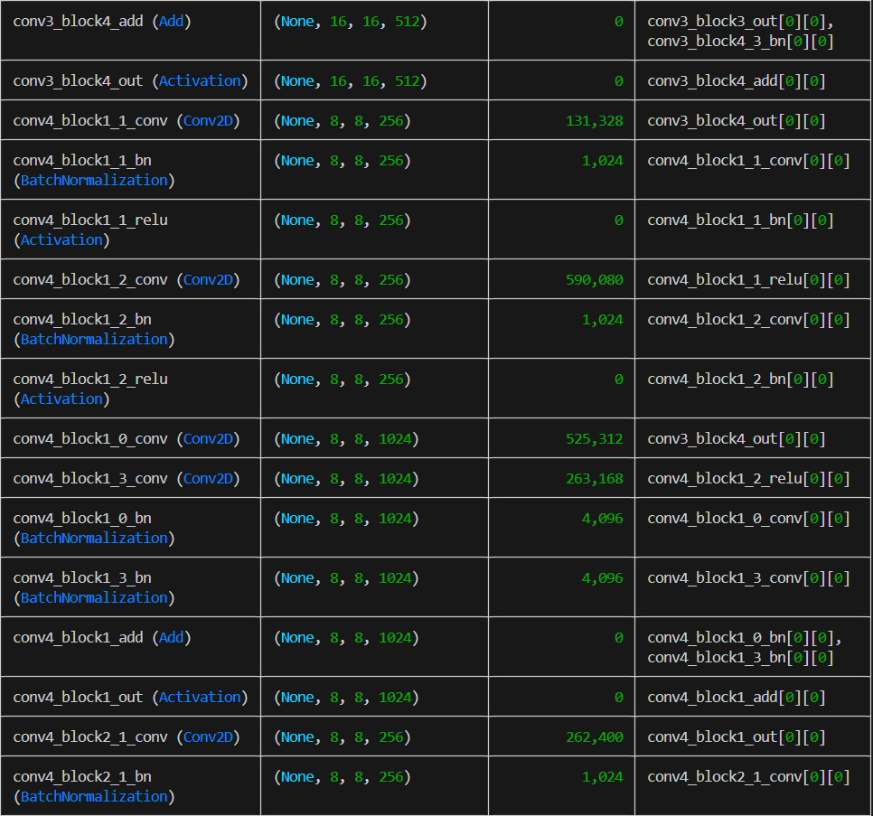

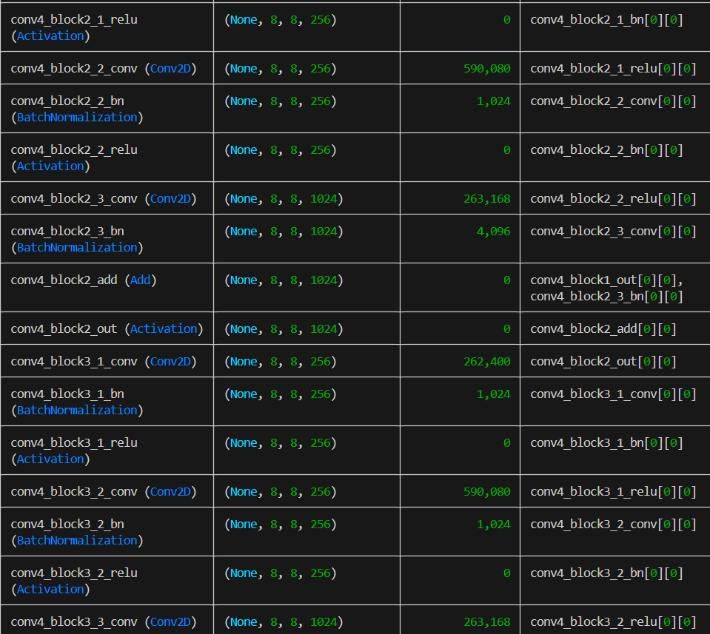

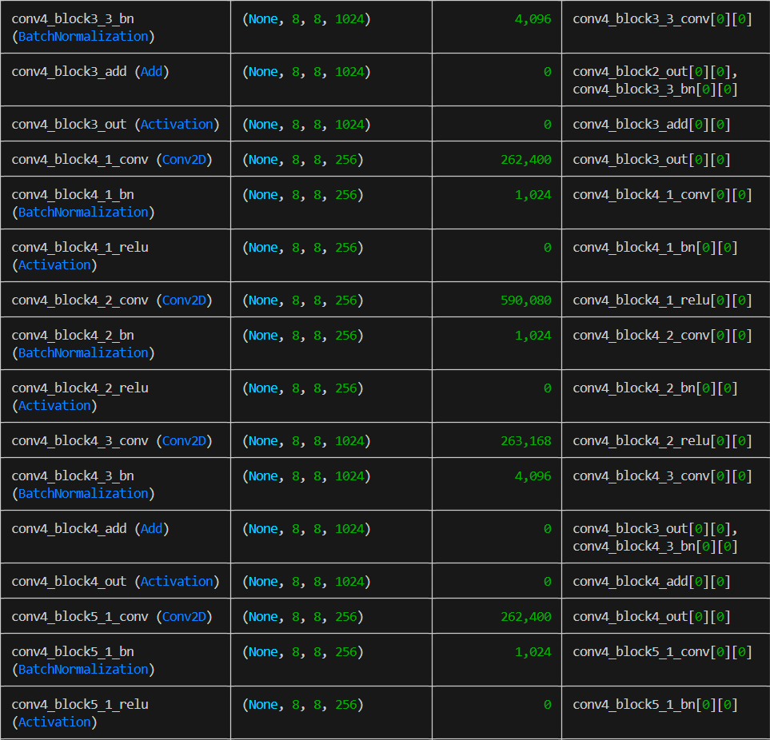

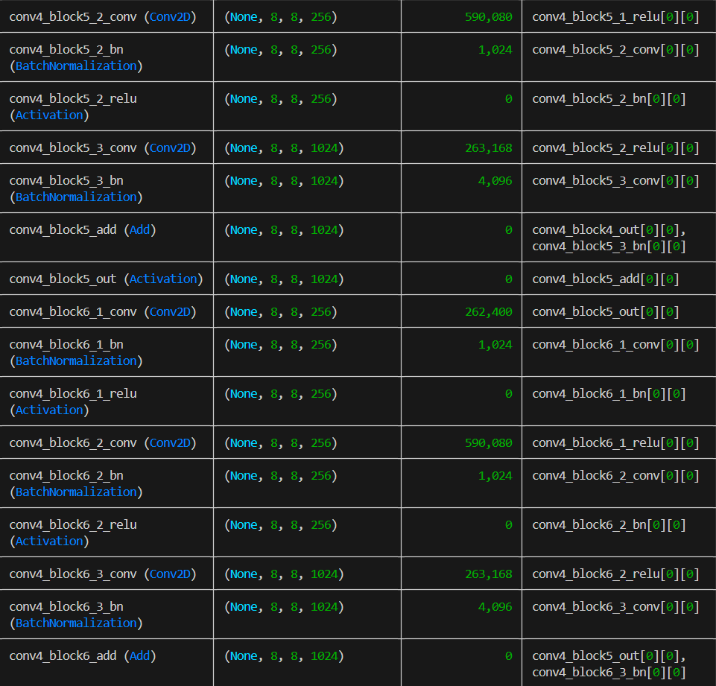

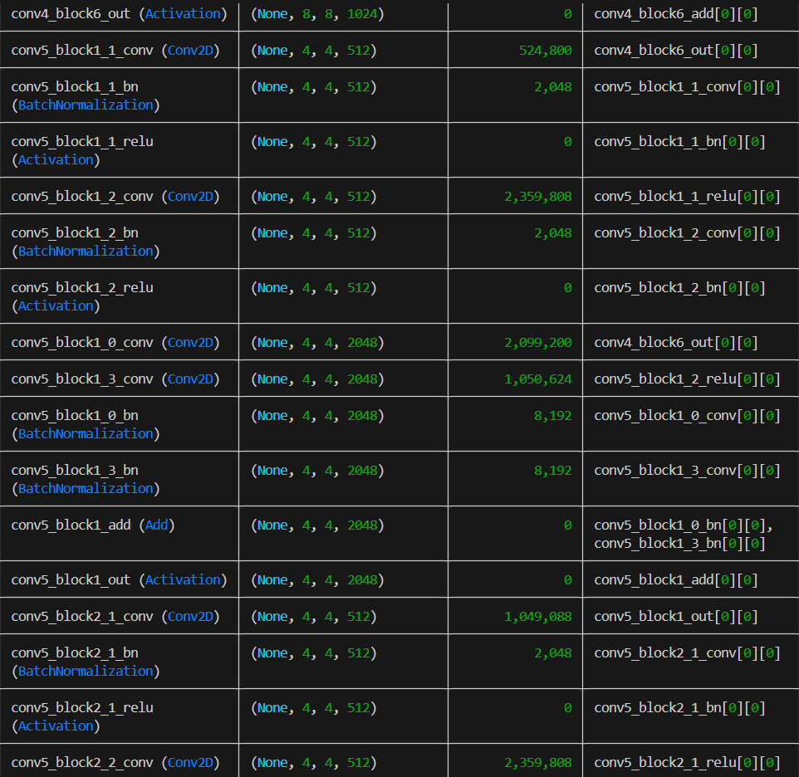

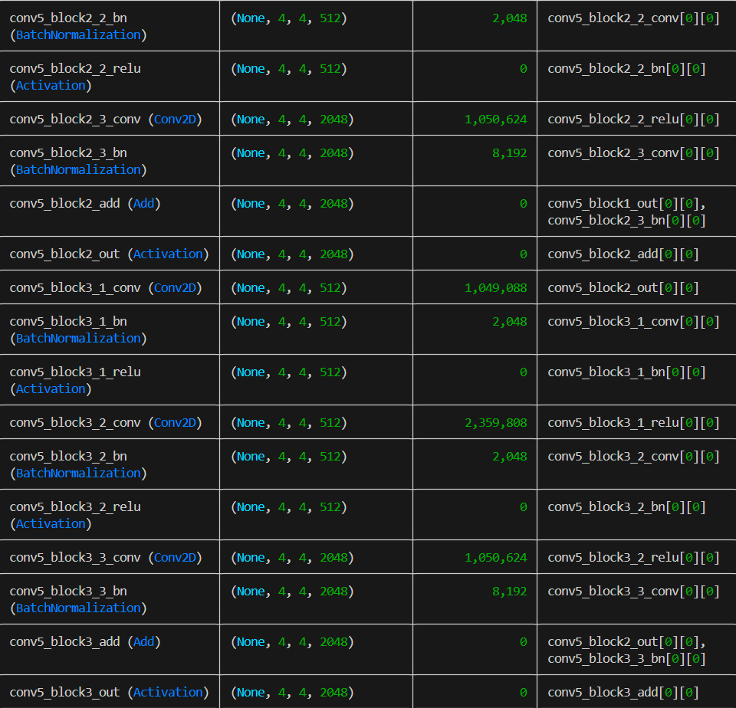

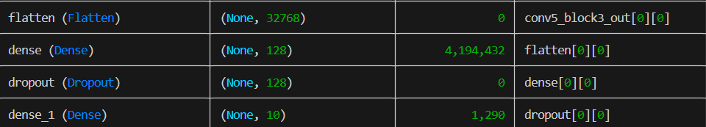

Total params: 27,783,434 (105.99 MB)

Trainable params: 4,195,722 (16.01 MB)

Non-trainable params: 23,587,712 (89.98 MB)

### InceptionV3

Downloading data from https://storage.googleapis.com/tensorflow/keras-applications/inception_v3/inception_v3_weights_tf_dim_ordering_tf_kernels_notop.h5

87910968/87910968 ━━━━━━━━━━━━━━━━━━━━ 10s 0us/step

Model: "functional"

Es mucho concidero yo .

Total params: 22,852,778 (87.18 MB)

Trainable params: 1,049,994 (4.01 MB)

Non-trainable params: 21,802,784 (83.17 MB)

# 3. Ajuste de Hiperparámetros y Fine-tuning:

## Intento 1

Capas convolucionales: 3 (32, 64, 128 filtros).

Capas densas: 2 (128 y 10 neuronas).

Tasa de aprendizaje: 0.0001.

Épocas de entrenamiento: 20.

**Entrenamiento**

Epoch 1/20

158/158 ━━━━━━━━━━━━━━━━━━━━ 0s 694ms/step - accuracy: 0.1755 - loss: 3.0943

158/158 ━━━━━━━━━━━━━━━━━━━━ 129s 742ms/step - accuracy: 0.1757 - loss: 3.0906 - val_accuracy: 0.1775 - val_loss: 4.4247

Epoch 2/20

158/158 ━━━━━━━━━━━━━━━━━━━━ 24s 151ms/step - accuracy: 0.2922 - loss: 2.0505 - val_accuracy: 0.1919 - val_loss: 4.0960

Epoch 3/20

158/158 ━━━━━━━━━━━━━━━━━━━━ 24s 152ms/step - accuracy: 0.3376 - loss: 1.9528 - val_accuracy: 0.3225 - val_loss: 2.3217

Epoch 4/20

158/158 ━━━━━━━━━━━━━━━━━━━━ 24s 149ms/step - accuracy: 0.3711 - loss: 1.8437 - val_accuracy: 0.5159 - val_loss: 1.5404

Epoch 5/20

158/158 ━━━━━━━━━━━━━━━━━━━━ 24s 151ms/step - accuracy: 0.3940 - loss: 1.7784 - val_accuracy: 0.5677 - val_loss: 1.3055

Epoch 6/20

158/158 ━━━━━━━━━━━━━━━━━━━━ 24s 150ms/step - accuracy: 0.4220 - loss: 1.7162 - val_accuracy: 0.5828 - val_loss: 1.2533

Epoch 7/20

158/158 ━━━━━━━━━━━━━━━━━━━━ 24s 150ms/step - accuracy: 0.4483 - loss: 1.6532 - val_accuracy: 0.6027 - val_loss: 1.2126

Epoch 8/20

158/158 ━━━━━━━━━━━━━━━━━━━━ 24s 155ms/step - accuracy: 0.4544 - loss: 1.5887 - val_accuracy: 0.6361 - val_loss: 1.1142

Epoch 9/20

158/158 ━━━━━━━━━━━━━━━━━━━━ 24s 151ms/step - accuracy: 0.4701 - loss: 1.5612 - val_accuracy: 0.6314 - val_loss: 1.1300

Epoch 10/20

158/158 ━━━━━━━━━━━━━━━━━━━━ 24s 151ms/step - accuracy: 0.4652 - loss: 1.5703 - val_accuracy: 0.6202 - val_loss: 1.1578

Epoch 11/20

158/158 ━━━━━━━━━━━━━━━━━━━━ 24s 151ms/step - accuracy: 0.4809 - loss: 1.5185 - val_accuracy: 0.6417 - val_loss: 1.0854

Epoch 12/20

158/158 ━━━━━━━━━━━━━━━━━━━━ 24s 150ms/step - accuracy: 0.4952 - loss: 1.4947 - val_accuracy: 0.6513 - val_loss: 1.0911

Epoch 13/20

158/158 ━━━━━━━━━━━━━━━━━━━━ 24s 150ms/step - accuracy: 0.5002 - loss: 1.4738 - val_accuracy: 0.6537 - val_loss: 1.1066

Epoch 14/20

158/158 ━━━━━━━━━━━━━━━━━━━━ 23s 148ms/step - accuracy: 0.5229 - loss: 1.4362 - val_accuracy: 0.6473 - val_loss: 1.0800

Epoch 15/20

158/158 ━━━━━━━━━━━━━━━━━━━━ 23s 148ms/step - accuracy: 0.5301 - loss: 1.4193 - val_accuracy: 0.6497 - val_loss: 1.1092

Epoch 16/20

158/158 ━━━━━━━━━━━━━━━━━━━━ 23s 147ms/step - accuracy: 0.5216 - loss: 1.3885 - val_accuracy: 0.6489 - val_loss: 1.1513

Epoch 17/20

158/158 ━━━━━━━━━━━━━━━━━━━━ 23s 148ms/step - accuracy: 0.5397 - loss: 1.3448 - val_accuracy: 0.6561 - val_loss: 1.0941

Epoch 18/20

158/158 ━━━━━━━━━━━━━━━━━━━━ 23s 148ms/step - accuracy: 0.5480 - loss: 1.3540 - val_accuracy: 0.6935 - val_loss: 0.9734

Epoch 19/20

158/158 ━━━━━━━━━━━━━━━━━━━━ 23s 148ms/step - accuracy: 0.5433 - loss: 1.3442 - val_accuracy: 0.6855 - val_loss: 1.0042

Epoch 20/20

158/158 ━━━━━━━━━━━━━━━━━━━━ 24s 149ms/step - accuracy: 0.5600 - loss: 1.3179 - val_accuracy: 0.6632 - val_loss: 1.1103

**Resultado**

1/1 ━━━━━━━━━━━━━━━━━━━━ 1s 688ms/step

Probabilidades predichas: [[7.6634175e-01 1.5471841e-01 1.8256930e-04 2.6065083e-03 2.1045500e-02

1.6118800e-03 2.0995019e-03 2.9583112e-03 1.3356742e-03 4.7099933e-02]]

La imagen pertenece a la clase: ajedrez

## Intento 2

**Entrenamiento**

Número total de capas: 13

Neuronas por capa: 64, 128, 256, 512 (en capas convolucionales), 512, 256 (en capas densas), 10 (capa de salida).

Tasa de aprendizaje: 0.00005

Épocas de entrenamiento: 20

Epoch 1/20

158/158 ━━━━━━━━━━━━━━━━━━━━ 0s 477ms/step - accuracy: 0.1268 - loss: 4.2156

158/158 ━━━━━━━━━━━━━━━━━━━━ 93s 524ms/step - accuracy: 0.1270 - loss: 4.2109 - val_accuracy: 0.1234 - val_loss: 2.8660

Epoch 2/20

158/158 ━━━━━━━━━━━━━━━━━━━━ 47s 299ms/step - accuracy: 0.2310 - loss: 2.5200 - val_accuracy: 0.2126 - val_loss: 2.9034

Epoch 3/20

158/158 ━━━━━━━━━━━━━━━━━━━━ 48s 303ms/step - accuracy: 0.2716 - loss: 2.1844 - val_accuracy: 0.2994 - val_loss: 2.2436

Epoch 4/20

158/158 ━━━━━━━━━━━━━━━━━━━━ 48s 305ms/step - accuracy: 0.2886 - loss: 2.0554 - val_accuracy: 0.4021 - val_loss: 1.7081

Epoch 5/20

158/158 ━━━━━━━━━━━━━━━━━━━━ 48s 306ms/step - accuracy: 0.3238 - loss: 1.9770 - val_accuracy: 0.5151 - val_loss: 1.4257

Epoch 6/20

158/158 ━━━━━━━━━━━━━━━━━━━━ 49s 313ms/step - accuracy: 0.3487 - loss: 1.9247 - val_accuracy: 0.5175 - val_loss: 1.3865

Epoch 7/20

158/158 ━━━━━━━━━━━━━━━━━━━━ 49s 307ms/step - accuracy: 0.3786 - loss: 1.8373 - val_accuracy: 0.5318 - val_loss: 1.3529

Epoch 8/20

158/158 ━━━━━━━━━━━━━━━━━━━━ 48s 303ms/step - accuracy: 0.3924 - loss: 1.7794 - val_accuracy: 0.5318 - val_loss: 1.3455

Epoch 9/20

158/158 ━━━━━━━━━━━━━━━━━━━━ 48s 302ms/step - accuracy: 0.4021 - loss: 1.7535 - val_accuracy: 0.5573 - val_loss: 1.2996

Epoch 10/20

158/158 ━━━━━━━━━━━━━━━━━━━━ 48s 306ms/step - accuracy: 0.4135 - loss: 1.7215 - val_accuracy: 0.5621 - val_loss: 1.2767

Epoch 11/20

158/158 ━━━━━━━━━━━━━━━━━━━━ 49s 307ms/step - accuracy: 0.4196 - loss: 1.6854 - val_accuracy: 0.5820 - val_loss: 1.2770

Epoch 12/20

158/158 ━━━━━━━━━━━━━━━━━━━━ 48s 304ms/step - accuracy: 0.4329 - loss: 1.6540 - val_accuracy: 0.5685 - val_loss: 1.2739

Epoch 13/20

158/158 ━━━━━━━━━━━━━━━━━━━━ 47s 299ms/step - accuracy: 0.4225 - loss: 1.6532 - val_accuracy: 0.5685 - val_loss: 1.2459

Epoch 14/20

158/158 ━━━━━━━━━━━━━━━━━━━━ 47s 299ms/step - accuracy: 0.4597 - loss: 1.5912 - val_accuracy: 0.5780 - val_loss: 1.2461

Epoch 15/20

158/158 ━━━━━━━━━━━━━━━━━━━━ 47s 298ms/step - accuracy: 0.4526 - loss: 1.5855 - val_accuracy: 0.5780 - val_loss: 1.2477

Epoch 16/20

158/158 ━━━━━━━━━━━━━━━━━━━━ 47s 298ms/step - accuracy: 0.4811 - loss: 1.5530 - val_accuracy: 0.5772 - val_loss: 1.2804

Epoch 17/20

158/158 ━━━━━━━━━━━━━━━━━━━━ 47s 300ms/step - accuracy: 0.4658 - loss: 1.5597 - val_accuracy: 0.5772 - val_loss: 1.2976

Epoch 18/20

158/158 ━━━━━━━━━━━━━━━━━━━━ 48s 300ms/step - accuracy: 0.4976 - loss: 1.5079 - val_accuracy: 0.5876 - val_loss: 1.3028

Epoch 19/20

158/158 ━━━━━━━━━━━━━━━━━━━━ 47s 299ms/step - accuracy: 0.4917 - loss: 1.5158 - val_accuracy: 0.5900 - val_loss: 1.3056

Epoch 20/20

158/158 ━━━━━━━━━━━━━━━━━━━━ 47s 300ms/step - accuracy: 0.5053 - loss: 1.4689 - val_accuracy: 0.5613 - val_loss: 1.4412

**Resultado:**1/1 ━━━━━━━━━━━━━━━━━━━━ 1s 759ms/step

Probabilidades predichas: [[6.3904268e-01 4.6268832e-03 1.0647571e-05 1.8780770e-03 3.2737848e-01

3.3115069e-03 1.5684500e-03 1.0513433e-02 1.0284714e-02 1.3849881e-03]]

La imagen pertenece a la clase: ajedrez

## Intento 3

**Entrenamiento**

Capas convolucionales: 3 (32, 64, 128 filtros).

Capas densas: 2 (128 y 10 neuronas).

Tasa de aprendizaje: 0.1.

Épocas de entrenamiento: 20.

Epoch 1/20

158/158 ━━━━━━━━━━━━━━━━━━━━ 0s 430ms/step - accuracy: 0.1098 - loss: 48.8317

158/158 ━━━━━━━━━━━━━━━━━━━━ 82s 472ms/step - accuracy: 0.1098 - loss: 48.6214 - val_accuracy: 0.0223 - val_loss: 166.6405

Epoch 2/20

158/158 ━━━━━━━━━━━━━━━━━━━━ 26s 162ms/step - accuracy: 0.0977 - loss: 2.3019 - val_accuracy: 0.1234 - val_loss: 2.3048

Epoch 3/20

158/158 ━━━━━━━━━━━━━━━━━━━━ 25s 158ms/step - accuracy: 0.1127 - loss: 2.3010 - val_accuracy: 0.1059 - val_loss: 2.3014

Epoch 4/20

158/158 ━━━━━━━━━━━━━━━━━━━━ 25s 156ms/step - accuracy: 0.1055 - loss: 2.3039 - val_accuracy: 0.1059 - val_loss: 2.3041

Epoch 5/20

158/158 ━━━━━━━━━━━━━━━━━━━━ 24s 154ms/step - accuracy: 0.1159 - loss: 2.3031 - val_accuracy: 0.0979 - val_loss: 2.3127

Epoch 6/20

158/158 ━━━━━━━━━━━━━━━━━━━━ 24s 154ms/step - accuracy: 0.1048 - loss: 2.3063 - val_accuracy: 0.1115 - val_loss: 2.2974

Epoch 7/20

158/158 ━━━━━━━━━━━━━━━━━━━━ 23s 148ms/step - accuracy: 0.1043 - loss: 2.3060 - val_accuracy: 0.1234 - val_loss: 2.2938

Epoch 8/20

158/158 ━━━━━━━━━━━━━━━━━━━━ 24s 149ms/step - accuracy: 0.1116 - loss: 2.2990 - val_accuracy: 0.1075 - val_loss: 2.2944

Epoch 9/20

158/158 ━━━━━━━━━━━━━━━━━━━━ 24s 149ms/step - accuracy: 0.1050 - loss: 2.3047 - val_accuracy: 0.1099 - val_loss: 2.3004

Epoch 10/20

158/158 ━━━━━━━━━━━━━━━━━━━━ 24s 148ms/step - accuracy: 0.1142 - loss: 2.3034 - val_accuracy: 0.1234 - val_loss: 2.3050

Epoch 11/20

158/158 ━━━━━━━━━━━━━━━━━━━━ 23s 147ms/step - accuracy: 0.1099 - loss: 2.3045 - val_accuracy: 0.1234 - val_loss: 2.2956

Epoch 12/20

158/158 ━━━━━━━━━━━━━━━━━━━━ 24s 150ms/step - accuracy: 0.1085 - loss: 2.3067 - val_accuracy: 0.1234 - val_loss: 2.2943

Epoch 13/20

158/158 ━━━━━━━━━━━━━━━━━━━━ 23s 148ms/step - accuracy: 0.1182 - loss: 2.2994 - val_accuracy: 0.1234 - val_loss: 2.3014

Epoch 14/20

158/158 ━━━━━━━━━━━━━━━━━━━━ 24s 149ms/step - accuracy: 0.1163 - loss: 2.3072 - val_accuracy: 0.1107 - val_loss: 2.2988

Epoch 15/20

158/158 ━━━━━━━━━━━━━━━━━━━━ 24s 149ms/step - accuracy: 0.1218 - loss: 2.3008 - val_accuracy: 0.1107 - val_loss: 2.3037

Epoch 16/20

158/158 ━━━━━━━━━━━━━━━━━━━━ 24s 149ms/step - accuracy: 0.1125 - loss: 2.3001 - val_accuracy: 0.1107 - val_loss: 2.2970

Epoch 17/20

158/158 ━━━━━━━━━━━━━━━━━━━━ 24s 149ms/step - accuracy: 0.1152 - loss: 2.2991 - val_accuracy: 0.1059 - val_loss: 2.3121

Epoch 18/20

158/158 ━━━━━━━━━━━━━━━━━━━━ 24s 149ms/step - accuracy: 0.1106 - loss: 2.3050 - val_accuracy: 0.1099 - val_loss: 2.3032

Epoch 19/20

158/158 ━━━━━━━━━━━━━━━━━━━━ 24s 151ms/step - accuracy: 0.1112 - loss: 2.2965 - val_accuracy: 0.1115 - val_loss: 2.3006

Epoch 20/20

158/158 ━━━━━━━━━━━━━━━━━━━━ 24s 150ms/step - accuracy: 0.1214 - loss: 2.2987 - val_accuracy: 0.1075 - val_loss: 2.2954

**Resultado**:

1/1 ━━━━━━━━━━━━━━━━━━━━ 0s 143ms/step

Probabilidades predichas: [[0.09412367 0.07104202 0.11214792 0.07394501 0.09356966 0.09034933

0.11499183 0.11127781 0.12282662 0.11572617]]

Traceback (most recent call last):

File "d:\Trabajos_escuela\IA2\Seminario\Programas\Practica2_CNN\predecir.py", line 31, in <module>

predicted_class_label = class_labels[predicted_class_index]

~~~~~~~~~~~~^^^^^^^^^^^^^^^^^^^^^^^

No sabe a que clase pertenece y da error por el poco Accuracy

## Intento 4:

**Entrenamiento**:

Capas convolucionales: 3 (32, 64, 128 filtros).

Capas densas: 2 (128 y 10 neuronas).

Tasa de aprendizaje: 0.0001.

Épocas de entrenamiento: 30.

Epoch 1/30

158/158 ━━━━━━━━━━━━━━━━━━━━ 0s 420ms/step - accuracy: 0.1666 - loss: 3.1708

158/158 ━━━━━━━━━━━━━━━━━━━━ 75s 461ms/step - accuracy: 0.1669 - loss: 3.1668 - val_accuracy: 0.1075 - val_loss: 2.7652

Epoch 2/30

158/158 ━━━━━━━━━━━━━━━━━━━━ 24s 149ms/step - accuracy: 0.2877 - loss: 2.0327 - val_accuracy: 0.2476 - val_loss: 2.3415

Epoch 3/30

158/158 ━━━━━━━━━━━━━━━━━━━━ 24s 149ms/step - accuracy: 0.3577 - loss: 1.8724 - val_accuracy: 0.4379 - val_loss: 1.6226

Epoch 4/30

158/158 ━━━━━━━━━━━━━━━━━━━━ 24s 150ms/step - accuracy: 0.3808 - loss: 1.8162 - val_accuracy: 0.5669 - val_loss: 1.2827

Epoch 5/30

158/158 ━━━━━━━━━━━━━━━━━━━━ 24s 151ms/step - accuracy: 0.4169 - loss: 1.7113 - val_accuracy: 0.5852 - val_loss: 1.2048

Epoch 6/30

158/158 ━━━━━━━━━━━━━━━━━━━━ 24s 151ms/step - accuracy: 0.4273 - loss: 1.6540 - val_accuracy: 0.5947 - val_loss: 1.1344

Epoch 7/30

158/158 ━━━━━━━━━━━━━━━━━━━━ 24s 151ms/step - accuracy: 0.4506 - loss: 1.6239 - val_accuracy: 0.6290 - val_loss: 1.0963

Epoch 8/30

158/158 ━━━━━━━━━━━━━━━━━━━━ 24s 153ms/step - accuracy: 0.4515 - loss: 1.6124 - val_accuracy: 0.6202 - val_loss: 1.1001

Epoch 9/30

158/158 ━━━━━━━━━━━━━━━━━━━━ 23s 149ms/step - accuracy: 0.4724 - loss: 1.5567 - val_accuracy: 0.6449 - val_loss: 1.0636

Epoch 10/30

158/158 ━━━━━━━━━━━━━━━━━━━━ 24s 150ms/step - accuracy: 0.4848 - loss: 1.5236 - val_accuracy: 0.6561 - val_loss: 1.0367

Epoch 11/30

158/158 ━━━━━━━━━━━━━━━━━━━━ 23s 148ms/step - accuracy: 0.4941 - loss: 1.4966 - val_accuracy: 0.6553 - val_loss: 1.0830

Epoch 12/30

158/158 ━━━━━━━━━━━━━━━━━━━━ 23s 147ms/step - accuracy: 0.5019 - loss: 1.4741 - val_accuracy: 0.6592 - val_loss: 1.0233

Epoch 13/30

158/158 ━━━━━━━━━━━━━━━━━━━━ 23s 147ms/step - accuracy: 0.4971 - loss: 1.4532 - val_accuracy: 0.6775 - val_loss: 1.0130

Epoch 14/30

158/158 ━━━━━━━━━━━━━━━━━━━━ 23s 148ms/step - accuracy: 0.5326 - loss: 1.4038 - val_accuracy: 0.6823 - val_loss: 1.0060

Epoch 15/30

158/158 ━━━━━━━━━━━━━━━━━━━━ 24s 149ms/step - accuracy: 0.5263 - loss: 1.3992 - val_accuracy: 0.6967 - val_loss: 0.9127

Epoch 16/30

158/158 ━━━━━━━━━━━━━━━━━━━━ 24s 150ms/step - accuracy: 0.5438 - loss: 1.3692 - val_accuracy: 0.6975 - val_loss: 0.9116

Epoch 17/30

158/158 ━━━━━━━━━━━━━━━━━━━━ 24s 149ms/step - accuracy: 0.5419 - loss: 1.3598 - val_accuracy: 0.6935 - val_loss: 0.9121

Epoch 18/30

158/158 ━━━━━━━━━━━━━━━━━━━━ 23s 148ms/step - accuracy: 0.5503 - loss: 1.3311 - val_accuracy: 0.6863 - val_loss: 0.9502

Epoch 19/30

158/158 ━━━━━━━━━━━━━━━━━━━━ 24s 149ms/step - accuracy: 0.5461 - loss: 1.3301 - val_accuracy: 0.7054 - val_loss: 0.9068

Epoch 20/30

158/158 ━━━━━━━━━━━━━━━━━━━━ 24s 149ms/step - accuracy: 0.5491 - loss: 1.3325 - val_accuracy: 0.6943 - val_loss: 0.9643

Epoch 21/30

158/158 ━━━━━━━━━━━━━━━━━━━━ 24s 149ms/step - accuracy: 0.5693 - loss: 1.3191 - val_accuracy: 0.7094 - val_loss: 0.9273

Epoch 22/30

158/158 ━━━━━━━━━━━━━━━━━━━━ 24s 149ms/step - accuracy: 0.5789 - loss: 1.2633 - val_accuracy: 0.7102 - val_loss: 0.9698

Epoch 23/30

158/158 ━━━━━━━━━━━━━━━━━━━━ 24s 150ms/step - accuracy: 0.5686 - loss: 1.2681 - val_accuracy: 0.6919 - val_loss: 0.9672

Epoch 24/30

158/158 ━━━━━━━━━━━━━━━━━━━━ 23s 148ms/step - accuracy: 0.5820 - loss: 1.2333 - val_accuracy: 0.7070 - val_loss: 0.8909

Epoch 25/30

158/158 ━━━━━━━━━━━━━━━━━━━━ 24s 149ms/step - accuracy: 0.5865 - loss: 1.2201 - val_accuracy: 0.7166 - val_loss: 0.8687

Epoch 26/30

158/158 ━━━━━━━━━━━━━━━━━━━━ 24s 149ms/step - accuracy: 0.6035 - loss: 1.1975 - val_accuracy: 0.6783 - val_loss: 1.0460

Epoch 27/30

158/158 ━━━━━━━━━━━━━━━━━━━━ 24s 149ms/step - accuracy: 0.6021 - loss: 1.1983 - val_accuracy: 0.7046 - val_loss: 0.9772

Epoch 28/30

158/158 ━━━━━━━━━━━━━━━━━━━━ 24s 149ms/step - accuracy: 0.6087 - loss: 1.1710 - val_accuracy: 0.7086 - val_loss: 0.9864

Epoch 29/30

158/158 ━━━━━━━━━━━━━━━━━━━━ 24s 149ms/step - accuracy: 0.6250 - loss: 1.1402 - val_accuracy: 0.7404 - val_loss: 0.8509

Epoch 30/30

158/158 ━━━━━━━━━━━━━━━━━━━━ 24s 149ms/step - accuracy: 0.6066 - loss: 1.1492 - val_accuracy: 0.7150 - val_loss: 0.9300

## Intento 5

Capas convolucionales: 3 (32, 64, 128 filtros).

Capas densas: 2 (128 y 10 neuronas).

Tasa de aprendizaje: 0.00001.

Épocas de entrenamiento: 20.

Epoch 1/20

158/158 ━━━━━━━━━━━━━━━━━━━━ 0s 432ms/step - accuracy: 0.1036 - loss: 4.6228

158/158 ━━━━━━━━━━━━━━━━━━━━ 87s 479ms/step - accuracy: 0.1036 - loss: 4.6200 - val_accuracy: 0.1266 - val_loss: 2.4567

Epoch 2/20

158/158 ━━━━━━━━━━━━━━━━━━━━ 32s 201ms/step - accuracy: 0.1412 - loss: 3.2436 - val_accuracy: 0.1768 - val_loss: 2.2836

Epoch 3/20

158/158 ━━━━━━━━━━━━━━━━━━━━ 27s 171ms/step - accuracy: 0.1901 - loss: 2.6147 - val_accuracy: 0.3296 - val_loss: 1.9661

Epoch 4/20

158/158 ━━━━━━━━━━━━━━━━━━━━ 24s 150ms/step - accuracy: 0.1974 - loss: 2.4402 - val_accuracy: 0.3933 - val_loss: 1.7762

Epoch 5/20

158/158 ━━━━━━━━━━━━━━━━━━━━ 24s 149ms/step - accuracy: 0.2235 - loss: 2.2820 - val_accuracy: 0.4299 - val_loss: 1.7052

Epoch 6/20

158/158 ━━━━━━━━━━━━━━━━━━━━ 23s 148ms/step - accuracy: 0.2497 - loss: 2.1863 - val_accuracy: 0.4395 - val_loss: 1.6702

Epoch 7/20

158/158 ━━━━━━━━━━━━━━━━━━━━ 23s 148ms/step - accuracy: 0.2563 - loss: 2.1475 - val_accuracy: 0.4634 - val_loss: 1.6255

Epoch 8/20

158/158 ━━━━━━━━━━━━━━━━━━━━ 24s 150ms/step - accuracy: 0.2787 - loss: 2.0943 - val_accuracy: 0.4873 - val_loss: 1.5691

Epoch 9/20

158/158 ━━━━━━━━━━━━━━━━━━━━ 24s 149ms/step - accuracy: 0.2742 - loss: 2.0698 - val_accuracy: 0.4912 - val_loss: 1.5505

Epoch 10/20

158/158 ━━━━━━━━━━━━━━━━━━━━ 23s 148ms/step - accuracy: 0.3168 - loss: 1.9960 - val_accuracy: 0.4960 - val_loss: 1.5201

Epoch 11/20

158/158 ━━━━━━━━━━━━━━━━━━━━ 24s 149ms/step - accuracy: 0.3074 - loss: 1.9919 - val_accuracy: 0.5008 - val_loss: 1.4905

Epoch 12/20

158/158 ━━━━━━━━━━━━━━━━━━━━ 24s 149ms/step - accuracy: 0.3280 - loss: 1.9498 - val_accuracy: 0.5207 - val_loss: 1.4605

Epoch 13/20

158/158 ━━━━━━━━━━━━━━━━━━━━ 24s 149ms/step - accuracy: 0.3367 - loss: 1.9510 - val_accuracy: 0.5263 - val_loss: 1.4244

Epoch 14/20

158/158 ━━━━━━━━━━━━━━━━━━━━ 24s 150ms/step - accuracy: 0.3246 - loss: 1.9492 - val_accuracy: 0.5366 - val_loss: 1.3934

Epoch 15/20

158/158 ━━━━━━━━━━━━━━━━━━━━ 24s 149ms/step - accuracy: 0.3574 - loss: 1.8934 - val_accuracy: 0.5334 - val_loss: 1.3700

Epoch 16/20

158/158 ━━━━━━━━━━━━━━━━━━━━ 24s 155ms/step - accuracy: 0.3656 - loss: 1.8609 - val_accuracy: 0.5478 - val_loss: 1.3669

Epoch 17/20

158/158 ━━━━━━━━━━━━━━━━━━━━ 23s 148ms/step - accuracy: 0.3590 - loss: 1.8754 - val_accuracy: 0.5470 - val_loss: 1.3416

Epoch 18/20

158/158 ━━━━━━━━━━━━━━━━━━━━ 24s 151ms/step - accuracy: 0.3470 - loss: 1.8670 - val_accuracy: 0.5677 - val_loss: 1.3305

Epoch 19/20

158/158 ━━━━━━━━━━━━━━━━━━━━ 23s 148ms/step - accuracy: 0.3643 - loss: 1.8517 - val_accuracy: 0.5661 - val_loss: 1.3012

Epoch 20/20

158/158 ━━━━━━━━━━━━━━━━━━━━ 23s 148ms/step - accuracy: 0.3808 - loss: 1.8247 - val_accuracy: 0.5621 - val_loss: 1.2942

## Intento 6:

Capas convolucionales: 3 (32, 64, 128 filtros).

Capas densas: 2 (128 y 10 neuronas).

Tasa de aprendizaje: 0.001.

Épocas de entrenamiento: 20.

Epoch 1/20

158/158 ━━━━━━━━━━━━━━━━━━━━ 0s 136ms/step - accuracy: 0.2315 - loss: 2.7354

158/158 ━━━━━━━━━━━━━━━━━━━━ 27s 155ms/step - accuracy: 0.2318 - loss: 2.7321 - val_accuracy: 0.1473 - val_loss: 4.5405

Epoch 2/20

158/158 ━━━━━━━━━━━━━━━━━━━━ 24s 150ms/step - accuracy: 0.3561 - loss: 1.8841 - val_accuracy: 0.2898 - val_loss: 2.6907

Epoch 3/20

158/158 ━━━━━━━━━━━━━━━━━━━━ 24s 152ms/step - accuracy: 0.3898 - loss: 1.8147 - val_accuracy: 0.3607 - val_loss: 1.9633

Epoch 4/20

158/158 ━━━━━━━━━━━━━━━━━━━━ 24s 152ms/step - accuracy: 0.4167 - loss: 1.7221 - val_accuracy: 0.5494 - val_loss: 1.3324

Epoch 5/20

158/158 ━━━━━━━━━━━━━━━━━━━━ 24s 153ms/step - accuracy: 0.4436 - loss: 1.6470 - val_accuracy: 0.5390 - val_loss: 1.3928

Epoch 6/20

158/158 ━━━━━━━━━━━━━━━━━━━━ 24s 152ms/step - accuracy: 0.4599 - loss: 1.5760 - val_accuracy: 0.5637 - val_loss: 1.3085

Epoch 7/20

158/158 ━━━━━━━━━━━━━━━━━━━━ 24s 152ms/step - accuracy: 0.4861 - loss: 1.5654 - val_accuracy: 0.5597 - val_loss: 1.2477

Epoch 8/20

158/158 ━━━━━━━━━━━━━━━━━━━━ 25s 155ms/step - accuracy: 0.4927 - loss: 1.5044 - val_accuracy: 0.6194 - val_loss: 1.0801

Epoch 9/20

158/158 ━━━━━━━━━━━━━━━━━━━━ 24s 153ms/step - accuracy: 0.5050 - loss: 1.4701 - val_accuracy: 0.6027 - val_loss: 1.1388

Epoch 10/20

158/158 ━━━━━━━━━━━━━━━━━━━━ 25s 155ms/step - accuracy: 0.5151 - loss: 1.4387 - val_accuracy: 0.6417 - val_loss: 1.0513

Epoch 11/20

158/158 ━━━━━━━━━━━━━━━━━━━━ 24s 154ms/step - accuracy: 0.5373 - loss: 1.3761 - val_accuracy: 0.6409 - val_loss: 1.0445

Epoch 12/20

158/158 ━━━━━━━━━━━━━━━━━━━━ 24s 154ms/step - accuracy: 0.5518 - loss: 1.3244 - val_accuracy: 0.6696 - val_loss: 0.9553

Epoch 13/20

158/158 ━━━━━━━━━━━━━━━━━━━━ 24s 153ms/step - accuracy: 0.5464 - loss: 1.3461 - val_accuracy: 0.5518 - val_loss: 1.2577

Epoch 14/20

158/158 ━━━━━━━━━━━━━━━━━━━━ 24s 154ms/step - accuracy: 0.5635 - loss: 1.2642 - val_accuracy: 0.7349 - val_loss: 0.8581

Epoch 15/20

158/158 ━━━━━━━━━━━━━━━━━━━━ 24s 153ms/step - accuracy: 0.5850 - loss: 1.2289 - val_accuracy: 0.6545 - val_loss: 1.0413

Epoch 16/20

158/158 ━━━━━━━━━━━━━━━━━━━━ 25s 157ms/step - accuracy: 0.5734 - loss: 1.2577 - val_accuracy: 0.7452 - val_loss: 0.8205

Epoch 17/20

158/158 ━━━━━━━━━━━━━━━━━━━━ 24s 150ms/step - accuracy: 0.5942 - loss: 1.1976 - val_accuracy: 0.7381 - val_loss: 0.8210

Epoch 18/20

158/158 ━━━━━━━━━━━━━━━━━━━━ 23s 148ms/step - accuracy: 0.6127 - loss: 1.1633 - val_accuracy: 0.7341 - val_loss: 0.7908

Epoch 19/20

158/158 ━━━━━━━━━━━━━━━━━━━━ 24s 149ms/step - accuracy: 0.6054 - loss: 1.1883 - val_accuracy: 0.6847 - val_loss: 0.9450

Epoch 20/20

158/158 ━━━━━━━━━━━━━━━━━━━━ 25s 159ms/step - accuracy: 0.6032 - loss: 1.1786 - val_accuracy: 0.7365 - val_loss: 0.8508

Otro

158/158 ━━━━━━━━━━━━━━━━━━━━ 244s 1s/step - accuracy: 0.2280 - loss: 2.2084 - val_accuracy: 0.6943 - val_loss: 1.2393

Epoch 2/10

158/158 ━━━━━━━━━━━━━━━━━━━━ 232s 1s/step - accuracy: 0.5271 - loss: 1.4636 - val_accuracy: 0.7691 - val_loss: 0.9072

Epoch 3/10

158/158 ━━━━━━━━━━━━━━━━━━━━ 232s 1s/step - accuracy: 0.6132 - loss: 1.1923 - val_accuracy: 0.8145 - val_loss: 0.7422

Epoch 4/10

158/158 ━━━━━━━━━━━━━━━━━━━━ 231s 1s/step - accuracy: 0.6602 - loss: 1.0719 - val_accuracy: 0.8232 - val_loss: 0.6527

Epoch 5/10

158/158 ━━━━━━━━━━━━━━━━━━━━ 231s 1s/step - accuracy: 0.6865 - loss: 0.9565 - val_accuracy: 0.8471 - val_loss: 0.5575

Epoch 6/10

158/158 ━━━━━━━━━━━━━━━━━━━━ 232s 1s/step - accuracy: 0.7239 - loss: 0.8725 - val_accuracy: 0.8519 - val_loss: 0.5492

Epoch 7/10

158/158 ━━━━━━━━━━━━━━━━━━━━ 232s 1s/step - accuracy: 0.7393 - loss: 0.8303 - val_accuracy: 0.8607 - val_loss: 0.5063

Epoch 8/10

158/158 ━━━━━━━━━━━━━━━━━━━━ 235s 1s/step - accuracy: 0.7584 - loss: 0.7805 - val_accuracy: 0.8670 - val_loss: 0.4832

Epoch 9/10

158/158 ━━━━━━━━━━━━━━━━━━━━ 233s 1s/step - accuracy: 0.7702 - loss: 0.7261 - val_accuracy: 0.8782 - val_loss: 0.4441

Epoch 10/10

158/158 ━━━━━━━━━━━━━━━━━━━━ 233s 1s/step - accuracy: 0.7814 - loss: 0.6917 - val_accuracy: 0.8806 - val_loss: 0.4430

Epoch 1/20

158/158 ━━━━━━━━━━━━━━━━━━━━ 746s 5s/step - accuracy: 0.7898 - loss: 0.6596 - val_accuracy: 0.8854 - val_loss: 0.3550 - learning_rate: 1.0000e-05

Epoch 2/20

158/158 ━━━━━━━━━━━━━━━━━━━━ 744s 5s/step - accuracy: 0.8295 - loss: 0.5122 - val_accuracy: 0.8925 - val_loss: 0.3153 - learning_rate: 1.0000e-05

Epoch 3/20

158/158 ━━━━━━━━━━━━━━━━━━━━ 742s 5s/step - accuracy: 0.8824 - loss: 0.3646 - val_accuracy: 0.9188 - val_loss: 0.2485 - learning_rate: 1.0000e-05

Epoch 4/20

158/158 ━━━━━━━━━━━━━━━━━━━━ 742s 5s/step - accuracy: 0.8970 - loss: 0.3282 - val_accuracy: 0.9260 - val_loss: 0.2370 - learning_rate: 1.0000e-05

Epoch 5/20

158/158 ━━━━━━━━━━━━━━━━━━━━ 744s 5s/step - accuracy: 0.9067 - loss: 0.3134 - val_accuracy: 0.9307 - val_loss: 0.2239 - learning_rate: 1.0000e-05

Epoch 6/20

158/158 ━━━━━━━━━━━━━━━━━━━━ 744s 5s/step - accuracy: 0.9234 - loss: 0.2453 - val_accuracy: 0.9092 - val_loss: 0.2567 - learning_rate: 1.0000e-05

Epoch 7/20

158/158 ━━━━━━━━━━━━━━━━━━━━ 743s 5s/step - accuracy: 0.9332 - loss: 0.2046 - val_accuracy: 0.9379 - val_loss: 0.2146 - learning_rate: 1.0000e-05

Epoch 8/20

158/158 ━━━━━━━━━━━━━━━━━━━━ 742s 5s/step - accuracy: 0.9394 - loss: 0.1979 - val_accuracy: 0.9355 - val_loss: 0.2164 - learning_rate: 1.0000e-05

Epoch 9/20

158/158 ━━━━━━━━━━━━━━━━━━━━ 740s 5s/step - accuracy: 0.9509 - loss: 0.1523 - val_accuracy: 0.9387 - val_loss: 0.2143 - learning_rate: 1.0000e-05

Epoch 10/20

158/158 ━━━━━━━━━━━━━━━━━━━━ 742s 5s/step - accuracy: 0.9555 - loss: 0.1466 - val_accuracy: 0.9427 - val_loss: 0.2103 - learning_rate: 1.0000e-05

Epoch 11/20

158/158 ━━━━━━━━━━━━━━━━━━━━ 743s 5s/step - accuracy: 0.9641 - loss: 0.1127 - val_accuracy: 0.9395 - val_loss: 0.2147 - learning_rate: 1.0000e-05

Epoch 12/20

158/158 ━━━━━━━━━━━━━━━━━━━━ 744s 5s/step - accuracy: 0.9711 - loss: 0.0995 - val_accuracy: 0.9427 - val_loss: 0.1857 - learning_rate: 1.0000e-05

# Pantallazos

# Codigo-Fuente

# Conclusiones