**Shortcuts**

**File**

New - Ctrl + N

Open - Ctrl + O

**Edit**

Undo **-** Ctrl + Z

Redo - Ctrl + Y

Cut - Ctrl + X

Copy - Ctrl + C

Paste - Ctrl + V

Free Transform – Ctrl + T

**DELETE** button on keyboard should delete a selected layer

**Other functionalities**

**C:\Users\cyp\Desktop\screen-text.jpg**

Spacing Line Height

If possible

The text function should be similar to Photoshop – the user should draw a text box and the text won’t go out of the box. The size of the box can be modified later on without the modifying the size of the font

The shapes to be similar to Photoshop – user should click and select a starting point when the mouse is released the process is complete. When the Shift key is pressed the proportion should be constrained, meaning for the rectangle tool will draw a square, the Ellipse tool will draw a circle

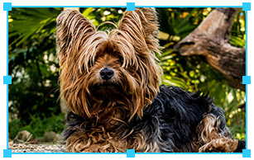When a user clicks on a layer and selects Free Transform ( or Ctrl + T ) the blue border should appear around the layer. The user should be able to drag and scale from any of the small squares. When the mouse is outside the layer the rotate function should be enabled

When scaling a layer, if you hold down the SHIFT button the proportions should be constrained