Scheduler
SW Component MPC5606B

Revision History
Issue status  (Index) | Maturity/Date  (draft/invalid/valid)  (dd-mmm-yyyy) | Author  Department | Check/Release  Department | Description
1.0 | Draft  04-0ct-09 | Miguel Garcia | Miguel Garcia | Creation of the document
2.0 | Draft  17-Nov-15 | Jorge Luis Gomez Gonzalez | Jose Luis Martinez Vicuña | Scheduler functionality

Table of Contents
1 Purpose 3
2 Definitions and abbreviations 3
Definitions 3
Abbreviations 3
3 Paths and files 3
4 How to add a new Task 4
5 Warnings 5

Purpose
The purpose is a simple manual use to add new task for the scheduler created.

Definitions and abbreviations

Definitions
Scheduling | is the method by which work specified by some means is assigned to resources that complete the work.

Abbreviations
msec milliseconds
MCU Microcontroller
GPIO General-Purpose input/output
PIT Periodic Interrupt Timer
HAL Hardware Abstraction Layer
MAL Middleware Abstraction Layer

Paths and files

HAL
  - Exceptions
  - IntcInterrupts
  - ivor_branch_table
  - MainConfig

MAL
  - Kernel
  - Task

APPLICATION
  - BlinkingLedsApp

How to add new peripherals

On the file MainConfig.c are initialized all the different peripherals of the MCU, if is needed add new ones to make a personalized code.
That gives to the programmer a flexible code.

In this example are only initialized the GPIOs embedded of the MPC5606B.

How to add a new Task
For add a new task you must only modify two files, Task.c, Task.h and add a new file in the path called “Application”. Follow the next steps:

- Create a new file in the path called “Application”. That must contain the new application function.
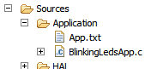
- Add the new task in the enumeration E_NUMTASK. It is on the file Task.h
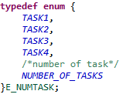
- Add the new task prototype on the file Task.h
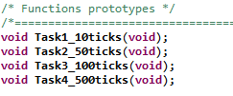
- Add the exported application function on the same file.
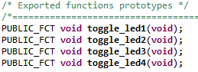
- On the file Task.c in the structure “cas_TaskList” add the new task, put the Execution Period and the Startup delay, as show in the next image:
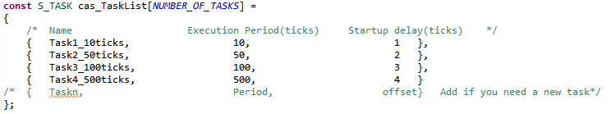
- Define the new task function on the file Task.c.
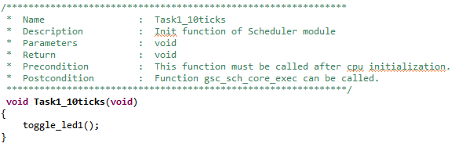

Warnings
Do not modify the files Kernel.c and Kernel.h in that files is contain the algorithm of the scheduler.

