**Project Description:** Keyboard Hero will be a single or multi user-interactive game where the player hits oncoming notes on the screen with assigned letters on the keyboard as they approach the “line” close to the bottom of the screen.

**Similar projects:** This project is very similar to Piano Tiles and the xbox game Guitar Hero where the same concept of hitting oncoming notes is applied. My project will be similar in that aspect and will consist of a few songs with notes allocated to the rhythm/beat of the song.

**Structural Plan:** A structural plan for how the finalized project will be organized in different functions, files and/or classes.

This finalized project will contain various functions, such as keys pressed, gameDimension, appStarted, timerFired, drawingNotes, drawingScore and drawingHealthBar, drawFallingPiece, and several more. I will be importing several pictures/png’s as well, such as the notes, the background design, and others.

**Algorithmic Plan:** The trickiest part of the project by far will be allocating notes to specific beats and rhythms. I believe I can do this by finding a graph or chart with the volume/beat (digital audio spectrum analyzer) of a song and somehow assigning notes accordingly (e.g having keys be assigned to the louder parts of the song). I am still unsure on how I can make this happen, may potentially need additional software or module, but still figuring it out.

**Timeline Plan**: November 18th: have the background/format of the screen that the player will be playing on. Additionally, have a menu for what song to choose, the pause/exit menu

November 25th: Apply notes to each song and key, make sure it works nearly perfect.

November 25th - December 2nd: Implement additional features for creativity, such as health bar, score, streak, 8x multiplier, multiplayer songs.

**Version Control Plan:** A short description **and image** demonstrating how you are using version control to back up your code. Notes: Code will be backed up on external flash drive and Google Drive in a doc. In a google doc, I will be copying and pasting my current code and progress that I make to it after every few days of progress.

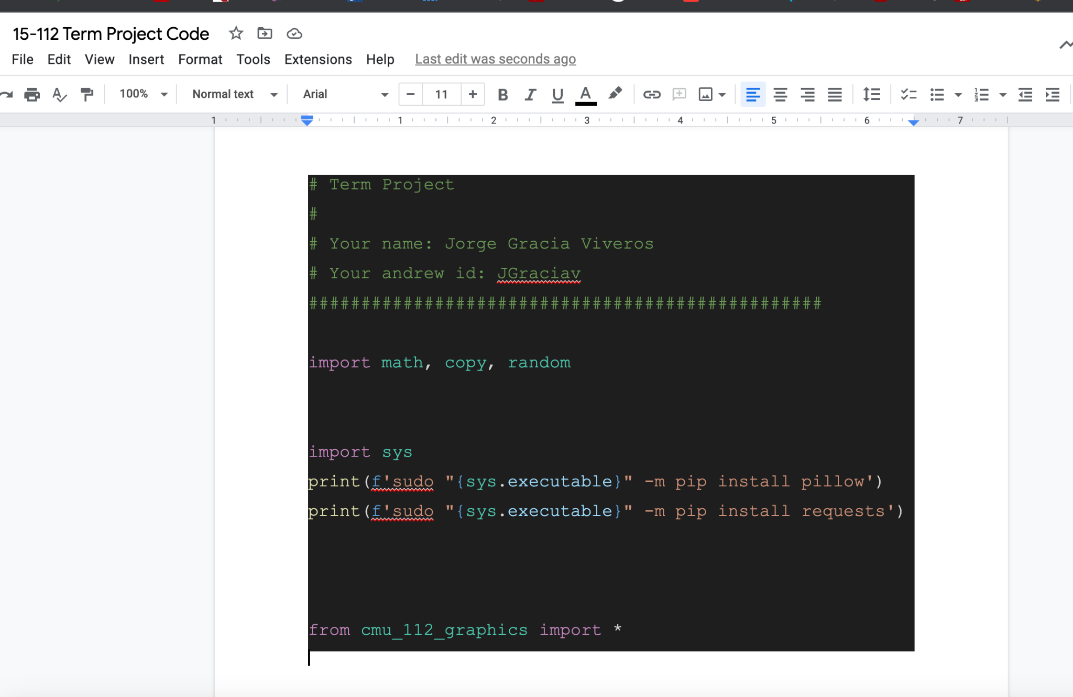

**Storyboard:** As described above, the user will interact with the project by pressing on specific keys associated with the song as they approach the bottom of the screen. The user will need to maintain a certain “streak” so that the health bar does not drop to zero. In that case, the song will end and the user will either have to restart or choose a different song. The project will begin in the press any key to start and will redirect the user to the main menu where they will have the option to choose any of the listed songs. Once a user selects the song, they will be asked to select the difficulty (easy, medium, hard) and each will have notes coming down faster, respectively. The user will then be led into the start of the song and play the game. Once they finish the song, the user’s score will be displayed and will be asked to return to the main menu or restart the game.

**Module List** [1 pts]: Potentially will use audio and numpy. Will be incorporating a digital audio spectrum analyzer in some way but still figuring out.

TP1 Update

**Updated Design Docs**:

I will be approaching this term project by designing a completely different game. I will be attempting to create a lite version of the 1985 Super Mario Bros game. This will be relatively similar to the original game where Mario has to reach a flag in order to advance to the next level while avoiding enemies along the way. The character will have three lives before the game is over and the user will have to restart the entire game.

Time sheet:

November 18th: have the background/format of the screen that the player will be playing on. Additionally, create some classes of elements of the game (e.g mario, enemies, game start and end.

November 25th: Have a functional character (mario) and have the game be running without enemies

November 25th - December 2nd: Implement additional features necessary for Super Mario, such as the enemies, potential power ups, next levels, have super mario attack enemies