Panell Fix
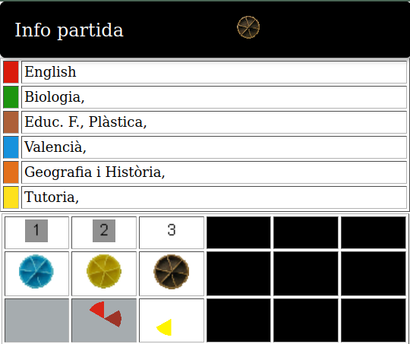
a
b
c
e
d
f

a
b

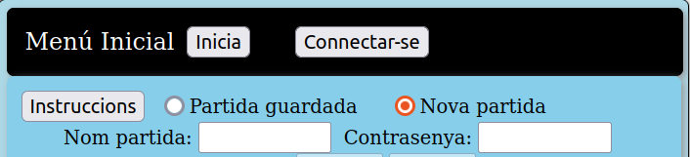

c
d
e

a
b

c
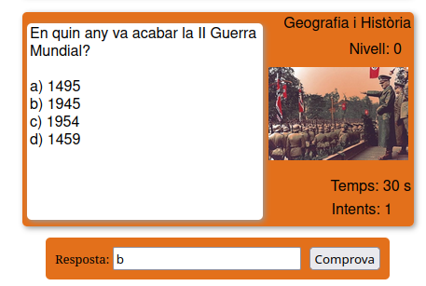
d

e

f
h
g
i

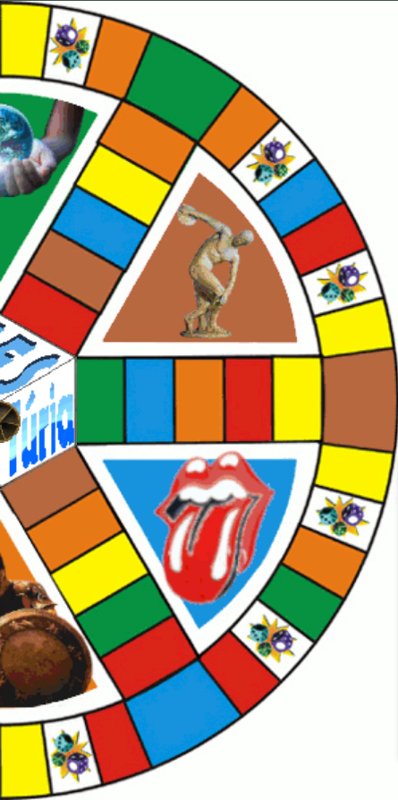

a

b

c
d

h

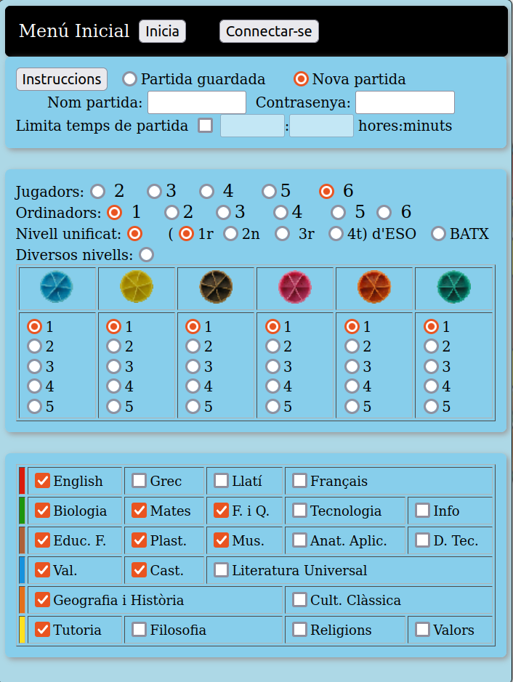
a
b
h
f
e
d
c

