**Window Lifter’s [State Machine Implementation] Test Log**

* Debounce Testing:
  + Signal Generator’s Testing Time Constraints [ > 9ms ]:
    - 7ms 🡪 PASS: No action is performed provided the time length of input signal.
    - 8ms 🡪 PASS: No action is performed provided the time length of input signal.
    - 9ms 🡪 PASS: No action is performed provided the time length of input signal.
    - 10ms 🡪 PASS: Enters in automatic mode (either up or down).
    - 11ms 🡪 PASS: Enters in automatic mode (either up or down).
  + Signal Generator’s code snippets:
  + 7ms Test:

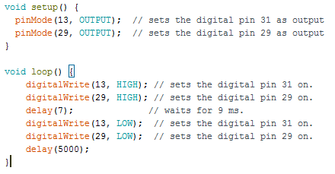

* 8ms Test:

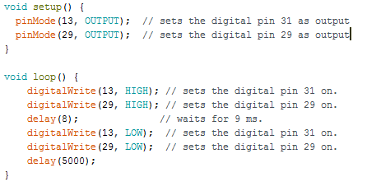

* 9ms Test:

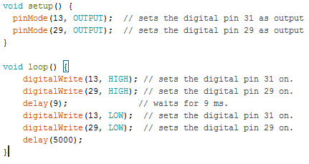

* 10ms Test:

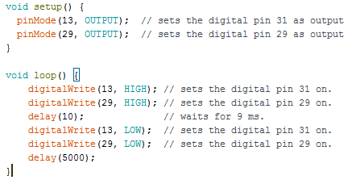

* 11ms Test:

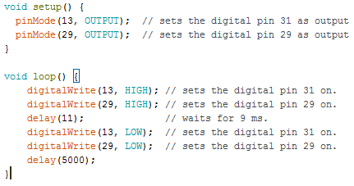

* Automatic activation Testing:
  + Signal Generator’s Testing Time Constraints [ < 500ms ]:
    - 498ms 🡪 PASS: Enters in automatic mode (either up or down).
    - 499ms 🡪 PASS: Enters in automatic mode (either up or down).
    - 500ms 🡪 PASS: No action is performed provided the time length of input signal.
    - 501ms 🡪 PASS: No action is performed provided the time length of input signal.
    - 502ms 🡪 PASS: No action is performed provided the time length of input signal.
  + Signal Generator’s Code Snippet:
  + 498ms Test:

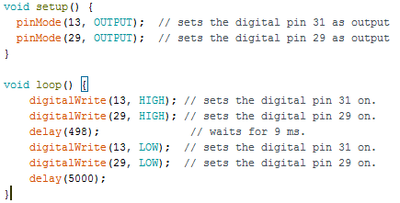

* + 499ms Test:

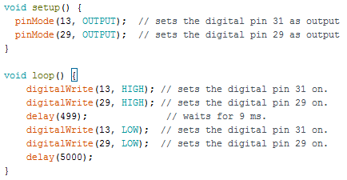

* + 500ms Test:

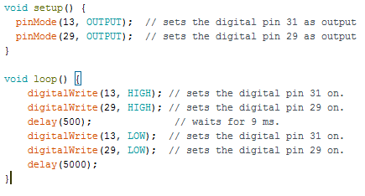

* + 501ms Test:

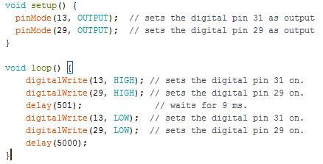

* + 502ms Test:

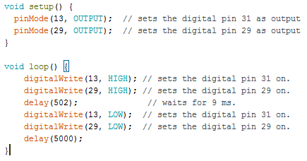

* Semi-automatic activation Testing [ >= 500ms ]:
  + Signal Generator’s Testing Time Constraints:
    - 498ms 🡪 PASS: Enters in automatic mode (either up or down).
    - 499ms 🡪 PASS: Enters in automatic mode (either up or down).
    - 500ms 🡪 PASS: No action is performed provided the time length of input signal.
    - 501ms 🡪 PASS: No action is performed provided the time length of input signal.
    - 502ms 🡪 PASS: No action is performed provided the time length of input signal.
  + Signal Generator’s Code Snippets:
  + 498ms Test:



* + 499ms Test:



* + 500ms Test:



* + 501ms Test:



* + 502ms Test:



* Semi-automatic activation Testing [ considering LED transition times: 500ms + 400ms = 900ms ]:
  + Signal Generator’s Testing Time Constraints:
    - 888ms 🡪 PASS: No action is performed provided the time length of input signal.
    - 889ms 🡪 PASS: No action is performed provided the time length of input signal.
    - 900ms 🡪 PASS: Enters in semi-automatic mode (either up or down).
    - 901ms 🡪 PASS: Enters in semi-automatic mode (either up or down).
    - 902ms 🡪 PASS: Enters in semi-automatic mode (either up or down).
  + Signal Generator’s Code Snippet:
  + 888ms Test:

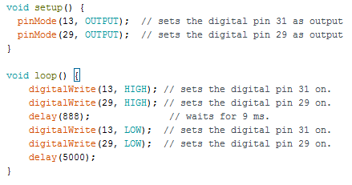

* + 889ms Test:

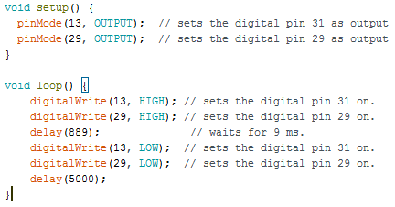

* + 900ms Test:

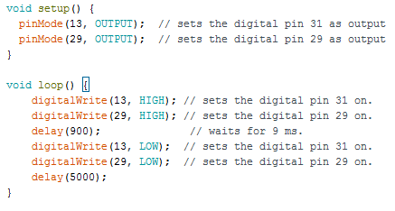

* + 901ms Test:

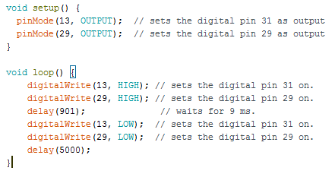

* + 902ms Test:

