**WINDOW LIFTER’S**

**[STATE MACHINE IMPLEMENTATION WITH INFINITE LOOP] TEST LOG**

* **Debounce Testing**
* **Automatic work validation Testing**
* **Semiautomatic work validation Testing**
* **Semiautomatic work validation (Considering the time transition) Testing**
* **DEBOUNCE TESTING: (TEST PASSED)**
  + Signal Generator’s Testing Time Constraints [ > 9ms ]:
    - 7ms 🡪 PASS: No action is performed provided the time length of input signal.
    - 8ms 🡪 PASS: No action is performed provided the time length of input signal.
    - 9ms 🡪 PASS: No action is performed provided the time length of input signal.
    - 10ms 🡪 PASS: Enters in automatic mode (either up or down).
    - 11ms 🡪 PASS: Enters in automatic mode (either up or down).
  + Signal Generator’s code snippets:
  + 7ms Test:

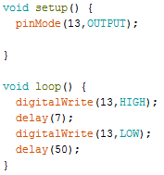 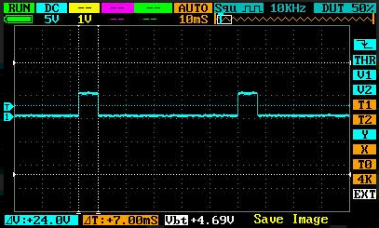

* 8ms Test:

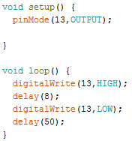 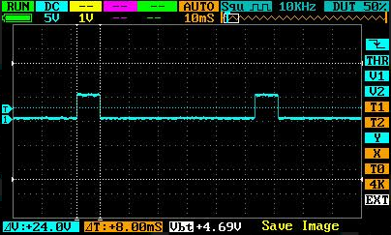

* 9ms Test:

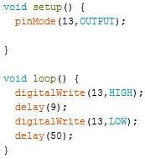 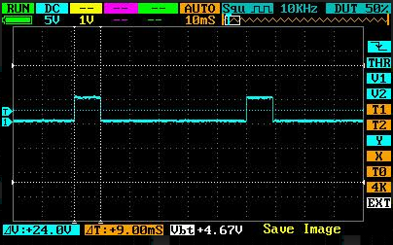

* 10ms Test:

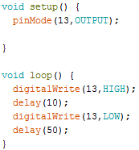 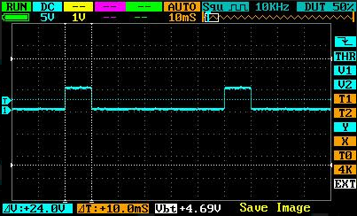

* 11ms Test:

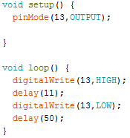 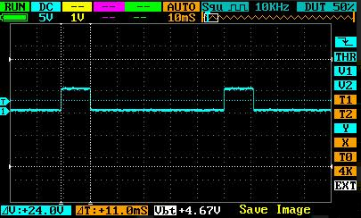

* **AUTOMATIC ACTIVATION TESTING: (TEST PASSED)**
  + Signal Generator’s Testing Time Constraints [ < 500ms ]:
    - 498ms 🡪 PASS: Enters in automatic mode (either up or down).
    - 499ms 🡪 PASS: Enters in automatic mode (either up or down).
    - 500ms 🡪 PASS: No action is performed provided the time length of input signal.
    - 501ms 🡪 PASS: No action is performed provided the time length of input signal.
    - 502ms 🡪 PASS: No action is performed provided the time length of input signal.
  + Signal Generator’s Code Snippet:
  + 498ms Test:

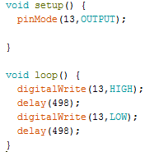 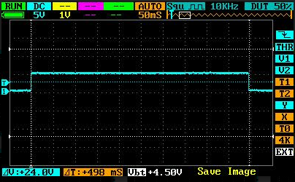

* + 499ms Test:

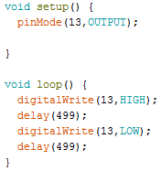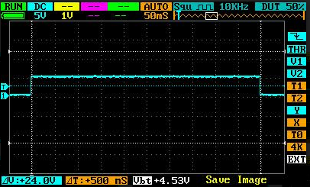

* + 500ms Test:

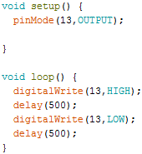 

* + 501ms Test:

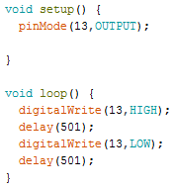

* + 502ms Test:

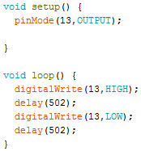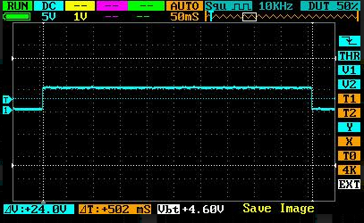

* **SEMI-AUTOMATIC ACTIVATION TESTING [ >= 500MS** ]: **(TEST PASSED)**
  + Signal Generator’s Testing Time Constraints:
    - 498ms 🡪 PASS: Enters in automatic mode (either up or down).
    - 499ms 🡪 PASS: Enters in automatic mode (either up or down).
    - 500ms 🡪 PASS: No action is performed provided the time length of input signal.
    - 501ms 🡪 PASS: No action is performed provided the time length of input signal.
    - 502ms 🡪 PASS: No action is performed provided the time length of input signal.
  + Signal Generator’s Code Snippets:
  + 498ms Test:

 

* + 499ms Test:



* + 500ms Test:

 

* + 501ms Test:



* + 502ms Test:



* **SEMI-AUTOMATIC ACTIVATION TESTING [ CONSIDERING LED TRANSITION TIMES: 500MS + 400MS = 900MS ]: (TEST PASSED)**
  + Signal Generator’s Testing Time Constraints:
    - 887ms 🡪 PASS: No action is performed provided the time length of input signal.
    - 900ms 🡪 PASS: No action is performed provided the time length of input signal
    - 901ms 🡪 PASS: Enters in semi-automatic mode (either up or down).
    - 903ms 🡪 PASS: Enters in semi-automatic mode (either up or down).
  + Signal Generator’s Code Snippet:
  + 887ms Test:

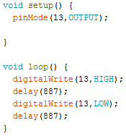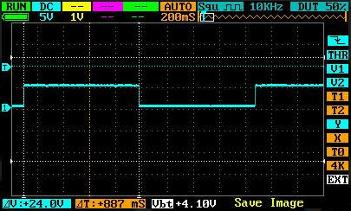

* + 900ms Test:

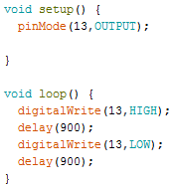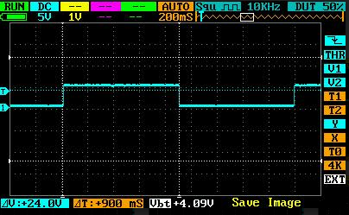

* + 903ms Test:

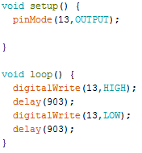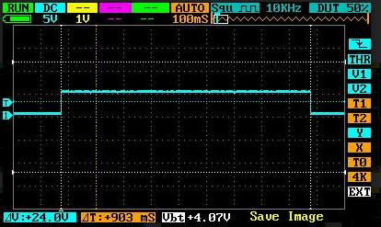

**WINDOW LIFTER’S**

**[STATE MACHINE IMPLEMENTATION WITH SCHEDULER BPS] TEST LOG**

* **Period of the tasks Testing**
* **Transition time of the Led Bar Testing**
* **Debounce Testing**
* **Automatic work validation Testing**
* **Semiautomatic work validation Testing**
* **Semiautomatic work validation (Considering the time transition) Testing**
* **PERIOD OF THE TASKS: (TEST PASSED)**

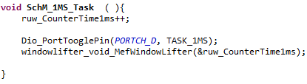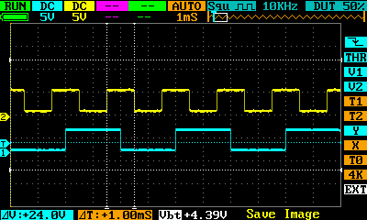

Added code in function SchM_1MS_Task () //file SchM_Tasks.c

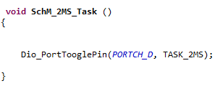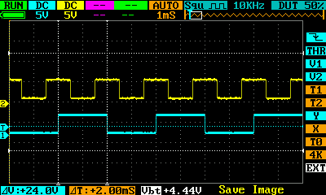

Added code in function SchM_2MS_Task () //file SchM_Tasks.c

* **TRANSITION TIME OF THE WINDOWS´LEDS TESTING: (TEST PASSED)**

We modified the code to test the transition time of the window´s leds. The system works in automatic down mode and automatic up mode for this test.

We added the following code to the system (Always Automatic work)

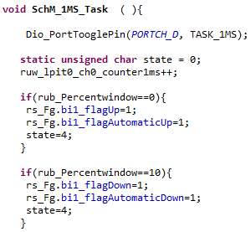

Added code in function wc­_WindowUp () and wc_WindowDown () //file app_windowcontrol.c

Added code in function SchM_1MS_Task () //file SchM_Tasks.c





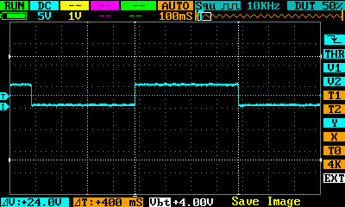

* **DEBOUNCE TESTING: (TEST PASSED)**
  + Signal Generator’s Testing Time Constraints [ > 9ms ]:
    - 7ms 🡪 PASS: No action is performed provided the time length of input signal.
    - 8ms 🡪 PASS: No action is performed provided the time length of input signal.
    - 9ms 🡪 PASS: No action is performed provided the time length of input signal.
    - 10ms 🡪 PASS: No action is performed provided the time length of input signal.
    - **11ms 🡪 PASS: Enters in automatic mode (either up or down).**
  + Signal Generator’s code snippets:
  + 7ms Test:

 

* 8ms Test:

 

* 9ms Test:

 

* 10ms Test:

 

* 11ms Test:

 

* **AUTOMATIC ACTIVATION TESTING: (TEST PASSED)**
  + Signal Generator’s Testing Time Constraints [ < 500ms ]:
    - 498ms 🡪 PASS: Enters in automatic mode (either up or down).
    - 499ms 🡪 PASS: Enters in automatic mode (either up or down).
    - **500ms 🡪 UNDIFINED:**
    - 501ms 🡪 PASS: No action is performed provided the time length of input signal.
    - 502ms 🡪 PASS: No action is performed provided the time length of input signal.
  + Signal Generator’s Code Snippet:
  + 498ms Test:

 

* + 499ms Test:



* + 500ms Test:

 

* + 501ms Test:



* + 502ms Test:



* **SEMI-AUTOMATIC ACTIVATION TESTING [ >= 500MS** ]: **(TEST PASSED)**
  + Signal Generator’s Testing Time Constraints:
    - 498ms 🡪 PASS: Enters in automatic mode (either up or down).
    - 499ms 🡪 PASS: Enters in automatic mode (either up or down).
    - **500ms 🡪 UNDIFINED.**
    - 501ms 🡪 PASS: No action is performed provided the time length of input signal.
    - 502ms 🡪 PASS: No action is performed provided the time length of input signal.
  + Signal Generator’s Code Snippets:
  + 498ms Test:

 

* + 499ms Test:



* + 500ms Test:

 

* + 501ms Test:



* + 502ms Test:



* **SEMI-AUTOMATIC ACTIVATION TESTING [ CONSIDERING LED TRANSITION TIMES: 500MS + 400MS = 900MS ]: (TEST PASSED)**
  + Signal Generator’s Testing Time Constraints:
    - 887ms 🡪 PASS: No action is performed provided the time length of input signal.
    - 900ms 🡪 PASS: No action is performed provided the time length of input signal
    - 901ms 🡪 PASS: Enters in semi-automatic mode (either up or down).
    - 903ms 🡪 PASS: Enters in semi-automatic mode (either up or down).
  + Signal Generator’s Code Snippet:
  + 887ms Test:



* + 900ms Test:



* + 903ms Test:

