Title: | AEPs Window Lifter  SW Component < 0000001 >

History
Issue status  (Index) | Maturity/Date  (draft/invalid/valid)  (dd-mmm-yyyy) | Author  Department | Check/Release  Department | Description
1.0 | Draft  19-0ct-2017 | Luis Archundia | Luis Archundia | Document inception

Table of Contents
1 Purpose 3
2 Definitions and abbreviations 3
3 Realization constraints and targets 3
4 SW Conceptual design 3
5 SW Component internal breakdown 4
5.1 Functional Decomposition 4
5.2 Function <Type> <function name> (type par 1, .., type par n) 5
5.3 Function <Type> <function name> (type par 1, .., type par n) 5

Purpose
To provide an embedded SW solution based on the ARM Cortex M4 Microcontroller along with a hardware functional prototype, capable of emulating the behavior of a car’s window lifter module, using an LED bar and NXP’s S32K144 Development Kit Platform, implementing basic movement functionalities as well as safety and comfort features.

Definitions and abbreviations
Definitions
Special Byte | Special byte received to change the baudrate 55h

Abbreviations
SW Software
References
N° | Document name | Reference
1  2 | WindowLifterRequirementsLetter  WindowLifter_TraceabilityMatrix

Realization constraints and targets

To create a SW solution along with a functional hardware prototype that is capable of emulating the behavior of a car’s window movement along with the use of simple hardware components such as an LED bar.
The solution provided must be developed using the NXP S32K144EVB Development Kit Platform provided.
The solution must consider implementing basic functionality such as upward/downward movement, automatic movement using the provided mechanical interfaces within the platform, as well as safety functionality such as an “Anti-Pinch” functionality and fail proven activation algorithms such as a de-bouncing mechanism (software de-bounce).
The project must also consider timing critical. It is mandatory that it comply within the time boundaries previously agreed in the requirements document.

SW Conceptual design
- Initialization before main:
  - Define interrupt addresses and flash configuration
  - Initialize stack pointer registers
  - Disable watchdog
  - Unmask Interrupts
  - Enable clock to Port D module
  - PTD0: GPIO output (LED goes lit)
- Initialize system oscillator (SOSC) for 8 MHz crystal
  - Initialize desired SOSC dividers
  - Ensure SOSC Control & Status register are unlocked
  - Wait for SOSC to be valid
- Initialize System PLL (SPLL) to 160 MHz using 8 MHz SOSC
- Initialize LPIT0 channel 0:
  - Enable clock source of SPLL_DIV2_CLK
  - Enable clock to LPIT0 registers
  - Enable LPIT0 module
  - Initialize channel 0:
    - Timeout = 1 second of clocks
- LPIT_0 Channel 0 Interrupt Handler:
  - Increment counter
  - Toggle PTD0 GPIO output
  - Clear channel flag
- Enable clocks to GPIO modules and GPIO port configuration
  - PTC #: GPIO (goes to BTN 0 on evaluation board)
  - PTD #: GPIO (goes to blue LED)
- Loop:
  - Wait for LPIT0 channel 0 flag
  - Increment counter, toggle PTD0 GPIO output and clear channel flag
  - IF lsdjfañljad
    - Then lñajdflña
  - Else (djfñalj)
    - Ñdjfñaljfañldjk

SW Component internal breakdown
For complex SW Components, the designer may define SW Subcomponents. Please consider also the work step "Deal with complexity" provided by the method for Detailed SW Design.
Note: SW Subcomponents are synonymous with the previous used term "Module"
Mapping to the file structure:
- Non complex SW Components should be represented by one object file.
- For complex SW Components each SW Subcomponent should be represented by one object file.
<Subcomponent decomposition if applicable>

Functional Decomposition
Overview of functions and their dependencies shown by a Static Function Tree
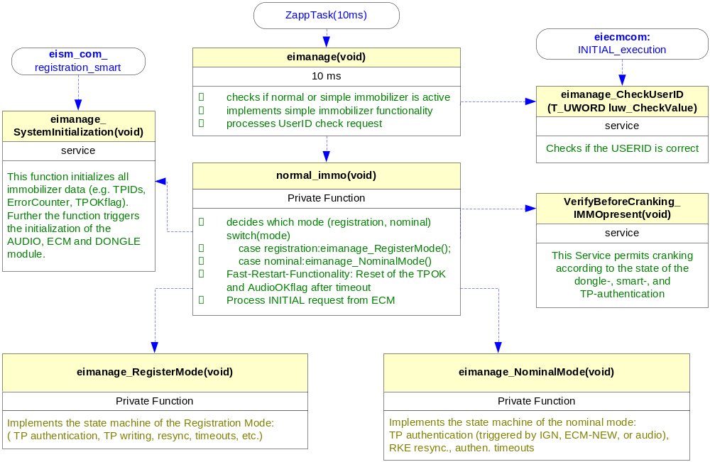
Function Description and Dynamic Behavior
Provide detailed static and dynamic description of all functions of the SW Component.
Functions which are defined in other SW Components shall only be referenced in the external interface description!
The signature description shall be done inside the function header in the source code.
For each function, the following section should be copied

Function <Type> <function name> (type par 1, .., type par n)

Description | Brief description of the function behavior and useful remarks
Parameter 1  <input| output| inout> | Give an explanation if the parameter shall be checked by the user, or if a check is implemented in the function here
Parameter 2..n
Return Value
Precondition | e.g. Function can only be called in a certain state, SW component is initialized  Relation between input parameters where applicable (Input for Module Test)
Post condition | e.g. specific State change e.g. car is locked, EEPROM Values written,  Relation between output parameters where applicable
Error Conditions

Dynamic Behavior
State Chart¹, Flow Chart¹
¹ Preferred
In this document, the dynamic behavior shall be designed on an abstract level showing the principle workflow of a function. Do not show the detailed implementation to ensure that the design description can be maintained with a reasonable effort. The target is not to show the complete detailed implementation 1:1.
The detailed design shall reflect in detail what a function is doing from a black box view. The internal details are useful on an abstract, but not very detailed level.
If the function is not complex a short textual description might be sufficient and a graphical description is not needed.
Symbol and function names shall be self explaining.
The link to the implementation may be provided by using the same names as in the design or by a comment showing the full name followed by the declaration showing the implementation.

Function <Type> <function name> (type par 1, .., type par n)
Description | Brief description of the function behavior and useful remarks
Parameter 1
<input| output| inout>
Parameter 2..n
Return Value
Precondition | e.g. Function can only be called in a certain state, SW component is initialized  Relation between input parameters where applicable (Input for Module Test)
Post condition | e.g. specific State change e.g. car is locked, EEPROM Values written,  Relation between output parameters where applicable
Error Conditions

Dynamic Behavior
State Chart¹, Flow Chart¹, Nassi Shneiderman
¹ Preferred
In this document, the dynamic behavior shall be designed on an abstract level showing the principle workflow of a function. Do not show the detailed implementation to ensure that the design description can be maintained with a reasonable effort. The target is not to show the complete detailed implementation 1:1.
The detailed design shall reflect in detail what a function is doing from a black box view. The internal details are useful on an abstract, but not on a very detailed level.
Symbol and function names shall be self explanatory.
The link to the implementation may be provided by using the same name as in the design or by a comment showing the full name followed by the declaration showing the implementation.

