01-04-2025

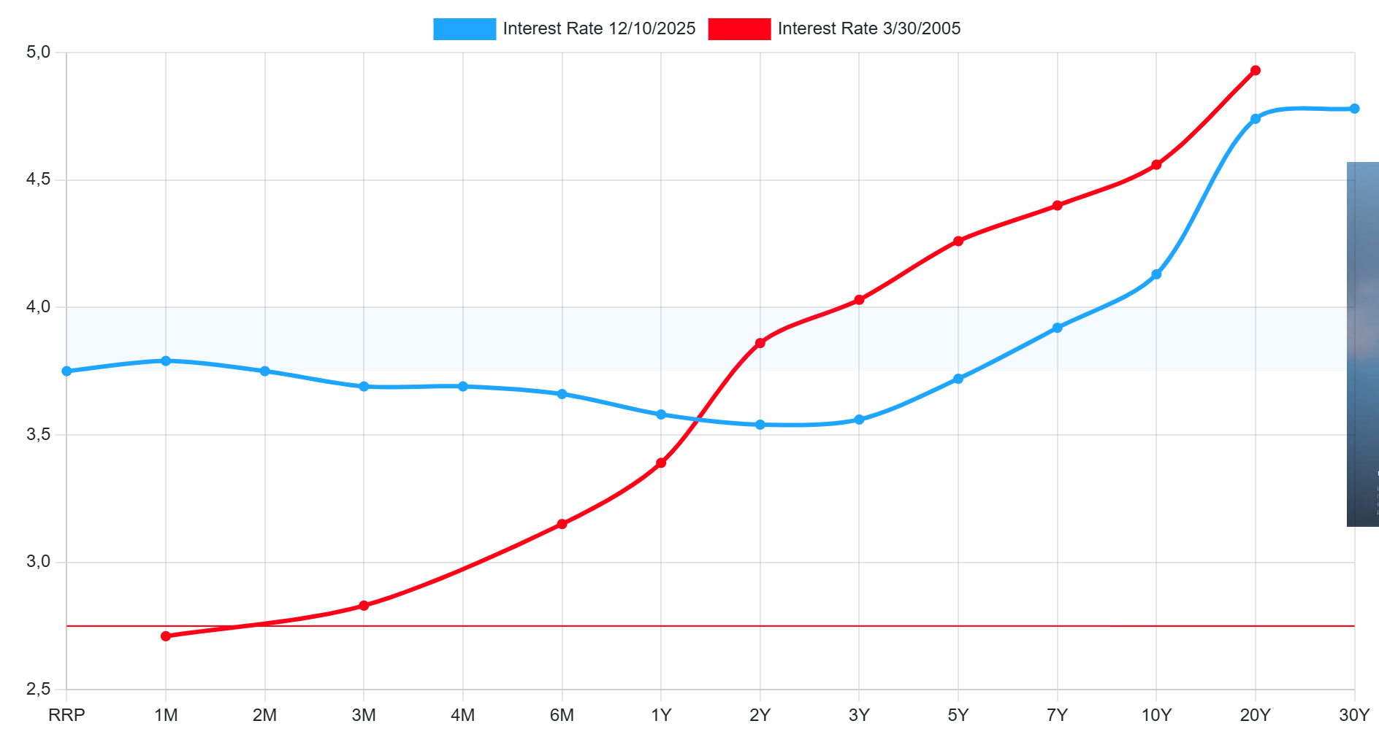
- As we can see on the red line, on short term duration the risk premium of bonds is below 3%. From year 2 on, the slope increases significantly, ending with a risk premium near 5% on maturities around 10Y-20Y.
This curve can be interpreted as a good sign of future expectations, discounting at that moment a higher economic growth. Also, we can assume that the consumers were expecting an increase in the interest rate in order to keep in control inflation.
Now, the yielding curve is flatter, reflecting the uncertainty of the market after the inflation shock due to the QE after covid and 2022 ucranian war. On the medium run the interest rate is expected to return to “normal values”, this is reflected on maturities around 1Y-5Y. The actual yielding curve could also mean a possible desacceleration process of the economy.
- The current economic situation in USA reflects the conflict between inflation and unemployment that monetary policy face.
On the short term the curve shows that a tightening policy is expected, as the inflation seems to not be fully controlled. However, the last data published about employment shows that the creation of jobs is being desaccelerated and unemployment could increase as a consequence.
This is reflected in the medium term where the risk premium is lower, assuming that the interest rates are lower, in order to stimulate employment.
On the long term the risk premiums are similar to my birth date, as in both times there are some structural problems and geopolitical tensions that could lead to a new recession, on my birth date that recession was 2008.
- If I were to invest on short term, and I would be looking for a bigger return, so, I would invest now as the yielding curve is higher, and would give a more return. This would be bonds with maturities inferior to one year.
However if I were to invest on long term, I would definitely go back to 2005, as the environment was supposed to be safer and the return would be higher.
When the crisis happened, I could have sold the bonds at a higher price, as the risk premium offered was lower.

