

LD6053

Computing and Digital Technologies Project Dissertation
From Public Funding to Sponsor-Capable Career Pathways:

A Medallion Data Pipeline Using Token-Based Fuzzy Matching, Unsupervised Nearest-Neighbour Matching with TF-IDF and Cosine Distance, and Power BI

By
24056316 - Jorge Tomas Chabrillon
Supervisor Name: Salma Tajbel
A Dissertation
Submitted to Department of Computer and Information Sciences

Northumbria University
In Partial Fulfilment of the Requirements
For BSc (Hons) in Computing with Data Science and Big Data Technology

Word Count: 6,523
Submission date: 26 Aug 2026

Declaration
I declare the following:
- that the material contained in this dissertation is the end result of my own work and that due acknowledgement has been given in the bibliography and references to ALL sources be they printed, electronic or personal.
- the Word Count of this Dissertation is 6,523 (between the 10% allowance)
- that unless this dissertation has been confirmed as confidential, I agree to an entire electronic copy or sections of the dissertation to being placed on Blackboard, if deemed appropriate, to allow future students the opportunity to see examples of past dissertations. I understand that if displayed on Blackboard it would be made available for no longer than five years and that students would be able to print off copies or download. The authorship would remain anonymous.
- I agree to my dissertation being submitted to a plagiarism detection service, where it will be stored in a database and compared against work submitted from this or any other Department or from other institutions using the service.
In the event of the service detecting a high degree of similarity between content within the service this will be reported back to my supervisor and second marker, who may decide to undertake further investigation that may ultimately lead to disciplinary actions, should instances of plagiarism be detected.
- I have read the UNN/CEIS Policy Statement on Ethics in Research and Consultancy and I confirm that ethical issues have been considered, evaluated and appropriately addressed in this research.
Signature:
Date: 26/08/2026

Declaration of the Use of AI Tool

EITHER
​​☐​ I have not used AI at any point in preparing this assignment.
OR
​​☒​ I have used AI tools (including, but not limited to ChatGPT) to help me (select all that apply):
​​☒​ Generate initial ideas in response to the question.
​​☐​ Develop my structure.
​​☒ Generate ideas for examples / sources.
​​☒​ Provide feedback and suggestions for improvement on my content.
​​☒​ Edit and improve my spelling and grammar.
​​☐​ Other: please explain:

​​☒​ I have NOT used AI to generate whole sentences, paragraphs, sections, or the whole of this assignment and I understand that this would be considered academic misconduct.
Your signature: |  | Date: | 26/08/2026

Acknowledgements
I would like to express my sincere gratitude to my supervisor, Salma Tajbel, for guidance, constructive feedback and continued encouragement throughout this project. She has provided me with indispensable weekly input, professional experience and kindness that made the development and writing easier for me and helped me tackle issues more confidently and clearly.
I owe my gratitude to Syed Raza and Omer Raza for their knowledge, practical perception and regular feedback during this module. Their willingness to answer my questions, share their experience and provide their advice were priceless during my preparation of this dissertation.
I would also like to thank Faisal Hashmi, whose teaching of other modules imparted knowledge and technical foundations that I was able to apply to this project. Skills that I learned during his sessions shaped my way of approaching data, development and problem solving for the entire project.
Finally, I would like to thank all the lecturers and staff who supported me throughout my degree. Their patience, approachability and commitment to teaching have contributed greatly to my academic and professional development.

Abstract
International graduates in the United Kingdom will need to choose sponsors with a sponsor licence, from which they will need to make a decision based on different sets of information that are dispersed across the Home Office Sponsor Register, Contracts Finder and the UK Research and Innovation Gateway to Research. This project developed a medallion pipeline to evaluate data engineering, conservative entity resolution and decision support, and to provide caveated career-intelligence signals from these datasets using Python, a SQL Server reporting layer and a Power BI dashboard. In addition to Contracts Finder and Gateway to Research as JSON, comparison against the Sponsor Register (CSV) was done. Names were standardised prior to matching and took a conservative approach to matching fuzzy scores on tokens with unsupervised TF-IDF/nearest-neighbour similarity. Non-exact links were dashboard-eligible only where both routes linked to the same sponsor and both scores exceeded 90 and 75 respectively. On the final run of 11 August 2026, 126,582 unique sponsor organisations were provided. The pipeline compared 199 unique organisations from Contracts Finder and 141 from Gateway to Research. It accepted 45 and 81 unique organisations respectively and excluded 214 organisations and retained the reasons for exclusion. The organisations accepted by Contracts Finder and Gateway to Research produced 243 funding-evidence rows in SQL and Power BI. Thus far, SQL preflight, same-day replacement, row reconciliation, history checks and dashboard-view mapping have all been completed, demonstrating bounded, traceable integration, transparent method agreement and traceable reporting, but match accuracy, job availability, employer willingness to sponsor, and user usability remain to be established in the future. Its main contribution is as an auditable decision-support artefact that narrows the evidence base available to future research, not as an endorsement of suitable employers, or as a replacement for human verification, or as a predictor of employment outcomes.

Table of Contents
Declaration II
Declaration of the Use of AI Tool III
Acknowledgements IV
Abstract V
List of Figures IX
List of Tables X
List of Abbreviations XI
1 Introduction 12
1.1 Background and Context 12
1.2 Problem Statement 12
1.3 Aim 13
1.4 Research Questions 13
1.5 Objectives 13
1.6 Scope and Limitations 14
1.7 Structure of the Report 14
2 Literature Review / Background 15
2.1 Introduction 15
2.2 International Graduate Employability and Sponsorship Barriers 15
2.3 Public Funding as a Cautious Opportunity Signal 16
2.4 Entity Resolution and Non-Normalised Public Data 17
2.5 Decision Support and Dashboard Visualisation 18
2.6 Literature Gap 20
3 Research Methodology 21
3.1 Research Strategy 21
3.2 Data Collection Methods 21
3.3 Data Analysis and Matching Methods 22
3.4 Mapping Research Questions to Methods 23
3.5 Research Limitations 23
3.6 Ethical Considerations 23
3.7 Summary 24
4 Requirements and Analysis 25
4.1 Requirement Elicitation 25
4.2 Functional Requirements 26
4.3 Non-Functional Requirements 26
4.4 Use Case Analysis 26
4.5 Summary 27
5 Design 29
5.1 System Architecture 29
5.2 Database Design 29
5.3 User Interface Design 30
5.4 Algorithm / Logic Design 31
5.5 Technology Stack 33
5.6 Summary 33
6 Implementation 34
6.1 Development Environment 34
6.2 Implementation Details 34
6.2.1 Run Configuration and Evidence Retention 34
6.2.2 API Extraction and the Bronze Layer 34
6.2.3 Silver Transformation 35
6.2.4 Gold Matching and Comparison 35
6.2.5 SQL Persistence and Audit 35
6.2.6 Power BI Reporting 36
6.3 Challenges Encountered 36
6.3.1 Runtime and Scale 36
6.3.2 Hosted SQL Capacity and Safe Replacement 36
6.3.3 Source Variation and Evaluation Language 36
6.4 Summary 36
7 Testing and Evaluation 37
7.1 Testing Strategy 37
7.2 Unit / Component Testing 38
7.3 Integration and System Testing 38
7.4 User Evaluation 38
7.5 Requirements Evaluation 39
7.6 Answering the Research Questions 39
7.6.1 RQ1 – Data Engineering 39
7.6.2 RQ2 – Entity Resolution 39
7.6.3 RQ3 – Decision Support 40
7.7 Objective Achievement 40
7.8 Summary 40
8 Conclusion 41
8.1 Summary of Work 41
8.2 Contributions 41
8.3 Limitations 42
8.4 Future Work 42
8.5 Reflective Statement 42
References 45
Appendix A: AI Usage Declaration 48
Appendix B: Full Source Code / GitHub Repository Link 49
Appendix C: Survey Questionnaire 57
Appendix D: User Testing Results / Raw Data 58
Appendix E: Ethics Approval Form 59
Appendix F: Meeting Logs 64
Appendix G: Final Technical Run Evidence 68
Appendix H: SQL Schema and Reporting Views 70
Appendix I: Project Planning and Additional Visual Evidence 75

List of Figures
Figure No. | Caption | Page
Figure 4.1 | UML use case diagram for the Sponsor-Capable Career Intelligence System | 27
Figure 5.1 | Implemented end-to-end architecture | 29
Figure 5.2 | SQL Server reporting schema | 30
Figure 5.3 | Implemented Power BI Overview page from the 10 August viva snapshot | 31
Figure 5.4 | Conservative matching and dashboard-eligibility decision pseudocode | 32
Figure 5.5 | Hybrid matching and conservative acceptance logic from the final presentation | 32
Figure 6.1 | Final bounded-run configuration used on 11 August 2026 | 34
Figure 6.2 | GtR JSON request and raw-payload retention code excerpt | 35
Figure B.1 | Google Colab, Drive and bounded-run configuration | 50
Figure B.2 | Contracts Finder extraction, raw-payload retention and cursor pagination | 51
Figure B.3 | Gateway to Research extraction, recency filtering and raw-payload retention | 52
Figure B.4 | Silver-layer normalisation and GtR organisation enrichment | 53
Figure B.5 | TF-IDF shortlist and cosine-similarity candidate scoring | 54
Figure B.6 | Conservative automatic match acceptance and exclusion logic | 55
Figure B.7 | Public GitHub repository root structure | 56
Figure B.8 | GitHub code-directory contents | 56
Figure G.1 | Google Drive output folder after a successful final run | 68
Figure G.2 | Contracts Finder comparison CSV file after a successful final pipeline run | 68
Figure G.3 | Gateway to Research comparison CSV file | 69
Figure H.1 | SQL schema and reporting-flow diagram | 71
Figure H.2 | Sponsor dimension, Gold evidence tables and foreign keys | 72
Figure H.3 | MatchComparison, DataLoadAudit and validation constraints | 73
Figure H.4 | Dashboard reporting view definitions | 74
Figure I.1 | Final Gantt chart | 75
Figure I.2 | Power BI dashboard: Overview page | 76
Figure I.3 | Power BI dashboard: Contracts Finder page | 76
Figure I.4 | Power BI dashboard: Gateway to Research page | 77
Figure I.5 | Power BI dashboard: Data Quality page | 77

List of Tables
Table No. | Caption | Page
Table 1.1 | Research questions and project evidence | 13
Table 1.2 | Project objectives and success indicators | 14
Table 2.1 | Summary of literature themes and research gap | 18
Table 2.2 | Critical comparison of related evidence and project transfer | 19
Table 3.1 | Research-question-to-method mapping | 23
Table 4.1 | Functional requirements | 26
Table 4.2 | Non-functional requirements | 26
Table 5.1 | Technology stack and rationale | 33
Table 7.1 | Final 11 August 2026 evaluation snapshot | 37
Table 7.2 | System test cases and results | 38
Table 7.3 | Requirements evaluation | 39
Table 7.4 | Objective closure against the executed evidence | 40
Table G.1 | Final technical run evidence | 68
Table H.1 | SQL schema and reporting views | 70

List of Abbreviations
Abbreviation | Definition
API | Application Programming Interface
CSV | Comma-Separated Values
DSS | Decision-Support System
ERD | Entity-Relationship Diagram
GtR | Gateway to Research
JSON | JavaScript Object Notation
ML | Machine Learning
NFR | Non-Functional Requirement
OCDS | Open Contracting Data Standard
PBIX | Power BI Desktop project file
RQ | Research Question
SQL | Structured Query Language
TF-IDF | Term Frequency–Inverse Document Frequency
UKRI | UK Research and Innovation
UML | Unified Modelling Language

Introduction

Background and Context
Finding work in the longer term can be difficult for international graduates in the UK. The Graduate route allows them to take temporary employment upon leaving university but further long-term employment is dependent on finding UK-based employers who want to, and are able to, offer Skilled Worker sponsorship (Ahmed and Davies, 2025). The literature exploring international graduates’ employability and how to improve it highlights a range of barriers such as a lack of professional contacts and social networks; insufficient work experience; a lack of UK-based social capital; an information deficit, which can include weak careers and course advice (Nguyen and Cheng, 2025; Wang et al., 2025), discrimination and assumptions from employers about international workers and the complexity and burden of sponsoring visa workers (Nguyen and Cheng, 2025; Wang et al., 2025). The barriers encountered by international graduates are a critical factor, as many need to identify an accessible employer and secure work within the period that their post-study visa is valid.
Post-Brexit, the UK labour market has seen increased complexity to work and student mobility (Portes, 2024; Liu-Farrer et al., 2023) with changes to the patterns of international graduate working, where labour shortages do not automatically result in international students gaining access to accessible employment. Access is further complicated by factors like the cost, risk and sponsorship requirements associated with employing international staff (Liu-Farrer et al., 2023; Thornton, 2022).

Problem Statement
Current approaches do not easily combine three useful signals for the target audience (international graduates): recent activity with public money; sponsorship capability; and searchable decision support. Contracts Finder, UKRI Gateway to Research and the Home Office Sponsor Register are separate, publicly available data sources with varying degrees of naming consistency across these datasets, representing a technical data integration/entity resolution problem. Literature about non-normalised data indicates that inconsistency of representations of identical real-world objects can hamper any analytical approach; literature on entity-resolution demonstrates how uncertain matches can be estimated but not trusted to be accurate (Cvetkov-Iliev, Allauzen and Varoquaux, 2022; Sharifi and Ahmadzadeh, 2025).
Concretely, this means students may waste their time trying to manually find this information, as it is uncertain which organisations can sponsor a visa, or what their funding trends might be (Nguyen and Cheng, 2025; Wang et al., 2025).
Evidence around public sector procurement links this activity, through supply chains and contracts, to the potential occurrence of short-term jobs, but does not go as far as indicating that an organisation is actively hiring or in a position to sponsor (Srhoj and Dragojevic, 2024). To address this gap, the project created a computing artefact linking these datasets into career intelligence signals, suitable for a decision-support dashboard.

Aim
The aim of this project is to design, implement and evaluate a Python-based medallion data pipeline, SQL Server data layer, and Power BI dashboard to integrate UK public funding data and the Home Office Sponsor Register to provide international graduate career intelligence.

Research Questions
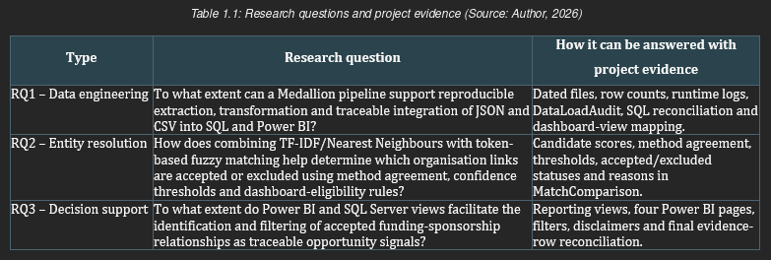

Objectives

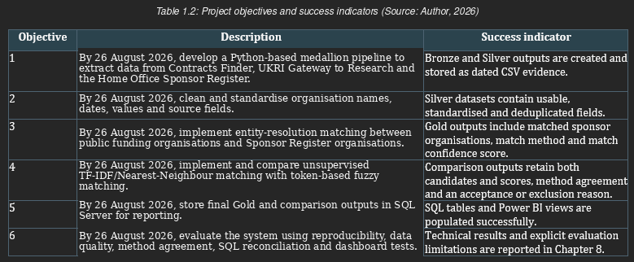

Scope and Limitations
This project focuses on analysing public secondary datasets. No personal information was collected because no interviews were conducted. Public funding is interpreted as a signal that opportunities might become available, but it does not guarantee an intent to hire, nor that the applicant would receive support from their desired sponsors. This tool aims to inform decisions and facilitate further research for graduates, but does not replace job searching or verification with employers (Srhoj and Dragojevic, 2024; Thornton, 2022).
The completed evaluation is technical; it is not a participant or ground-truth study. The results present evidence of reproducibility, row reconciliation, method agreement, exclusions, SQL and view connections and dashboard operation; these claims do not include, for instance, precision or recall, employment effects or usability.

Structure of the Report
Chapters 1 to 3 cover the introduction, literature and methodology. Chapters 4 to 7 present requirements and analysis, design, implementation, testing and evaluation. Finally, Chapter 8 consists of the conclusion, limitations, future work and reflective statement, followed by the references and appendices.

Literature Review / Background

Introduction
This chapter presents relevant existing literature, within four thematic streams of interest: 'The employability of international graduates', 'public funding as an opportunity signal', 'entity resolution with non-normalised data' and 'decision-support dashboards'. The goal of this chapter is not merely a summary of past research but to explain the research gap addressed by this project. The literature indicated structural barriers impacting the international postgraduate labour market, while technical literature illustrated the need for fragmented datasets to be cleaned, matched and validated prior to data being used for decision-support.

International Graduate Employability and Sponsorship Barriers
The literature on international graduate employability suggests that employment entry for international students depends on various individual, institutional, employer, and policy level variables. Workforce integration for international students is framed by Han, Gulanowski and Sears (2022) as a multi-level problem and cannot be explained solely by graduates' skills. This is relevant as international graduates can be educated and well-motivated but struggle to translate their skills and qualifications into sustained employment because of external barriers to integration into workforces.
For instance, UK-specific research emphasises: information asymmetry and limited and fragmented careers support for international students. Nguyen and Cheng (2025) contend that international student agency exists, however they negotiate choices based on their visa policy, discrimination by employers, limited opportunity to be provided with and have access to labour market information etc. Similarly, Wang et al. (2025) emphasised lack of relevant and targeted support for the international postgraduate students within the UK. Nachatar Singh, Holmes and Gupta (2023) add that barriers can arise from both the host institution and the employer. These studies support the problem of employability barriers for international students.
However, these studies do not demonstrate how to develop a technical system that merges public datasets to support international graduates in identifying organisations that may be worth researching and keeping track of for possible future job posting and to secure an early application for early applicant advantage.
Therefore, although these studies justify the need for support, they do not provide a practical computing solution, nor do they contribute directly to the solution of integrating isolated sources of public data into a usable object.
The literature also supports findings from other studies that employability cannot be attributed solely to individual characteristics, for example, Donald, Baruch and Ashleigh (2024) identify nine dimensions of employability capital, Pham, Soltani and Nachatar Singh (2024) describe how graduates mobilise social, cultural and agentic resources and Orsmond, Merry and Reiling (2022) describe entry to work in terms of networks and communities of practice. These issues are consistent with those reported in the UK by Nguyen and Cheng (2025), Wang et al. (2025) and Nachatar Singh, Holmes and Gupta (2023), but do not identify potential sponsor-capable organisations. The dashboard could be used to filter these organisations in future research but does not create the associated social capital, work experience or employer relationships. A wider labour-market perspective supports the caveat of transferability, with Kaya (2025) observing disadvantages of recently arrived migrants relative to UK-born employees, and Portes (2024) highlighting heterogeneity and declining data quality in post-Brexit migration studies. Although Liu-Farrer et al. (2023), Ahmed and Davies (2025) and Thornton (2022) show that mobility, visa policies and sponsorship administration play a prominent role in multiple policy and occupational domains, they do not explore the suggested public-funding signal or its implications for graduates' outcomes.

Public Funding as a Cautious Opportunity Signal
Public funding and procurement data may indicate organisational activity, but caution should be used in their interpretation. There is evidence that award of a government procurement contract may be related to a small short-run employment effect among winning supplier firms in the study's setting (Srhoj and Dragojevic, 2024). This is consistent with viewing funding activity as a potential indication of opportunity.
But this study was undertaken in a different national setting and did not include UK international graduates, sponsor-capable organisations, or career pathways related to technology.
Its findings cannot be directly generalised to this project.
This difference is important, as the project does not claim that a recently funded institution is necessarily recruiting nor “actively trying to recruit international students”. Instead, the model provides signals of recent organisational activity. Taking account of funding alongside sponsor capability, geographical location, fund provider, and other dashboard filters may help users decide where to research. A cautious interpretation avoids any overclaiming about what the dashboard is providing in relation to future opportunities.
According to documentation in Contracts Finder and Gateway to Research (Contracts Finder, 2026; UK Research and Innovation, 2026), all records related to procurement and research projects could be traced via official sources, but the data concern project delivery rather than career opportunities. The only evidence on employment closest to the problem is in Srhoj and Dragojevic (2024) who study procurement auctions. However, auction-level analysis cannot unambiguously tell whether the UK awardee is seeking to employ or sponsor. In this sense, linking these sources is treated here as an engineering design problem, and funding as a cautious, non-causal activity signal.

Entity Resolution and Non-Normalised Public Data
A major technical difficulty in this project is entity resolution, due to the fact that “Contracts Finder”, “Gateway to Research” and “Sponsor Register” may use spellings, suffixes, punctuation, or abbreviations in different ways, along with different formats for organisational names. Analytics on non-normalised data sources can create problems when records refer to the same real-world entities using different formats or wording. Cvetkov-Iliev, Allauzen and Varoquaux (2022) also examine learning-based alternatives to exhaustive cleaning, while this project used cleansing, matching and standardisation. It should also be stated that the literature on entity-resolution points out that matches need to be verified and not assumed (Sharifi and Ahmadzadeh, 2025).
As Sharifi and Ahmadzadeh (2025) explain about hybrid approaches and reassessment of uncertain matches, it is crucial to be aware of false positives that may skew results.
A false positive link would incorrectly attribute a funded organisation to a sponsor, misrepresenting information to dashboard users. Consequently, the final project includes the scores for both methods and excludes all low-confidence, single-method and method-disagreement links, negating the previous plans to manually validate accuracy. The extra method involved was character-based TF-IDF with cosine-distance Nearest Neighbours. This was compared to fuzzy matching using tokens. Only when the same sponsor is identified by both methods, and the scores of both methods are above thresholds, does it become dashboard eligible. These filters were included as checks for reliable comparison, but method agreement and similarity do not equate to accuracy (Cvetkov-Iliev, Allauzen and Varoquaux, 2022; Sharifi and Ahmadzadeh, 2025).
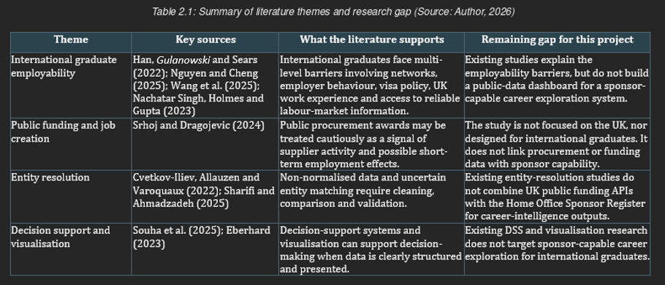

Decision Support and Dashboard Visualisation
This project extends beyond data collection and storage, and presents the processed evidence to enable interpretation and decision making. According to Souha et al. (2025), decision-support systems enable decision-making through data analysis, modelling and visualisation processes. They also discuss databases and user interfaces as important components. The authors’ work on a different application domain, but show that processed data, rules and a user interface are relevant components of a decision-support system.
Likewise, research on visualisation can be applied in the context of dashboard design. Eberhard (2023) summarises existing evidence concerning visualisation and decision-making and points out that visual display can affect judgment and comprehension. This supports the use of dashboard visualisation for the purpose of the project (Souha et al., 2025). Yet there are limitations that may lead to a false sense of certainty if omitted (Eberhard, 2023). Thus funding should be presented as a signal rather than a guarantee, and confidence in the match should also be displayed.
This scope becomes clearer when digital systems are considered. For example, Baranyi (2025) shows that digital personnel selection may improve efficiency while creating ethical, bias and adoption concerns. Hence a digital personnel dashboard is not proposed as part of an organisation's employment-selection process. While Flores, Ramirez and Mauricio (2025) show how scattered government records can be structured and audited using a multi-agent system applied to Peruvian government-transparency data, they do not compare with this limited Power BI application. Unlike Souha et al. (2025), who attempt to automate rule-centric DSSs, this work is an evidence filter. Eberhard (2023) states that visualisations can introduce bias in the outcome and that the evidence for provenance, scores and warnings should not create a false impression of certainty.
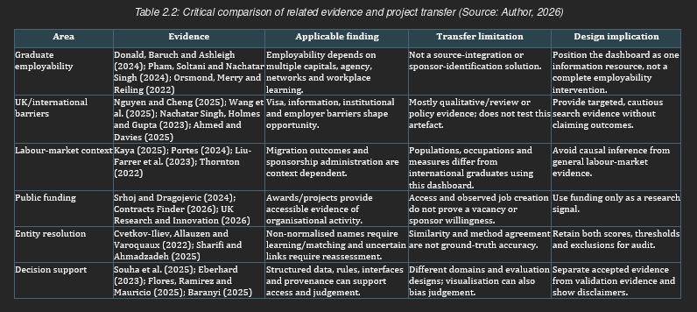

Literature Gap
The reviewed research indicates the existence of multiple factors impairing the employability of international graduates; that public funding can provide a more conservative measure of company activities, entity resolution can occur over distributed datasets, and dashboards can be used for decision making (Nguyen and Cheng, 2025; Wang et al., 2025; Srhoj and Dragojevic, 2024; Cvetkov-Iliev, Allauzen and Varoquaux, 2022; Sharifi and Ahmadzadeh, 2025). Each of these areas is typically researched in isolation. Employability literature defines the problem but does not provide a data pipeline, procurement literature reports employment effects but does not examine UK sponsor-capable job streams, entity-resolution literature provides a solution to the matching problem but does not consider UK public-funding APIs and the Sponsor Register in tandem; decision-support literature highlights benefits of dashboards but not their use in developing international graduate job-search intelligence.
Taken together, the reviewed studies do not provide one combined system linking the mentioned tools and data sources. This project addresses this gap by constructing a medallion data pipeline that would take UK public funding and sponsorship data, clean, match and then visualise it in order to inform the job-search efforts of international graduates.

Research Methodology

Research Strategy
A Design and Build research approach is adopted here due to the nature of the artefact that was produced: a Python pipeline for the processing of data, SQL Server as the storage layer, and Power BI as the visualisation tool. This methodology was employed as the project investigates the current issue but focused on the research of an appropriate solution and tests the results. This approach is suitable as it resulted in a practical computing artefact that measured its utility in a public sector data situation.
The development process was iterative: layers added, tested and honed prior to moving to the next stage.
Thus issues in API development, data quality, the SQL layer and entity matching were resolved in early stages, ensuring the research remained pragmatic. It supports the project aim to have a reproducible and testable artefact.
Design and build was preferred to a survey or experiment because the research questions concern constructing and technically evaluating an artefact. Because the project involved no participants and no labelled ground truth, those alternatives could not validly test usability or match accuracy.

Data Collection Methods
The project relies on readily available secondary public data. Contracts Finder provides procurement data; UKRI’s Gateway to Research provides data related to UK research projects. The Home Office Sponsor Register is utilised as the reference data that identifies sponsor-capable organisations.
All datasets were selected due to accessibility, pertinence to UK organisational activity and ease of use as inputs for a reproducible data engineering approach.
Contracts Finder and Gateway to Research datasets are ingested via HTTP requests to the source APIs using Python (Contracts Finder, 2026; UK Research and Innovation, 2026), whereas the Sponsor Register dataset is read from CSV. Initially all of the raw extracted data was placed in the Bronze layer which ensures a historical audit trail exists at the origin of the process. Subsequently cleaned and standardised datasets were written to the Silver layer
Finally, matching datasets are produced in the Gold layer, where further analysis can take place and were optimised for exporting into SQL Server and visualising in Power BI.
A sponsor register was gathered from the main worker licensing document (UK Visas and Immigration, 2026). An earlier version of a Gateway to Research tool read out XML (sample gtr.xml left in the code). The final notebook queries/parses both APIs as JSON. The dated Bronze/Silver/Gold/comparison documents are saved as CSV (JSON for APIs, CSV for saved work).

Data Analysis and Matching Methods
The analysis consists of data cleaning, entity resolution, comparison and validation. Initially organisation names were cleaned, any irrelevant punctuation removed and legal suffixes standardised, and differences in date and number formatting resolved, along with the elimination of duplicate or inaccurate rows, as non-normalised public data can include varied presentations for the same organisation (Cvetkov-Iliev, Allauzen and Varoquaux, 2022). The matching phase began with exact, then expanded to fuzzy entity resolution as organisational names were not necessarily identical across all datasets (Cvetkov-Iliev, Allauzen and Varoquaux, 2022; Sharifi and Ahmadzadeh, 2025).
The additional text-similarity method was finalised as unsupervised TF-IDF/Nearest-Neighbour matching and compared with token-based fuzzy matching.
This is presented as a measure of the robustness of the comparative process as relying on a single matching algorithm would weaken an evaluation and increase the risk of false positive matches (Sharifi and Ahmadzadeh, 2025).
If the names match exactly after cleaning (exact cleaned-name), it would return a score of 100. For names that do not match exactly, either a fuzzy token-sort scorer is used for the 25 named candidates or a TF-IDF/nearest-neighbour scorer is used to retrieve a candidate based on character n-gram cosine distance. Both paths must yield the same candidate, and have fuzzy score >=90 and TF-IDF/NN score >=75 to qualify. If not, all components are still present, but tagged with an exclusion cause. The two routes are not fully independent; the fuzzy route uses TF-IDF / nearest-neighbour on its shortlist, and results are interpreted as evidence of operability.

Mapping Research Questions to Methods
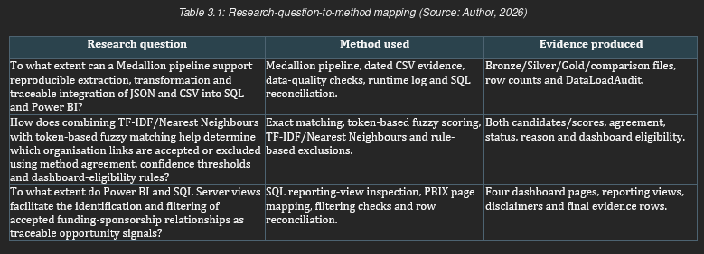

Research Limitations
The quality and format of public data limits the project: name entries for organisations may be incomplete, outdated or varied across datasets. Information on the Sponsor Register only identifies the company as capable of providing sponsorship and not if they wish to offer sponsorship to a particular graduate. A company appearing as a recipient of public funding is not an indication of them providing sponsorship. The nature of some entity resolution processes could result in false positives or miss true matches; cautious wording, displayed match scores and disclaimer notices within the dashboard address this.
Because no labelled ground-truth dataset was produced and no usability study was performed, this evaluation cannot estimate the precision, recall or accuracy of the matching, nor the usability of the dashboard. Additionally, the final run was limited, with only 90 days and 300-row coverage per public-funding entity, as opposed to full and continuous usage.

Ethical Considerations
Publicly available secondary data is used in the project. There are no participants; therefore no personal data is being collected. The project is assessed as low ethical risk. A potential ethical risk is that poor matching could misinform users (Sharifi and Ahmadzadeh, 2025; Flores, Ramirez and Mauricio, 2025). The dashboard does not present funding as evidence of an available employment opportunity but as a signal to be further investigated. The dashboard would not state any claims about "employer interest", job availability or related outcomes without supporting evidence. The approved ethics form is included in Appendix E.
As the data concerns organisations and not individuals, and since individuals have not been involved in the creation of the data, consent and anonymisation do not apply. Data minimisation, the secure storage of credentials and source provenance still apply, and source terms should still be reviewed prior to dissemination. Potential bias in the data is addressed through conservative filtering of potentially inappropriate data, and the statement that the factors of similarity, funding and licensing do not indicate employability.

Summary
The design-and-build methodology links the final artefact to technical evidence while keeping accuracy, usability and employment outcomes outside the claims.

Requirements and Analysis

Requirement Elicitation
Requirements came from multiple sources: Project aim, Literature review, Data-source documentation, Prototype development, and anticipated user needs. The primary user was a postgraduate international student who wants to identify organisations that could potentially offer sponsorship and showed recent government-supported activity in advance, providing suggestions and time to research before they may post job applications. Technical stakeholder (e.g. Software developer) ensured reproducibility and testability of the steps of extraction, cleaning, matching, SQL storage, and visualisation.
Also derived the requirements from the data structure of Contracts Finder and Gateway to Research in the fact the pipeline must handle the same sort of information: data fields from an API (e.g. Contracts Finder, 2026), time parameter, amounts funded and company names (UK Research and Innovation, 2026). The use of datasets in the literature highlighted the necessity of requirements related to the following items due to non-normalised entity matching can potentially lead to ambiguities (e.g. Cvetkov-Iliev, Allauzen and Varoquaux, 2022; Sharifi and Ahmadzadeh, 2025) to the highest possible extent. These predicted user needs are based on the project as a whole and literature, not participant interviews and therefore are assumptions based upon the project rather than tested user preferences.

Functional Requirements
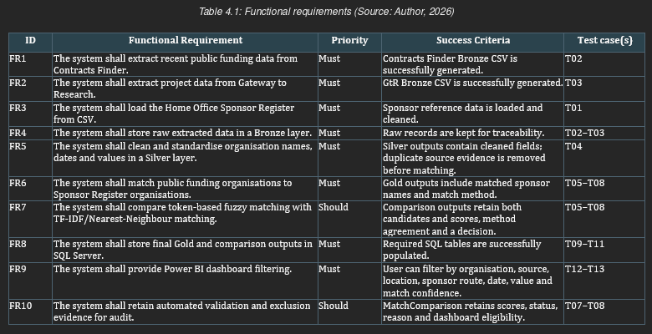

Non-Functional Requirements
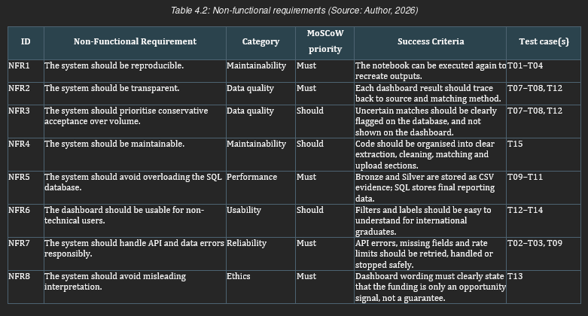

Use Case Analysis
The main use case is career-intelligence exploration. An international graduate opens the Power BI dashboard and filters organisations by locality, funder-sponsored route, source of funding, award date, award value or confidence in the match. The graduate then filters for those organisations that appear sponsor-capable and have recently received public funding. The dashboard does not imply that an employer is recruiting, yet it enables the graduate to prioritise employers that warrant further investigation.
The second use case is to check technical aspects, including row counts, dated files, candidates with and without scores, excluded organisation comparisons involving non-qualifying inputs (NQIs), SQL reconciliation, reporting views and dashboard-page linkages. This can provide traceability, but is not a substitute for labelled match validation or participant validation.

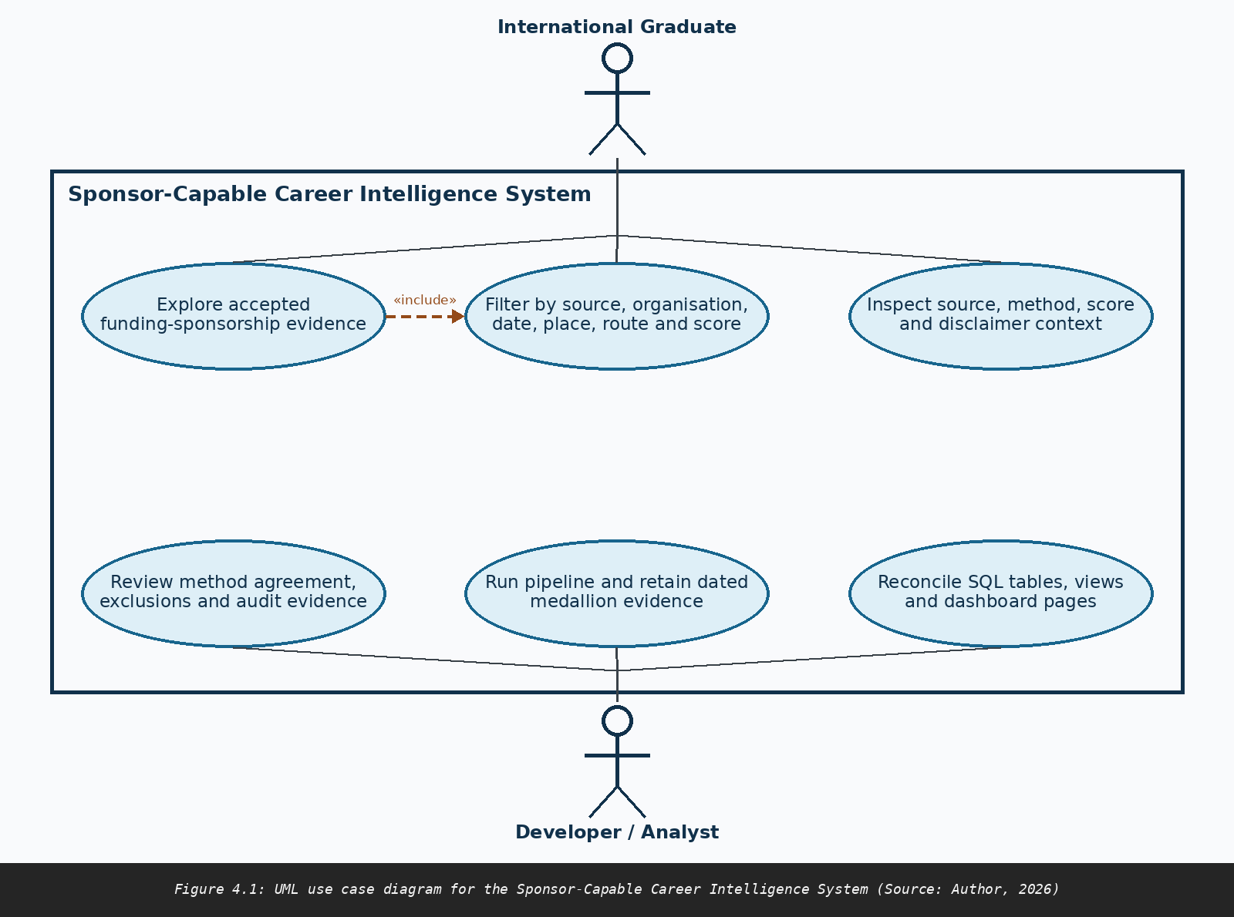

Summary
The requirements illustrate that the system must not only acquire data. Instead, it must persist the original evidence, clean inconsistent records, conduct entity resolution, evaluate methods for matching entities, retain final outputs and display outputs via a dashboard. The main quality requirement is that transparency is paramount (Sharifi and Ahmadzadeh, 2025; Flores, Ramirez and Mauricio, 2025). Users need to acknowledge outputs as intelligence signals regarding career decisions rather than job outcomes or sponsorship certainties.
Chapter 7 evaluates these requirements against the executed technical evidence and reports any limitation rather than treating design intent as proof of achievement.

Design

System Architecture
The architecture separates acquisition, transformation, matching, persistence and presentation. The Bronze items also include the Contracts Finder and Gateway to Research as strict JSON responses, and the Sponsor Register as CSV matching reference. Silver standardises their fields and names. Gold and comparison results indicate acceptance or rejection. For dated evidence, the data is kept in Google Drive, other reporting/auditing specific data is kept in SQL Server, and then Power BI consumes the Reporting Views from SQL, providing a contract both for auditing/reporting and also for ingestion.
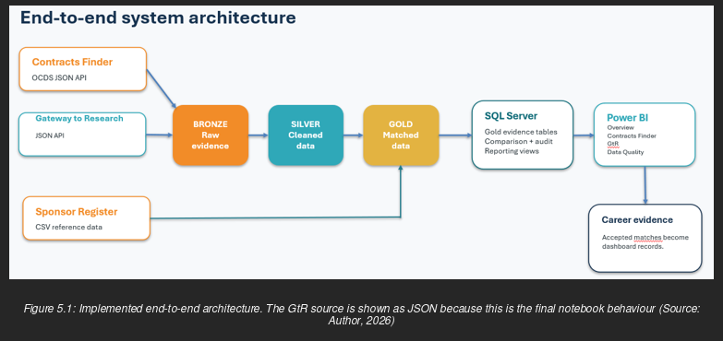

Database Design
In the SQL schema there is also a DimSponsorOrganisation table that contains the details for the sponsor dimension, and Gold_ContractsFinder and Gold_GtRResearch facts that use SponsorKey foreign keys to connect to it. MatchComparison is an audit table that stores for every input organisation the candidate matches, scores, comparison verdict, recommendation, status, rationale and dashboard readiness. DataLoadAudit contains the file, source, layer, method and file row-count facts. This structure ensures that the design separates accepted reporting evidence from potentially suspect rejected evidence and unclassifiable comparison results. The three accepted-evidence views: vw_Dashboard_Overview, vw_Dashboard_ContractsFinder and vw_Dashboard_GtRResearch expose accepted reporting evidence. Data Quality is supported by vw_AutomatedValidationEvidence and the vw_MatchingComparisonSummary view. (While vw_MatchingComparisonSummary exposes original nullable fields for manual accuracy measures, there was no accuracy data collected and these fields are not used as evidence).
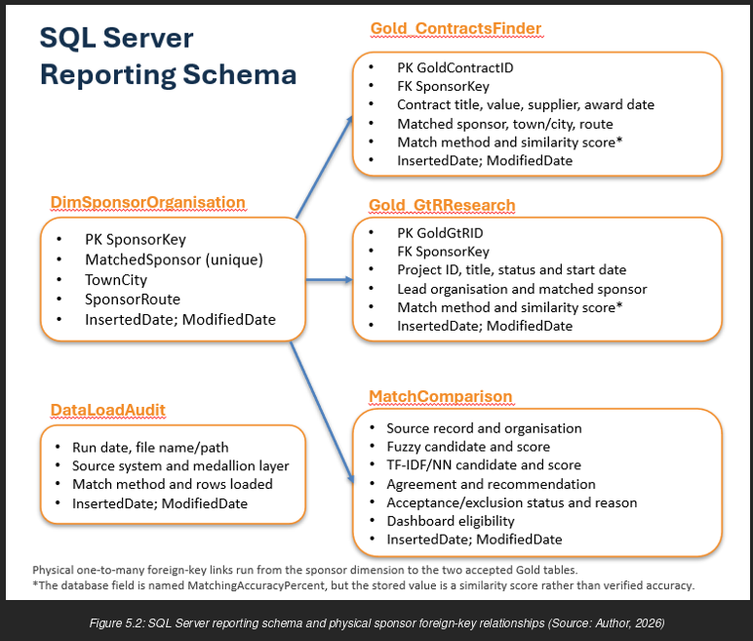

User Interface Design
The Power BI Desktop report pages include 'Overview', 'Contracts Finder', 'Gateway to Research' and 'Data Quality'. Source pages include award/project, organisation, sponsor and similarity context while data quality pages include scores, agreement and exclusion status. Navigation between pages is consistent. The disclaimer clarifies that the report presents evidence of funding, not vacancy/sponsorship possibility, and that its purpose is to support, not supplant, decision making. Despite the sources, method and score providing auditability, without participant testing it simply shows that the criteria have been followed in creating the score, rather than addressing usability (Souha et al., 2025; Eberhard, 2023). Consistent labelling, ordering of pages and a status/score display meant there was little need for colour coding. Contrast, keyboard focus and screen-reader compatibility were untested. Security and data-protection schemas include public organisational data, controlled reporting views and secure external credentials.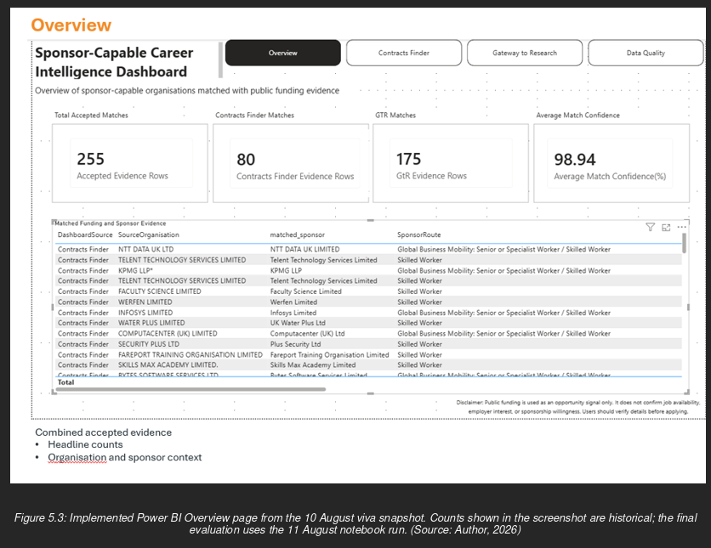

Algorithm / Logic Design
An exact cleaned-name match is attempted first. If names do not match exactly, non-exact matching is applied: one route applies token-sort scoring to a list of 25 TF-IDF/nearest-neighbour candidates; the second uses character n-grams and cosine-distance nearest neighbours. Both routes have their candidates and scores stored before the final decision is recorded.

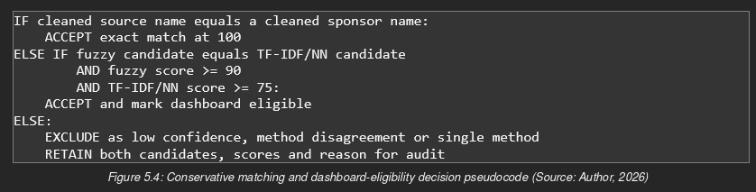
Fixed thresholds support repeatability and conservative exclusion, but they represent engineering constraints, not empirically optimal thresholds for classification accuracy. Because fuzzy uses a TF-IDF short-list, agreement between the routes is performance data with no guarantee of correct behaviour or independence.
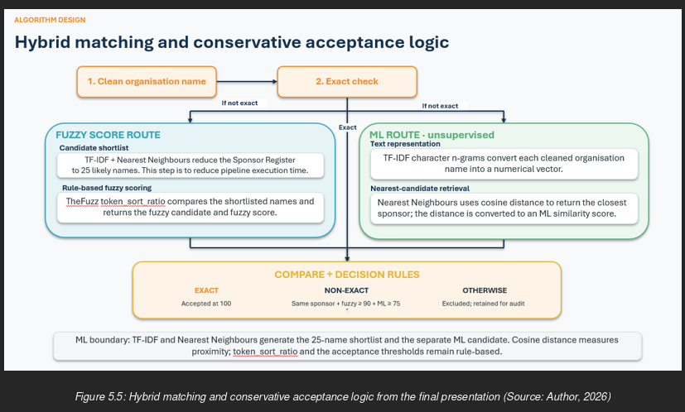

Technology Stack
Table 5.1 records the implemented technologies and the design role.
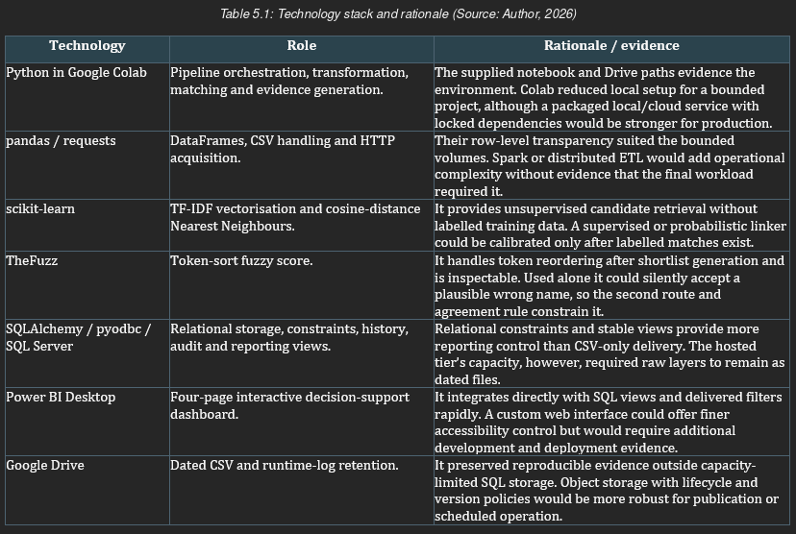

Summary
The result was an auditable bounded extract, a medallion transform, conservative matching, segregated SQL report and audit structures, and four dashboard pages.

Implementation

Development Environment
The final pipeline notebook was run in Google Colab (Drive-mounted outputs; re-execution requires a sign-in) and required pandas, NumPy, requests, scikit-learn, TheFuzz, tqdm, SQLAlchemy, and pyodbc. The SQL objects were defined in the database notebook and the PBIX file was constructed to provide the reporting. The GitHub repository is recorded in Appendix B.

Implementation Details

Run Configuration and Evidence Retention
The final configuration limited both APIs to 300 records over the 90-day period, with a fuzzy threshold of 90 and a TF-IDF/NN threshold of 75; dated outputs were stored in the 'Date' folders. The final run concluded on 11 August 2026.
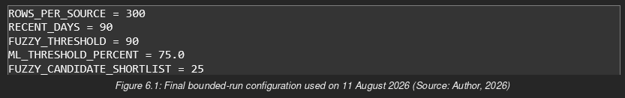

API Extraction and the Bronze Layer
Contracts Finder requested awarded OCDS releases; retried on transient failures; stopped after a given number of newly discovered suppliers. The final run retained 266 Bronze records and excluded 52 out-of-window records, as the stop condition applies to newly discovered suppliers rather than to rows retrieved. GtR requested active projects in most-recent-first order and stopped at the date bound after retaining 250 projects; this early stop assumes that the source ordering is reliable. The final GtR code requested the project and organisation lookups in JSON. The project API output is serialised in the date-specific Bronze CSV as rawprojectjson and can be downloaded and analysed without the need for a JSON evidence document.
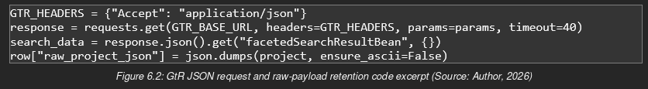

Silver Transformation
Silver processing normalises the names, values, and dates and unifies standard fields. All organisation names are converted to uppercase and thus normalised for variation in punctuation and legal suffixes. A GtR cache was used to avoid unnecessary GtR lookups. The latest Silver run loaded the cleaned name fields and retained all Contracts Finder (266) and all GtR Bronze (250) rows.

Gold Matching and Comparison
The Sponsor Register provided 126,582 unique organisation names. The candidate route and scores for each organisation, in each notebook, were retained prior to the combined rule being applied to prevent evidence of exclusion being lost because the organisations failed one or more thresholds. Of the 199 input organisations from Contracts Finder, 45 were accepted as sponsor matches, with 154 being rejected. Of the 141 input organisations from GtR, 81 were accepted, with 68 rows of contracts and 175 rows of research evidence accepted. Some organisations appeared in multiple awards/projects.

SQL Persistence and Audit
Before the database replacement, the notebook checked for the availability of a connection to the database and the database's disk space, the readiness of the prepared dataframes, and the completion of the comparison scores. For the daily-history option, only the most recent UTC day would be replaced. The last upload re-used 121 sponsor-dimension rows, added 10 rows for audits, 68 for contracts, 175 for GtRs and 340 for comparisons, and took 112.25 seconds to run. Database credentials and connection strings used to set up the database should not be included in the dissertation. Live secrets should be deleted from the code prior to publishing the repository, with connection settings stored in environment variables or a key store.

Power BI Reporting
The PBIX contains three accepted evidence views mapped to the Overview and source pages, and two comparison views mapped to the Data Quality page. A boundary and disclaimer separate the accepted dashboard rows from exclusions.

Challenges Encountered

Runtime and Scale
With files containing 500 records per source timing out after 50 minutes, row limitations, early stopping, cached GtR names and a shortlist of the top-25 sources were added. The trade-off was lower coverage of records.

Hosted SQL Capacity and Safe Replacement
Insufficient SQL storage due to free hosting made replacement risky. Storage preflight, table inspection, chunked inserts and same-day cleanup and fail-safe stop were added. The database contains evidence from 8, 10 and 11 August.

Source Variation and Evaluation Language
The structures, pagination, dates and names of sources differ and GtR requires additional organisation lookups. The inherited field MatchingAccuracyPercent stores a similarity score rather than an accuracy measure. The report should not refer to it as accuracy, and it should be renamed SimilarityScorePercent at the time of migration.

Summary
This version also created a bounded pipeline of acquisition to dated evidence with cautious matching, SQL history and Power BI. Coverage, retrieval independence and storage constraints were explicitly traded against runtime and hosting limits.

Testing and Evaluation

Testing Strategy
The tests included component tests, integration tests, end-to-end tests and requirements traceability tests for load, transform, scoring, acceptance, SQL and reporting. The final 11 August notebook, database notebook and PBIX contain the evaluated outputs. The 10 August figures show the former interface state. A technical pass means the expected file, field, status, row count or view mapping was observed. This is not a sign that the person has validated the link, that a participant knows how to use the link, or that a vacancy exists.
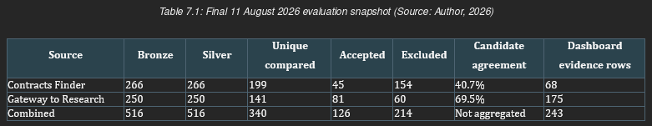
All agreement is source-specific, so there is no combined percentage-based figure to report. The 243 dashboard rows exceed the 126 accepted organisations because one organisation can appear in multiple awards or projects.

Unit / Component Testing
Each component was evaluated for inputs and expected outputs. Table 7.2 presents the expected and actual outputs, while the absence of participant testing was recorded as Not tested rather than as a pass.
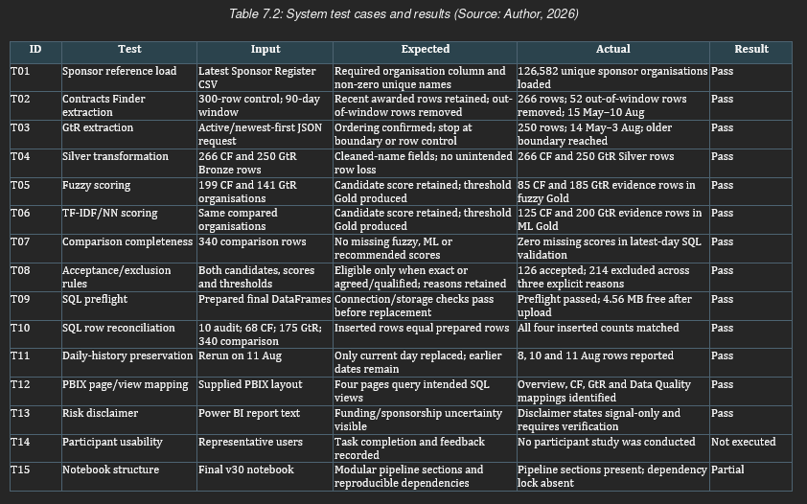

Integration and System Testing
The end-to-end run completed acquisition, file dating, matching/comparison, SQL upload and reporting, with all stages recorded as SUCCESS. The SQL upload took 112.25 seconds. SQL checks verified same-day replacement and insertion without loss of comparison scores. A PBIX check was used to confirm accepted views linked to Overview/source pages and comparison views linked to Data Quality; exclusions were documented outside the evidence.

User Evaluation
This study did not involve any surveys, interviews, or participant usability tests. The evaluation includes only the UI requirements implemented, mappings, filters, figures, and the disclaimers. Claims about usability and career outcomes necessitate ethics approval and recorded user evidence; Appendices C and D are thus designated NA.

Requirements Evaluation
Table 7.3 traces Chapter 4 to the executed evidence. NFR6 is partial because interface features exist but usability was not tested with users.
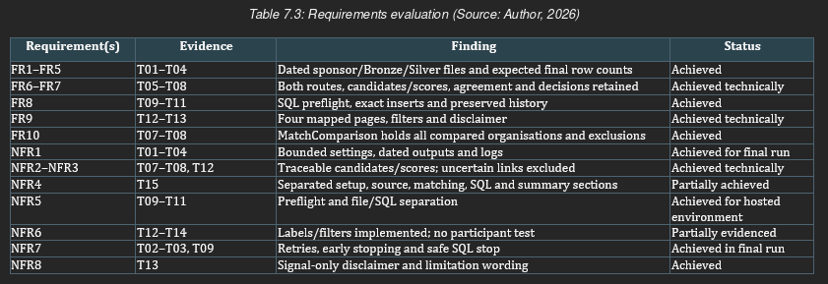

Answering the Research Questions

RQ1 – Data Engineering
To what extent can a Medallion pipeline support reproducible extraction, transformation and traceable integration of JSON and CSV into SQL and Power BI?
Within the tested limits. 516 Bronze and 516 Silver rows were generated, 12 date-stamped files were written, previous dates were stored in SQL, SQL tables were reconciled, view mappings, layer metadata, raw payloads, MatchComparison and DataLoadAudit provided traceability to originating sources, although changing sources and unpinned dependencies prevent exact reproducibility outside this environment.

RQ2 – Entity Resolution
How does combining TF-IDF/Nearest Neighbours with token-based fuzzy matching help determine which organisation links are accepted or excluded using method agreement, confidence thresholds and dashboard-eligibility rules?
Using a conservative and interpretable combination of the two implemented methods, the combined rule accepted 126 of 340 organisations. The 214 exclusions comprised 177 low-confidence cases, 29 single-method cases, and 8 disagreement cases. Agreement rates of 40.7% for Contracts Finder and 69.5% for GtR relate to eligibility rather than accuracy, and shared shortlist retrieval does not show route independence.

RQ3 – Decision Support
To what extent do Power BI and SQL Server views facilitate the identification and filtering of accepted funding-sponsorship relationships as traceable opportunity signals?
MatchComparison retained all 340 compared organisations, while SQL and Power BI exposed 243 accepted funding-evidence rows. Filters, source lineage, relevance context and disclaimer provide traceability. The artefact implements decision-support features, but it does not yield increased decision-making effectiveness or usability without participant evidence.

Objective Achievement
The objective closure against the executed evidence is presented in Table 7.4. All six objectives were satisfied within the boundary, although two are qualified: entity resolution is technically complete, with 126 of 340 organisations accepted and all 214 exclusions retained rather than validated, and the technical evaluation excludes ground-truth and participant measures.
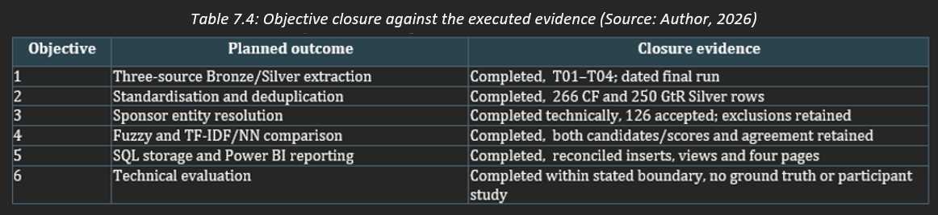

Summary
Testing confirms bounded technical claims: workflow executed, decision evidence is complete, exclusions are clear, SQL reconciles and PBIX visuals align with the intended views. Similarity is not verified accuracy, and alignment with PBIX visual output does not guarantee a user outcome.

Conclusion

Summary of Work
This project addressed the problem of fragmented public funding and sponsorship data. The solution relied on a Python “medallion” pipeline, “conservative” entity resolution (ER), SQL reporting and Power BI. The issue and need for care were demonstrated by the literature and by the three-part methodological link between the three research questions and the artefact evidence. The requirements defined the transparency and decision-support boundaries evaluated on 11 August without making claims about job or sponsorship outcomes.

Contributions
- Contracts Finder, Gateway to Research and Sponsor Register were linked in a dated medallion workflow. The contribution is the trackable merge of these, not the public datasets.
- Staggered entity-resolution evidence, including explicit evidence such as exact match, token-sort fuzzy, and TF-IDF/NN candidates, their scores, agreement, thresholds, and exclusions, avoids relying implicitly on a single similarity score.
- The distinction between accepted support evidence and match-comparison evidence enables reporting and Power BI to remain focused on accepted funding relationships while MatchComparison and Data Quality retain all assessed organisations along with the 'signal-only' disclaimer.

Limitations
The final run is limited to 300 rows per source, only recent data, and is non-exhaustive as public sources and the list of sponsor-registered members may not be complete or up to date. The two approaches are not independent, as the fuzzy matching algorithm requires the TF-IDF/nearest neighbour shortlist produced by the first step. No labelled ground truth means that it is impossible to compute false positive and false negative rates and precision, recall and accuracy scores. There is no study on usability or career impact. Implementation is environment-dependent: dependency versions are not pinned, and hosted SQL has storage limitations. MatchingAccuracyPercent is a misnomer and deprecated. Connection parameters should be securely stored, verified to not include secrets before sharing them, and secrets should be rotated if found.

Future Work
Future work involves a separate labelled stratified validation set, precision, recall, classification error and error types measured by source, threshold and organisation-name pattern. Another potential line of work is to have the ability to determine the threshold from the evidence itself instead of using it as a configuration parameter. Shared retrieval should also be compared to another matcher or probabilistic linkage. Further engineering refinements include extracting configuration, locking dependencies, documenting usage and hosting, automating runs, and renaming MatchingAccuracyPercent to SimilarityScorePercent. Long-term maintenance may benefit from monitoring, regression tests and developing a larger historical archive. An ethics-approved study could involve having target users or target graduates completing specified tasks and evaluating task success, completion time, errors, and interpretation of results. The career outcome study could be designed separately because it would necessitate evidence of activity rather than signals.

Reflective Statement
At the beginning of the project I thought it would be the extraction of data from Contracts Finder, Gateway to Research and the Sponsor Register that would be the technical challenge. Integration proved more difficult. There were inconsistencies in date formatting, naming conventions and details for organisations. GtR, as a separate dataset, needed to be processed to identify lead organisations. Some of the data that appeared valid at the Bronze or Silver level could fail to load into SQL or appear in Power BI. I thus learned to think of development as building a reliable data product, separating source preservation, standardisation and matching through Medallion architecture, and using runtime logs, SQL reconciliation and reporting views to make data movement auditable. A proper pipeline requires consistent schemas, controlled transformations and validation at each boundary of the pipeline. My research approach also developed, combining employability, public funding, entity resolution and decision-support research. However, none of these strands was sufficient to prove the existence of real vacancies on the dashboard, or that employers were interested in sponsoring them. I therefore learned to use each strand at different points: employability research for user need, public funding studies for a cautious activity signal, entity-resolution literature for the algorithm, and decision-support research for the dashboard. Explaining the limits of evidence transfer was more work than selecting convenient quotations without assessing their transferability. In future I will create a literature matrix, tabulating study method, context, limitations, and specific relevance. Project management created an area for development. I had identified the risks of APIs, matching, and the database, but I had not estimated how much time they would take. A test with 500 records per source timed out after 50 minutes, and hosted SQL has limited capacity for history. I added row controls and early stopping, and performed smaller tests on each dashboard component. I logged the time spent on each step, and created a valid state for the final dashboard. These design decisions reduced coverage, but enabled me to complete and justify this project in the time I had available. Identifying a risk is not the same as quantifying its potential impact on the schedule and the resources. For subsequent projects, representative volumes should be defined earlier and the interfaces between components should be confirmed. Finally, my professional identity changed through preparing and presenting the system. Initially, success was getting the pipeline and the dashboard to work. The viva taught me that a developer must communicate what their output means and does not mean. Similarity does not establish accuracy, and sponsorship registrations have not established a vacant position. Thus I kept scores and exclusion reasons, separated accepted evidence and comparison, and added a signal-only disclaimer. I also created a flat-file example in case the API, SQL or Power BI were broken. I learned that professional resilience is not hiding failure. It is documenting failure, testing alternatives, and being transparent about what I do not yet know. I learned that technical reliability, critical research, realistic design and clear communication are not separate parts of a project, but all blur together.

References
- Ahmed, A. and Davies, D. (2025) ‘The UK’s post-study work visa: Abolition and reinstatement of a degree mobility incentive’, Policy Futures in Education, 23(1), pp. 144–154. doi: 10.1177/14782103241240613.
- Baranyi, V. (2025) ‘Systematic literature review on the digital transformation of the personnel selection process’, German Journal of Human Resource Management, 40(2), pp. 223–254. doi: 10.1177/23970022251363012.
- Contracts Finder (2026) API Help Page. [online] Available at: https://www.contractsfinder.service.gov.uk/apidocumentation/home [Accessed 30 Apr. 2026].
- Cvetkov-Iliev, A., Allauzen, A. and Varoquaux, G. (2022) ‘Analytics on non-normalized data sources: More learning, rather than more cleaning’, IEEE Access, 10, pp. 42420–42431. doi: 10.1109/ACCESS.2022.3168013.
- Donald, W.E., Baruch, Y. and Ashleigh, M.J. (2024) ‘Construction and operationalisation of an Employability Capital Growth Model (ECGM) via a systematic literature review (2016–2022)’, Studies in Higher Education, 49(1), pp. 1–15. doi: 10.1080/03075079.2023.2219270.
- Eberhard, K. (2023) ‘The effects of visualisation on judgment and decision-making: A systematic literature review’, Management Review Quarterly, 73, pp. 167-214. doi: 10.1007/s11301-021-00235-8.
- Flores, N., Ramirez, C. and Mauricio, D. (2025) ‘Expert multi-agent conversational system using retrieval-augmented generation and dynamic text-to-SQL for government transparency’, IEEE Access, 13, pp. 198178-198200. doi: 10.1109/ACCESS.2025.3635530.
- Han, Y., Gulanowski, D. and Sears, G.J. (2022) ‘International student graduates’ workforce integration: A systematic review’, International Journal of Intercultural Relations, 86, pp. 163-189. doi: 10.1016/j.ijintrel.2021.11.003.
- Kaya, E. (2025) ‘Differences in labour market outcomes between immigrant and UK-born employees: Evidence from linked data’, The Scandinavian Journal of Economics, 127(4), pp. 765–808. doi: 10.1111/sjoe.12600.
- Liu-Farrer, G., Green, A.E., Ozgen, C. and Cole, M.A. (2023) ‘Immigration and labor shortages: Learning from Japan and the United Kingdom’, Asian and Pacific Migration Journal, 32(2), pp. 336-361. doi: 10.1177/01171968231188532.
- Nachatar Singh, J.K., Holmes, H.-L. and Gupta, S. (2023) ‘South Asian postgraduate international students’ employability barriers: A qualitative study from Australia and the United Kingdom’, British Journal of Educational Studies, 71(4), pp. 373-391. doi: 10.1080/00071005.2023.2197989.
- Nguyen, H. and Cheng, M. (2025) ‘Understanding international students’ agency in developing employability: Case study of a post-1992 university in the United Kingdom’, British Educational Research Journal, 00, pp. 1–17. doi: 10.1002/berj.70018.
- Orsmond, P., Merry, S. and Reiling, K. (2022) ‘Interconnected learning between university and the workplace: A socio-cultural perspective of graduate employability in the UK’, Oxford Review of Education, 48(3), pp. 303–319. doi: 10.1080/03054985.2021.1978961.
- Pham, T., Soltani, B. and Nachatar Singh, J.K. (2024) ‘Employability capitals as essential resources for employment obtainment and career sustainability of international graduates’, Journal of Further and Higher Education, 48(4), pp. 436-448. doi: 10.1080/0309877X.2024.2344771.
- Portes, J. (2024) ‘Unintended consequences? The changing composition of immigration to the United Kingdom after Brexit’, National Institute Economic Review, 268(1), pp. 63-78. doi: 10.1017/nie.2024.16.
- Sharifi, M. and Ahmadzadeh, D. (2025) ‘Transformer-Gather, Fuzzy-Reconsider: A scalable hybrid framework for entity resolution’, arXiv preprint, arXiv:2509.17470.
- Souha, A., Ouaddi, C., Benaddi, L., Abdelmalek, H., Bouziane, E.M. and Jakimi, A. (2025) ‘A DSL-driven solution and code generation for accelerated tourism decision support system development’, IEEE Access, 13, pp. 101558-101574. doi: 10.1109/ACCESS.2025.3578440.
- Srhoj, S. and Dragojevic, M. (2024) ‘Public procurement and supplier job creation: Insights from auctions’, The Journal of Law, Economics, and Organisation, 40(2), pp. 470–527. doi: 10.1093/jleo/ewac024.
- Thornton, J. (2022) ‘Visa bureaucracy causing GPs to leave the UK’, The Lancet, 400, p. 88.
- UK Research and Innovation (2026) Project API. [online] Available at: https://gtr.ukri.org/resources/gtrapi-project-api.html [Accessed 30 Apr. 2026].
- UK Visas and Immigration (2026) Register of licensed sponsors: workers. Available at: https://www.gov.uk/government/publications/register-of-licensed-sponsors-workers (Accessed: 5 August 2026).
- Wang, F., Huang, R., Wu, J. and Lim, W.M. (2025) ‘Employability of international postgraduate taught students in the UK: A systematic literature review using PRISMA’, British Journal of Guidance and Counselling. doi: 10.1080/03069885.2025.2496173.

Appendix A: AI Usage Declaration
I declare that this submission contains contributions from AI software and that it aligns with acceptable use as specified as part of the assignment brief/ guidance and is consistent with good academic practice.
I acknowledge use of AI software to [select as appropriate]:
☒​ Generate ideas or structure suggestions. [insert AI tool(s) and links and/or how used]
AI Tool | Links | How to use
Chat GPT | https://chatgpt.com | Provide feedback on my structure, and recommendations on how to improve or what I could be missing
☒​ Write, rewrite, or paraphrase part of this submission. [insert AI tool(s) and links]
AI Tool | Links | How to use
Claude | https://claude.ai/ | Help me find instances of informal vocabulary and provide me with more academically sounding synonyms.
Claude | https://claude.ai/ | Revise my text for punctuation mistakes and point them out to me.
Claude | https://claude.ai/ | Help me find instances where I used American rather than UK English
Claude | https://claude.ai/ | Check that my citations and references are correctly using Harvard style
☒ Generate any other aspect of the submission. [insert AI tool(s) and links] / Include brief details]
AI Tool | Links | How to use
Chat GPT | https://chatgpt.com | Help me find the cause of errors I got while coding, as well as how to optimise the execution time
Signed: Date: 26/08/2026

Appendix B: Full Source Code / GitHub Repository Link
https://github.com/JorgeTomasChabrillon/LD6053-dissertation/tree/main/

Re-execution requires a Google account, Google Colab sign-in and Google Drive authorisation. Output folders are created in the executing user's Drive.
Authoritative supplied source files:
• LD6053_dissertation_CF_GTR_PYTHON.ipynb: Final pipeline and executed outputs
• data base creation.sql: SQL tables, constraints and reporting views
• power bi dashboard.pbix: four-page Power BI implementation
README.md: Examiner re-execution instructions covering Google account and Google Colab sign-in, Google Drive authorisation, required repository files, Colab Secrets, cell execution order, expected outputs and troubleshooting.
SQL credentials are read from Colab Secrets; the published notebook must not contain commented or live credentials.
Selected implementation evidence
The following selected excerpts show the bounded extraction, Medallion transformations and conservative entity-resolution logic. The complete executable code remains in the repository notebook identified above.
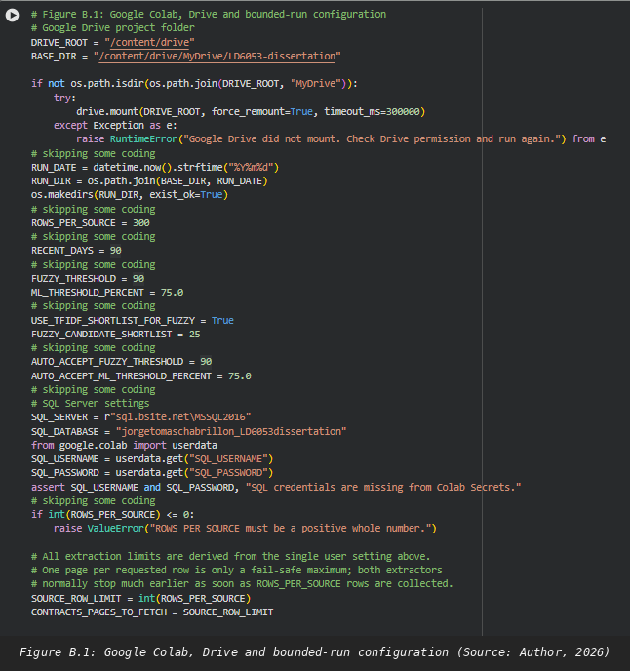
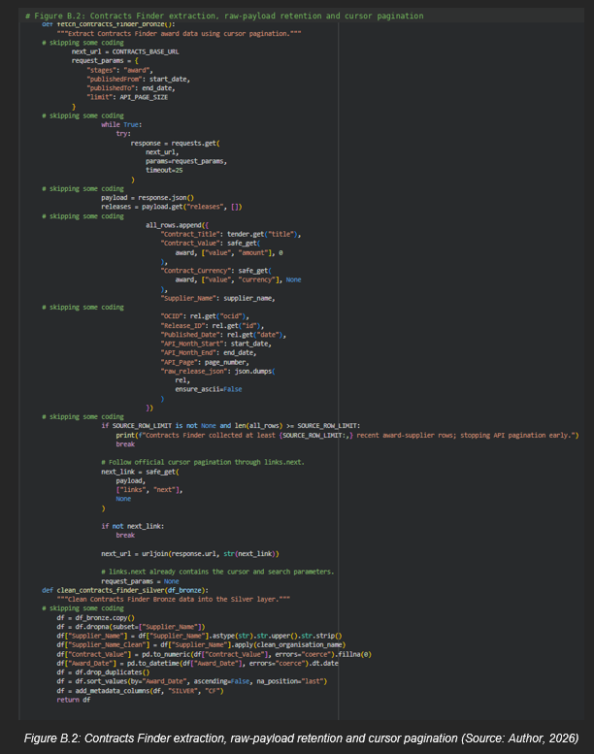
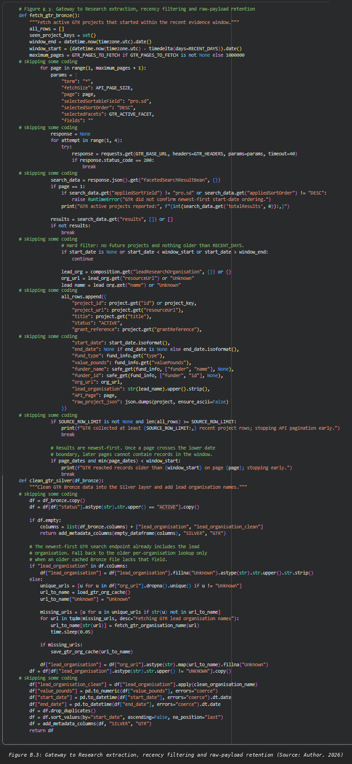
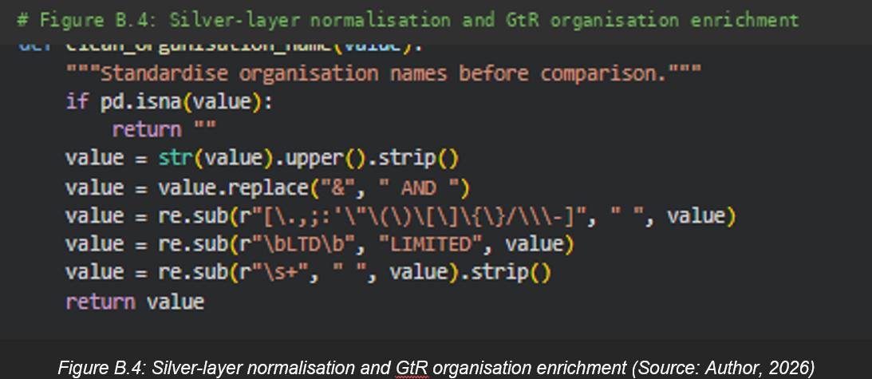
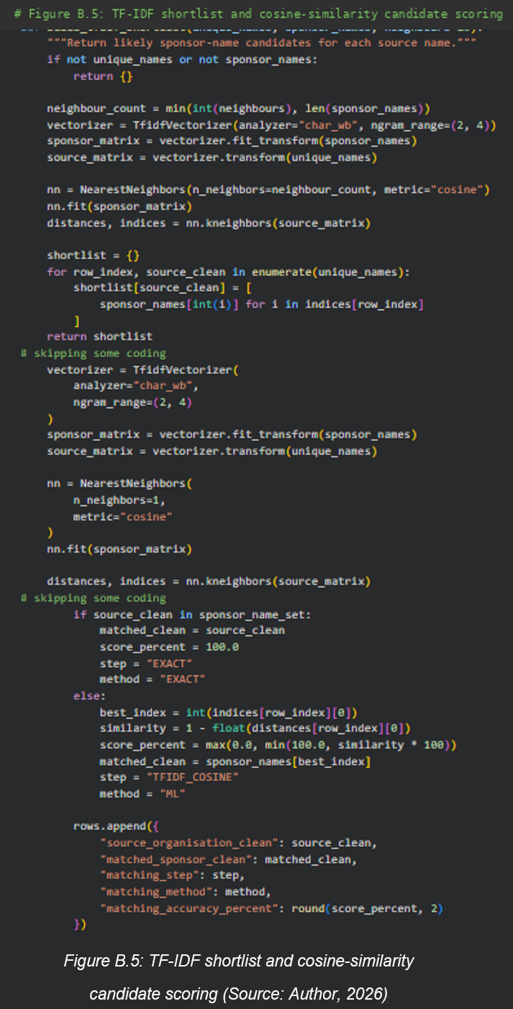
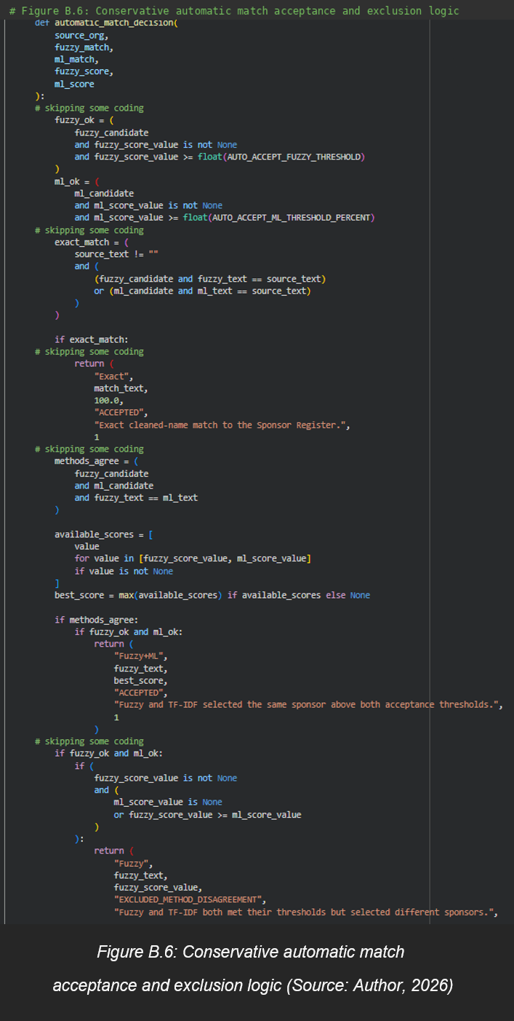
GitHub repository evidence
The following repository views record the public project structure and the files supplied in the code directory.
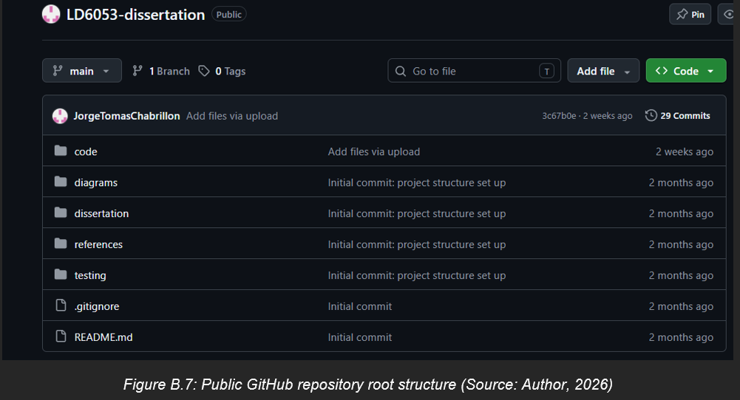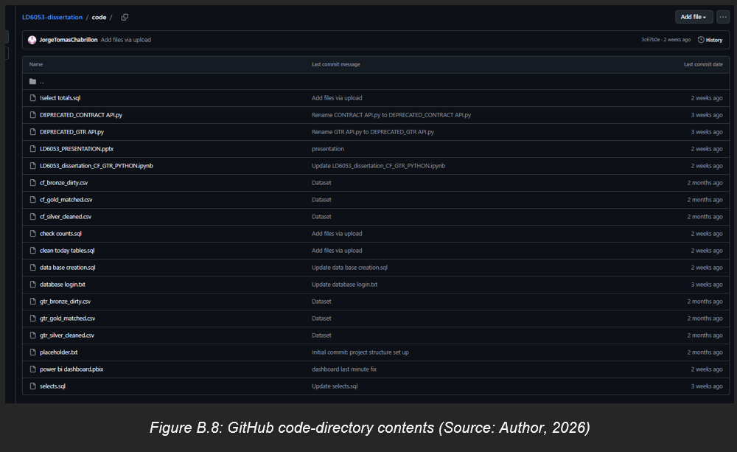

Appendix C: Survey Questionnaire
Not applicable: no participant survey was conducted. Any future questionnaire requires ethics approval.

Appendix D: User Testing Results / Raw Data
Not applicable: no participant user study was conducted. Technical run evidence is provided in Appendix G.

Appendix E: Ethics Approval Form
. 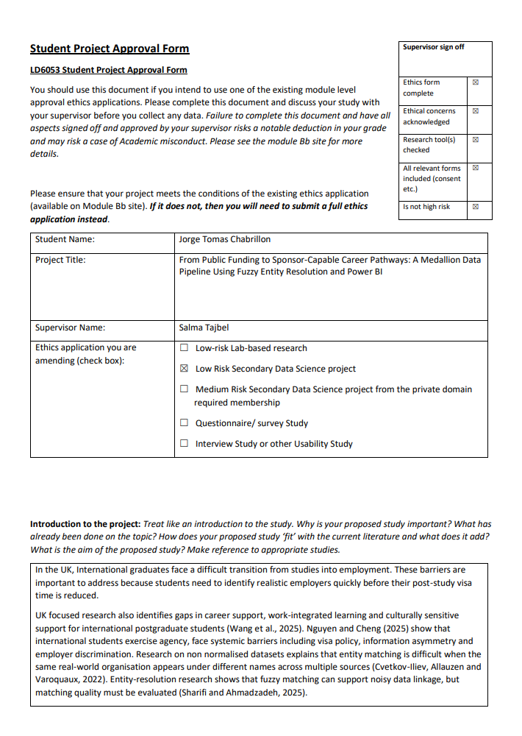
.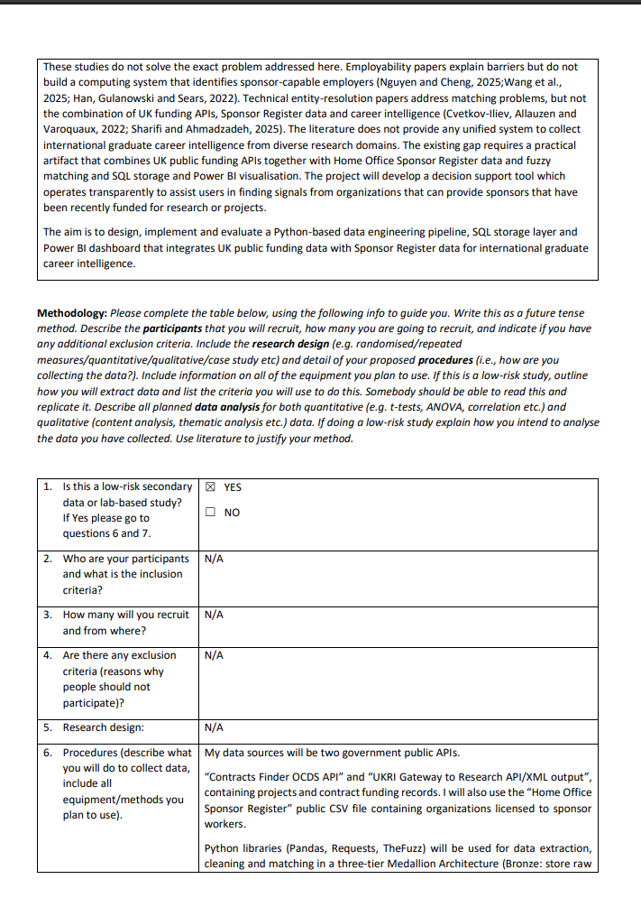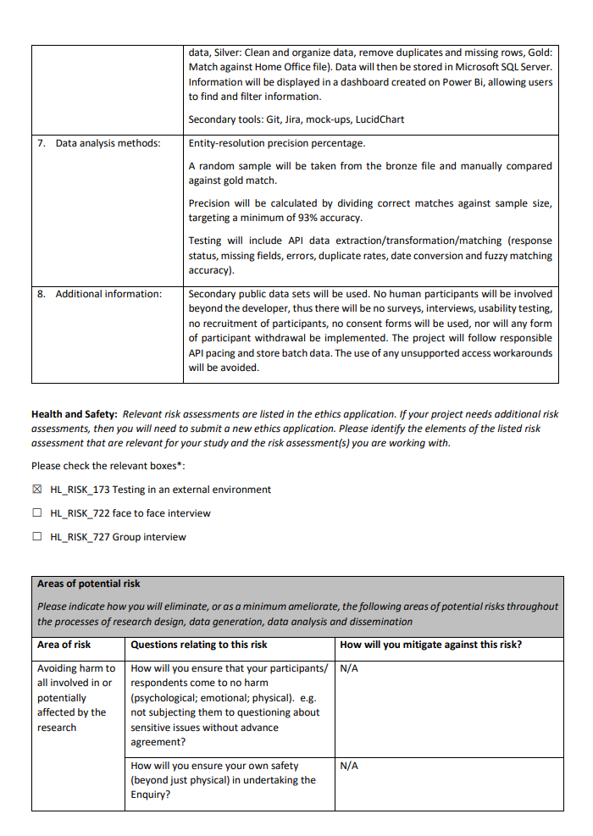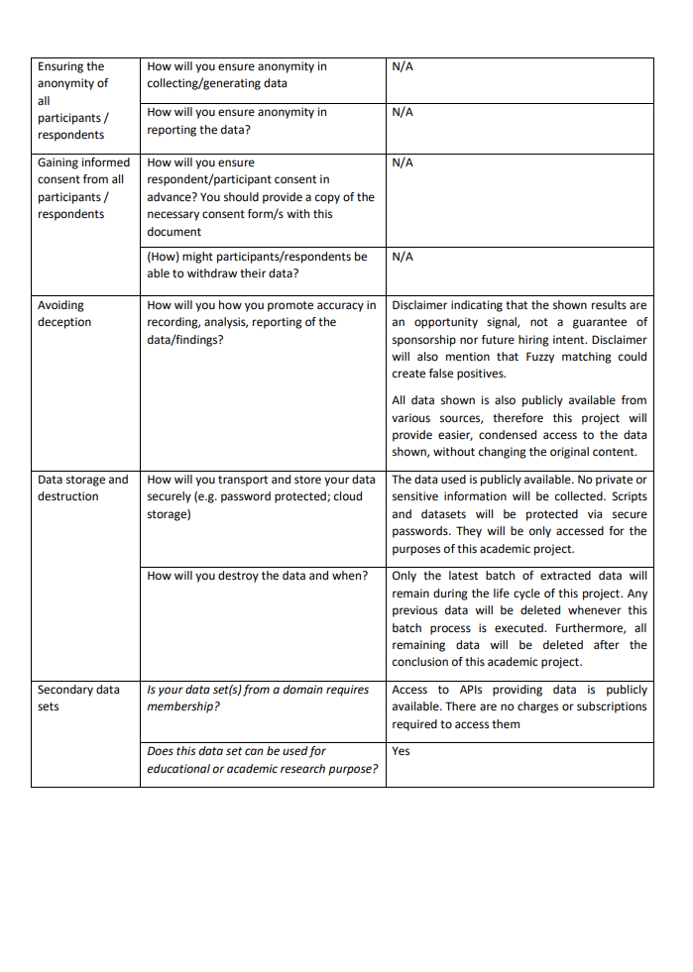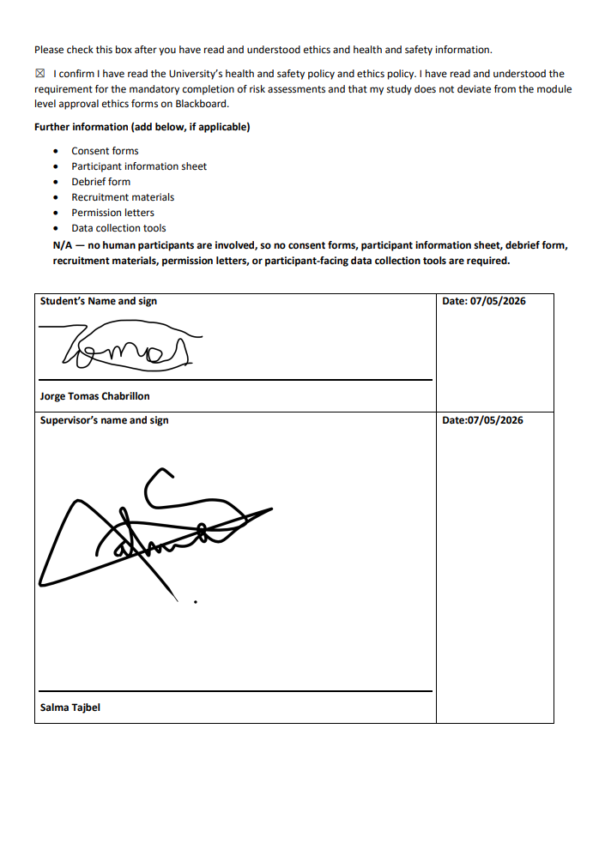

Appendix F: Meeting Logs
Selected supervisor meeting-log evidence is reproduced below.
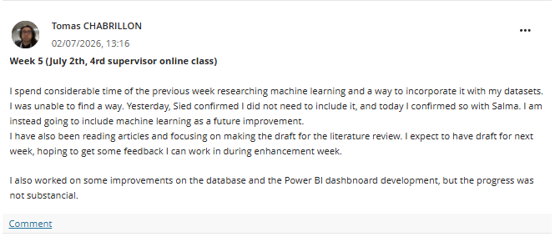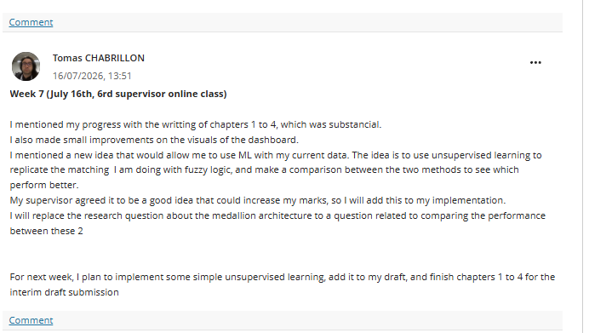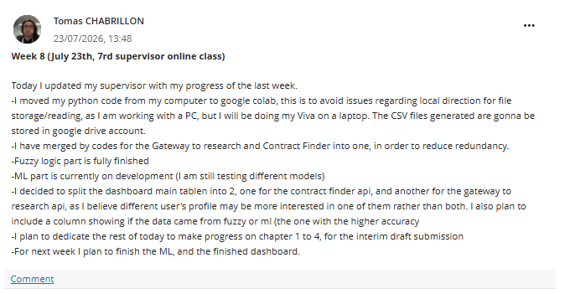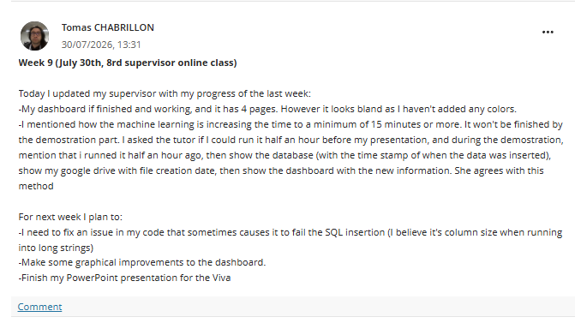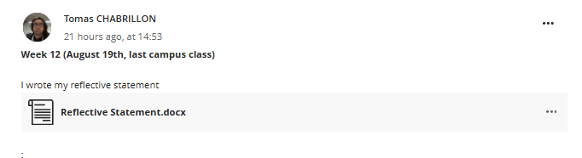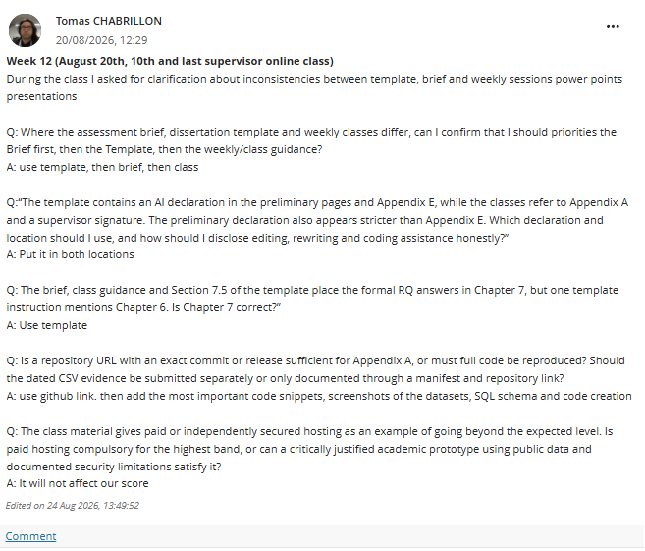

Appendix G: Final Technical Run Evidence
The authoritative final snapshot is the executed 11 August 2026 output in LD6053_dissertation_CF_GTR_PYTHON.ipynb. The 10 August presentation remains viva evidence but is not used as the final numerical snapshot.
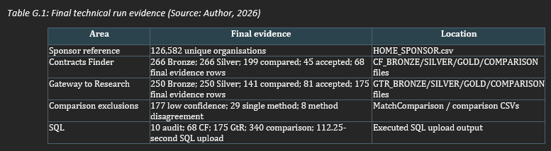

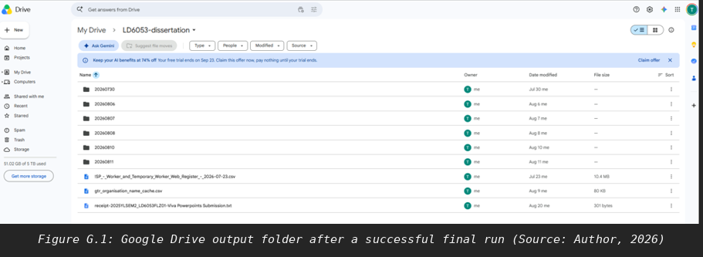
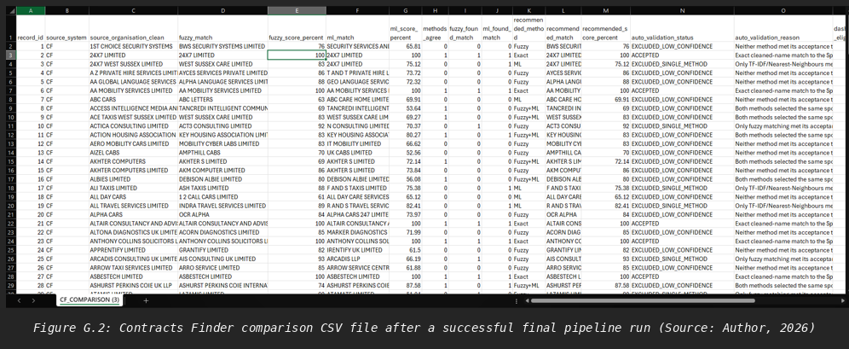
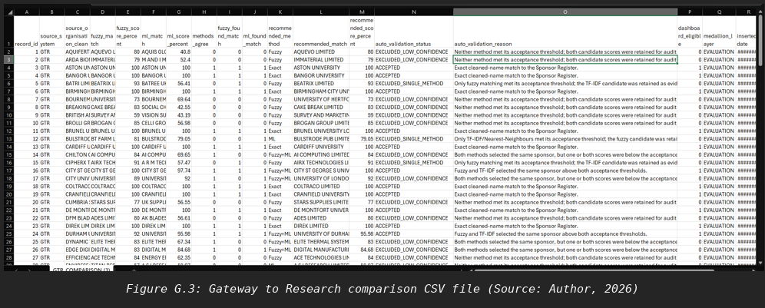

Appendix H: SQL Schema and Reporting Views
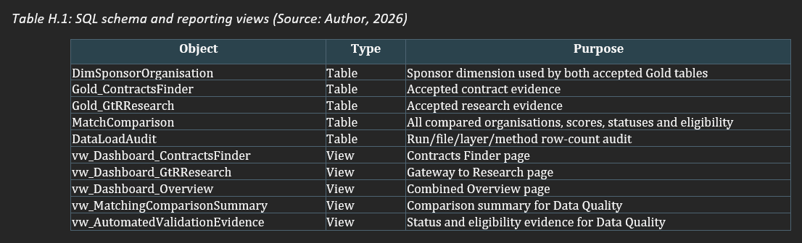

The full SQL schema and view definitions are provided in database creation.ipynb in Appendix B.
No database username, password, connection string or live secret should be included.
The diagram and selected SQL excerpts below show the implemented relational structure and the views used by the dashboard. Full definitions remain in database creation.ipynb.
Figure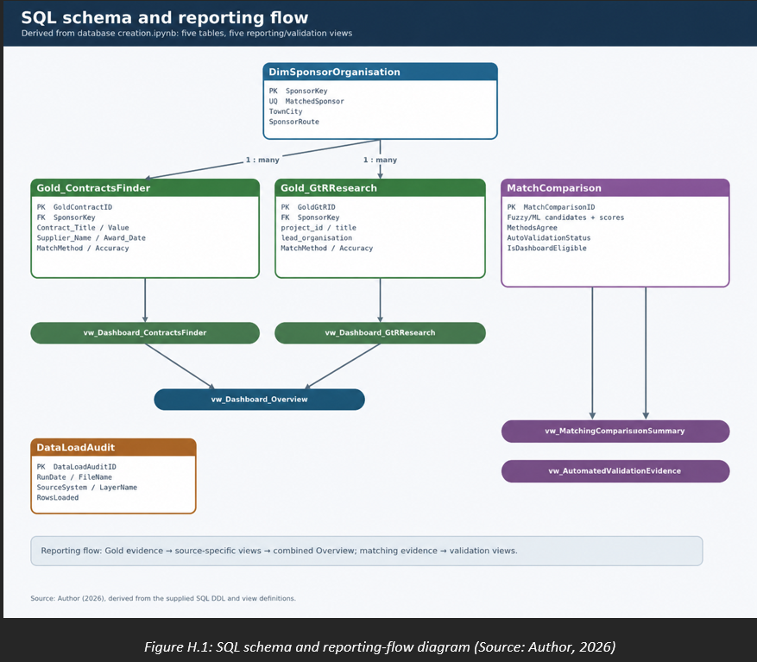
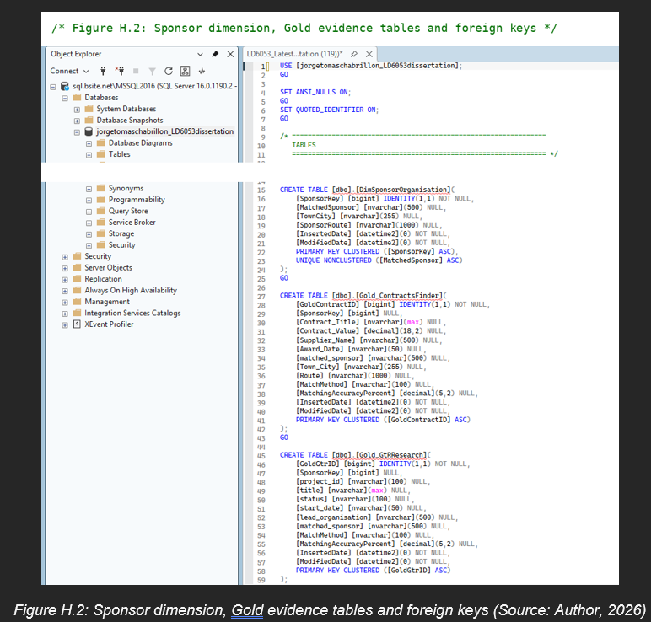
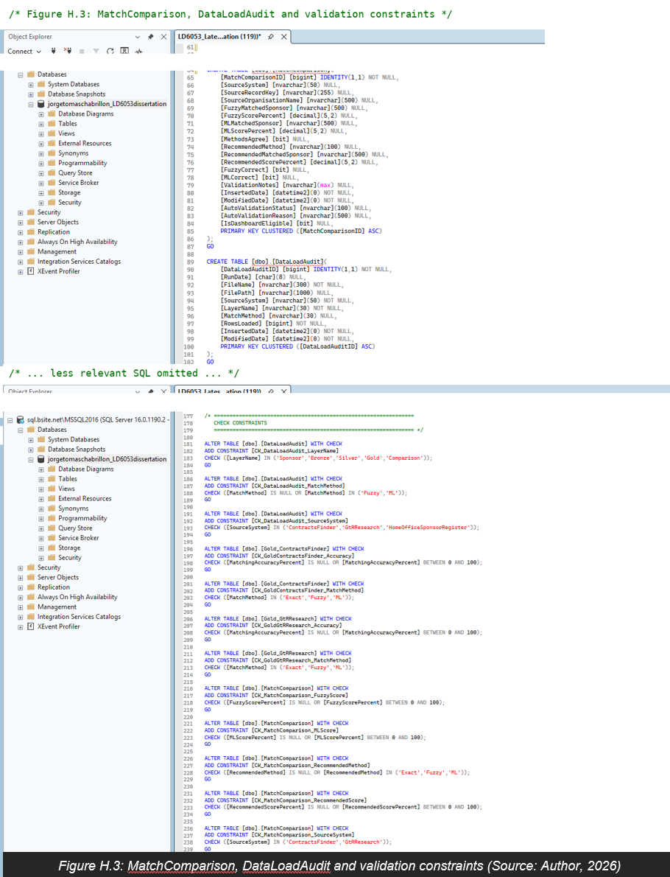
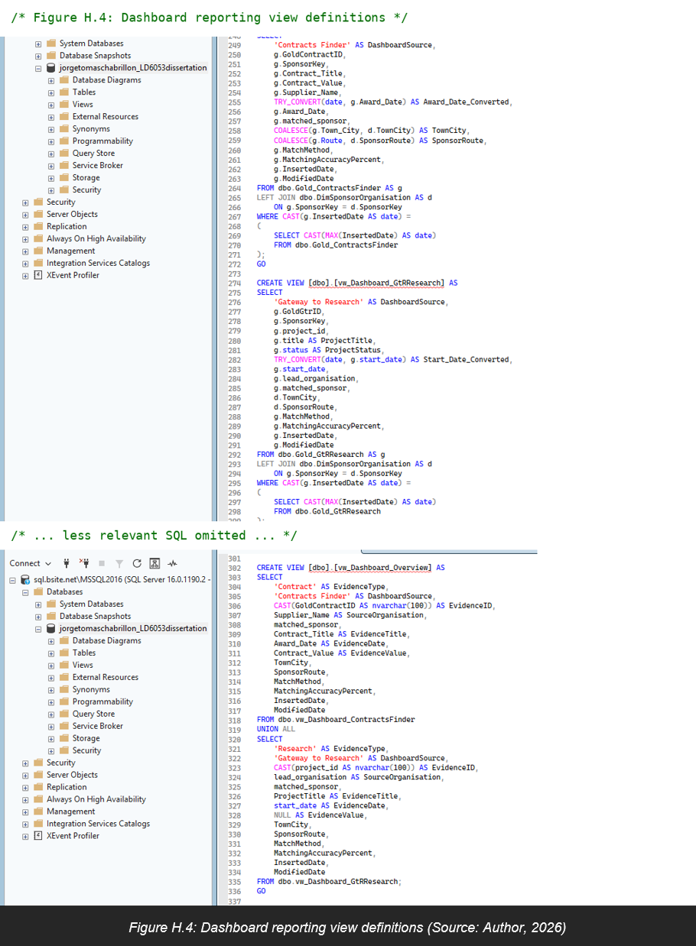

Appendix I: Project Planning and Additional Visual Evidence
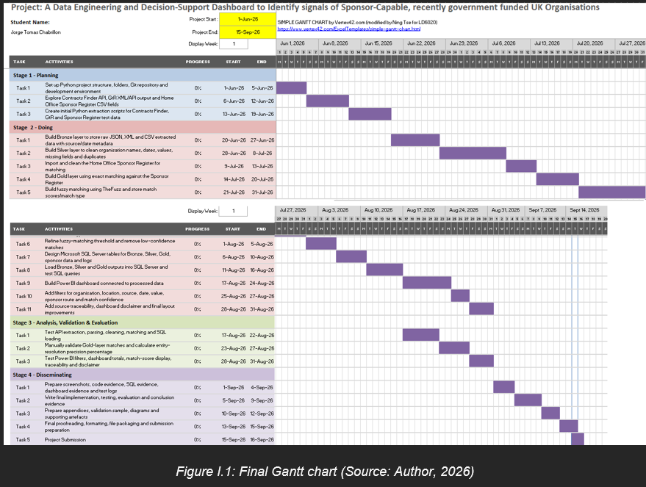

Selected Power BI evidence pages.
These are from the 10 August viva snapshot; the counts shown are historical and the final evaluation uses the 11 August run reported in Table 7.1.
