CPSC335 Project #4 Report

Jorge Diaz jorgediaz@csu.fullerton.edu

Jacqueline Isabel Cardenas jacisac@csu.fullerton.edu

Scatterplots:

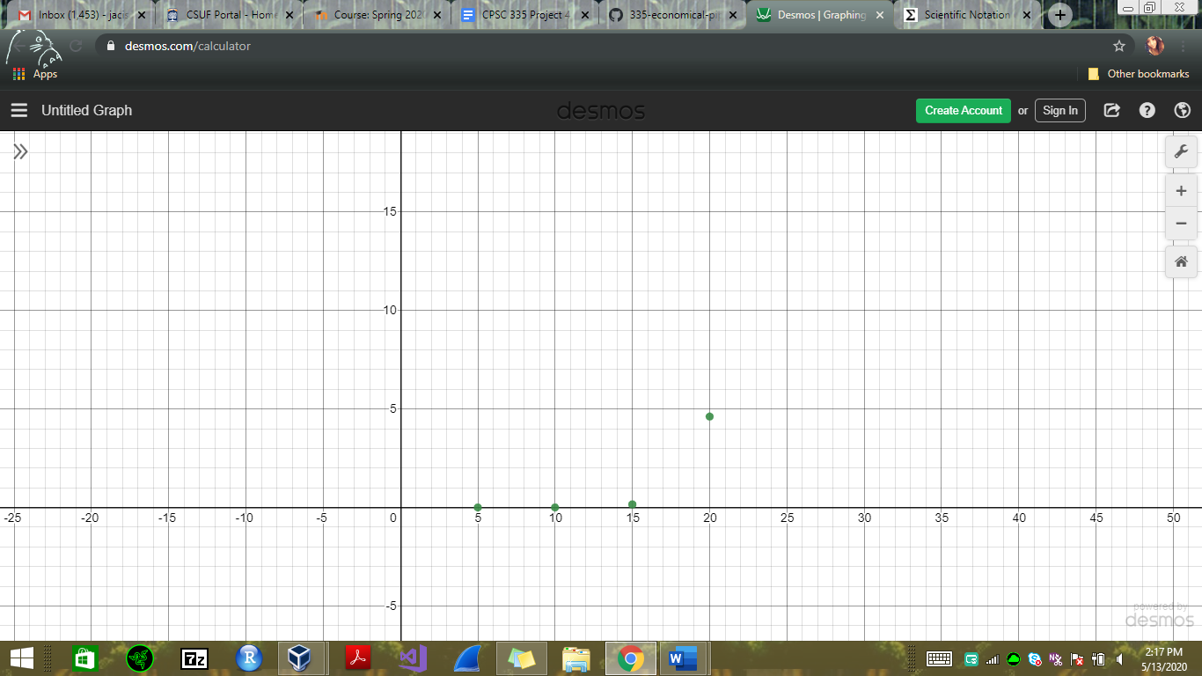

Exhaustive Algorithm

Time in seconds

n size

Dynamic Programming Algorithm

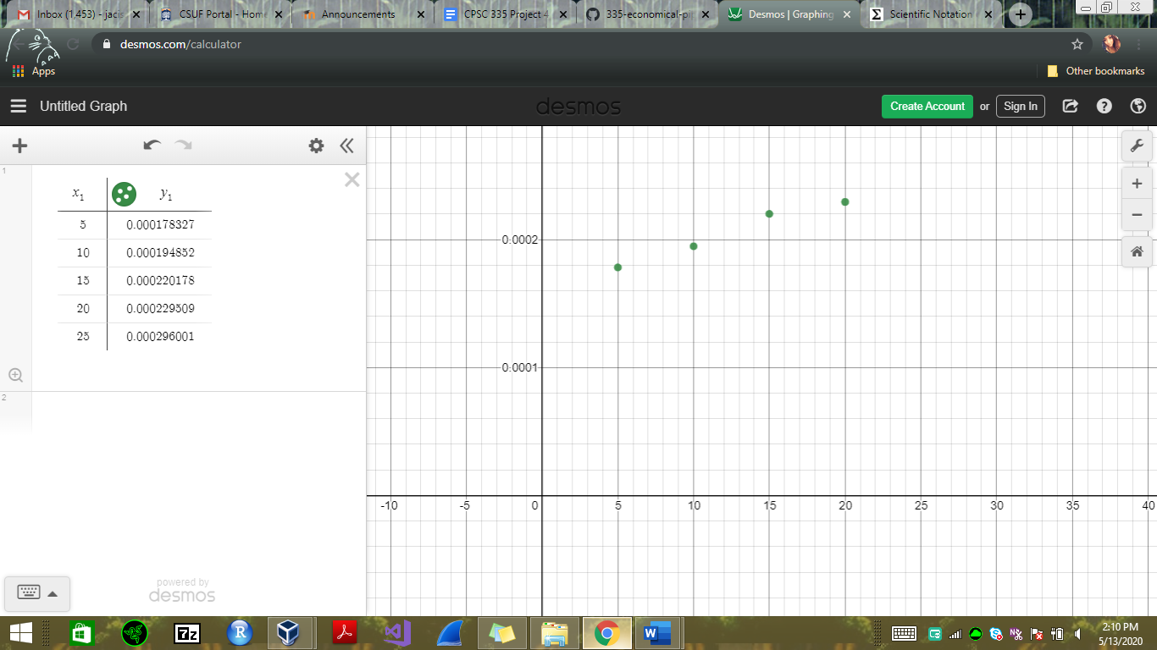

Time in seconds

n size

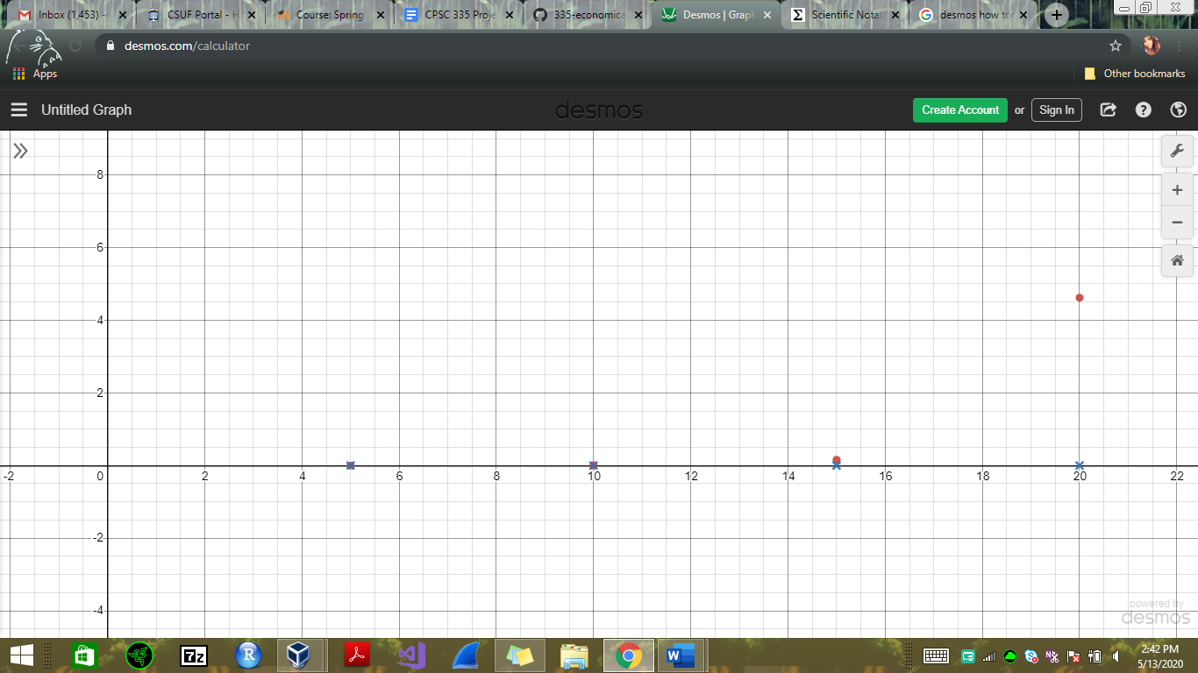

n size

Exhaustive Algorithm(red)

Dynamic Programming Algorithm (blue x’s)

Time in seconds

3a. The lines on the scatter plots are consistent with their respective efficiency class. This is seen in the exhaustive algorithm class since it is a slower algorithm, we can see how it takes in more time being that it runs in exponential time. As opposed to the dynamic programming algorithm which is faster because it runs in polynomial time.

3b. The evidence shown does support the hypothesis that polynomial dynamic programming algorithms are more efficient than exponential-time exhaustive search algorithms when solving the same problem.

3c. The most challenging part when working with these algorithms was with the dynamic programming algorithm. It was more of a challenge to work and implement the different paths in order to at the end make them work together. However, having worked on these different paths made me understand more clearly how these alternatives function into a more efficient dynamic programming algorithm which I ended up preferring when implementing.