  
JASP Audit Report

**This report is automatically generated by JASP for Audit (JfA) and serves the purpose of interpreting the evaluation of a frequentist attributes bound.   
For a more elaborate explanation, visit** [**www.jfa.com**](http://www.jfa.com)**.**

**___________________________________________________________________________**

**Objective**

**The objective of the attributes test is to determine with 95% confidence whether the population error lies below the materiality limit of 5%. An attributes test only considers the observations to be completely correct or completely in error.**

**Prior knowledge**

**The inherent risk was determined to be high. The internal control risk was determined to be medium. According to the Audit Risk Model, the required detection risk to maintain an audit risk of 5% should be set to 8.33%.**

**Result**

**The sample that was uploaded to JfA consisted of 77 observations. Of these 77 observations, 1 was found to contain a complete error. The proportion of errors in the data set is 1.29% with an 95% upper confidence bound of 5.2%. This means that, if one were to repeatedly do this experiment, there is a 95% probability that the maximum error in the population lies below 5.2%.**

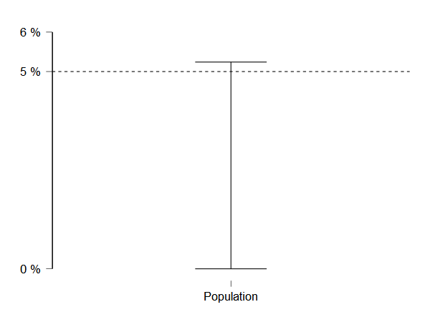

**Conclusion**

**To approve this data set, a 95% upper confidence bound on the population proportion of errors should lie below the set materiality. For the current data set, the confidence bound lies above the materiality. The conclusion is that this data set contains material misstatement.**

