Equal-Tailed versus Width-Optimized Conformal Scores under CDF Estimation Error: A Pilot Study
CKME–CP project · pilot for the score-choice ablation (E4) · 2026-07-16

1. Purpose and connection to the paper
Our paper constructs prediction intervals for stochastic simulation outputs. A kernel-based estimator (CKME) learns the conditional distribution function F(t | x) of the output Y at input x from a designed set of simulation runs, and split conformal prediction (CP) then calibrates the intervals on held-out runs so that 90% coverage is guaranteed regardless of how well F was estimated. The paper's central thesis is a division of labor: the calibration layer guarantees coverage, while interval EFFICIENCY (how narrow the intervals are) is governed by the estimation layer.
Within this pipeline, a “conformal score” determines the shape of the interval. The paper uses the score |F(y|x) − 1/2|, which yields equal-tailed intervals. A natural question (raised by the advisor) is whether this score is the best choice: for skewed output distributions, a width-optimized score promises intervals that are 12–28% narrower in theory. This pilot answers two questions empirically: (Q1) do width-optimized score variants realize their theoretical gains when F must be estimated from a realistic simulation budget, and (Q2) can a constraint derived from our tail-error analysis protect those gains? The results inform the score-choice ablation planned for the paper and provide a direct test of the layer-separation thesis: promises made at the score layer can only be cashed at the estimation layer.

2. Background in plain terms
Write u = F̂(y | x) ∈ [0, 1] for the estimated “probability position” of an output value y (the probability integral transform, PIT). If F̂ were exact, u would be uniformly distributed. A 90% prediction interval can be built by keeping all y whose PIT falls in a band [θ, θ + 0.9], and CP widens or narrows this band by a calibrated margin so that 90% coverage holds exactly. Every choice of the cut point θ ∈ [0, 0.1] gives a valid method; the choices differ only in width:
- Equal-tailed (ET): θ = 0.05, cutting 5% from each tail. This is the paper's default score |F̂(y|x) − 1/2| in disguise.
- Width-optimized (opt): for each x, pick θ*(x) that minimizes the estimated interval width. For our skewed test distribution the oracle version of this rule would give intervals 12.3% narrower than ET, by cutting almost everything from one tail (θ* ≈ 0).
- Bias-constrained opt (b-opt, our proposal): the same width minimization, but the interval endpoints are not allowed to sit where the estimated density is below 15% of its local peak. This is an implementable proxy for our theoretical tail-error formula, which shows that quantile estimation error is amplified by one over the density — i.e., precisely in the deep tails that the width optimizer likes to chase.
The hazard being tested: moving θ toward 0 places an endpoint at an extreme quantile, where the estimated CDF is flattest and least reliable. The theoretical width gain may therefore not survive estimation error — and if the tail estimate is poor, the calibration layer must widen ALL intervals to repair coverage, so the optimized score can end up wider than the simple one.

3. Experimental design
Data-generating process. Y = m(x) + 0.3·ε with m(x) = exp(x/10)·sin(x) on x ∈ [0, 2π], and ε a standardized Gamma(2) variable (mean 0, variance 1, skewness 1.41). The noise is skewed so that width optimization has a real prize (oracle: −12.3% width), and homoscedastic (constant spread) so that the score comparison is not confounded with the paper's separate bandwidth-adaptation question.
Data sizes. Training: 60 design sites × 10 replications = 600 simulator runs (low budget), or 200 × 10 = 2,000 runs (high budget); sites are space-filling in [0, 2π]. Calibration: 300 fresh input–output pairs drawn uniformly. Test: 1,000 fresh pairs. The CDF is evaluated on a 220-point output grid; CKME hyperparameters are held fixed across arms (length scale 0.3, ridge 10⁻³, output smoothing bandwidth 0.05). Macroreplications: 16 at the low budget, 8 at the high budget (each macroreplication regenerates all data from a fresh seed; seeds 20260716+k and 20260800+k). Total compute ≈ 80 seconds on a laptop-scale machine.
Protocol. Within each macroreplication all three scores share the SAME fitted CKME model and the SAME calibration set, so any difference between arms is attributable to the score alone (a paired design). The cut point θ*(x) is searched over a 41-point grid on [10⁻⁴, 0.1]. Validity is measured as the coverage of the conformal set itself (the exact quantity the CP theorem guarantees); width is measured on the monotone-projected interval, the paper's reporting convention.

4. Results
Table 1 summarizes all runs. Figures 1 and 2 show the same information graphically.
Budget | Score | Coverage (mean) | Width (mean) | Width (SD) | Paired width vs ET (mean / median) | Mean cut θ*
B = 600 | ET | 0.900 | 0.964 | 0.074 | — | 0.050
 | opt | 0.901 | 1.091 | 0.534 | +11.3% / −1.6% | 0.016
 | b-opt | 0.901 | 1.023 | 0.371 | +5.0% / −1.2% | 0.024
B = 2000 | ET | 0.900 | 0.879 | 0.044 | — | 0.050
 | opt | 0.901 | 0.855 | 0.056 | −2.6% / −3.2% | 0.013
 | b-opt | 0.900 | 0.874 | 0.046 | −0.5% / −2.6% | 0.020
Table 1. Summary over macroreplications (16 at B = 600, 8 at B = 2000). “Coverage” is the marginal coverage of the conformal set at nominal level 0.90. “Width” is the mean prediction-interval width in response units; the oracle equal-tailed width is 0.931 and the oracle shortest width is 0.816. “Paired width vs ET” is the per-macroreplication percentage width difference against the ET arm. “Mean cut θ*” is the average lower-tail cut point chosen by the score (ET fixes 0.050; smaller values mean deeper tail-chasing).
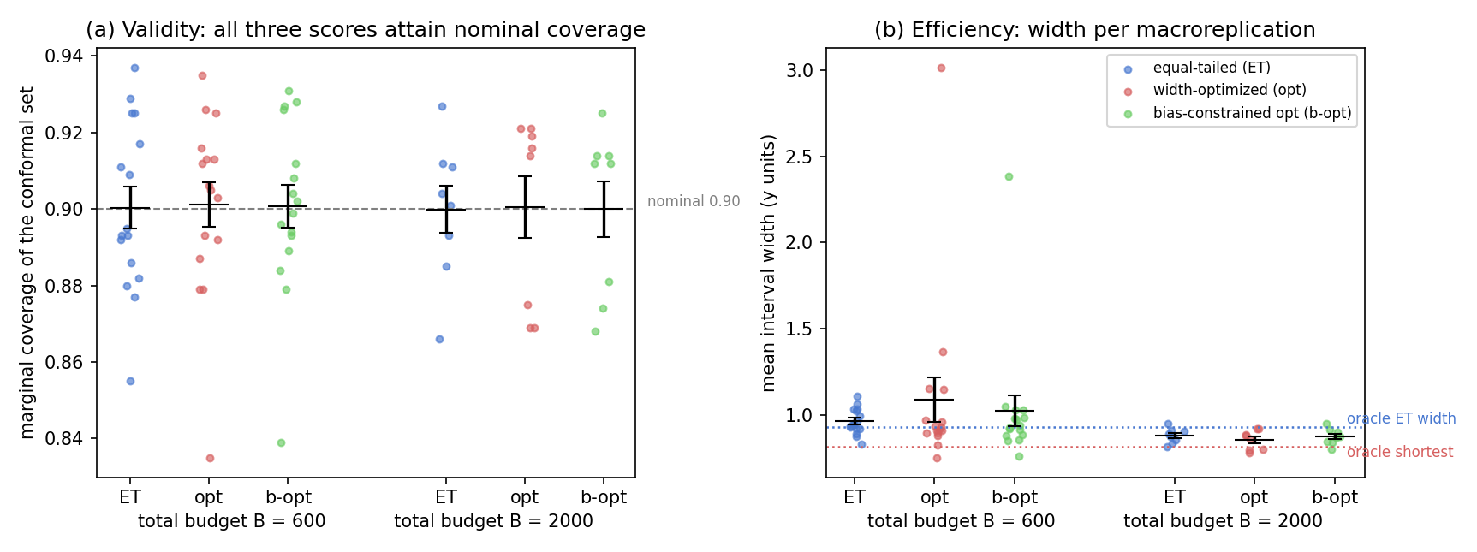
Figure 1. Validity and efficiency of the three conformal scores at two simulation budgets. (a) Marginal coverage of the conformal prediction set: each colored dot is one macroreplication, black bars show mean ± one standard error, the dashed gray line is the nominal level 0.90. All six arm×budget cells sit on the nominal line — score choice never threatens validity. (b) Mean interval width (response units): dotted lines mark the oracle equal-tailed width (blue, 0.931) and the oracle shortest width (red, 0.816). At B = 600 the width-optimized arms are wider and far more dispersed than ET; at B = 2000 all arms concentrate near the oracle frontier.
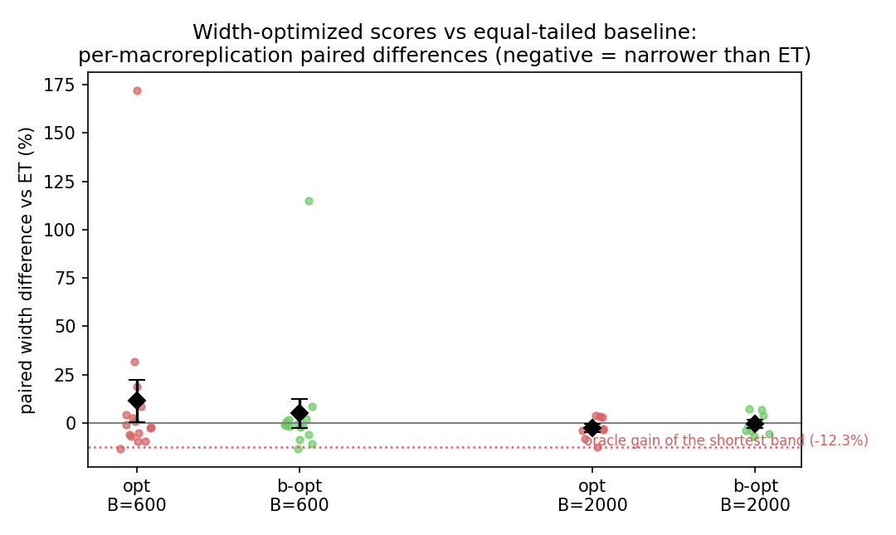
Figure 2. Paired width comparison against the equal-tailed baseline. Each dot is one macroreplication's percentage width difference (arm − ET)/ET; negative = narrower than ET. Black diamonds: mean ± one standard error. The red dotted line (−12.3%) is the oracle gain of the shortest band, i.e., the best achievable value. At B = 600 the distributions are heavy-tailed upward: medians are near zero (−1.6% for opt) but a minority of macroreplications fail catastrophically (up to +172%), dragging the means to +11.3% (opt) and +5.0% (b-opt). At B = 2000 the failures disappear and a modest genuine gain emerges (opt −2.6%, median −3.2%).
Findings.
- F1 (validity). All three scores attain 0.90 coverage at both budgets — as theory predicts, score choice is purely an efficiency question.
- F2 (low budget: the theoretical gain inverts). At B = 600 the width optimizer chases the poorly estimated deep tail (mean θ* = 0.016 vs 0.050 for ET). Its risk profile is heavy-tailed: usually slightly narrower than ET (median −1.6%) but occasionally catastrophic (up to +172% in one macroreplication), giving a mean of +11.3% and a width SD seven times that of ET. The oracle promise of −12.3% is not merely eroded — on average it is inverted.
- F3 (high budget: the gain emerges, modestly). At B = 2000 the tails are estimated well enough for the optimizer to help: −2.6% on average (median −3.2%), still far from the oracle −12.3%, with stability comparable to ET. The sign flip between budgets is the central result.
- F4 (the fixed protective constraint is not enough). The density-floor constraint (b-opt) halves the low-budget damage (+11.3% → +5.0%) but still loses to ET there, and at the high budget it gives back most of the optimizer's gain (−0.5% vs −2.6%). A fixed threshold cannot be right at both budgets: the safe tail-chasing depth depends on estimation quality, so the constraint must be calibrated from the estimated tail error itself.

5. Conclusion
Score choice never affects the coverage guarantee, but its efficiency promises are only as good as the estimated CDF behind them. At a realistic budget, the width-optimized score inverted its theoretical −12.3% prize into +11.3% wider intervals with occasional catastrophic failures, because its cut points chase poorly estimated tails; at a high budget a modest gain (−2.6%) emerged. A fixed protective constraint is directionally correct but insufficient in both regimes. Practical default for the paper: keep the equal-tailed score.

6. Implications for the paper
- Keep the equal-tailed DCP score as the paper's main score; the pilot justifies this choice quantitatively rather than by convention.
- Report the budget-indexed sign flip (Figure 2) as part of the score-choice ablation: it is direct evidence for the paper's thesis that score-layer efficiency promises are bounded by estimation-layer quality — the same argument that motivates our scale-adaptive bandwidth.
- An error-calibrated tail-depth rule (replacing the fixed density floor by the paper's tail-error formula, including its variance part) is a promising follow-up, but it is future work, not a claim of the current paper.
Reproducibility: exp_coverage_mechanism/pilot_score_design/ contains the runner (pilot_score_design.py), raw per-macroreplication results (pilot_score_design.csv), and the figure script (plot_pilot_report_figs.py). Seeds and all settings are hard-coded in the runner; the full study reruns in about 80 seconds.

